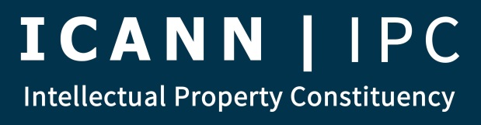
Leadership Meeting
FINAL AGENDA
September 29, 2015
- Introduction
- IPC Elections (Claudio)
- Report from Council (Brian, Heather)
- Westlake Recommendation 23 Issue
- Treasurer’s Report (Michael)
- New Secretariat
- GNSO Council Chair Election Update (Steve)
- GNSO Council Vice Chair Election Update (Steve)
- Dublin Planning
  - Travel Support
  - IPC Meetings (Closed, Open)
  - CSG Activities
    - Meetings (Closed, Open)
    - Breakfast
    - Board Roundtable
  - IPC Dinner
  - Notes/Overlaps Coordination
  - INTA/BRG/MarkMonitor Reception
- IPC Public Comments
  - ICANN Comments
    - Preliminary Issue Report on New gTLD Subsequent Procedures (Oct. 30)
    - New gTLD Auction Proceeds Discussion Paper (Nov. 8)
    - New gTLD Program Implementation Review Draft Report (Dec. 7)
  - Working Group Comments
    - Comment on Use of Country and Territory Names as top-level domains (Oct. 9)
- Outreach & Engagement
  - Outreach & Engagement Strategic Plan
  - ICANN Fellowships (Steve)
  - CROPP (Brian)
- SurveyMonkey Questionnaire on IPC Structure/IP Representation in ICANN
- NCPH Intersessional Planning
- IPC gTLD Data Portal Project
- Agenda for IPC Membership Meeting on October 6, 2015
- All Other Business
- Adjourn

