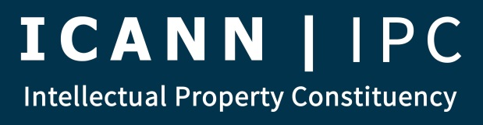

Membership and Policy Meeting - AGENDA
January 16, 2018

- Introduction (2 minutes)
- Report from Council (Heather & Paul) (5 minutes)
- Intersessional (L.A.) Planning Update (Brian W., Kiran M.) (5 minutes)
  - IPC co-chaired sessions
  - Questions to CEO
  - Remote Participation
- ICANN61 (San Juan) Planning (3 minutes)
  - Travel Funding Announcement (John)
  - ICANN Community Onboarding Pilot Program Announcement (Brian S.)
- Open Public Comments and Other Requests for Input/Volunteers (Brian S.) (5 minutes)
  - Open and Recently Closed Public Comments
Public Comment | Date
Competition, Consumer Trust, and Consumer Choice Review Team – New Sections to Draft Report of Recommendations | SUBMITTED
ICANN Request for Community Feedback on Proposed GDPR Compliance Models | 01/29/2018
Proposed Incremental Changes to the ICANN Meetings Strategy | 02/01/2018
Operating Standards for ICANN's Specific Reviews | 02/02/2018
  - Other Requests for input (5 minutes)
    - IPC Comments re: eco GDPR Playbook (P. Charnley, D. Marks, V. Sheckler)
    - IPC Letter to Board re: Geographic Terms Overarching Principles (Postponed)
    - IPC Letter re: Ways of Working and Process Improvements in RPM PDP (J. McElwaine)
- Policy Matters (30 minutes)
  - RPM Review (Susan)
    - Update on URS Discussions
  - GDPR/RDS Update
    - Letter from the IPC to Goran re: ICANN-proposed models
  - Subsequent Procedures (Open – anyone with urgent updates)
  - Other PDP Working Groups – Urgent Matters Only (all other matters and updates to list)
- AOB (5 minutes)
- Adjourn

