Importance of tonal diacritics in Kirundi

Kirundi, a national language of Burundi, has tonal diacritics that are very used in academic writings most of the times. Those tonal diacritics are not captured on the Omniglot page about Kirundi.
I could not get good online sources where tonal diacritics of Kirundi language are used. On this wikipedia page, the national anthem of Burundi "Burŭndi Bwâcu" is written with those tonal diacritics.
However, the tones in Kirundi are very important. Without the use of tonal diacritics, many words used in Kirundi would lead to confusion by having two or more meanings.
Here is one example :
When someone writes this : inkoko
There are two possible readings for a user :
- inkòko : This means a small garbage, or
- inkóko : This means a chicken
In order to provide a more reliable source, I have consulted a book on the Kirundi grammar.
The Title is : NOUVELLE GRAMMAIRE DU KIRUNDI, Volume 1, by Giovanni CRISTINI, written in 2000.
Here is the cover of the hard copy of the book :
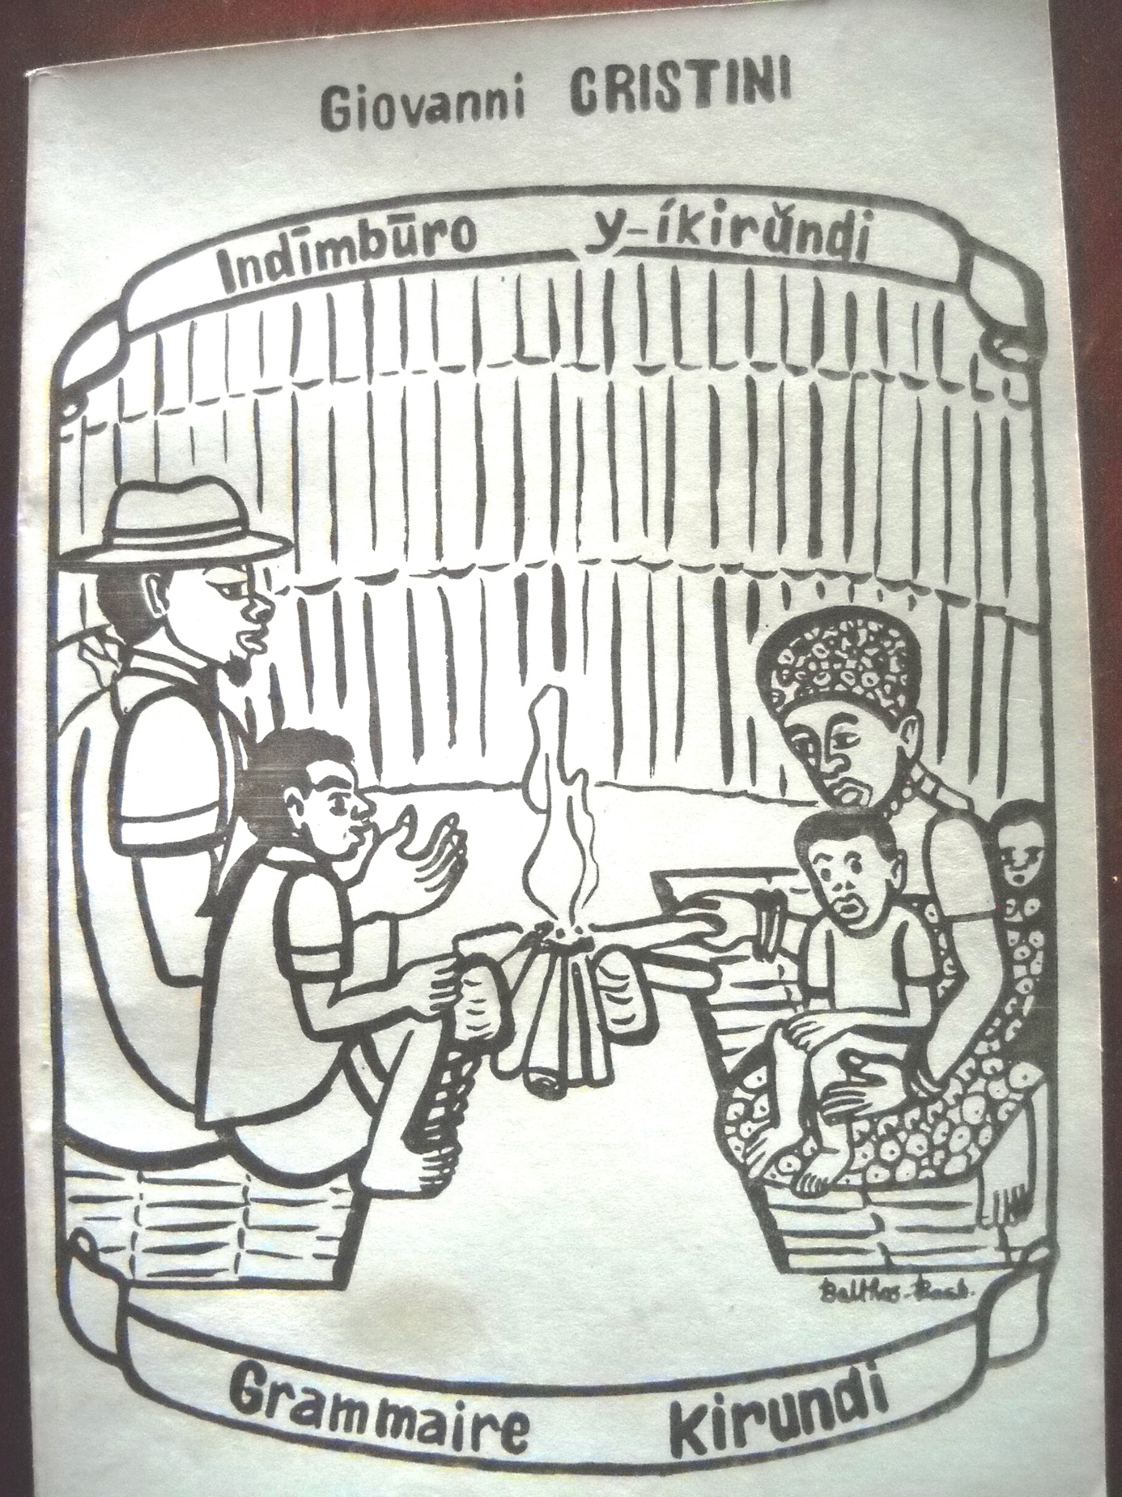
The cover of the book on Kirundi grammar.

And the title page of the book is below :
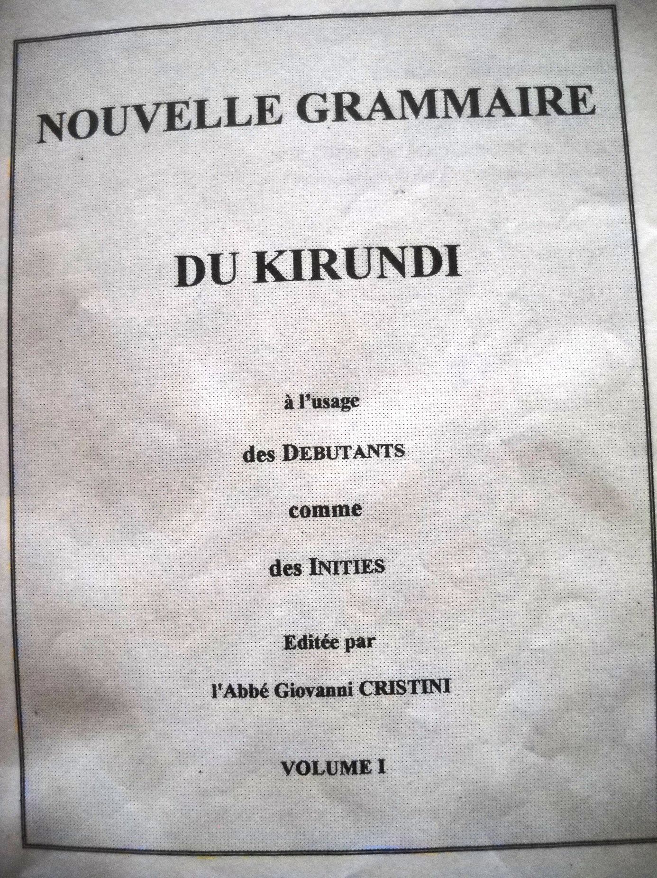

In that book, Giovanni Cristini starts the explanation of the use of tonal diacritics on page 8. Here is tha capture of his explanation on his subtitle "1.4. Tonalité" on the bottom of page 8 :
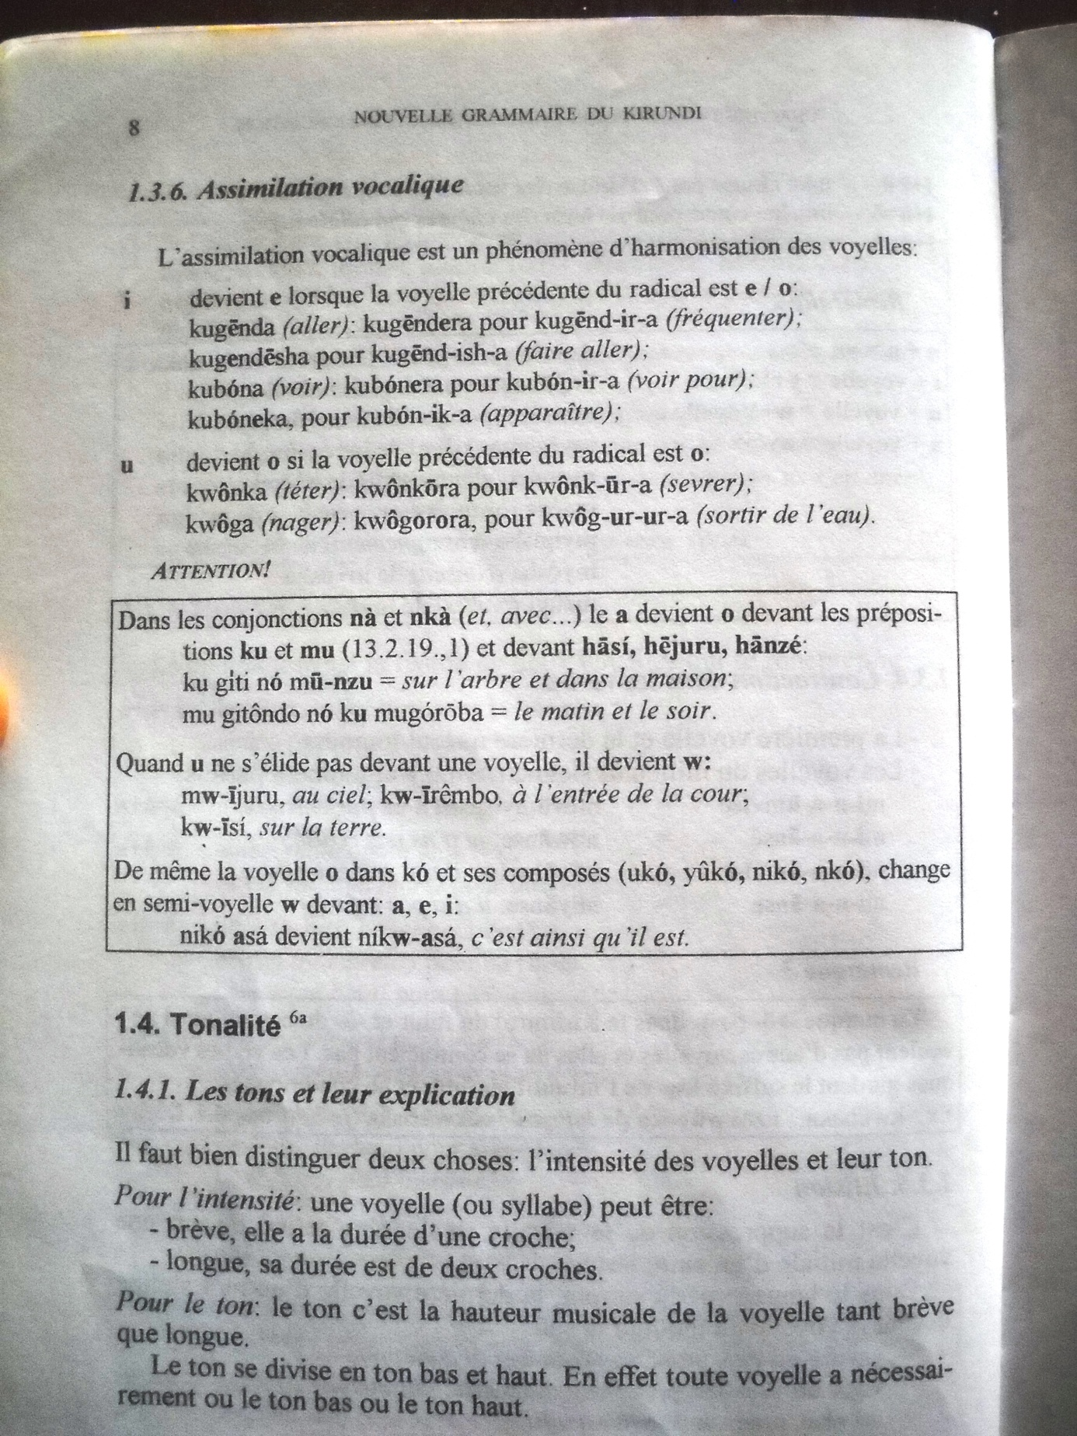

On the page 9 of that book, Giovanni CRISTINI made a table in which he listed the different vowels used in Kirundi with tonal signs :
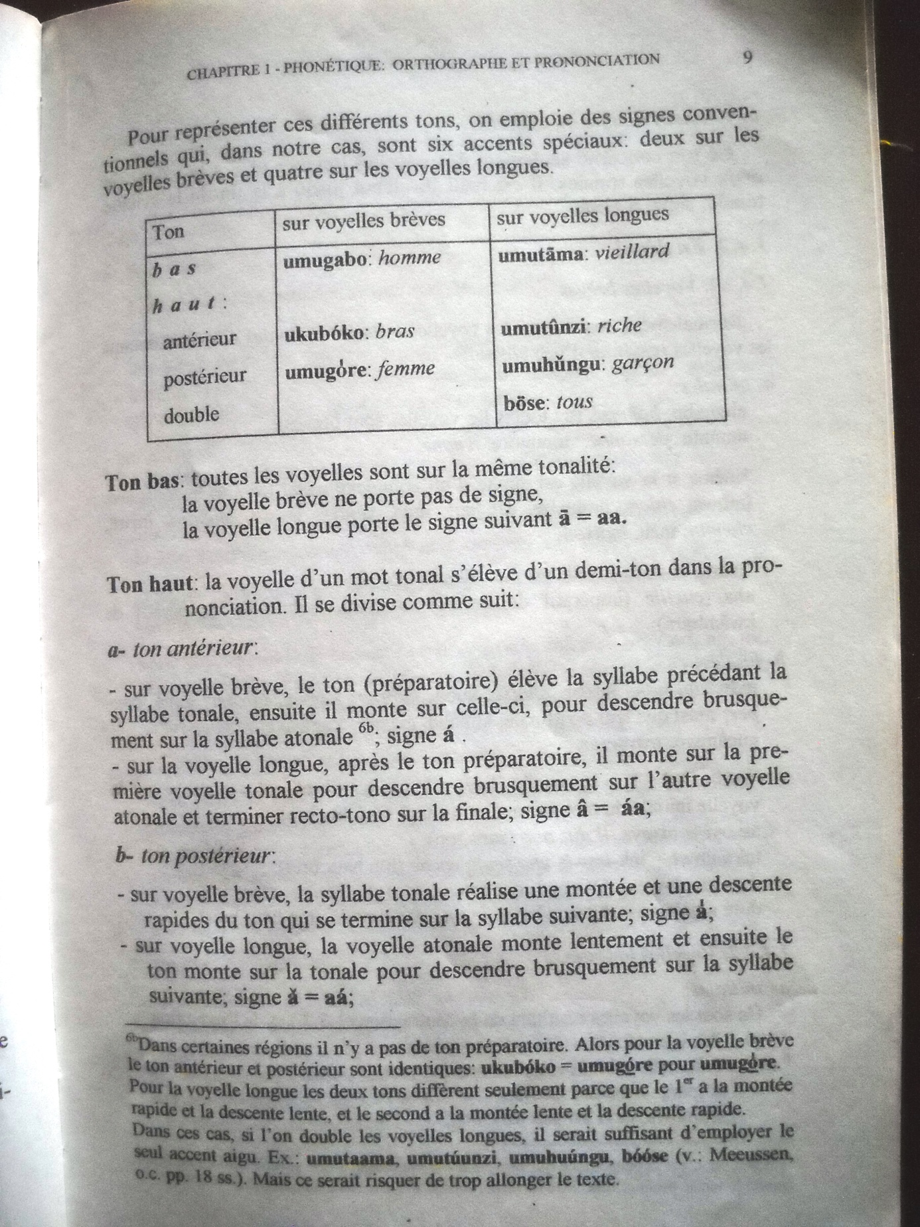

In order to provide example of the importance of writing with tonal diacritics, Giovanni CRISTINI lists some 28 words of Kirundi having different meanings according to the tone used while pronouncing them on the page 13 of that book :
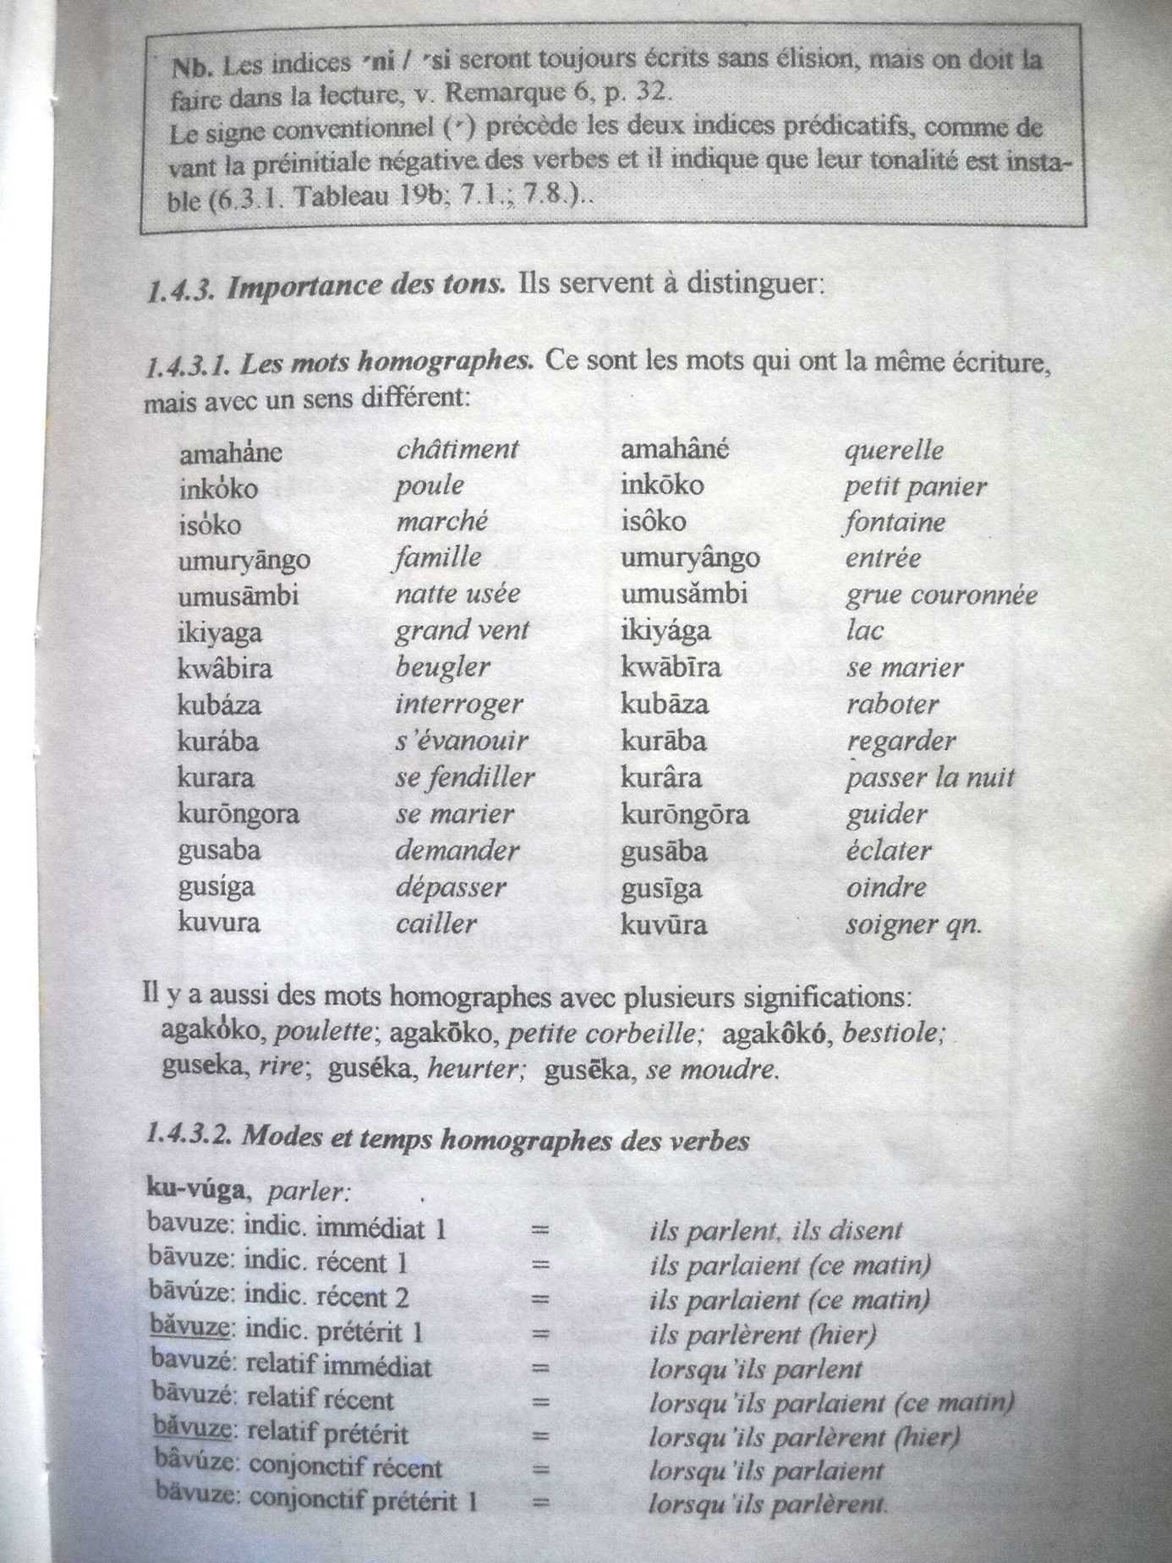

On page 15 of the book, Giovanni CRISTINI provides an example of a text where those tonal diacritics have been used. That text was extracted from a school manual used in primary schools of Burundi. Here it is :
