Basic Letter Shape Variant Analysis
Latin GP Member: Bill Jouris

i vs ı vs ɩ vs ĺ

Latin Small Letter I (0069) vs Latin Small Letter Dotless I (0131)
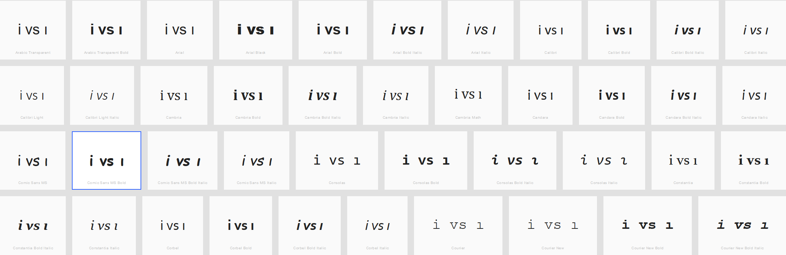
The dot is readily perceptible . . . IF the user is sensitized by familiarity to the possibility of a dotless I (which only occurs in a couple of languages). Otherwise, the user sees what he expects to see. But based on the criteria for visual similarity, this would not be a variant.
Mats made the case, based on case folding, for these being treated as variants. I concur, for this and other reasons. But this is a perception argument, not a basic letter shape one.
Decision: Variant

Latin Small Letter Dotless I (0131) vs Latin Small Letter Iota (0269)
In the italic versions of any of the serif fonts (e.g. Times New Roman or Consolas) these are identical. For example:
ı vs ɩ (Times New Roman) ı vs ɩ (Consolas)
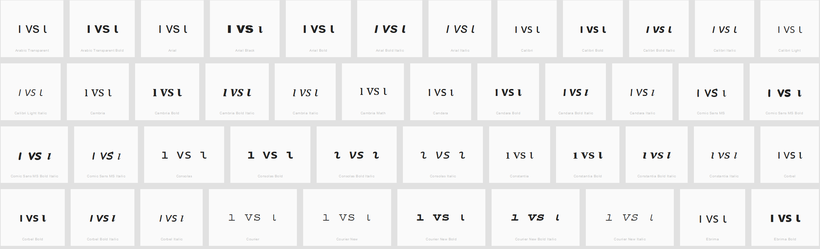
Decision: Variant

Latin Small Letter L with Acute (013A)
I’m not sure why this even got included here. Yes, in a san-serif font a small letter L with acute is indistinguishable from a capital letter I with acute:
ĺ vs Í
But compared to any of the Small Letter I variations? Not only not a variant, but probably not even confusable.
Decision: Not a Variant

