Basic Letter Shape Variant Analysis
Latin GP Member: Hazem Hezzah

p vs þ
Latin Small Letter P (0070) vs. Latin Small Letter Thorn (00FE)
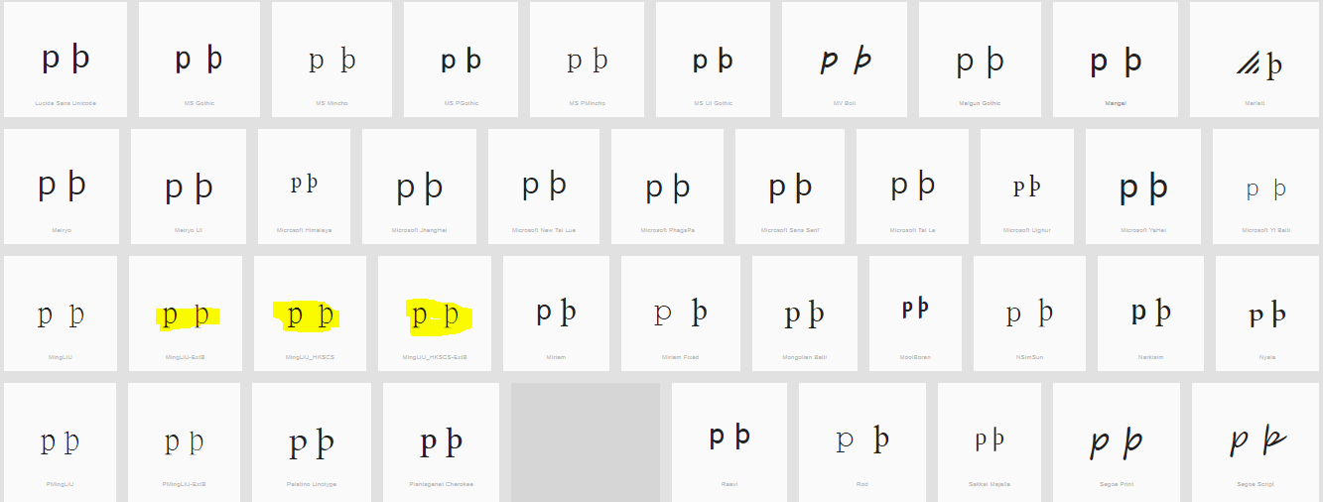

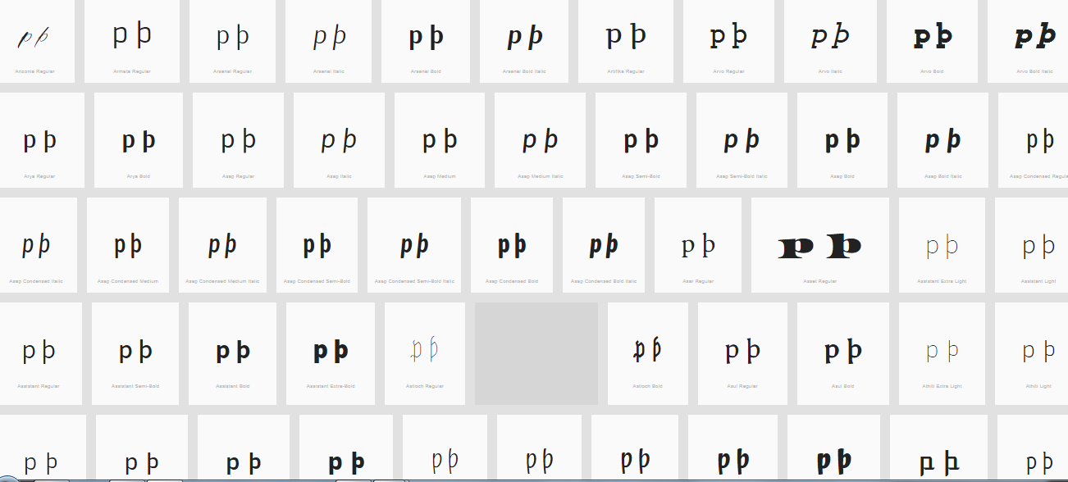

The upper leg of the Thorn is visible in most fonts (except those highlighted) can be somewhat unclear.
Decision: Not Variant

