Template for Appendix D on Variants

Kindly insert your data into each section, based on the type of difference as indicated by the L1 Headings (Spacing Evaluation, Base Character Evaluation, Diacritics Stacking Evaluation). If L1 Heading is missing please create a new one.
Kindly insert your data into a new subsection based on the actual variants compared
Insert code points into table. Color code lines
- GREEN for cases, where a final case for a variant was decide
- YELLOW where a graphic was created to compare two code points
- NO COLOR where no variant candidate for a code point was identified

Code Points | Glyph | Name

Meikla’s comments
I noticed that the coloring scheme has been used inconsistently.
For example in D 4.4. The table should show all characters in repertoire which have a grave. I’m not sure if the list is complete. However for all given code points there is a potential candidate to be compared listed in that table. Therefore al lines should be highlighted yellow.
I have corrected couloring
I also noted some minor formatting issues such as the underlining of elements in the first table and some typos here and there, but this is not relevant at this stage in my opinion.
I cannot find underlining of elements in the first table, sorry , probably I am missing something.
___________________________________________________________________________________________

D.2 Spacing Evaluation

D.2 DOUBLE ACUTE vs DIAERESIS

Code Points Analyzed:

Code Points | Glyph | Name
006E + 0308 | n̈ | LATIN SMALL LETTER N + COMBINING DIAERESIS
00E4 | ä | LATIN SMALL LETTER A WITH DIAERESIS
00EB | ë | LATIN SMALL LETTER E WITH DIAERESIS
00EF | ï | LATIN SMALL LETTER I WITH DIAERESIS
00F6 | ö | LATIN SMALL LETTER O WITH DIAERESIS
00FC | ü | LATIN SMALL LETTER U WITH DIAERESIS
00FF | ÿ | LATIN SMALL LETTER Y WITH DIAERESIS
0151 | ő | LATIN SMALL LETTER O WITH DOUBLE ACUTE
0171 | ű | LATIN SMALL LETTER U WITH DOUBLE ACUTE
0254 + 0308 | ɔ̈ | LATIN SMALL LETTER OPEN O + COMBINING DIAERESIS
025B + 0308 | ɛ̈ | LATIN SMALL LETTER OPEN E + COMBINING DIAERESIS
025B + 0331 + 0308 | ɛ̱̈ | LATIN SMALL LETTER OPEN E + COMBINING MACRON BELOW + COMBINING DIAERESIS
1E8D | ẍ | LATIN SMALL LETTER X WITH DIAERESIS

Sequence (őö and üű) (U+00F6 U+0151 and U+00FC U+0171) comapred using Google Fonts in https://wordmark.it/ :

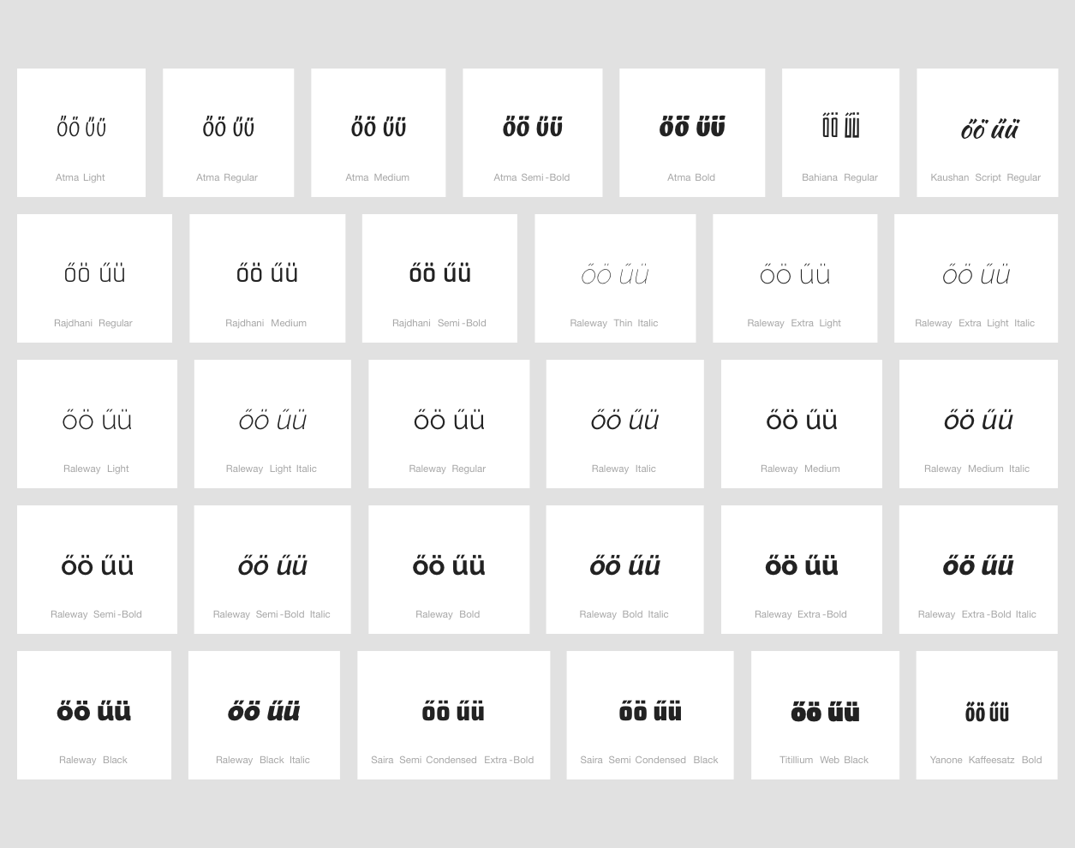

Findings:
- őö and üű were considered as potential variant pairs
- The representations of the Double Acute vs Diaeresis in these pairs are distinguishable in a number of fonts...
- In some number of fonts, the two diacritics look similar.

Conclusion:
- Code points őö and üű should be investigated for visual similarity

D.3 Base Character Evaluation

D.3.1 LATIN SMALL LETTER T VS LATIN SMALL LETTER L WITH STROKE

Code Points Analyzed:

Code Points | Glyph | Name
0074 | t | LATIN SMALL LETTER T
0142 | ł | LATIN SMALL LETTER L WITH STROKE

Sequence (t ł) (U+0074 U+0142) compared using Google Fonts in https://wordmark.it/ :
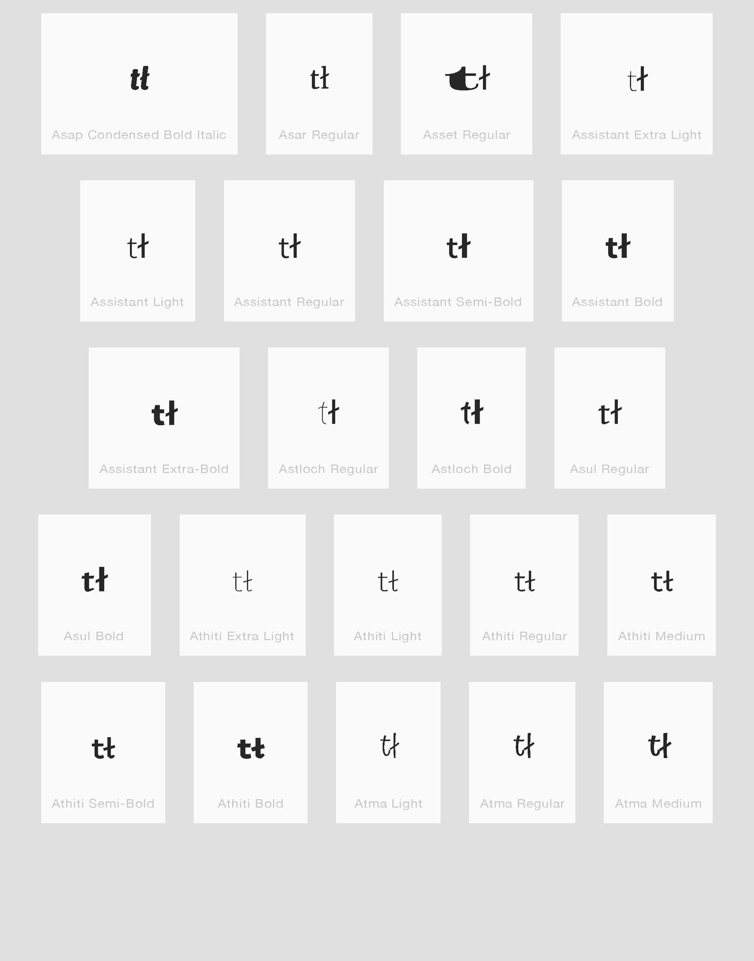

Findings:
- Glyphs are distinguishable

D.3.2 LATIN SMALL LETTER A VS LATIN SMALL LETTER ALPHA

Code Points Analyzed:

Code Points | Glyph |  | Name
0061 |  | a |  | LATIN SMALL LETTER A
0251 |  | ɑ |  | LATIN SMALL LETTER ALPHA

Findings:
- LATIN SMALL LETTER APLHA is not in the Repertoire

D.3.3 LATIN SMALL LETTER F VS LATIN SMALL LETTER F WITH HOOK

Code Points Analyzed:

Code Points | Glyph | Name
0066 | f | LATIN SMALL LETTER F
0192 | ƒ | LATIN SMALL LETTER F WITH HOOK

Findings:
- These two code points should be treated as variants

Example from Swedish Newspaper

Swedish uses a shape of “LATIN SMALL LETTER F” (U+0066) that is identical to “LATIN SMALL
LETTER F WITH HOOK” (U+0192) in italic style. Example from a large, daily newspaper, in
which all instances of “ƒ” are just variants of “f”.
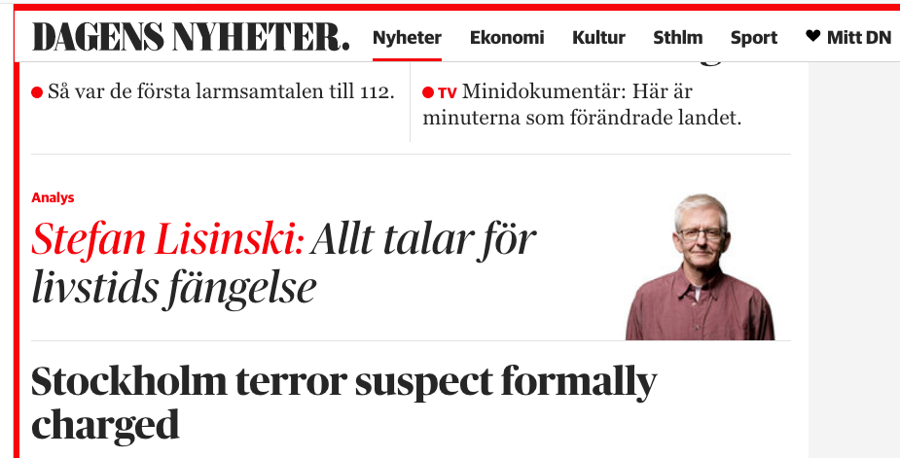

Example of U+0192 and U+0066, respectively, in Monotype Corsiva (48 pt):
ƒf
Data collected 2018-01-31 by Mats Dufberg (linguist and native speaker of Swedish)

D.4 Diacritics Stacking Evaluation

D.4.1 Latin SMALL LETTER A WITH CIRCUMFLEX AND TILDE

Code Points Analyzed:

Code Points | Glyph | Name
0061 | a | LATIN SMALL LETTER A
1EAB | ẫ | LATIN SMALL LETTER A WITH CIRCUMFLEX AND TILDE

Sequence (aẫa) (U+0061 U+1EAB U+0061) compared using Google Fonts in https://wordmark.it/ :

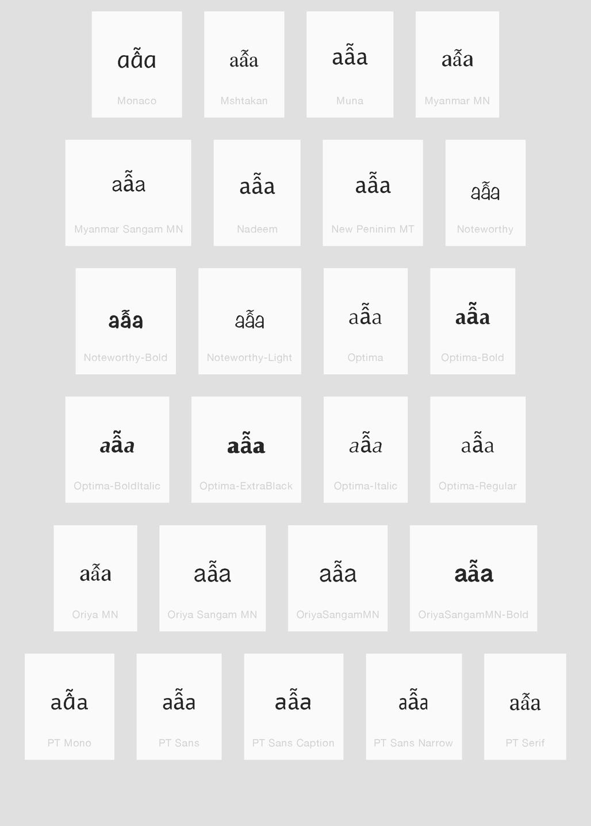
Findings:
- Stacking diacrtitics are always in place

D.4.2 LATIN SMALL LETTER E WITH CIRCUMFLEX AND TILDE

Code Points Analyzed:

Code Points | Glyph | Name
0065 | e | LATIN SMALL LETTER E
1EC5 | ễ | LATIN SMALL LETTER E WITH CIRCUMFLEX AND TILDE

Sequence (eễe) (U+0065 U+1EC5 U+0065) compared using Google Fonts in https://wordmark.it/ :

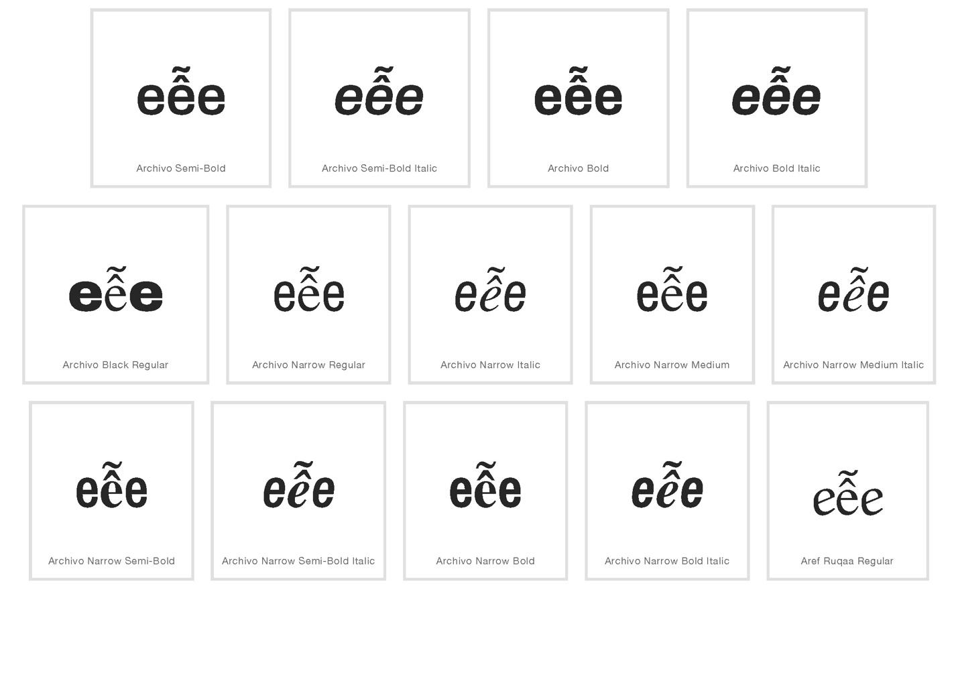
Findings:
- Stacking diacritics are always in place

D.4.3 LATIN SMALL LETTER O WITH CIRCUMFLEX AND TILDE

Code Points Analyzed:

Code Points | Glyph | Name
006F | o | LATIN SMALL LETTER E
1EC5 | ỗ | LATIN SMALL LETTER O WITH CIRCUMFLEX AND TILDE

Sequence (oỗo) (U+006F U+1EC5 U+006F) compared using Google Fonts in https://wordmark.it/ :

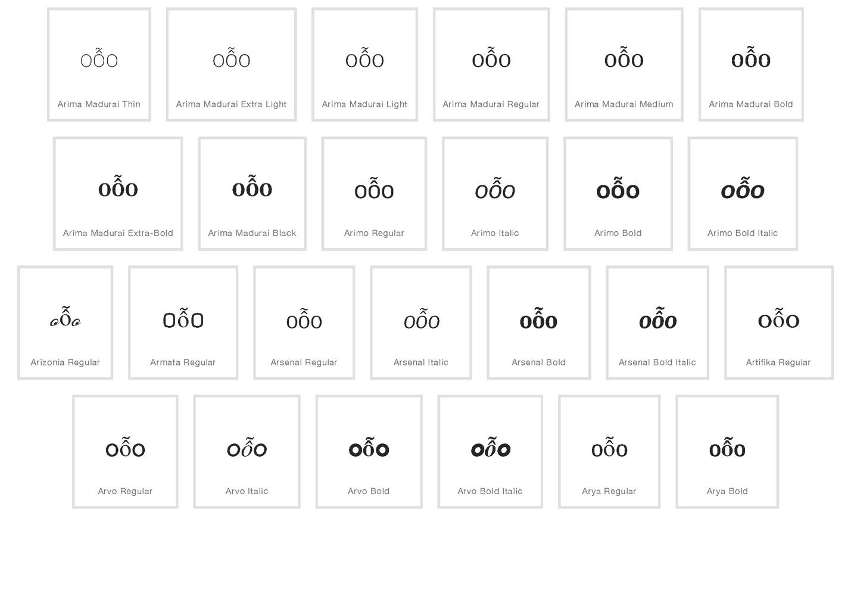

Findings:
- Stacking diacrtitics are always in place

D.4.4 DIACRITIC GRAVE

Code Points Analyzed:

Code Points | Glyph | Name
0061 | a | LATIN SMALL LETTER A
0065 | e | LATIN SMALL LETTER E
0069 | i | LATIN SMALL LETTER I
006F | o | LATIN SMALL LETTER E
0075 | u | LATIN SMALL LETTER U
0079 | y | LATIN SMALL LETTER Y
00E0 | à | LATIN SMALL LETTER A WITH GRAVE
00E8 | è | LATIN SMALL LETTER E WITH GRAVE
00EC | ì | LATIN SMALL LETTER I WITH GRAVE
00F2 | ò | LATIN SMALL LETTER O WITH GRAVE
00F9 | ù | LATIN SMALL LETTER U WITH GRAVE
1EF3 | ỳ | LATIN SMALL LETTER Y WITH GRAVE

Sequence (aàa and eèe and iìi and oòo and uùu and yỳy) (U+0061 U+00E0 U+0061 and U+0065 U+00E8 U+0065 and U+0069 U+00EC U+0069 and U+006F U+00F2 U+006F and U+0075 U+00F9 U+0075 and U+0079 U+1EF3 U+0079 ) compared using Google Fonts in https://wordmark.it/ :

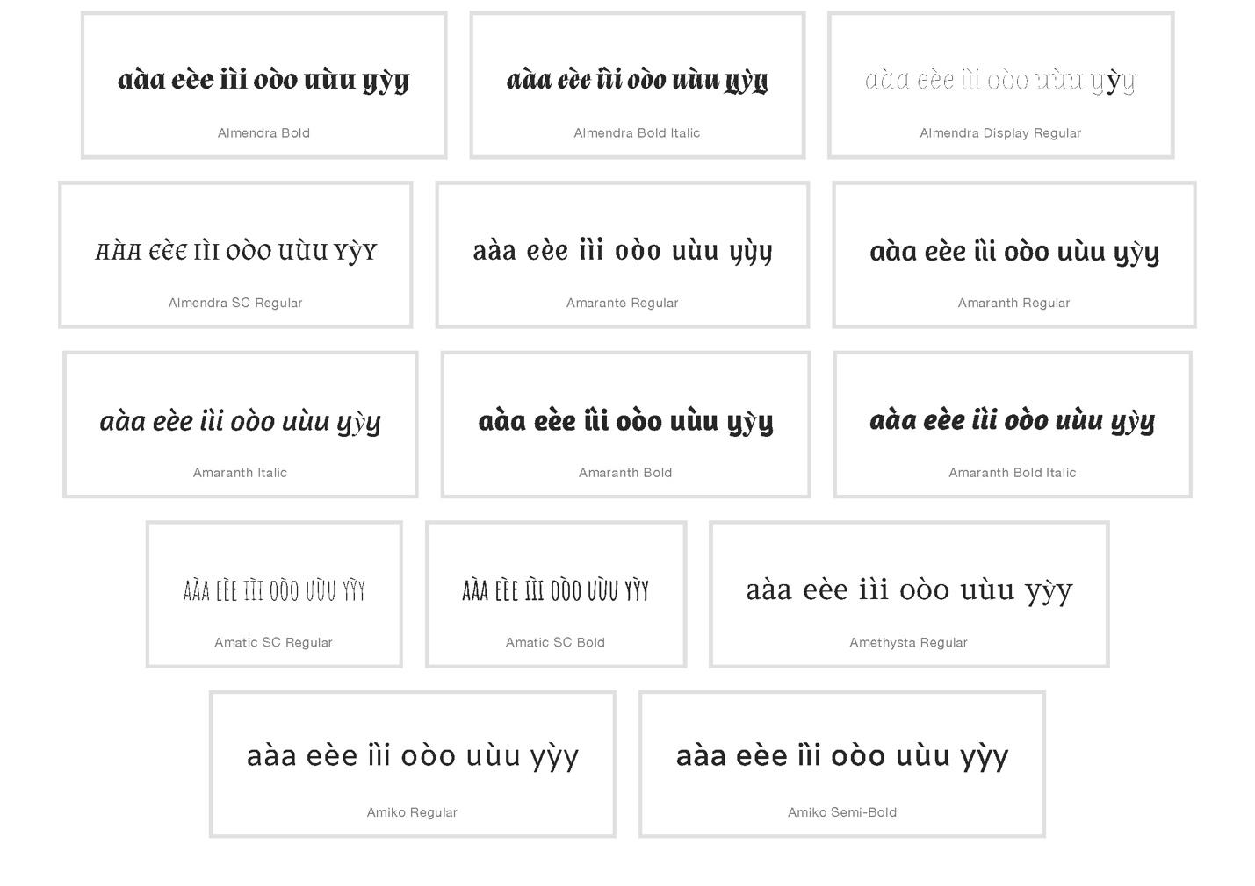

Findings:
- Diacrtitics are always in place

D.4.5 DIACITICS HORN AND GRAVE

Code Points Analyzed:

Code Points | Glyph |  | Name
006F |  | o | LATIN SMALL LETTER E
0075 |  | u | LATIN SMALL LETTER U
00F2 |  | ò | LATIN SMALL LETTER O WITH GRAVE
00F9 |  | ù | LATIN SMALL LETTER U WITH GRAVE
01A1 |  | ơ | LATIN SMALL LETTER O WITH HORN
01B0 |  | ư | LATIN SMALL LETTER U WITH HORN
1EDD |  | ờ | LATIN SMALL LETTER O WITH HORN AND GRAVE
1EEB |  | ừ | LATIN SMALL LETTER U WITH HORN AND GRAVE

Sequence (ờoơò and ừuưù) (U+1EDD U+006F U+01A1 U+00F2 and U+1EEB U+0075 U+01B0 U+00F9) compared using Google Fonts in https://wordmark.it/ :

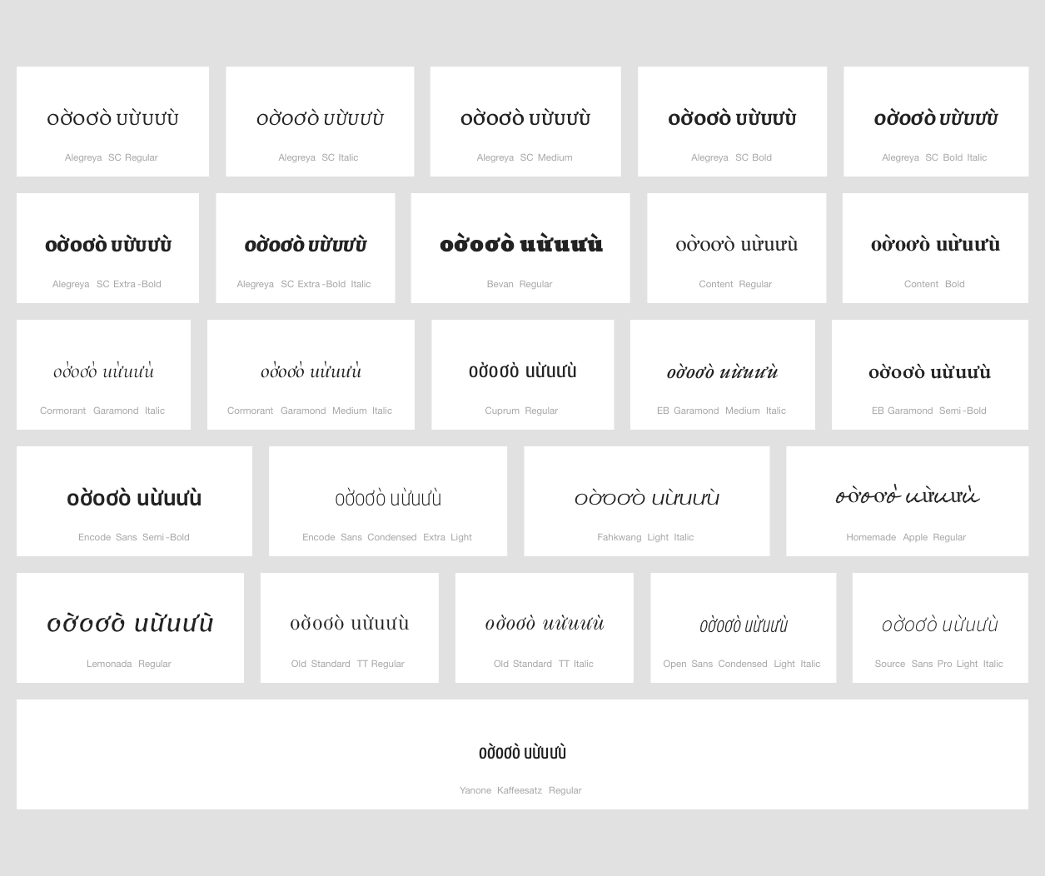

Findings:
- Diacrtitics are always in place

Additional findings:
- In some fonts, especially in letter "u" case, it seems that horn belongs to the next character. There is no character with horn to the left in Repertoire.

