D.2 Spacing Evaluation

D.3 Base Character Evaluation

D.3.1 LATIN SMALL LETTER B vs LATIN SMALL LETTER THORN

Code Points Considered:
Code Points Analyzed:

Code Points | Glyph | Name
00FE | þ | LATIN SMALL LETTER THORN
0062 | b | LATIN SMALL LETTER B

Sequence þb (00FE 0062) compared using Google Fonts in https://wordmark.it/ :

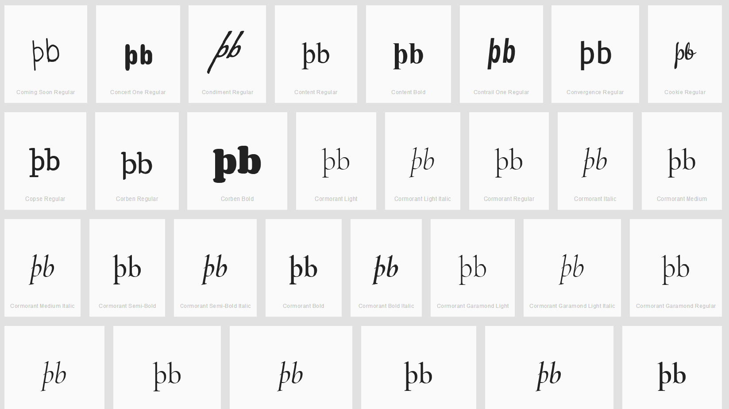

Findings:
- All cases I viewed on wordmark.it looked similar to the above screenshot. The þ and b always appear quite distinquishable as the þ always has a stroke below the base line and the b never crosses the base line.

D.3.2 LATIN SMALL LETTER V WITH HOOK vs LATIN SMALL LETTER V

Code Points Considered:
Code Points Analyzed:

Code Points | Glyph | Name
028B | ʋ | LATIN SMALL LETTER V WITH HOOK
0076 | v | LATIN SMALL LETTER V

Sequence ʋv (028B 0067) compared using Google Fonts in https://wordmark.it/ :

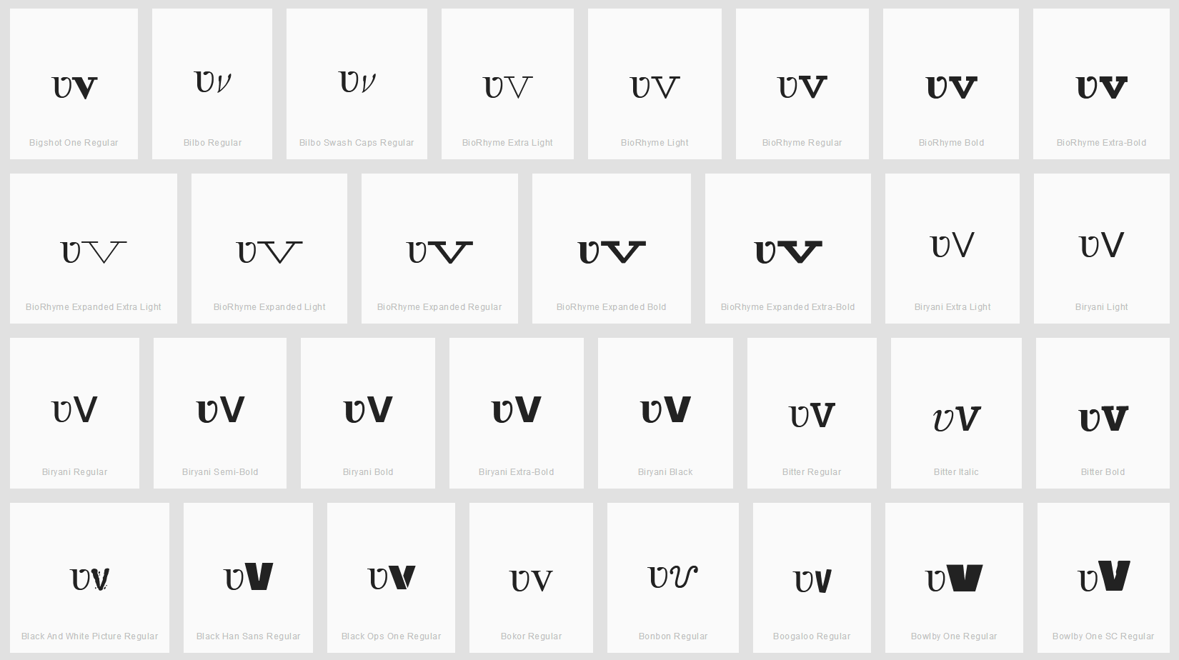

Findings:
- All cases I viewed on wordmark.it looked more or less similar to the above screenshot. In particular the ʋ looks more like a u than a v at the bottom in the sense that it never has a sharp angle, but always a curve (whereas v has almost always a sharp angle). Furthermore, the top right corner of the ʋ is always turned visibly to the left. Even in cases where the v has some serif this is distinguishable from the ʋ hook as the serif is always in both directions (left an right).

D.3.3 LATIN SMALL LETTER I vs LATIN SMALL LETTER DOTLESS I

Code Points Considered:
Code Points Analyzed:

Code Points | Glyph | Name
0069 | i | LATIN SMALL LETTER I
0131 | ı | LATIN SMALL LETTER DOTLESS I

Sequence ıi (0131 0069) compared using Google Fonts in https://wordmark.it/ :

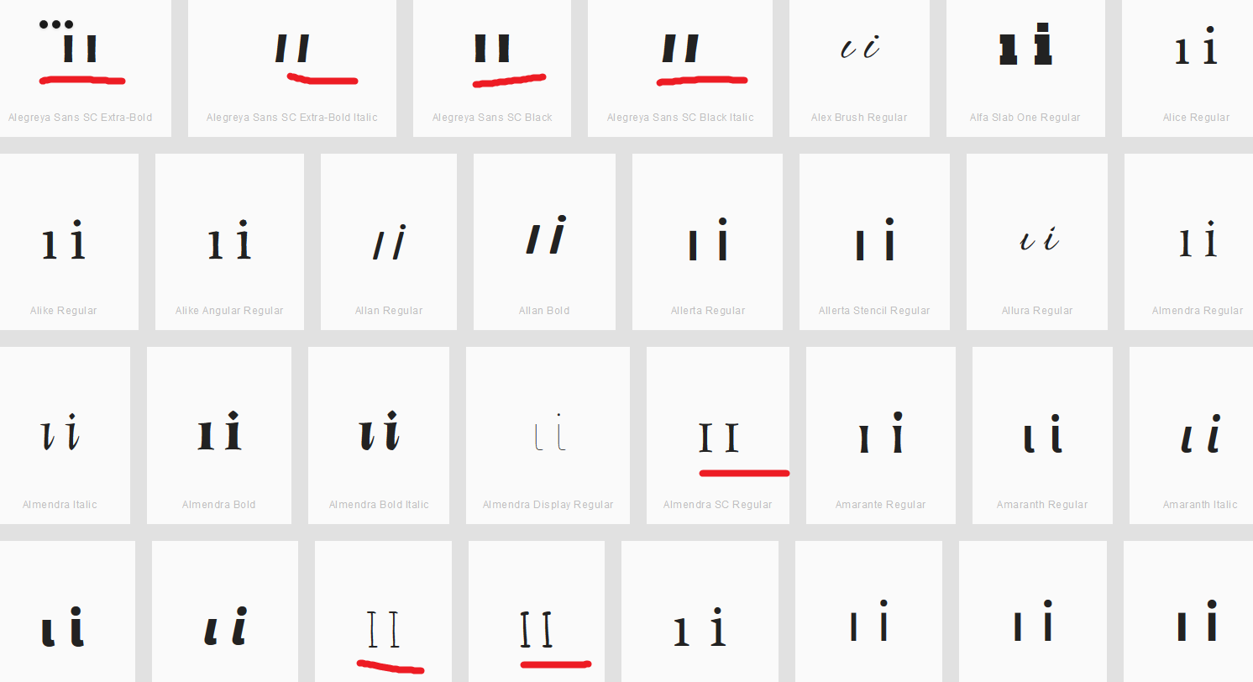

Findings:
- Both glyphs are distinguishable when written in lower case. I could not find a font, where the dot on the i was missing or almost invisible. However, some fonts displayed the lower case characters in upper case instead. In those examples, the letters were exactly the same (see red marked examples).

D.4 Diacritics Stacking Evaluation

D.4.1 Tilde vs Macron (Above)

Code Points Analyzed:

Code Points | Glyph | Name
0067 + 0303 | g̃ | LATIN SMALL LETTER G + COMBINING TILDE
006E + 0304 | n̄ | LATIN SMALL LETTER N + COMBINING MACRON
0072 + 0303 | r̃ | LATIN SMALL LETTER R WITH TILDE
00E3 | ã | LATIN SMALL LETTER A WITH TILDE
00F1 | ñ | LATIN SMALL LETTER N WITH TILDE
00F5 | õ | LATIN SMALL LETTER O WITH TILDE
0101 | ā | LATIN SMALL LETTER A WITH MACRON
0113 | ē | LATIN SMALL LETTER E WITH MACRON
0129 | ĩ | LATIN SMALL LETTER I WITH TILDE
012B | ī | LATIN SMALL LETTER I WITH MACRON
014D | ō | LATIN SMALL LETTER O WITH MACRON
0169 | ũ | LATIN SMALL LETTER U WITH TILDE
016B | ū | LATIN SMALL LETTER U WITH MACRON
1E21 | ḡ | LATIN SMALL LETTER G + MACRON
1EBD | ẽ | LATIN SMALL LETTER E WITH TILDE
1EF9 | ỹ | LATIN SMALL LETTER Y WITH TILDE

Sequence ãā (00E3 0101) compared using Google Fonts in https://wordmark.it/ :

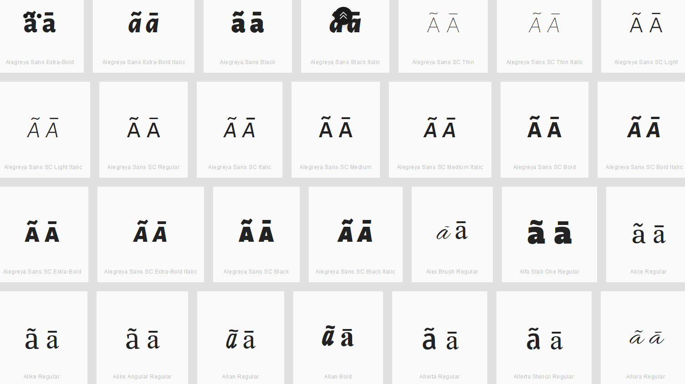

Findings:
- Macron and Tilde are distinguishable for the viewed fonts.

Sequence ēẽ (0113 1EBD) compared using Google Fonts in https://wordmark.it/ :

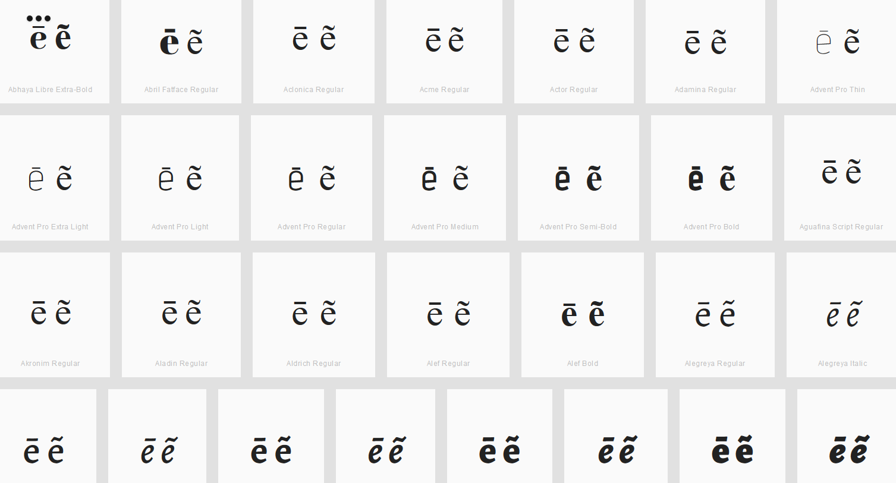

Findings:
- Macron and Tilde are distinguishable for the viewed fonts.

Sequence g̃ḡ (0067+0303 1E21) compared using Google Fonts in https://wordmark.it/ :

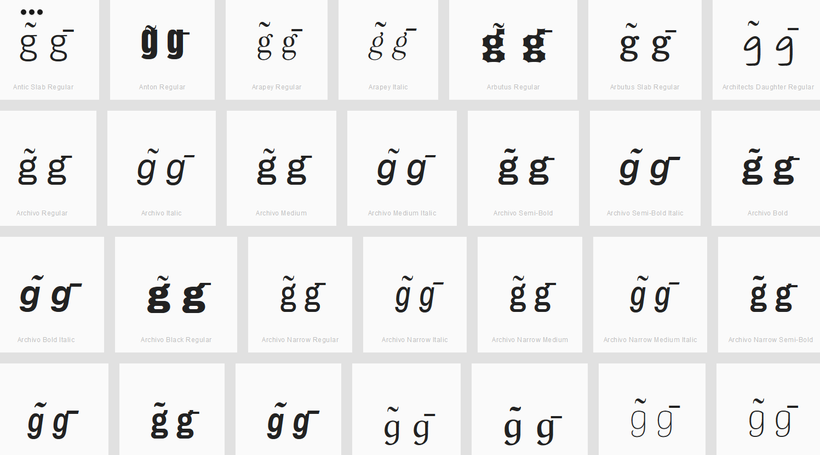

Findings:
- Macron and Tilde are distinguishable for the viewed fonts.

Sequence ĩī (0129 012B) compared using Google Fonts in https://wordmark.it/ :

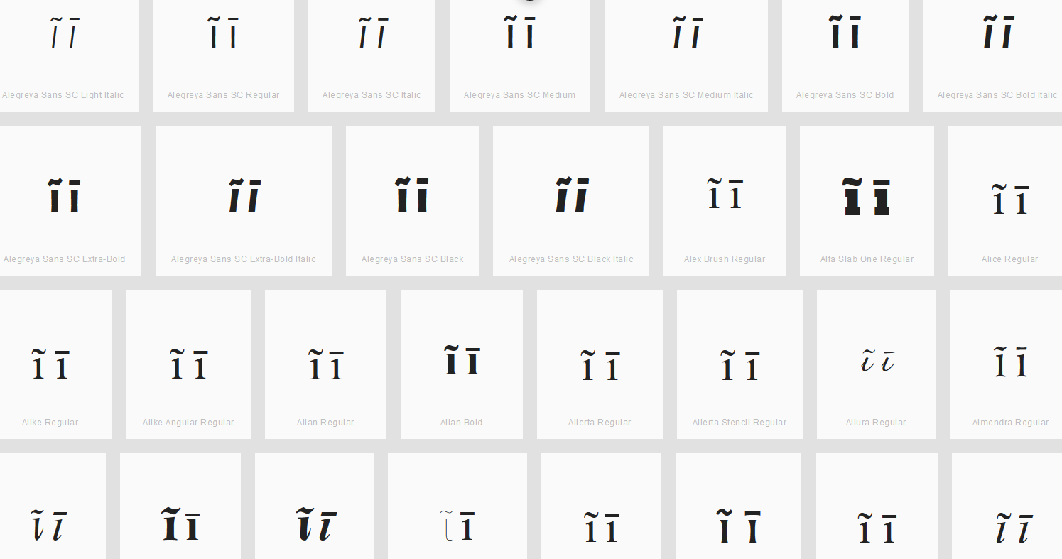

Findings:
- Macron and Tilde are distinguishable for the viewed fonts.

Sequence n̄ñ (006E+0304 00F1) compared using Google Fonts in https://wordmark.it/ :

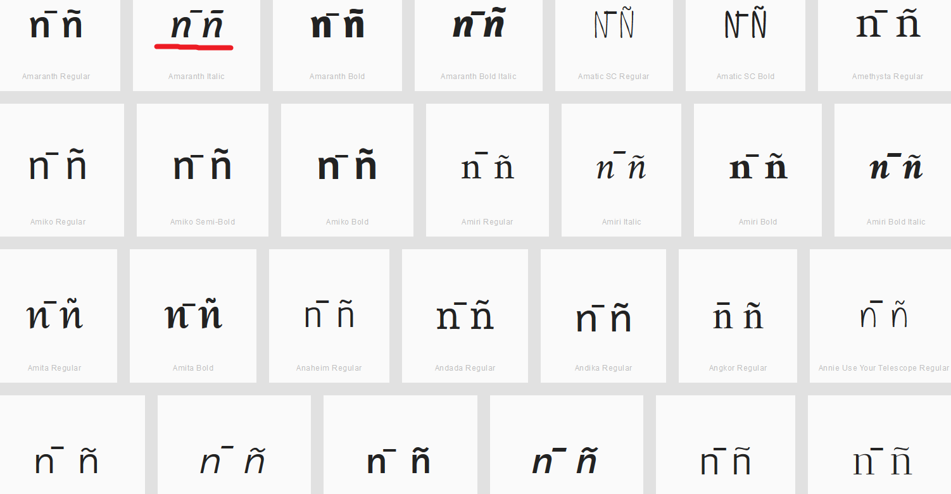

Findings:
- Macron and Tilde are distinguishable for almost all viewed fonts. I found very few examples where they are not. In the example below the second pair (marked red) is distinguishable, but only because the macron above is moved to the right.

Sequence õō (00F5 014D) compared using Google Fonts in https://wordmark.it/ :

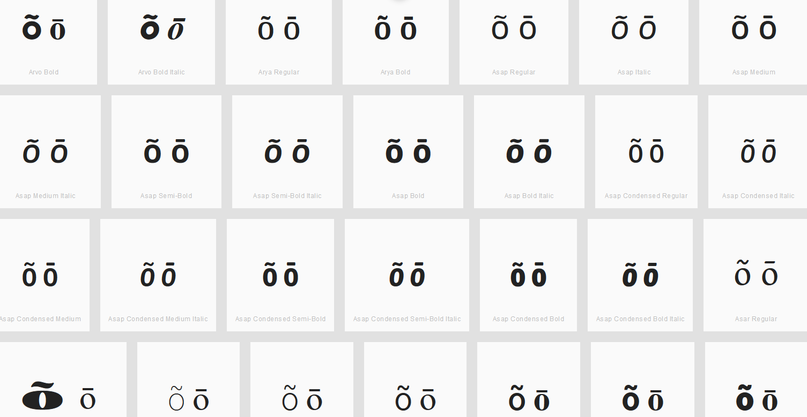

Findings:
- Macron and Tilde are distinguishable for the viewed fonts.

Sequence ũū (0169 016B) compared using Google Fonts in https://wordmark.it/ :

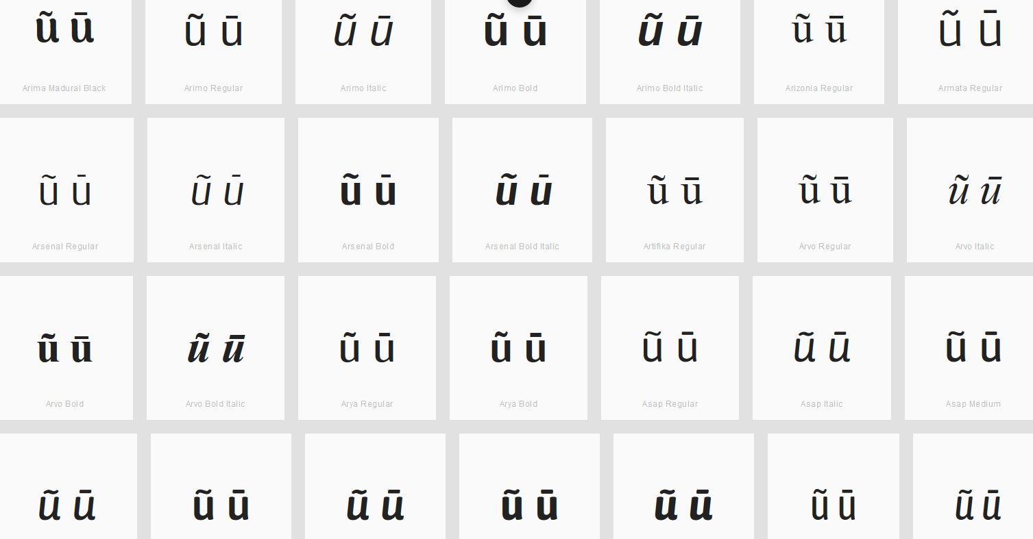

Findings:
- Macron and Tilde are distinguishable for the viewed fonts.

D.4.2 Hook vs Dot (Above)

Code Points Analyzed:

Code Points | Glyph | Name
0069 | i | LATIN SMALL LETTER I
010B | ċ | LATIN SMALL LETTER C WITH DOT ABOVE
0117 | ė | LATIN SMALL LETTER E WITH DOT ABOVE
0121 | ġ | LATIN SMALL LETTER G WITH DOT ABOVE
017C | ż | LATIN SMALL LETTER Z WITH DOT ABOVE
0199 | ƙ | LATIN SMALL LETTER K WITH HOOK
01B4 | ƴ | LATIN SMALL LETTER Y WITH HOOK
0253 | ɓ | LATIN SMALL LETTER B WITH HOOK
0257 | ɗ | LATIN SMALL LETTER D WITH HOOK
1E45 | ṅ | LATIN SMALL LETTER N WITH DOT ABOVE
1EA3 | ả | LATIN SMALL LETTER A WITH HOOK ABOVE
1EBB | ẻ | LATIN SMALL LETTER E WITH HOOK ABOVE
1EC9 | ỉ | LATIN SMALL LETTER I WITH HOOK ABOVE
1ECF | ỏ | LATIN SMALL LETTER O WITH HOOK ABOVE
1EE7 | ủ | LATIN SMALL LETTER U WITH HOOK ABOVE
1EF7 | ỷ | LATIN SMALL LETTER Y WITH HOOK ABOVE

Sequence ẻė (1EBB 0117) compared using Google Fonts in https://wordmark.it/ :

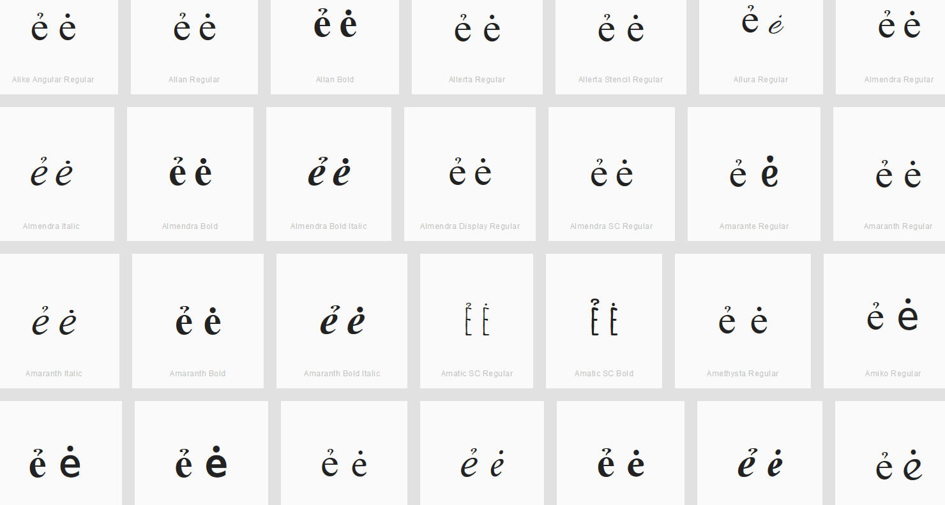

Findings:
- Dot and Hook are distinguishable for the viewed fonts.

Sequence iỉ (0069 1EC9) compared using Google Fonts in https://wordmark.it/ :

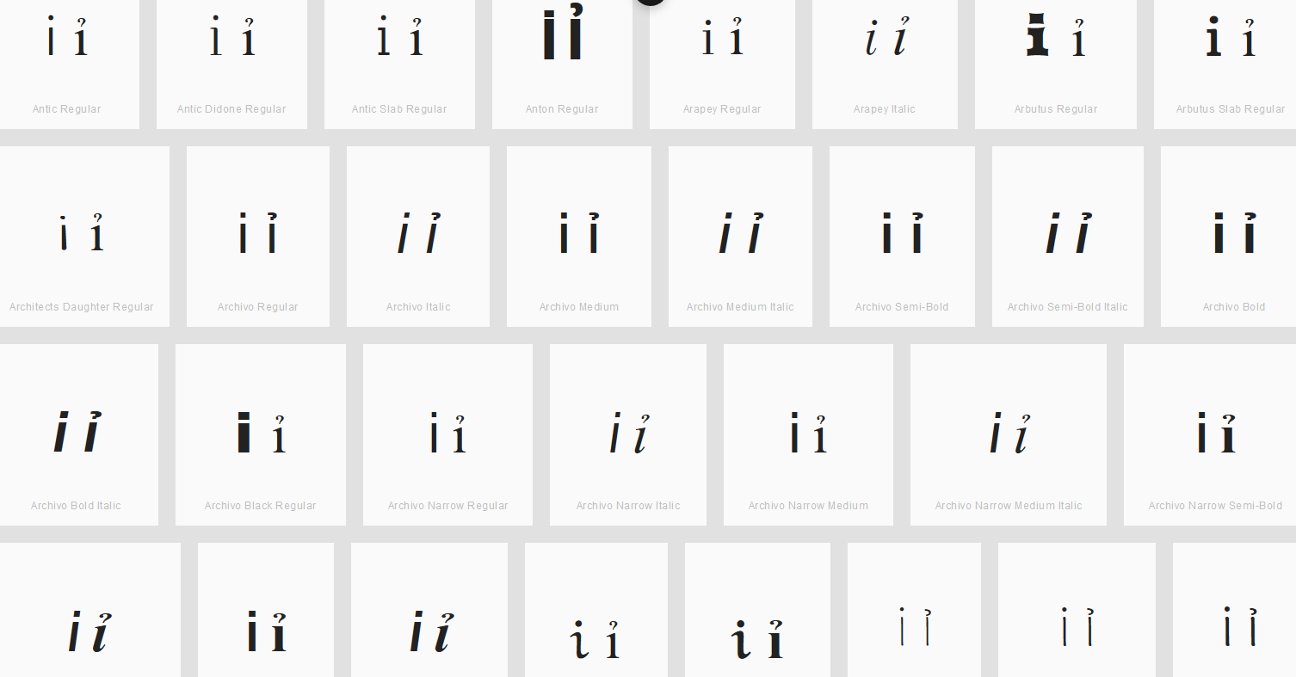

Findings:
- I am comparing the standard i with an i with a hook above. Dot and Hook are distinguishable for the viewed fonts.

Sequence ƴỷ (01B4 1EF7) compared using Google Fonts in https://wordmark.it/ :

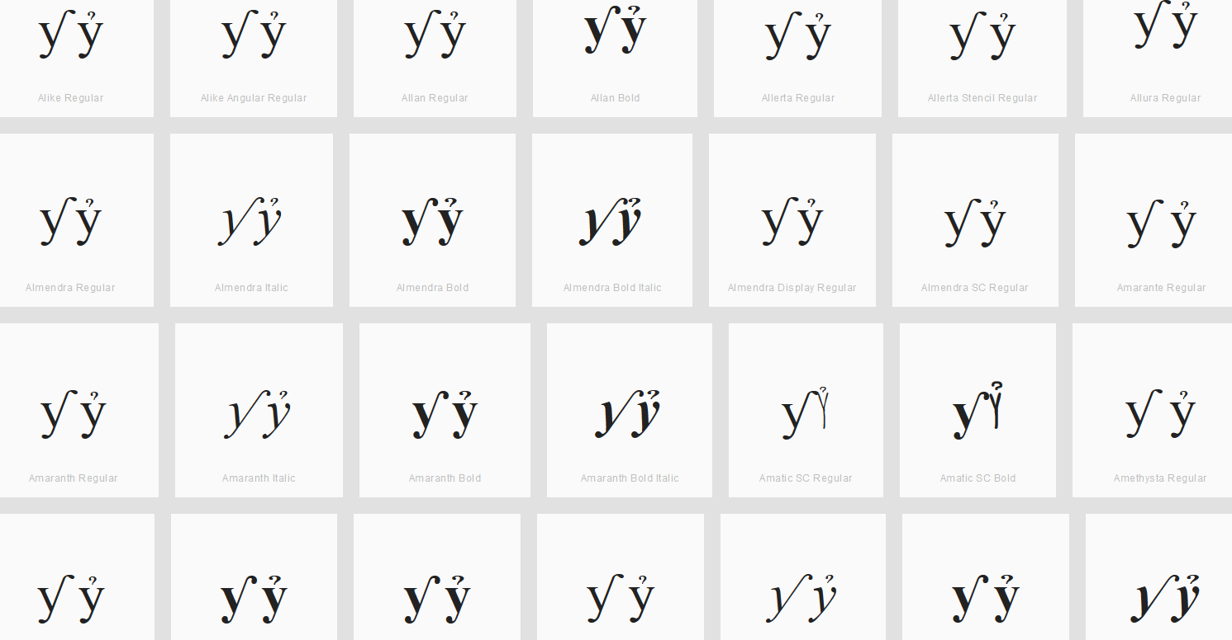

Findings:
- Even though not explicitly mentioned, I also compared y with hook and y with hook above. As they might turn out to be the same in some fonts. Hook and Hook Above are distinguishable for the viewed fonts.

D.4.3 CIRCUMFLEX AND HOOK ABOVE

Code Points Analyzed:

Code Points | Glyph | Name
1EA9 | ẩ | LATIN SMALL LETTER A WITH CIRCUMFLEX AND HOOK ABOVE
1EC3 | ể | LATIN SMALL LETTER E WITH CIRCUMFLEX AND HOOK ABOVE
1ED5 | ổ | LATIN SMALL LETTER O WITH CIRCUMFLEX AND HOOK ABOVE

Sequence ẩ (1EA9) compared using Google Fonts in https://wordmark.it/ :

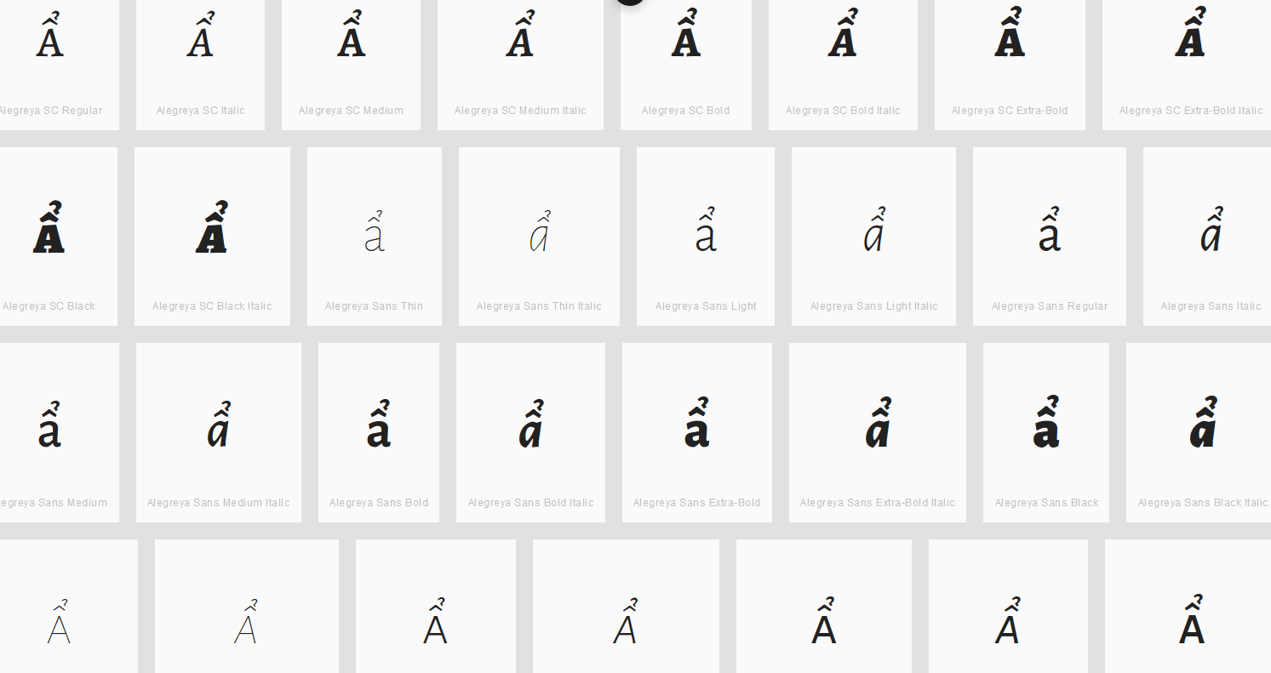

Findings:
- The double diacritics stay at the base character and thus will not be confused with characters next to it having just one of the diacritics.

Sequence ể (1EC3) compared using Google Fonts in https://wordmark.it/ :

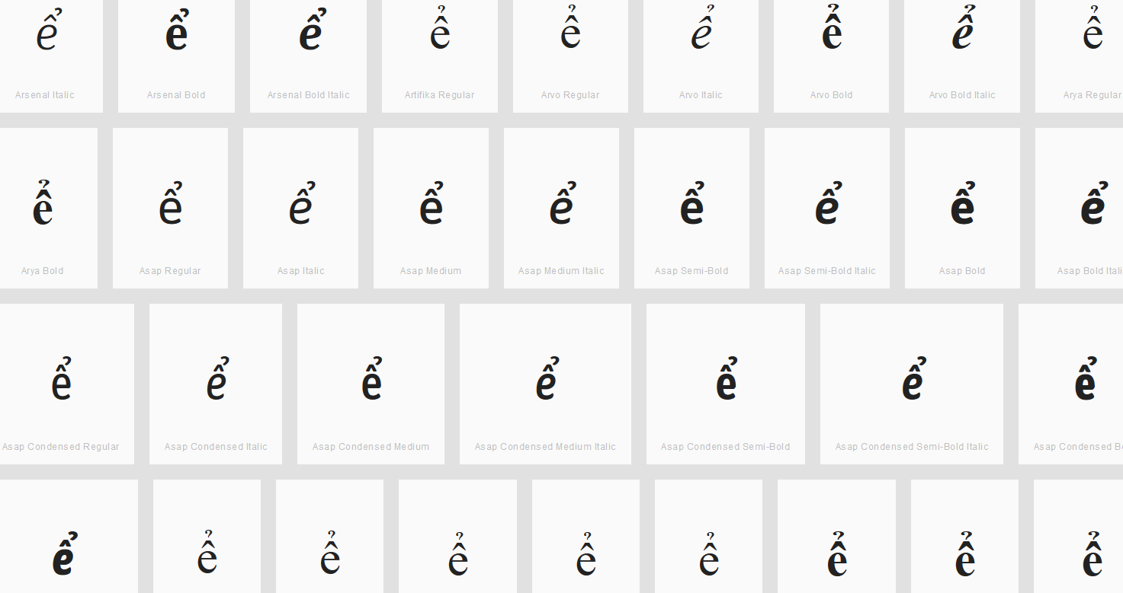

Findings:
- The double diacritics stay at the base character and thus will not be confused with characters next to it having just one of the diacritics.

Sequence ổ (1ED5) compared using Google Fonts in https://wordmark.it/ :

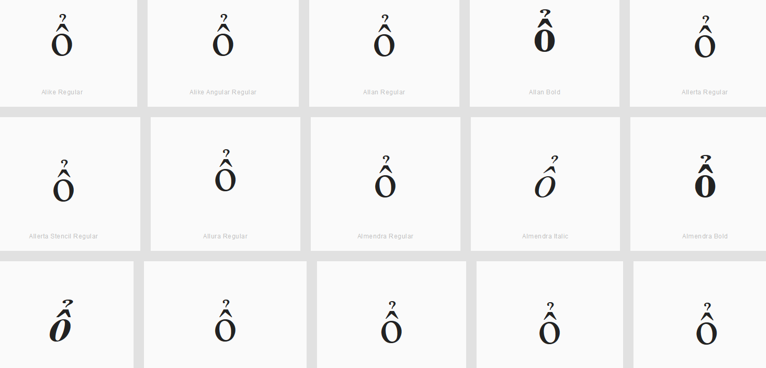

Findings:
- The double diacritics stay at the base character and thus will not be confused with characters next to it having just one of the diacritics.

D.4.4 BREVE AND TILDE

Code Points Analyzed:

Code Points | Glyph | Name
1EB5 | ẵ | LATIN SMALL LETTER A WITH BREVE AND TILDE

Sequence ẵ (1EB5) compared using Google Fonts in https://wordmark.it/ :

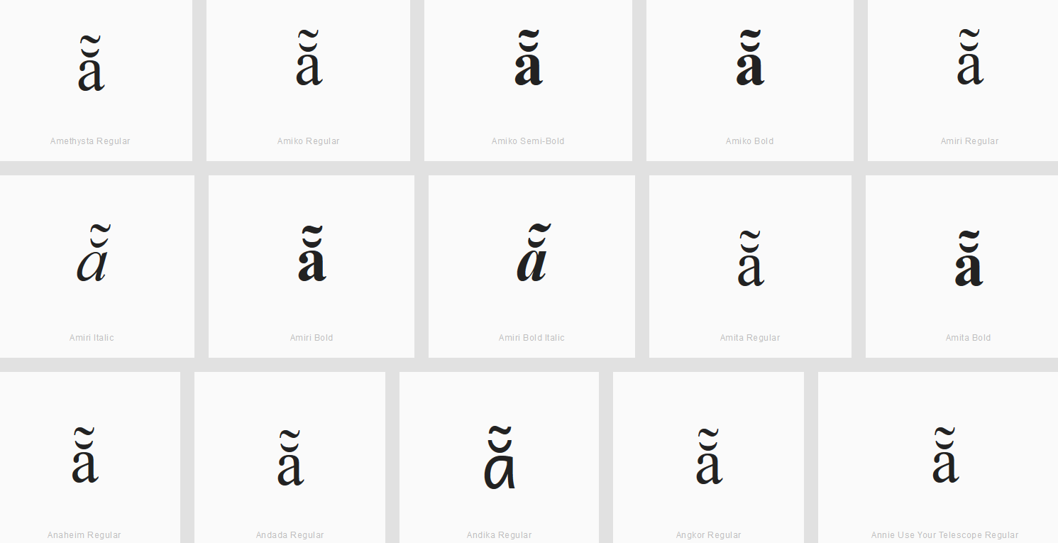

Findings:
- The double diacritics stay at the base character and thus will not be confused with characters next to it having just one of the diacritics.

