Appendix D on Variants
D.3 Base Character Evaluation

D.3.1 Letter Z vs. Letter Ezh

Code Points Analyzed:
Code Points | Glyph | Name
007A | z | Letter Z
0292 | ʒ | Letter Ezh

Sequence (z ʒ) (007A 0292) compared using Google Fonts in https://wordmark.it/ :

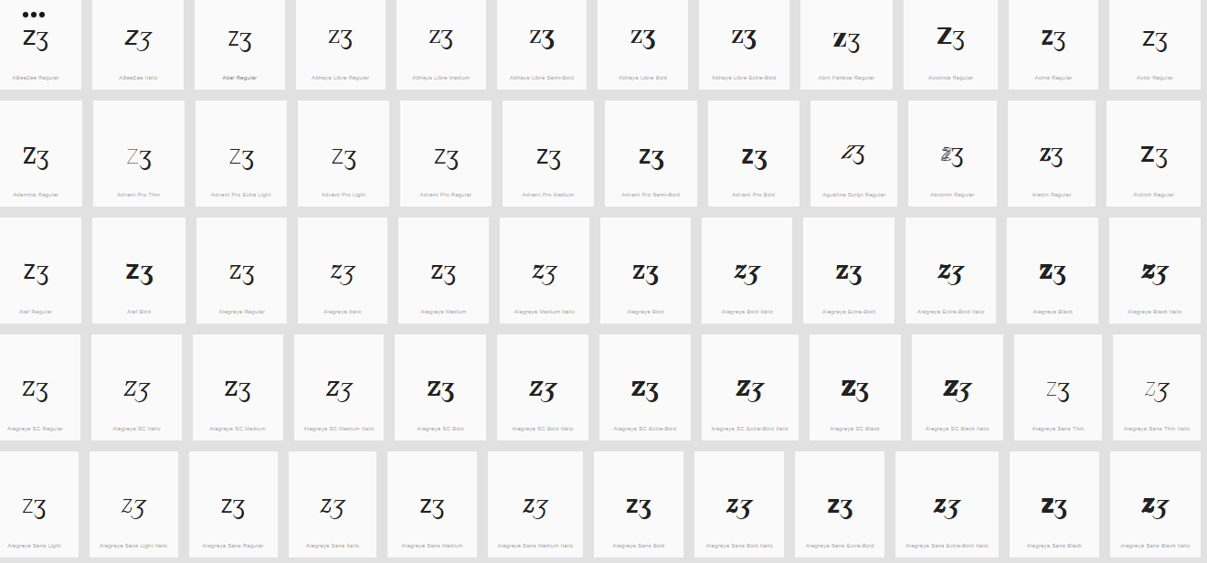

Findings:
- Glyphs are distinguishable
- In a large number of fonts, the two letters are consistently different.

D.3.2 Letter J vs. Letter I with Ogonek

Code Points Analyzed:
Code Points | Glyph | Name
006A | j | Letter J
012F | į | Letter I with Ogonek

Sequence (j į) (006A 012F) compared using Google Fonts in https://wordmark.it/ :

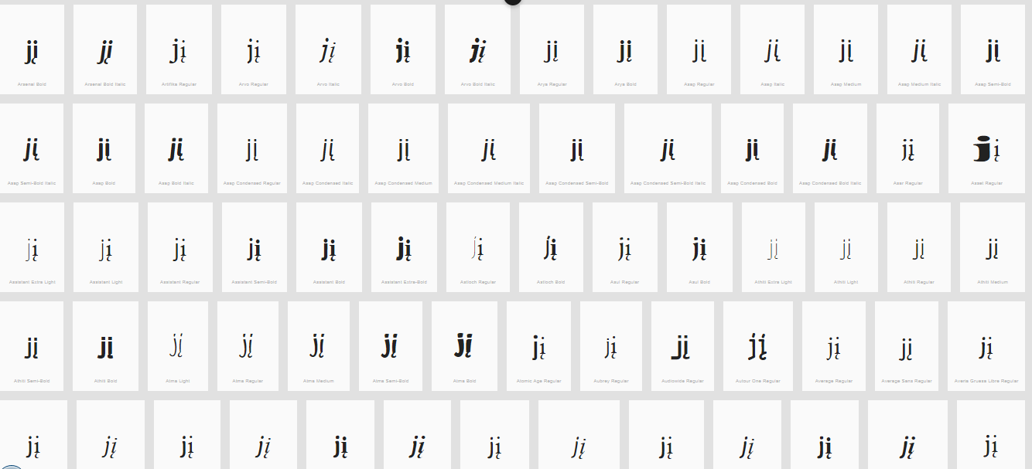

Findings:
- Glyphs are distinguishable
- In a large number of fonts, the two letters are consistently different.

D.3.3 Letter p vs. Letter Thorn

Code Points Analyzed:
Code Points | Glyph | Name
0070 | p | Small Letter p
00FE | þ | Small Letter Thorn

Sequence (p þ) (0070 00FE) compared using Google Fonts in https://wordmark.it/ :

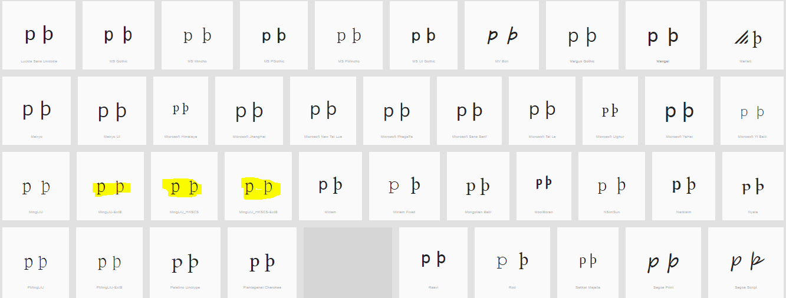
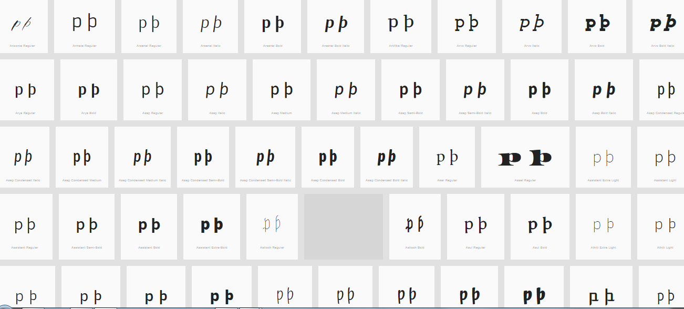
Findings:
- The upper leg of the Thorn is visible in most fonts (except those highlighted) can be somewhat unclear.
- Decision: Not Variant

D.4 Diacritics Stacking Evaluation

D.4.1 CARON (ABOVE) vs. BREVE

Code Points Considered:

Code Points | Glyph | Name
0103 | ă | Letter A with Breve
011F | ğ | Letter G with Breve
016D | ŭ | Letter U with Breve
010D | č | Letter C with Caron
011B | ě | Letter E with Caron
0148 | ň | Letter N with Caron
0159 | ř | Letter R with Caron
0161 | š | Letter S with Caron
017E | ž | Letter Z with Caron
01CE | ǎ | Letter A with Caron
01D0 | ǐ | Letter I with Caron
01D2 | ǒ | Letter O with Caron
01D4 | ǔ | Letter U with Caron
1E7 | ǧ | Letter G with Caron
1E9 | ǩ | Letter K with Caron
1EF | ǯ | Letter EZH with Caron

Code Points Analyzed:

Code Points | Glyph | Name
0103 | ă | Letter A with Breve
011F | ğ | Letter G with Breve
016D | ŭ | Letter U with Breve
01CE | ǎ | Letter A with Caron
01D4 | ǔ | Letter U with Caron
1E7 | ǧ | Letter G with Caron

Sequence (ă ǎ) (0103 01CE) compared using Google Fonts in https://wordmark.it/ :

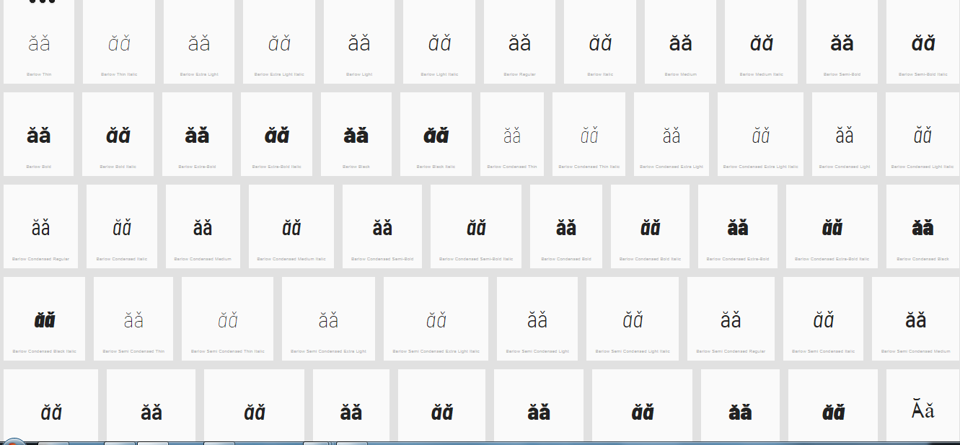
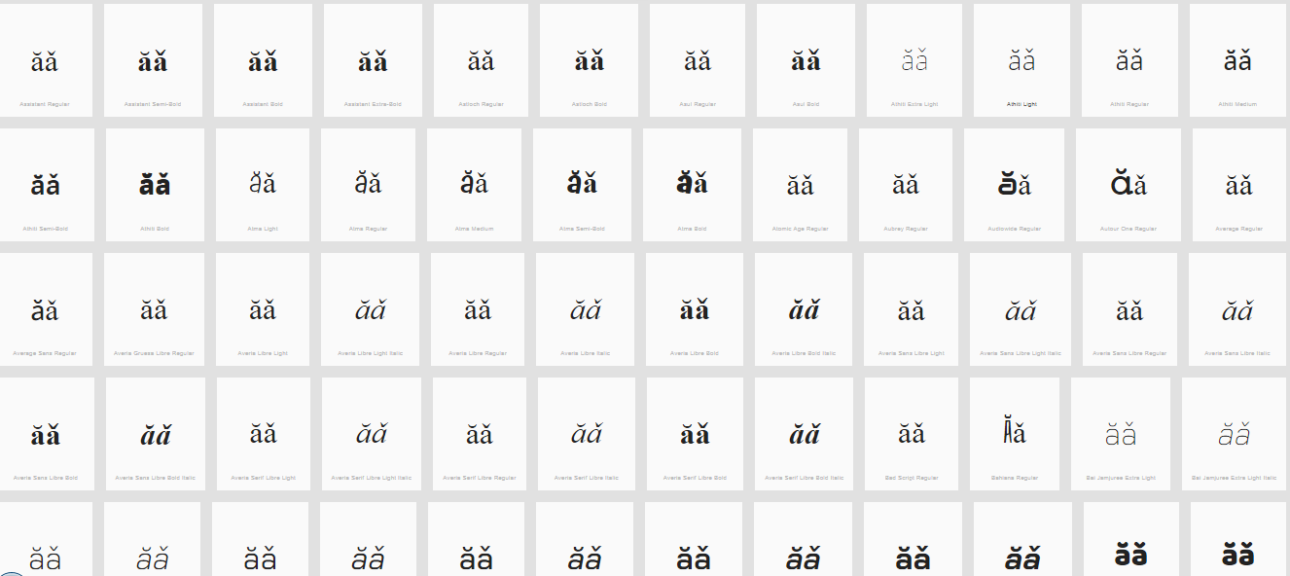

Sequence (ğ ǧ) (011F 01E7) compared using Google Fonts in https://wordmark.it/ :

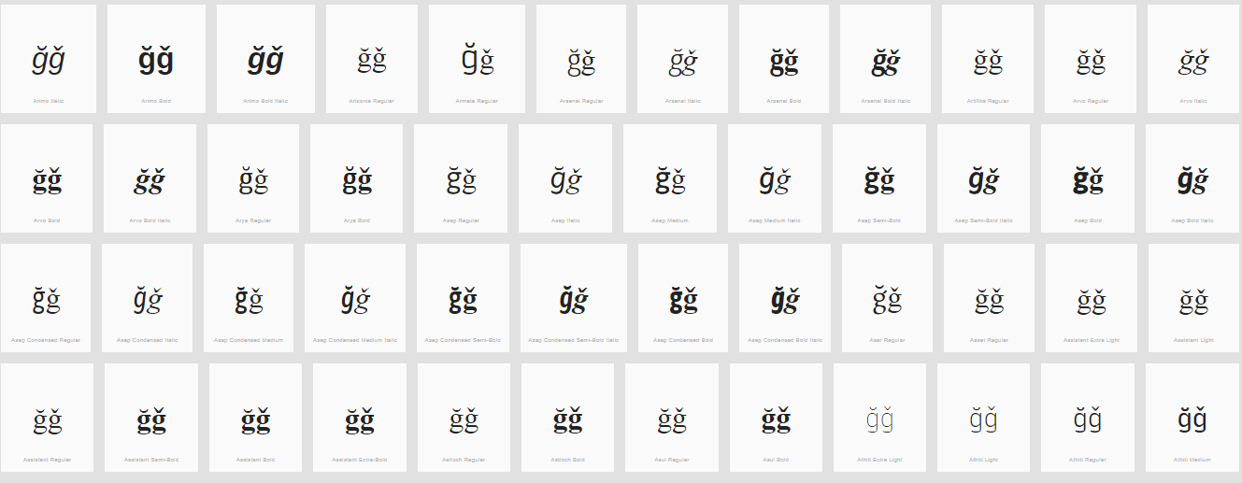
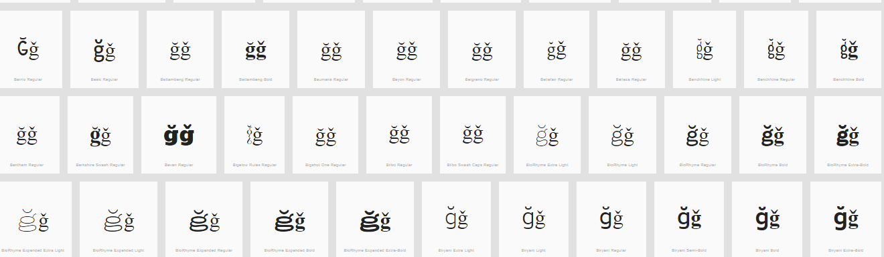

Sequence (ŭ ǔ) (016D 01D4) compared using Google Fonts in https://wordmark.it/ :

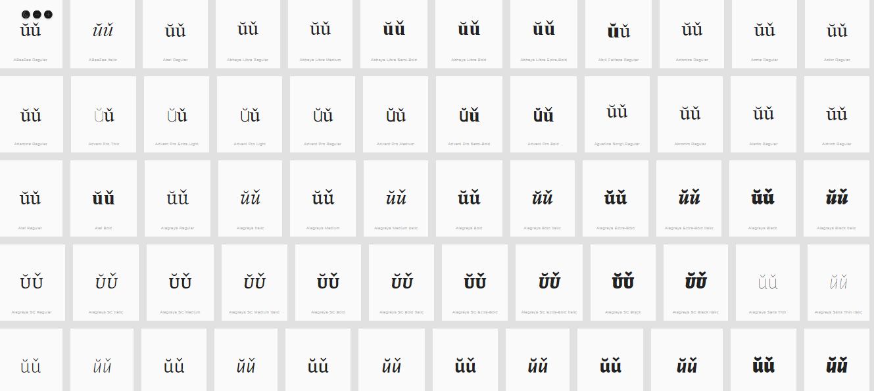
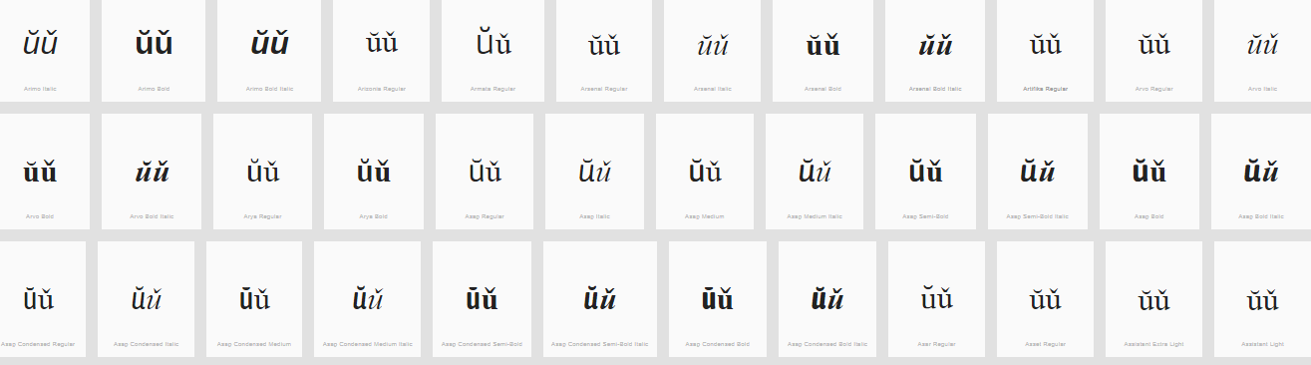

Findings:
- The representations of the Breve and the Caron in Letters A, G and U are distinguishable and undistinguishable in a number of fonts (see pictures above); depending on the font and size.

D.4.2 DOT BELOW vs. COMMA BELOW

Code Points Analyzed:

Code Points | Glyph | Name
1E37 | ḷ | Letter L with Dot below
1E43 | ṃ | Letter M with Dot below
1E47 | ṇ | Letter N with Dot below
1E63 | ṣ | Letter S with Dot below
1E6D | ṭ | Letter T with Dot below
1EA1 | ạ | Letter A with Dot below
1EB9 | ẹ | Letter E with Dot below
1ECB | ị | Letter I with Dot below
1ECD | ọ | Letter O with Dot below
1EE5 | ụ | Letter U with Dot below
1EF5 | ỵ | Letter Y with Dot below
0219 | ș | Letter S with Comma below
021B | ț | Letter T with Comma below

Code Points Considered:

Code Points | Glyph | Name
1E63 | ṣ | Letter S with Dot below
1E6D | ṭ | Letter T with Dot below
0219 | ș | Letter S with Comma below
021B | ț | Letter T with Comma below

Sequence (ṣ ș) (1E63 0219) compared using Google Fonts in https://wordmark.it/ :
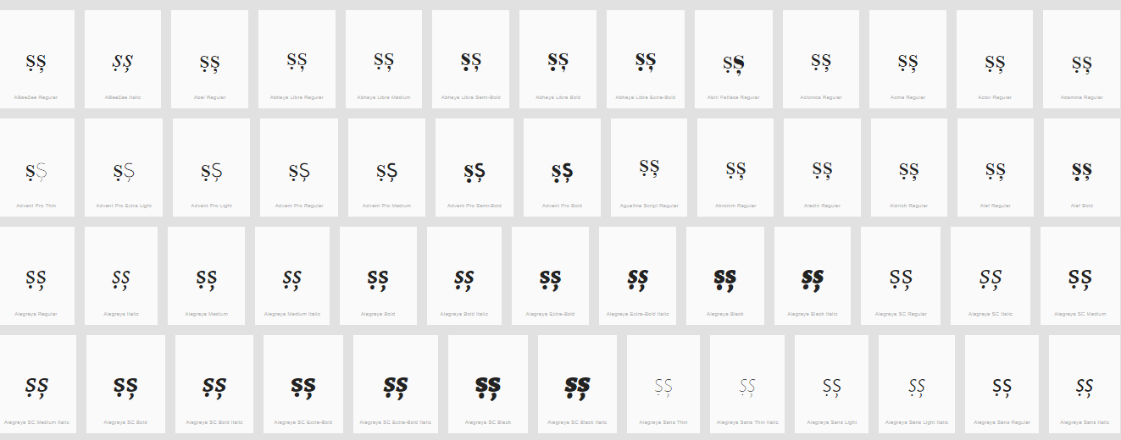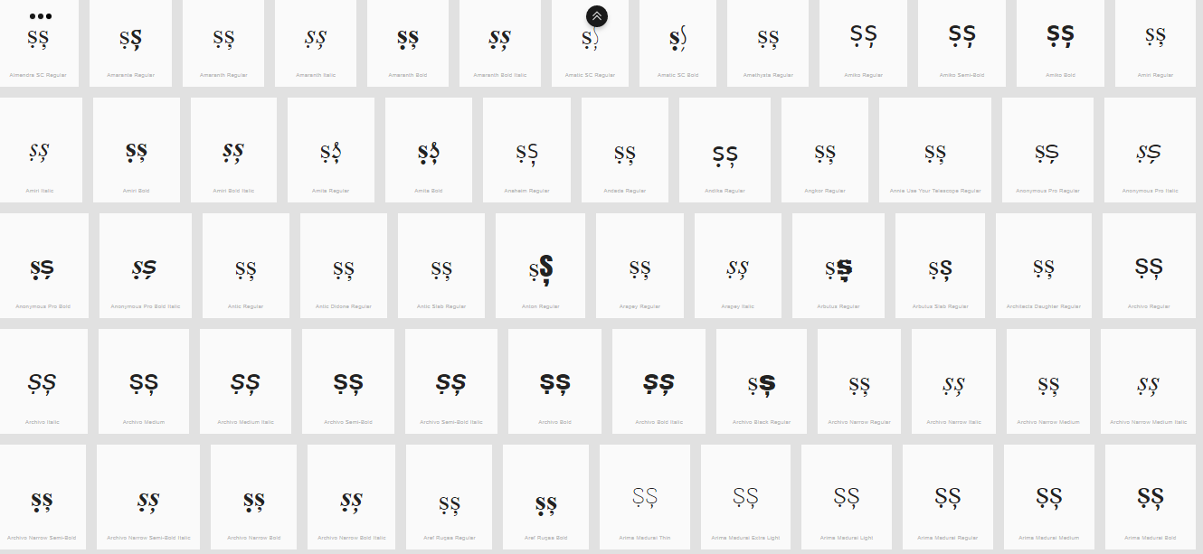

Sequence (ṭ ț) (1E6D 021B) compared using Google Fonts in https://wordmark.it/ :
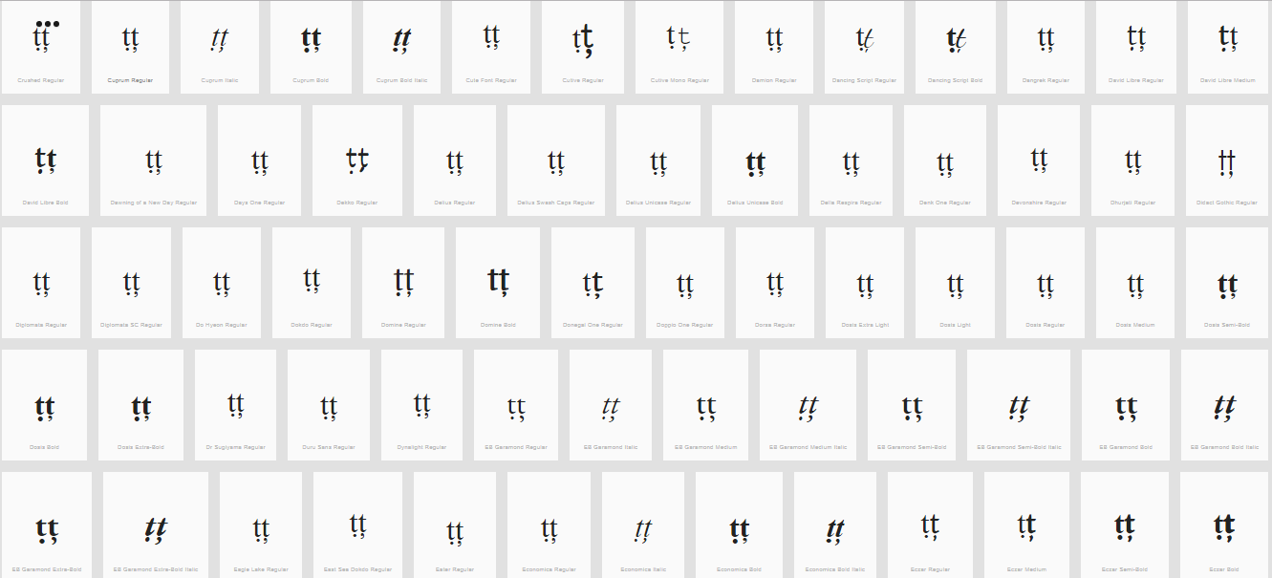
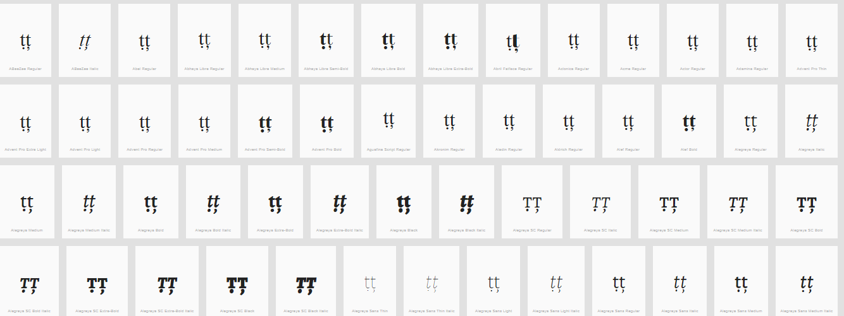
Findings:
- The representations of the Dot below and Comma below in Letters S and T are distinguishable in a number of fonts (see pictures above); in a large number of fonts, the two diacritics are consistently different.

D.4.3 Letter A with Breve and Hook above

Sequence (ẳ) (1EB3) compared using Google Fonts in https://wordmark.it/ :

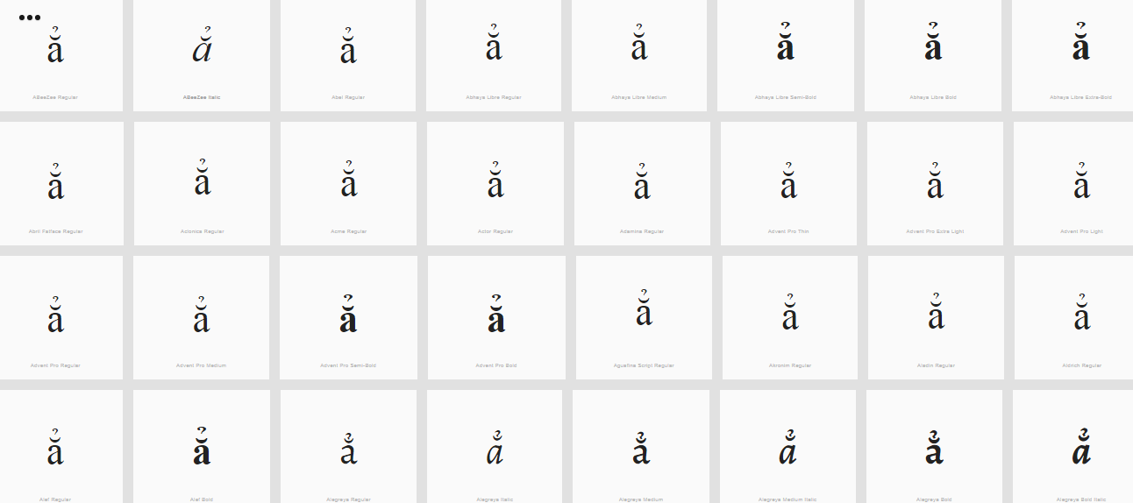
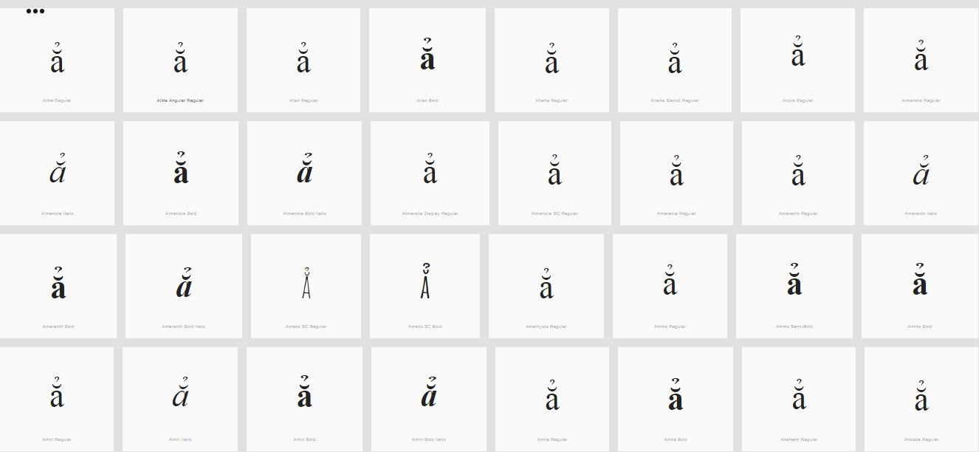

Findings:
- Stacking diacrtitics are always in place

