In-Script Non-Visual Variant Discovery Analysis
Latin GP Member: Dennis Tan

Diacritics Evaluation

Diacritics analyzed: Combining Cedilla (Below), Ogonek and Comma Below

Code Points Analyzed:

Code Points | Glyph | Name
006D 0327 | m̧ | Letter M with Combining Cedilla
006F 0327 | o̧ | Letter O with Combining Cedilla
00E7 | ç | Letter C with Cedilla
0105 | ą | Letter A with Ogonek
0119 | ę | Letter E with Ogonek
012F | į | Letter I with Ogonek
0137 | ķ | Letter K with Cedilla
013C | ļ | Letter L with Cedilla
0146 | ņ | Letter N with Cedilla
015F | ş | Letter S with Cedilla
0173 | ų | Letter U with Ogonek
0219 | ș | Letter S with Comma Below
021B | ț | Letter T with Comma Below

Findings:
- The representations of the Cedilla and the Comma Below in Letter S are distinguishable in a number of fonts (see pictures below); in a large number of fonts, the two diacritics are consistently different.
- No other point base character (except for Letter S) uses two different diacritics (i.e., Letter M only exists with a Combining Cedilla, but not with Ogonek or Comma Below).

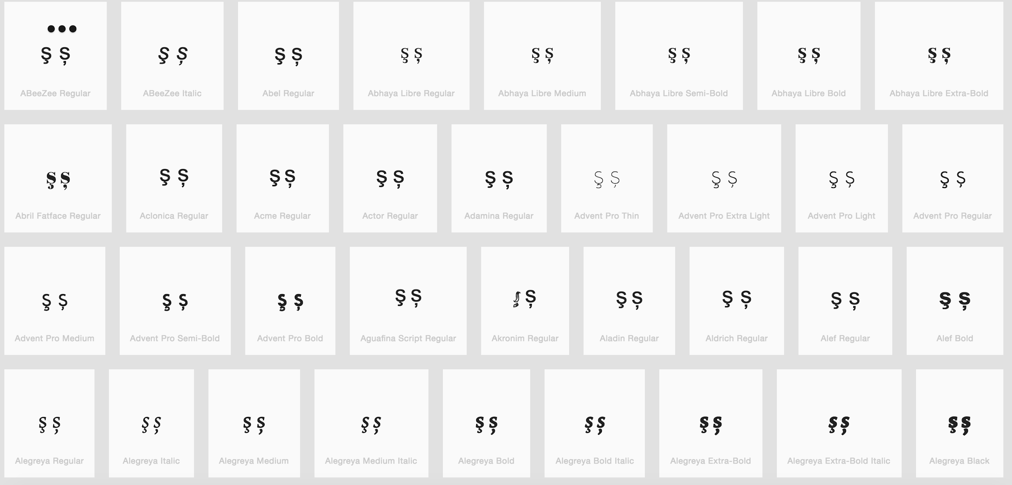
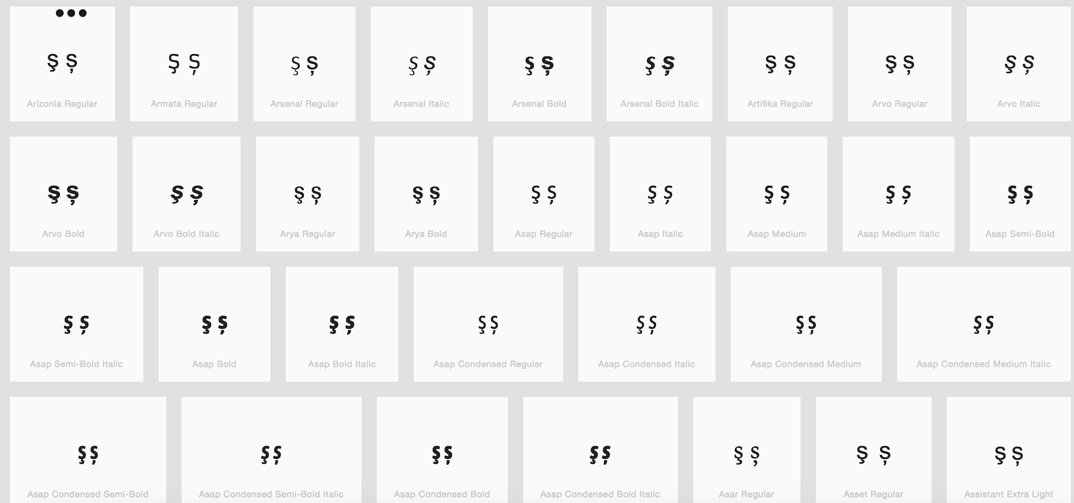

Base Character Evaluation

Code Points Analyzed:

Code Points | Glyph | Name
0065 | e | Letter E
025B | ɛ | Letter Open E

Glyph Representations per https://wordmark.it/ :

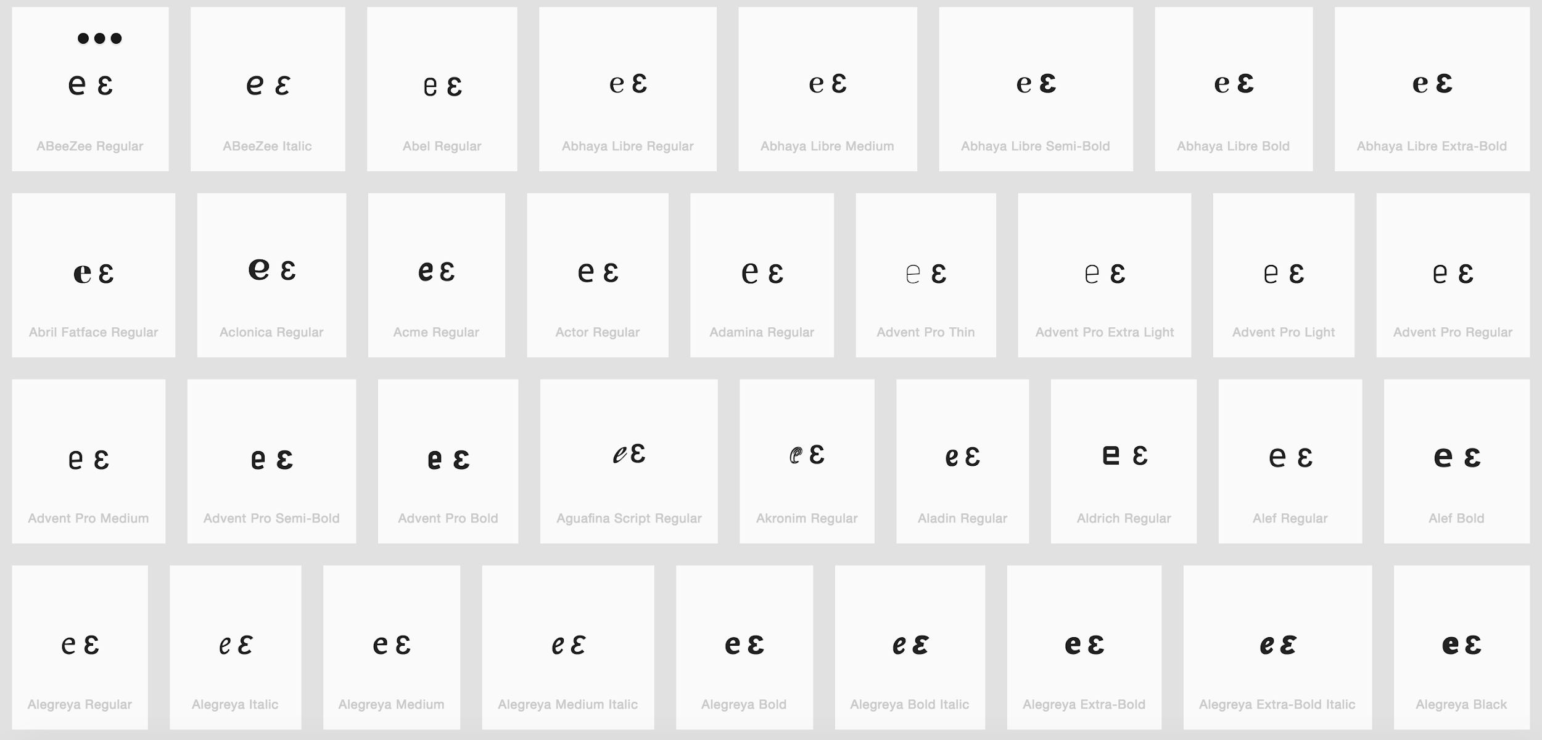

Findings:
- Glyphs are distinguishable
- In a large number of fonts, the two letters are consistently different.

Letter Eth versus Letter D with Stroke

Code Points | Glyph | Name
00F0 | ð | Letter Eth
0111 | đ | Letter D with Stroke

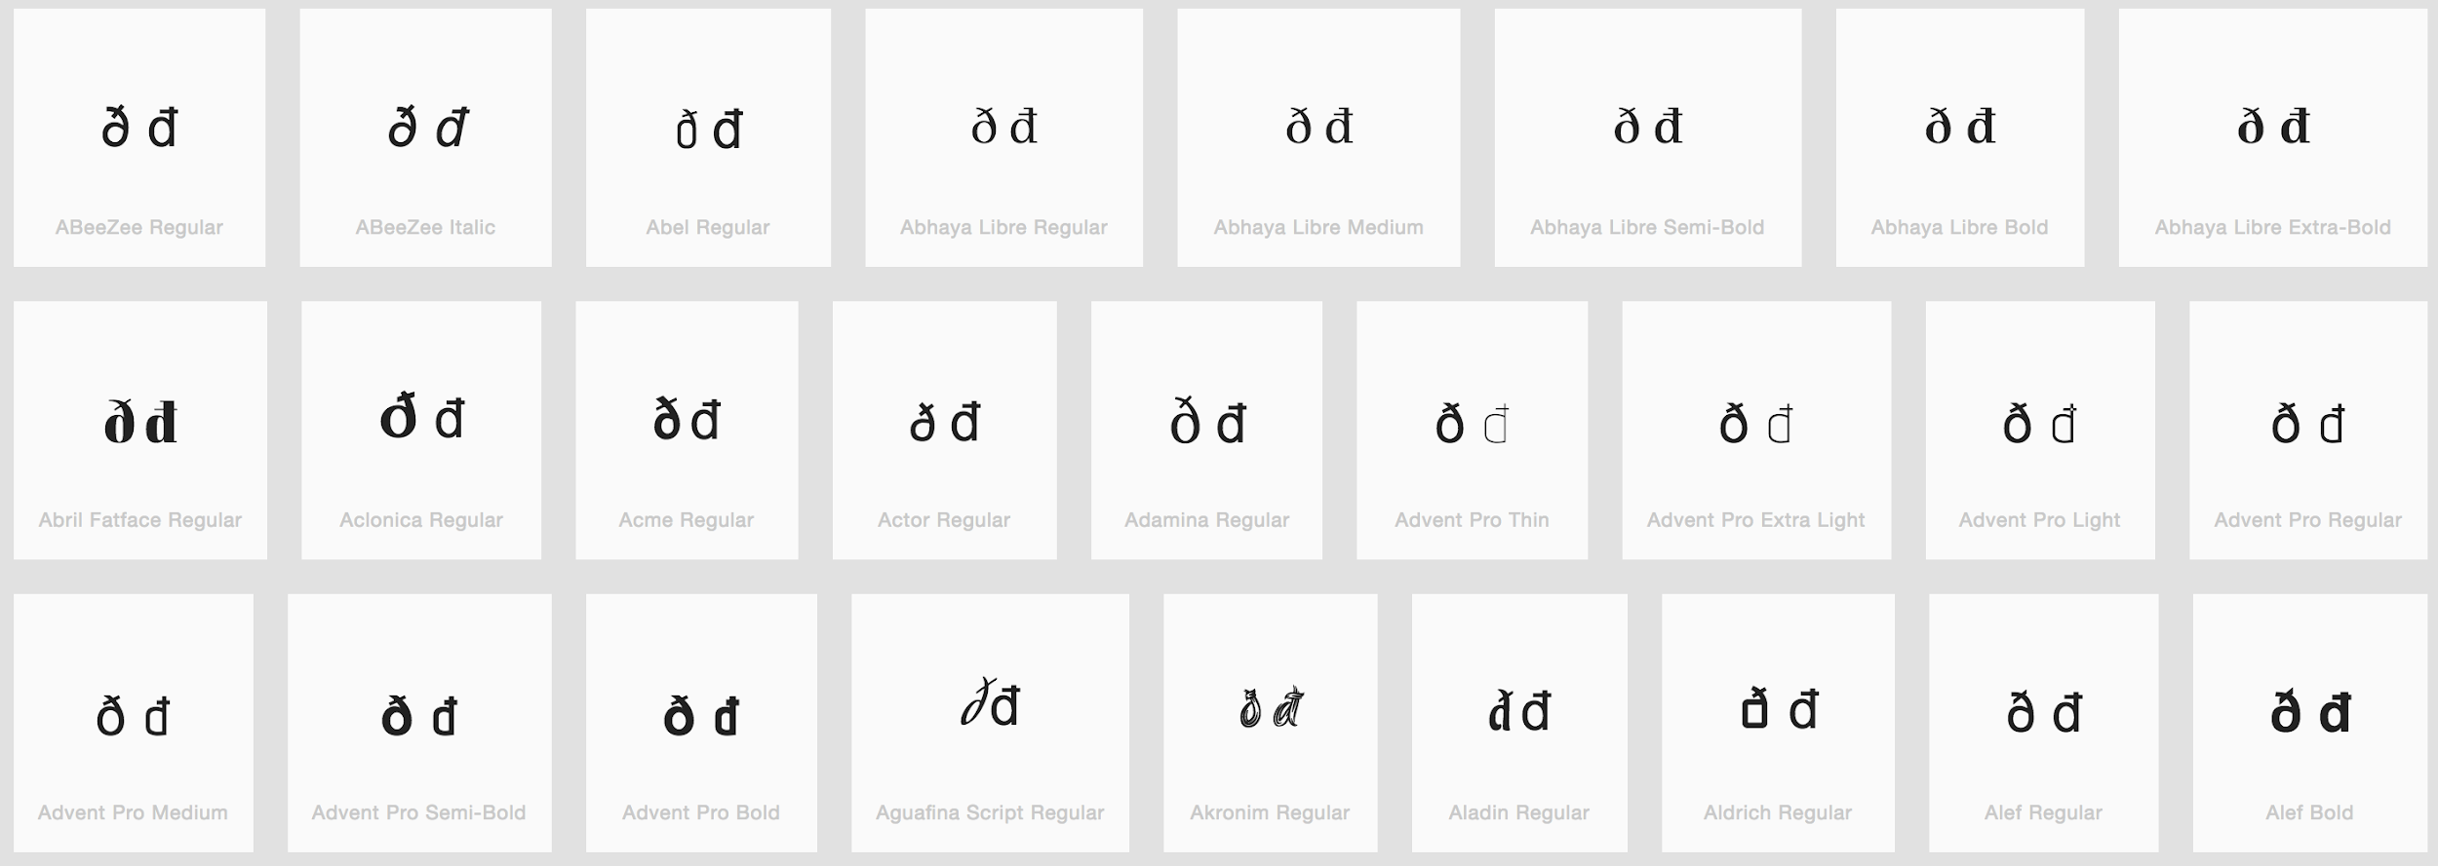
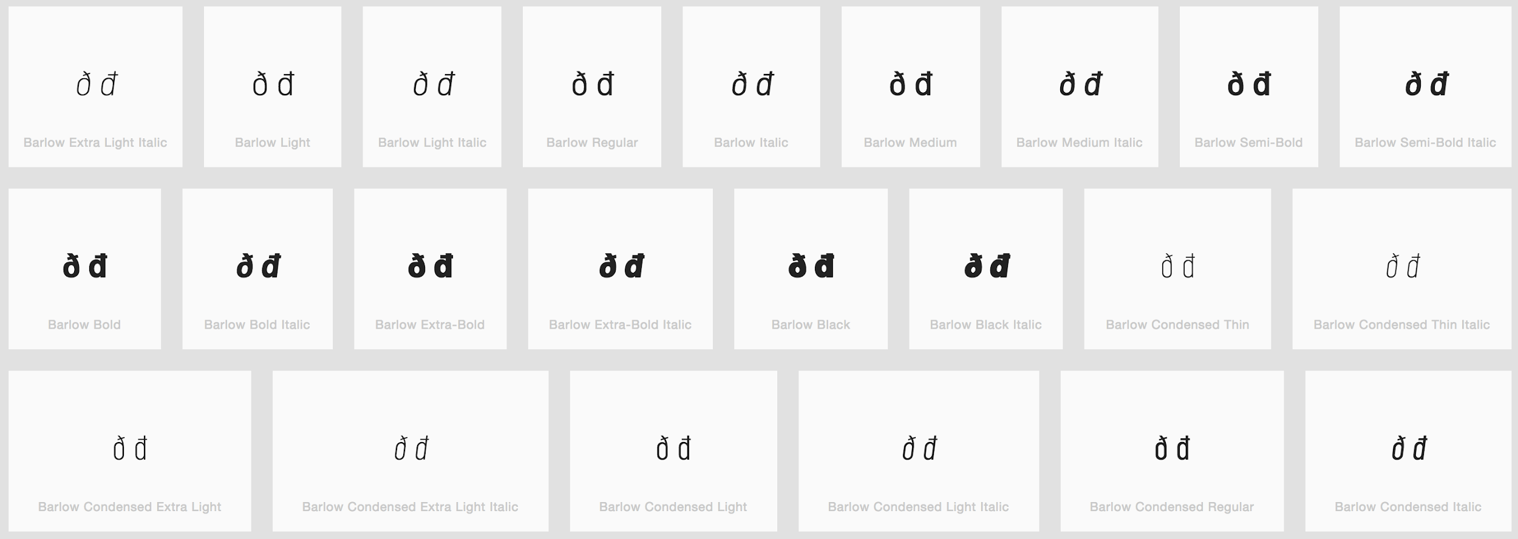

Findings: The two letters are consistently rendered with their distinguishable features.
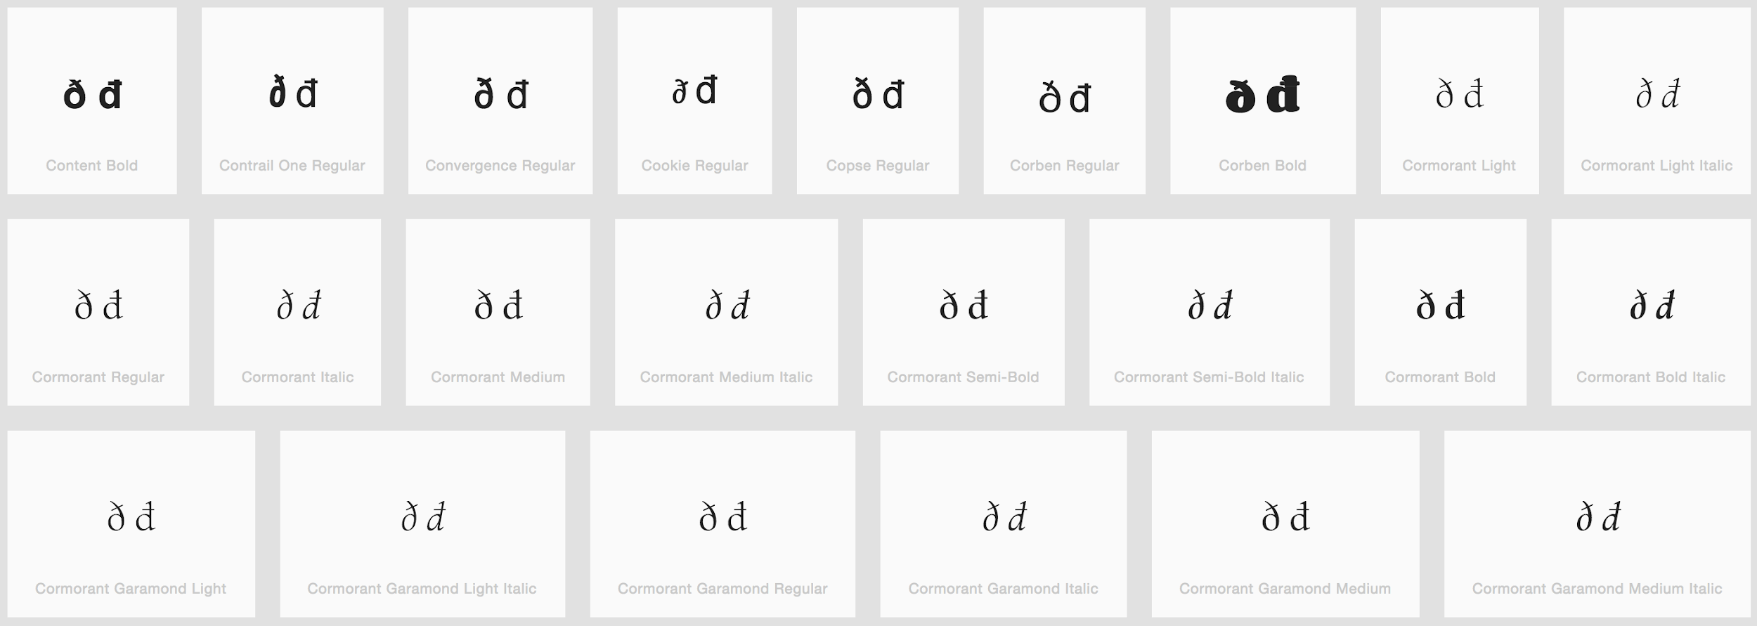

Sequence of two Letter V with Hook versus Letter W

Code Points | Glyph | Name
028B 028B | ʋʋ | Letter V with Hook (x2)
0077 | w | Letter W

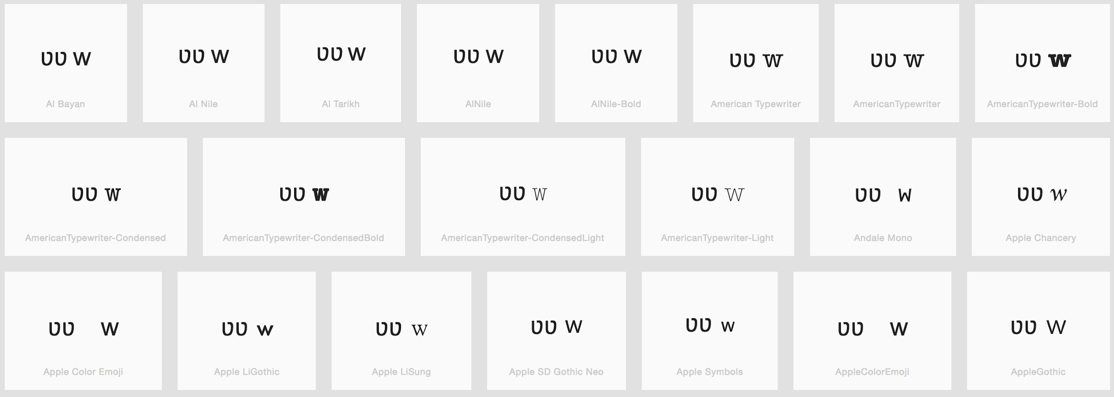
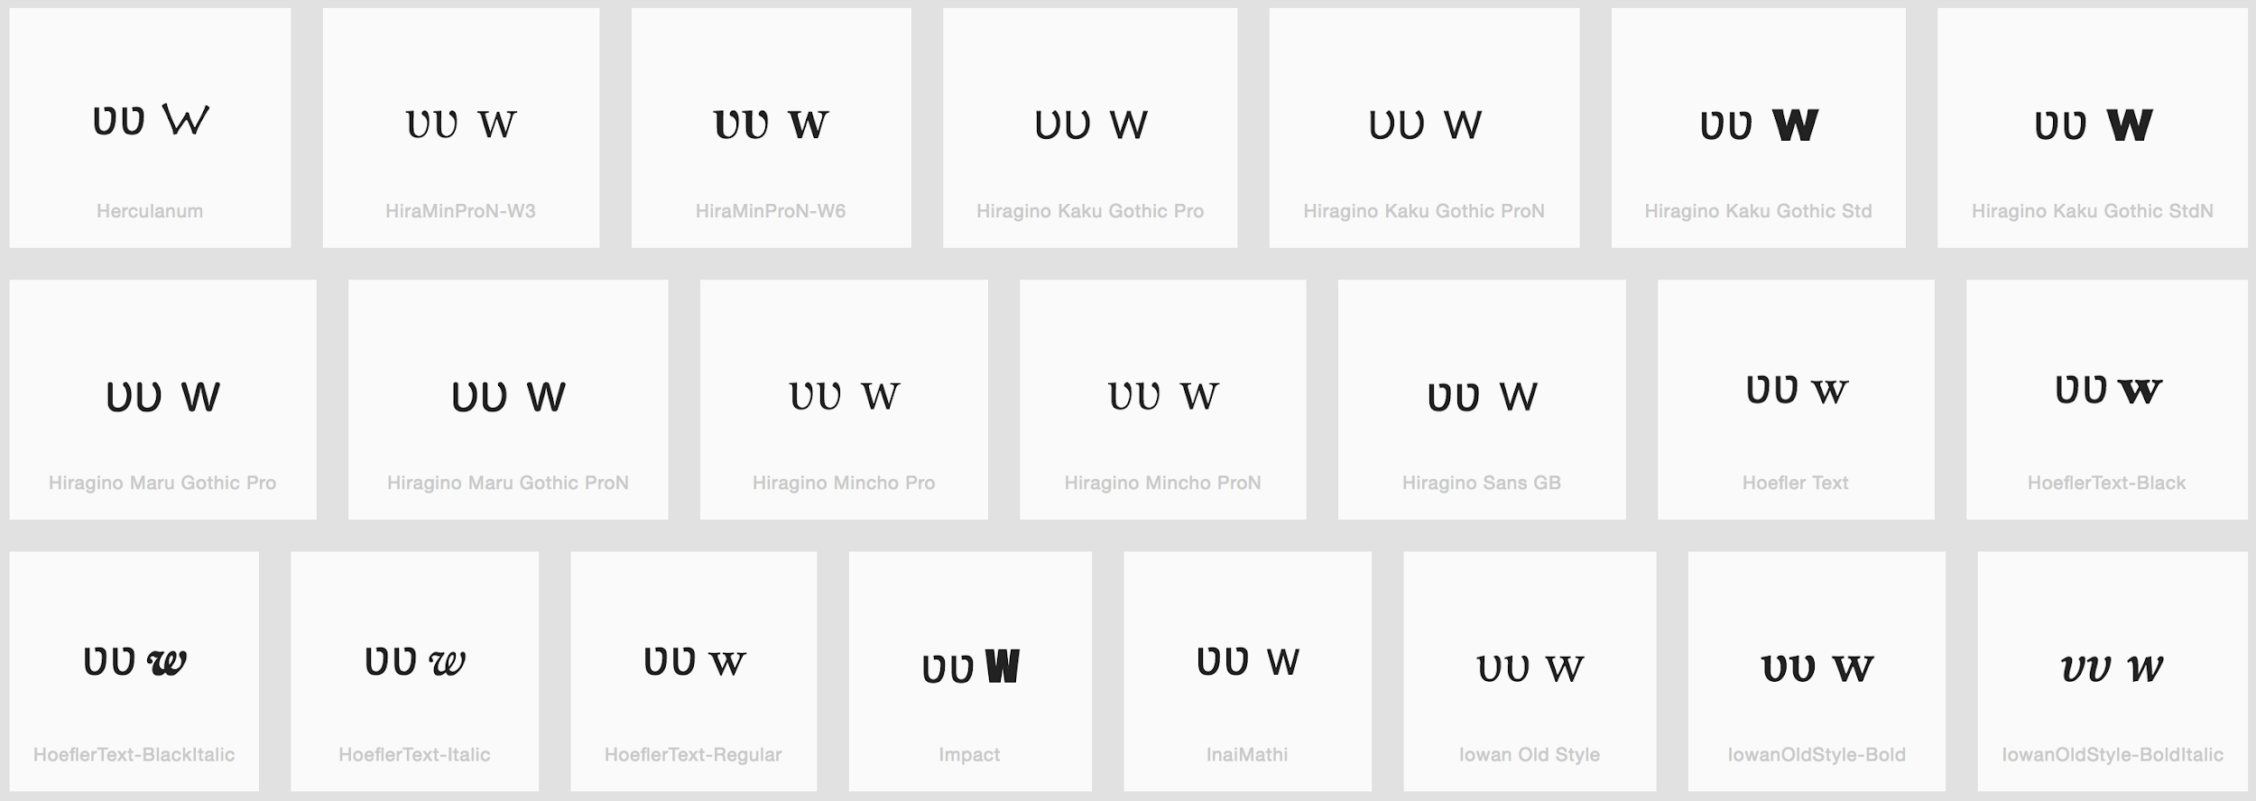
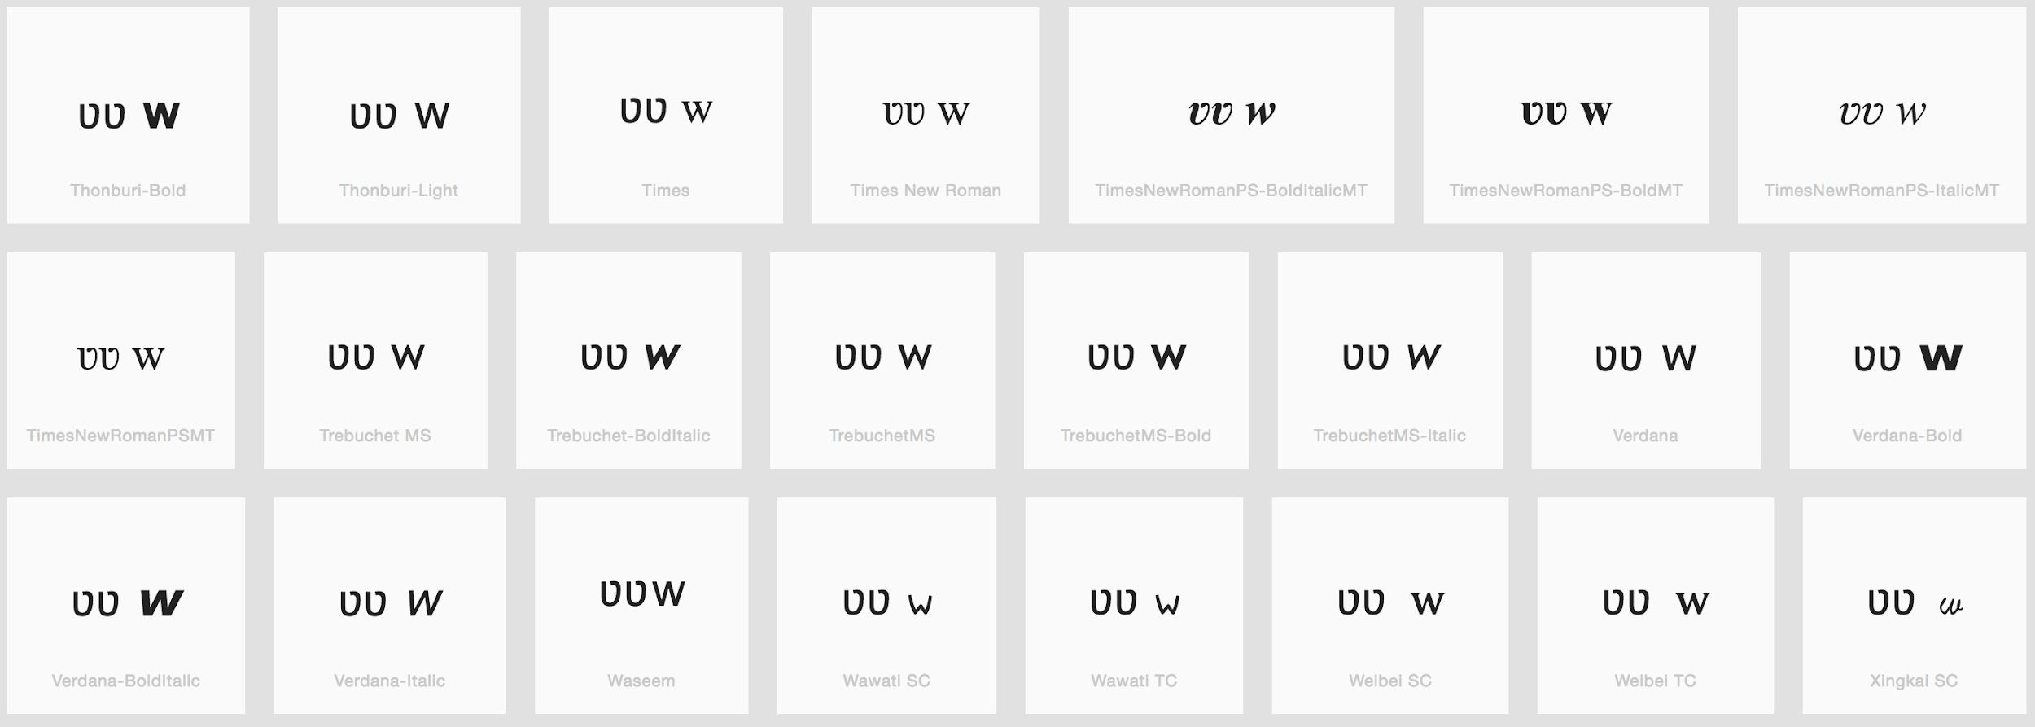

Finding: Sequence of two Letters V with Hook is different than Letter W

Diacritics Stacking Evaluation

Code Point: U+1EAB (ẫ) Letter A with Circumflex and Tilde

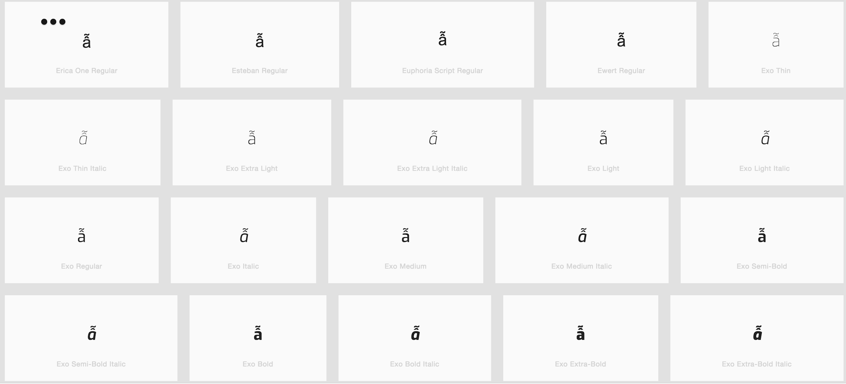

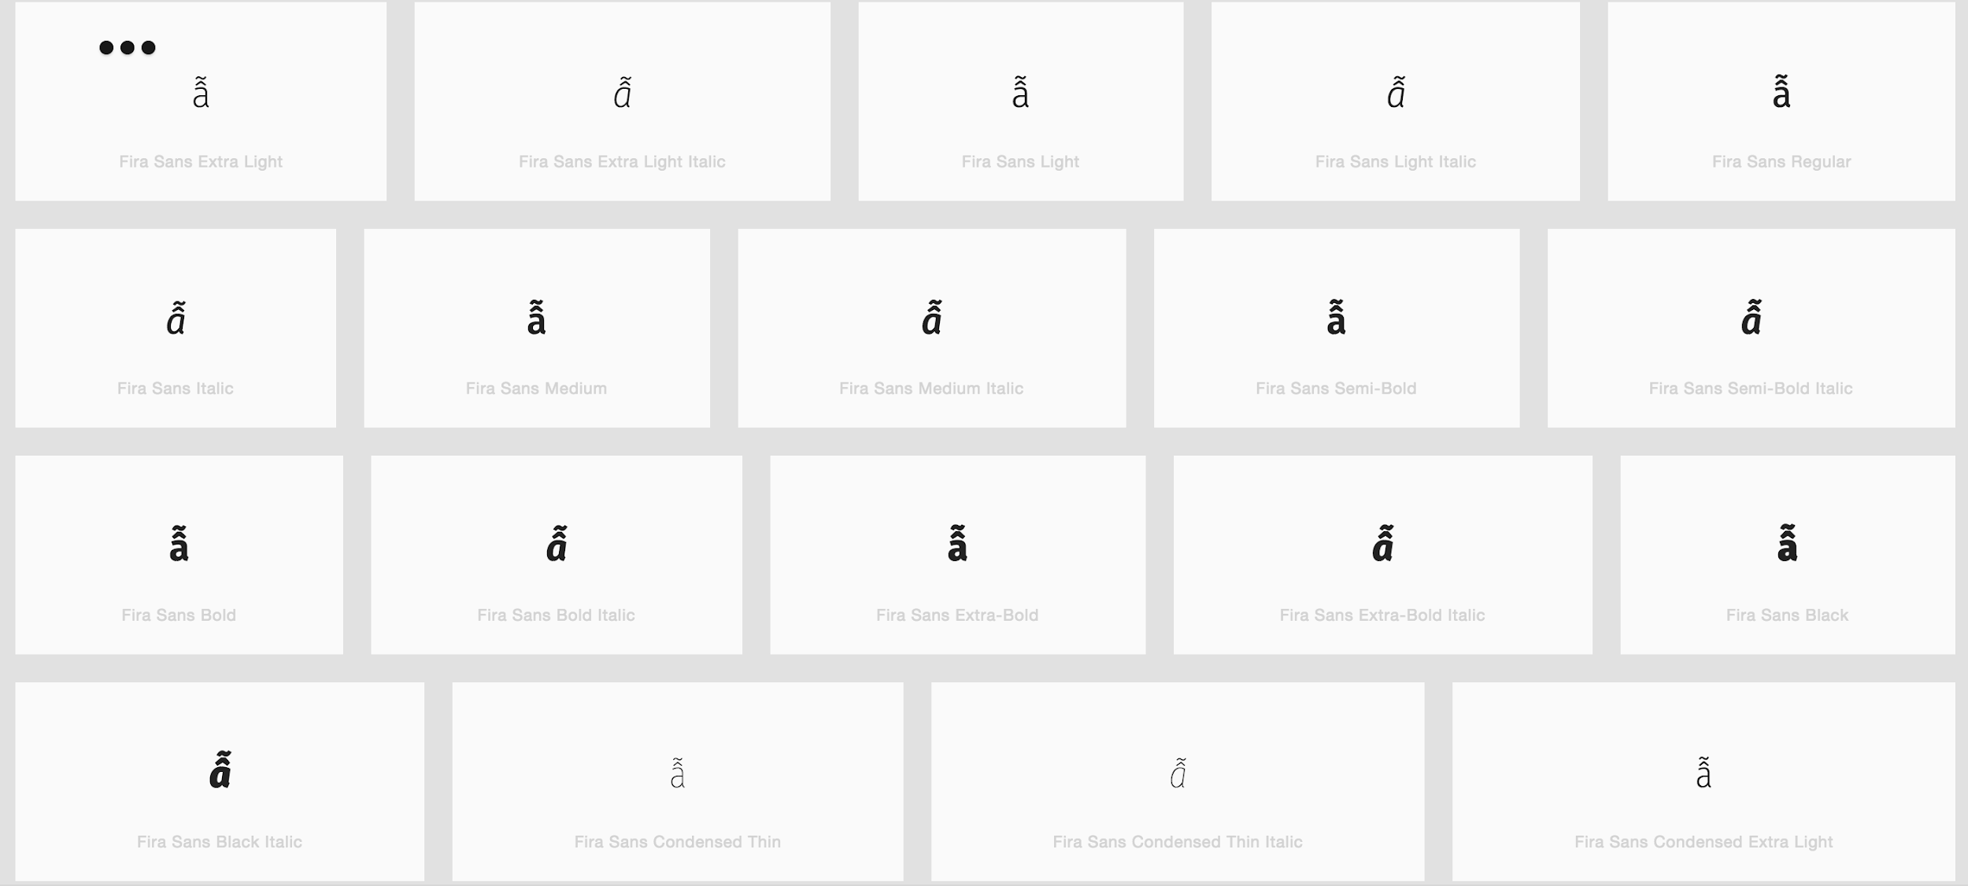

Code Point: U+1EC5 (ễ) Letter E with Circumflex and Tilde

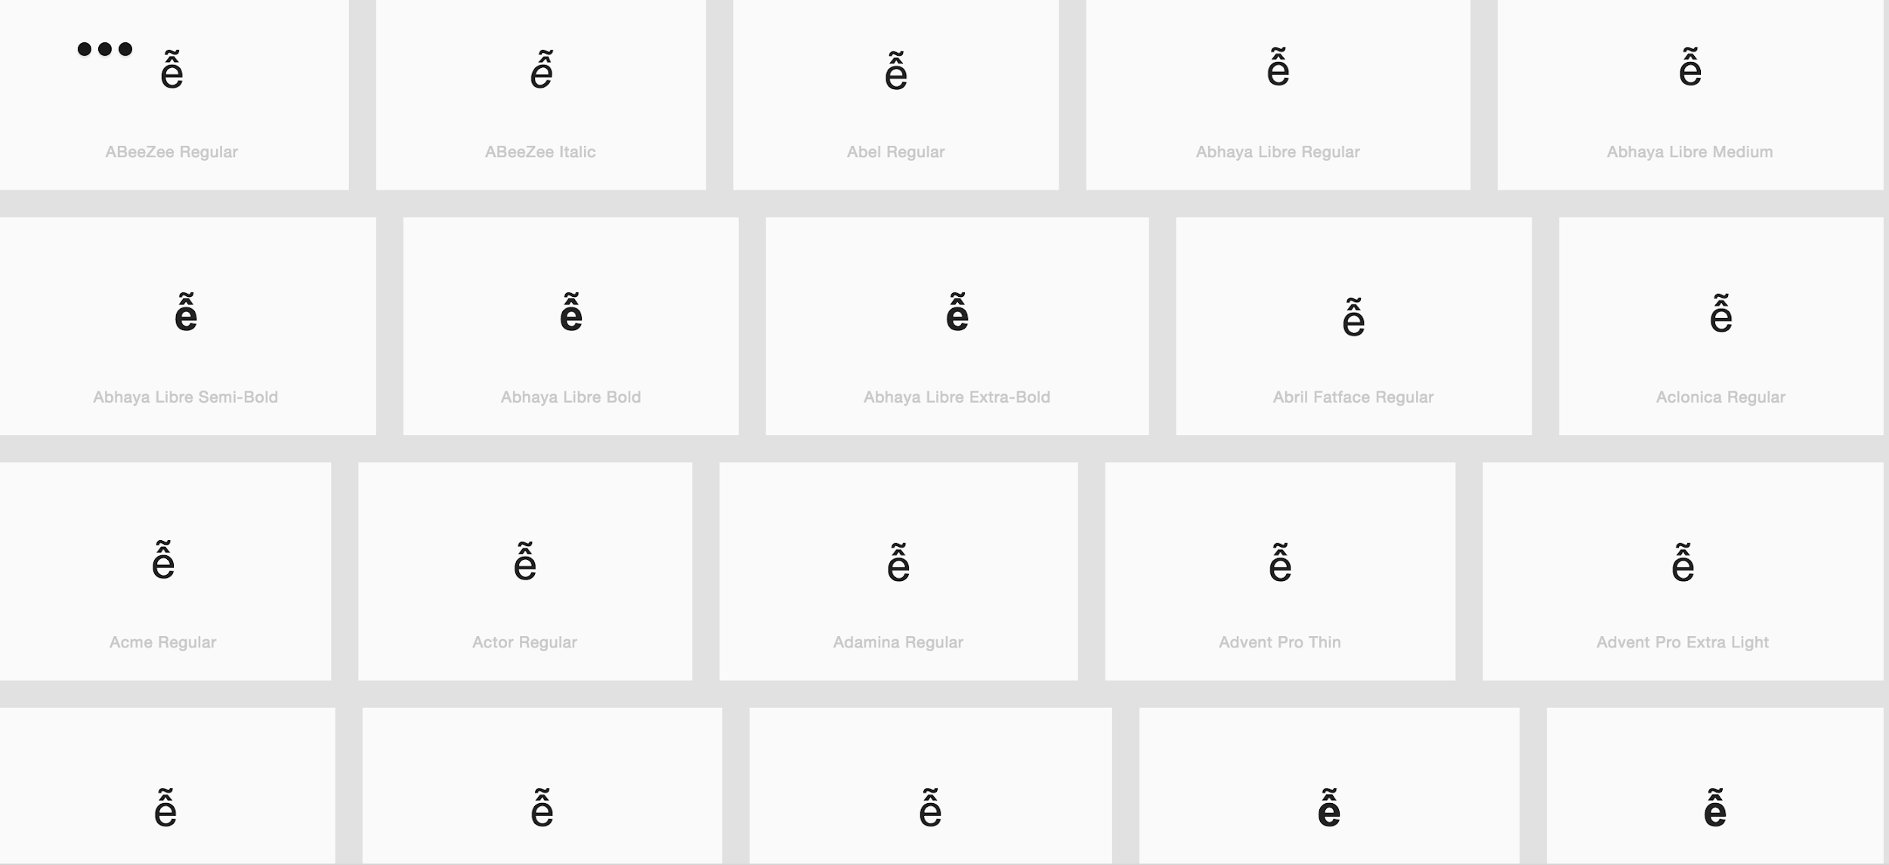

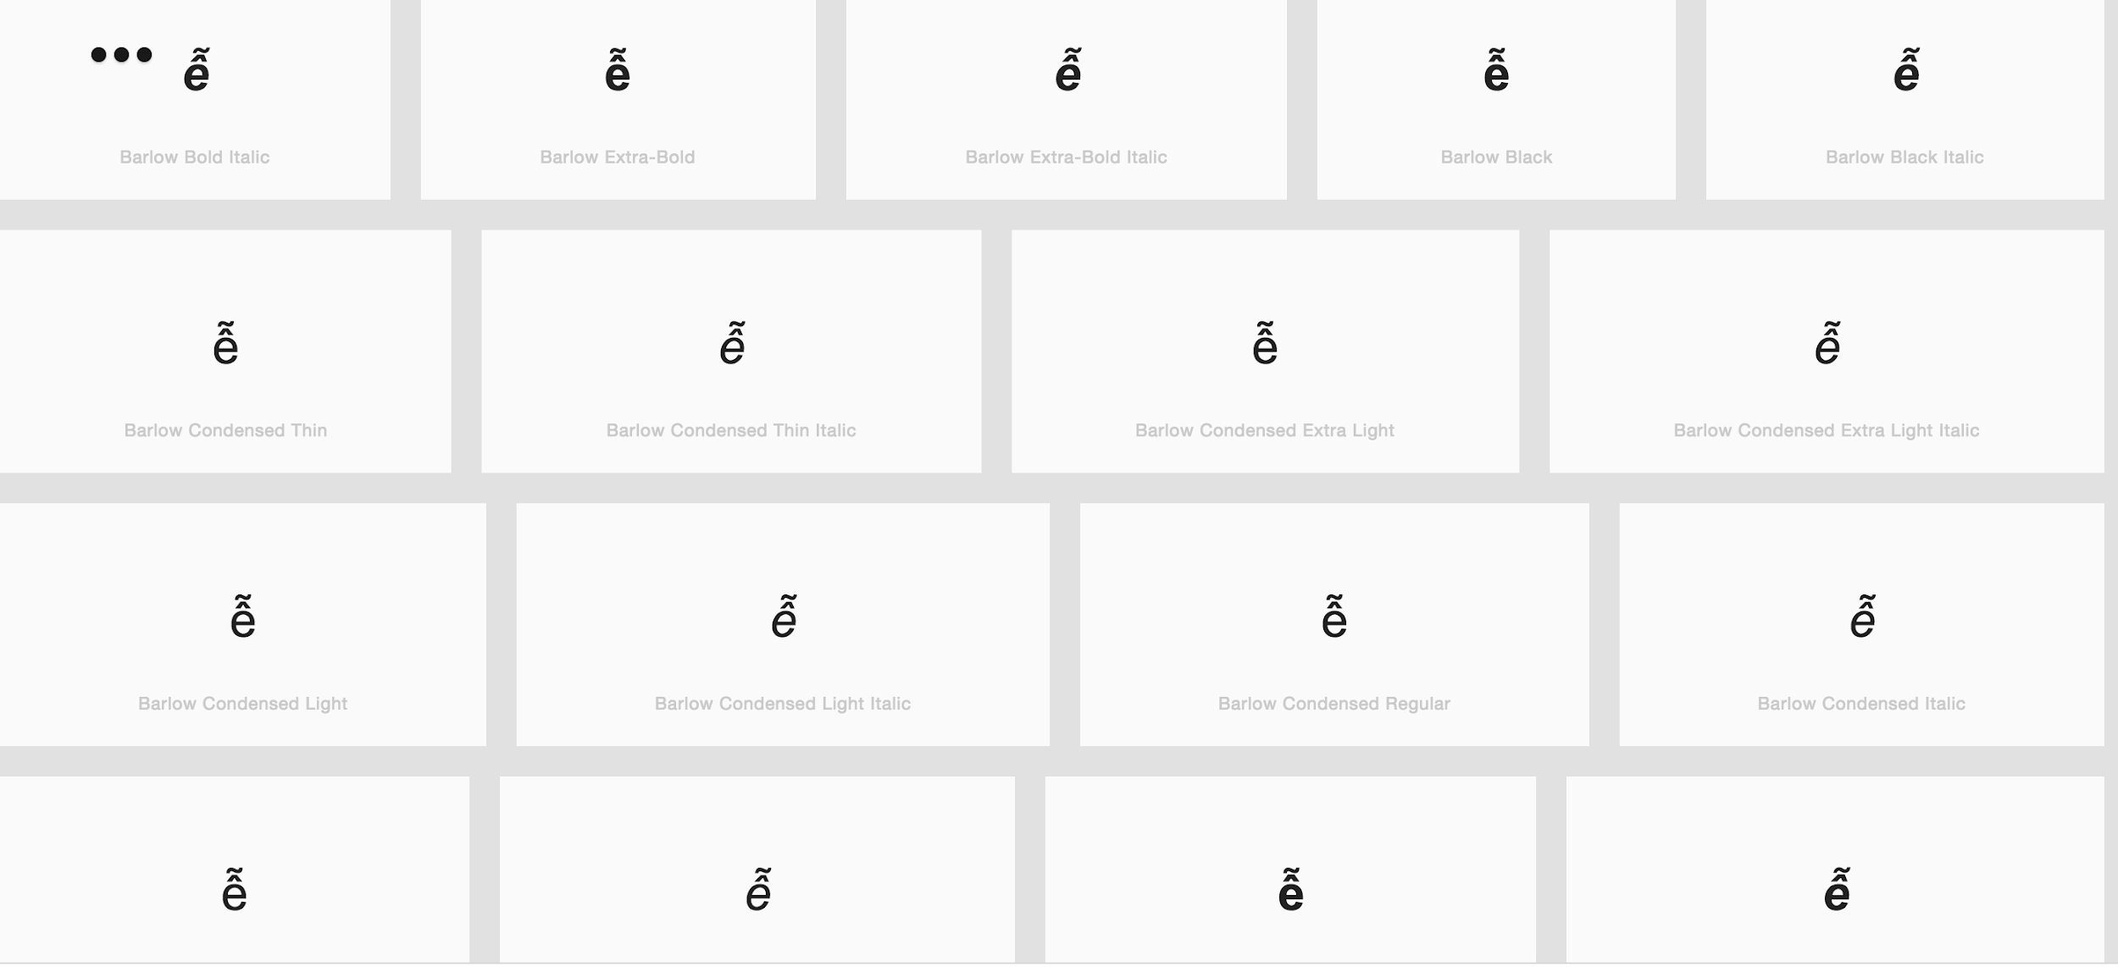

Code Point: U+1ED7 (ỗ) Letter O with Circumflex and Tilde

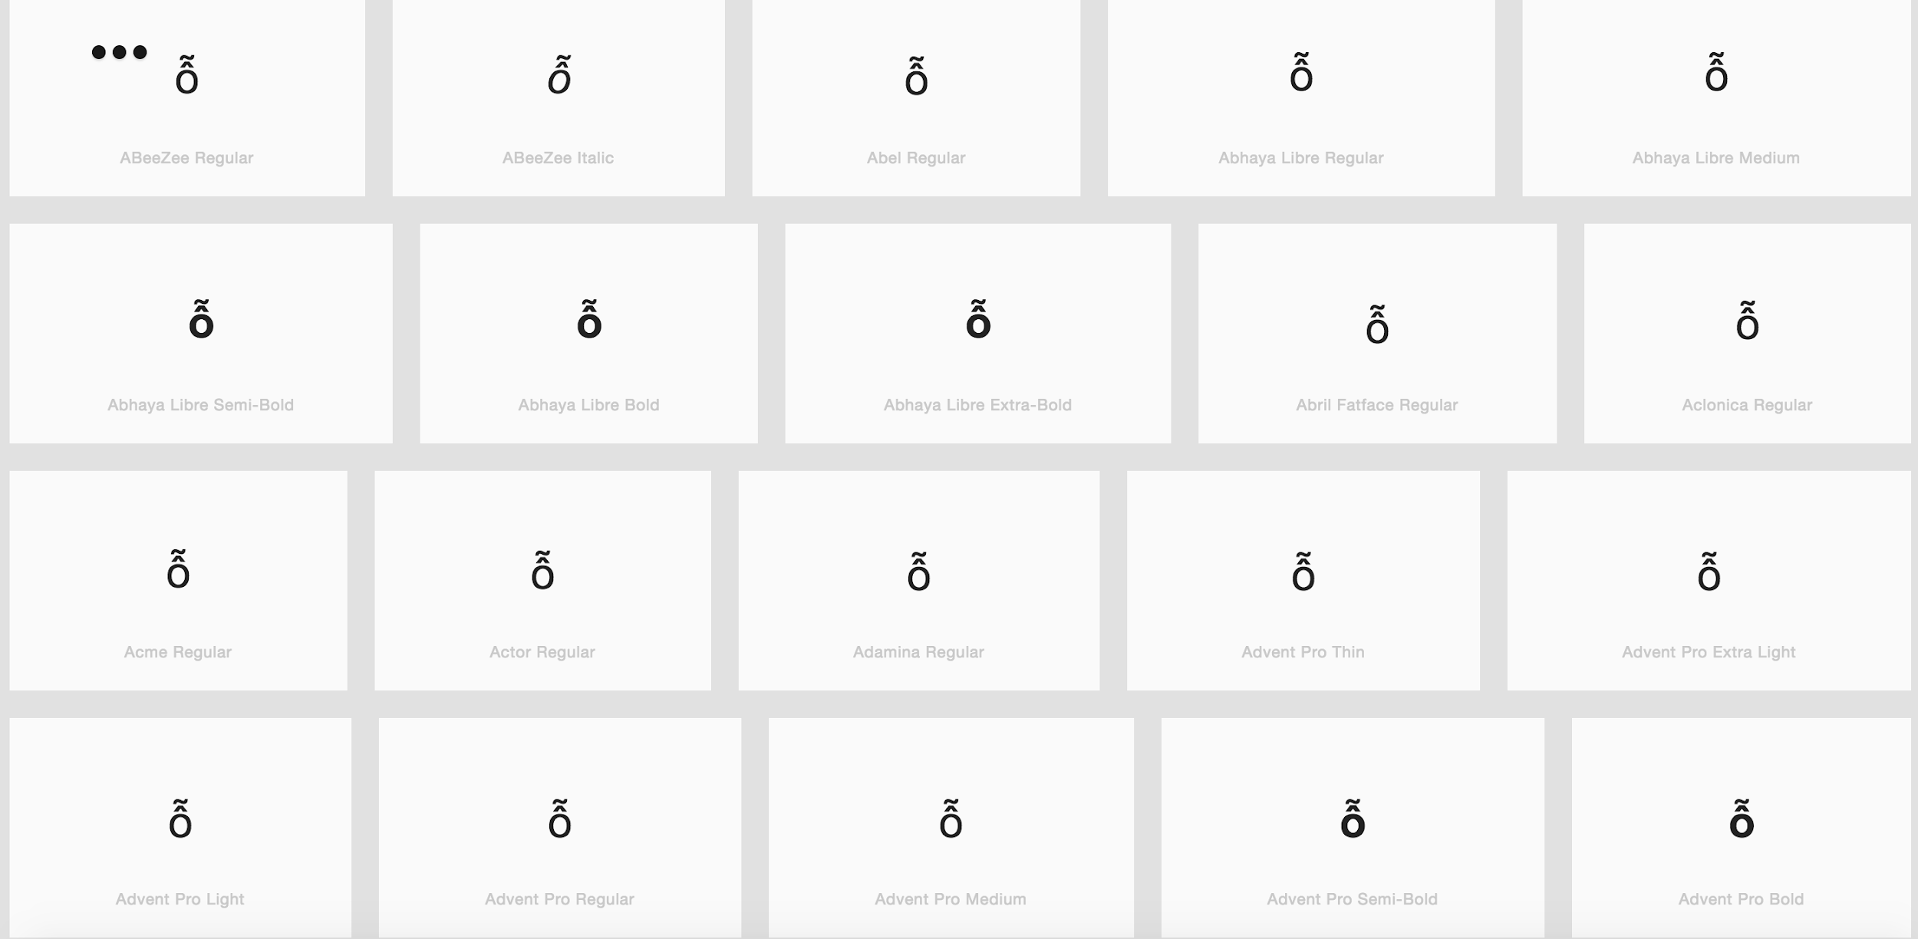
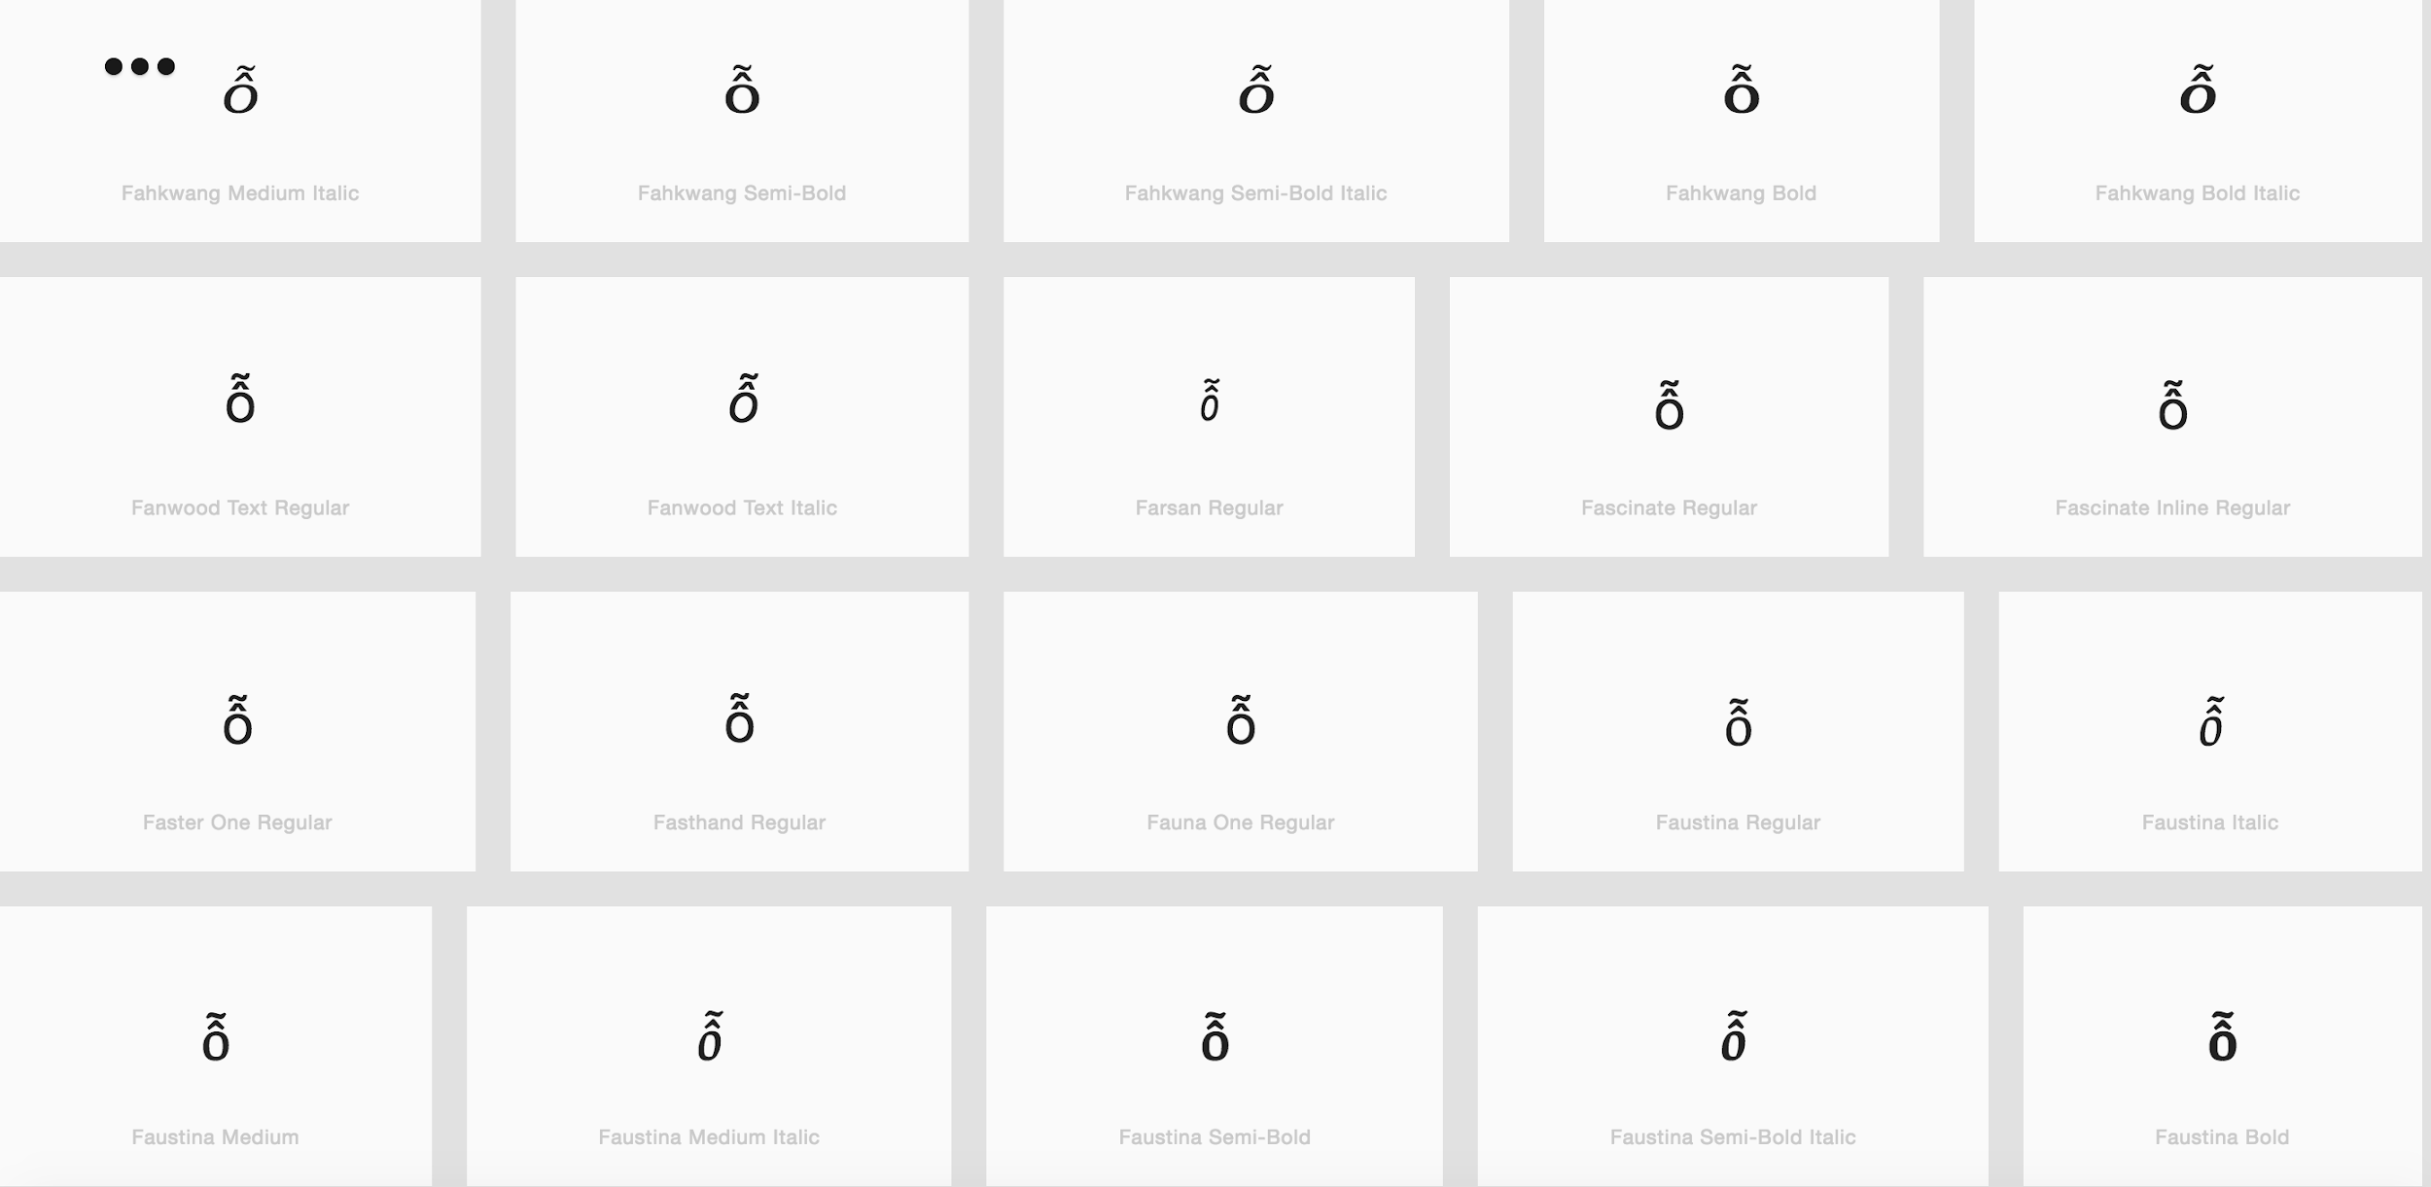

Code Point: U+1EDB (ớ) Letter O with Horn and Acute

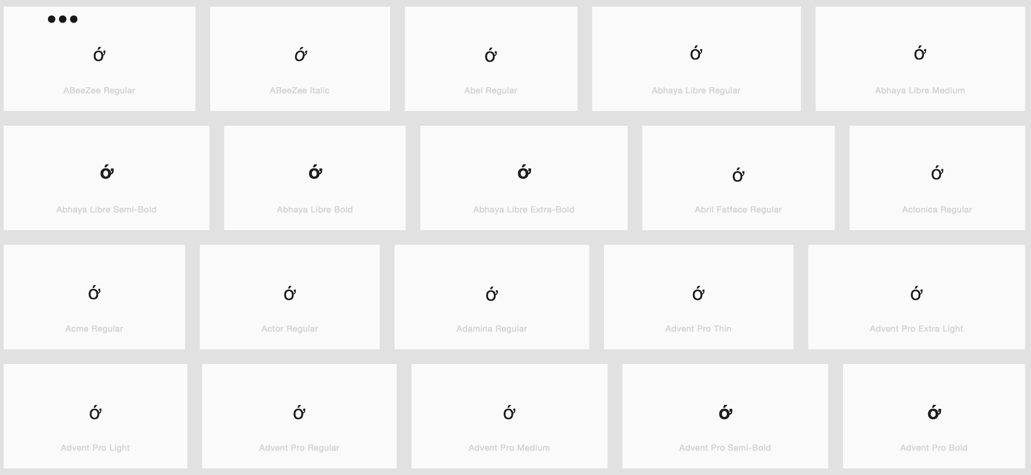
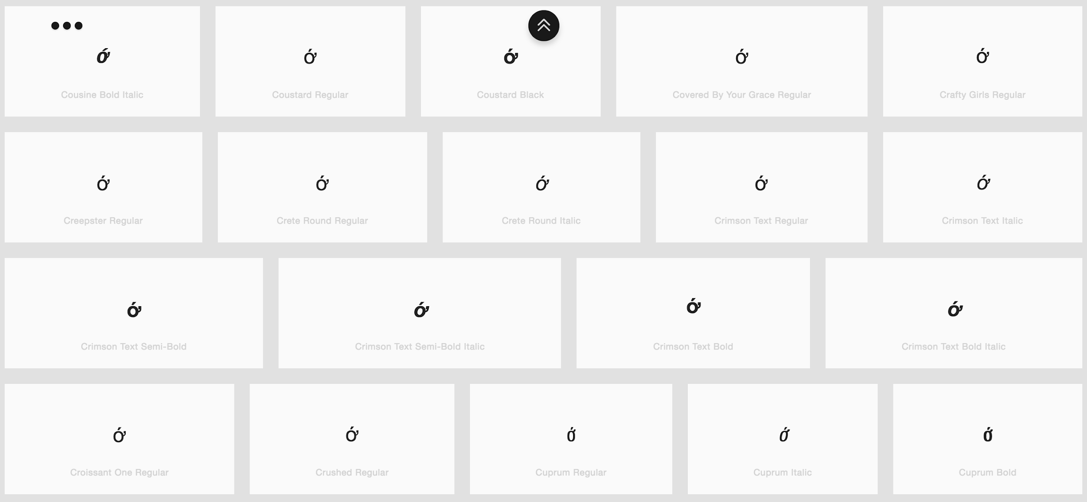

Code Point: U+1EE9 (ứ) Letter U with Horn and Acute

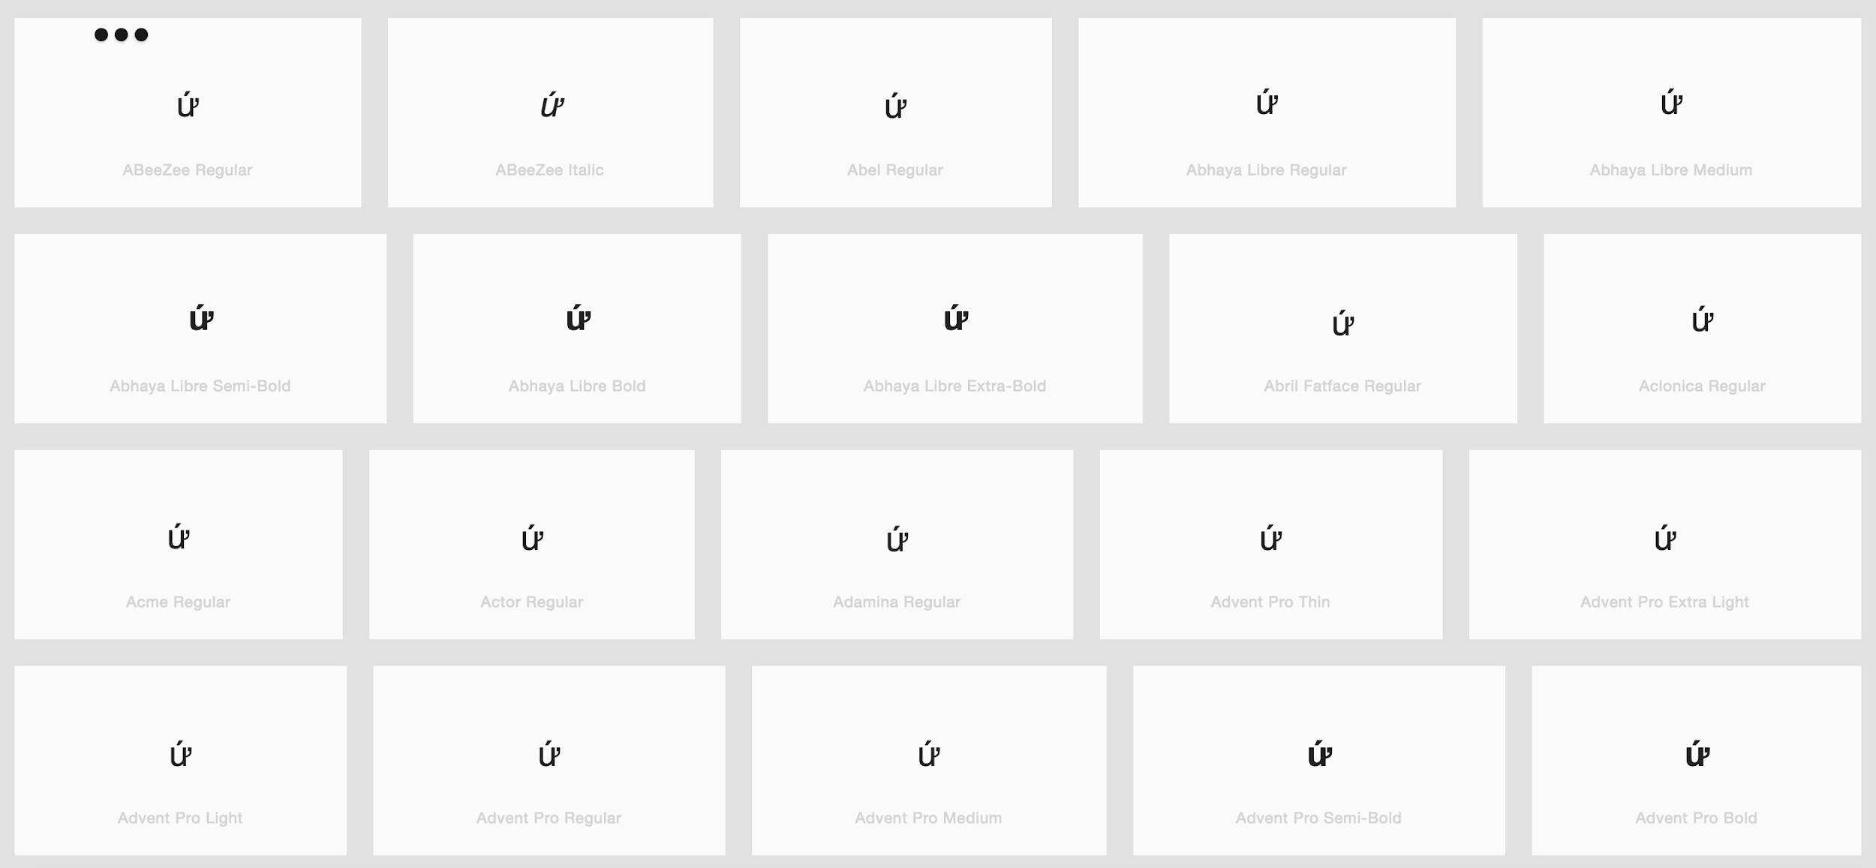

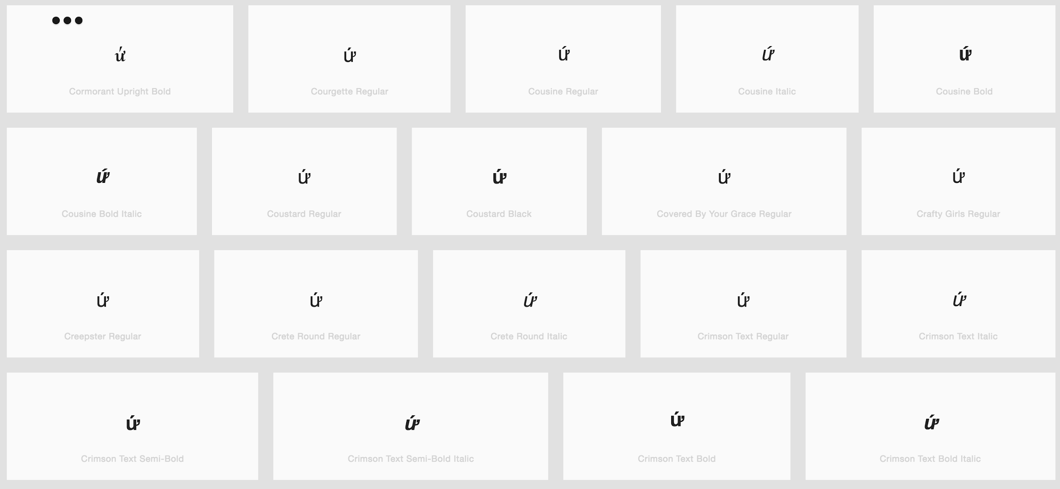

Finding: Diacritics are rendered properly in a consistent manner

