D.x Non-visual: Diacritics stacking

D.x.y BREVE + GRAVE ABOVE

Code Points Analyzed:

1EB1 | ằ | LATIN SMALL LETTER A WITH BREVE AND GRAVE

Sequence (aằa ) (U+0061 U+1EB1 U+0061) compared using Google Fonts in https://wordmark.it/ :

- Here is .png data set downloaded from wordmark.it

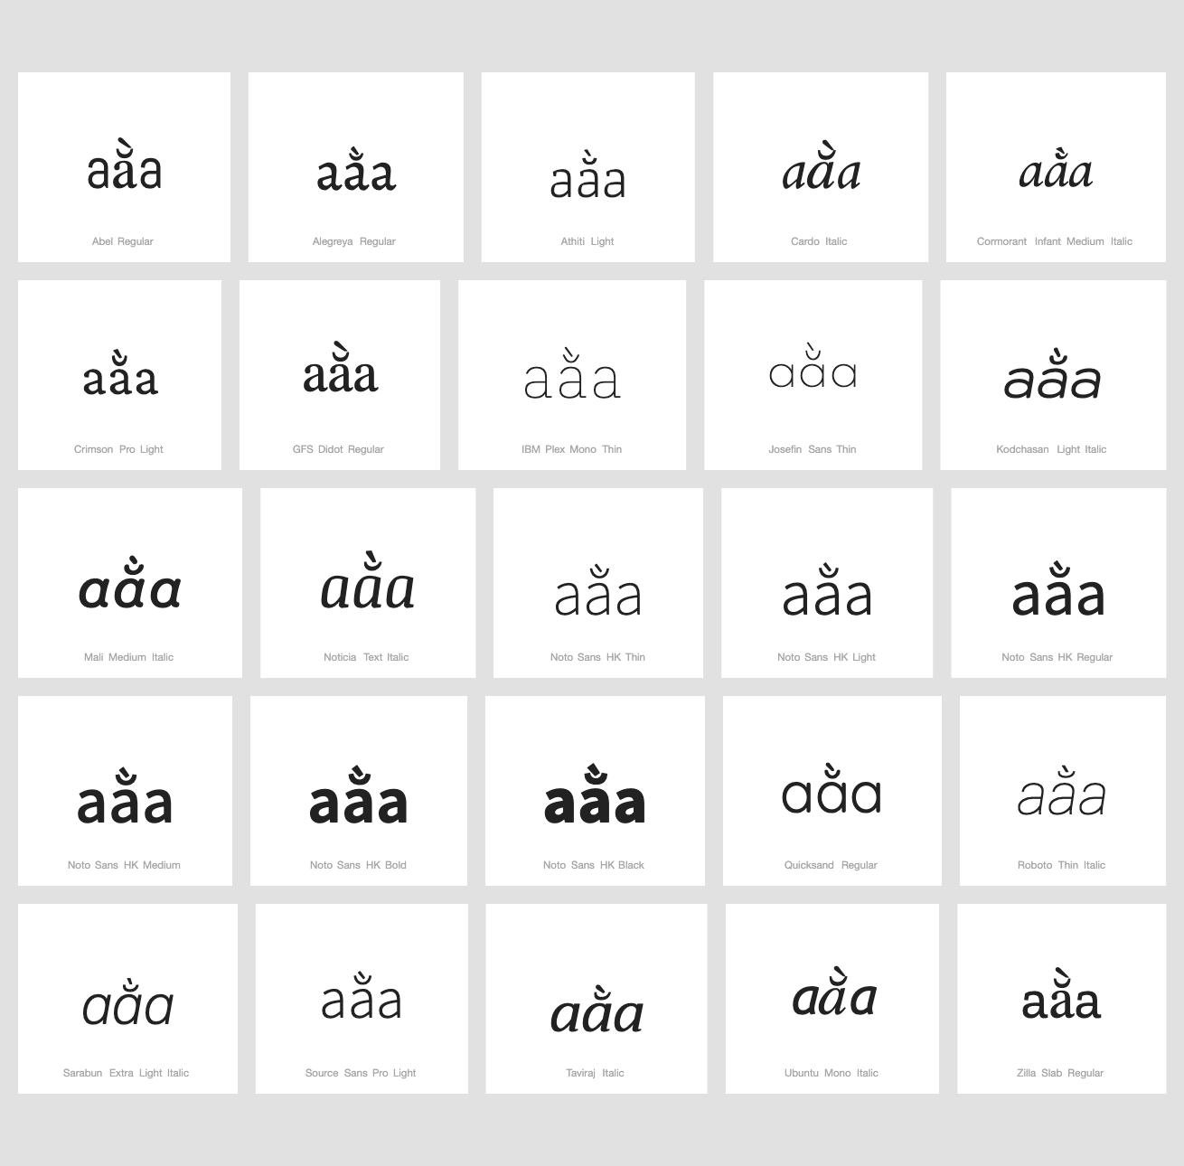

- Here is .pdf data set downloaded from wordmark.it and then converted to .jpeg

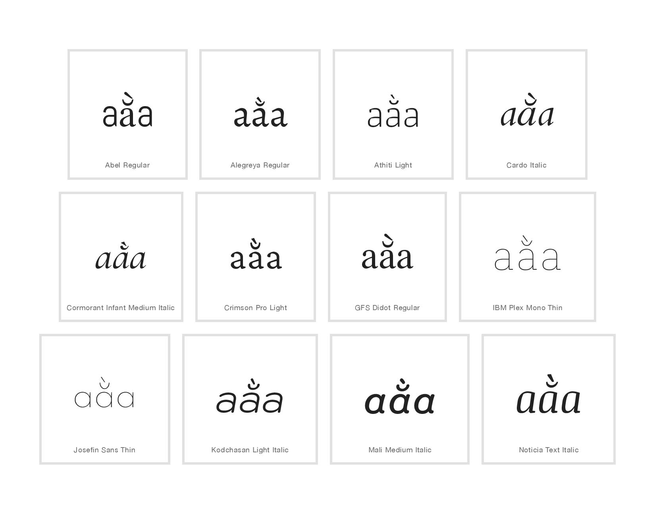
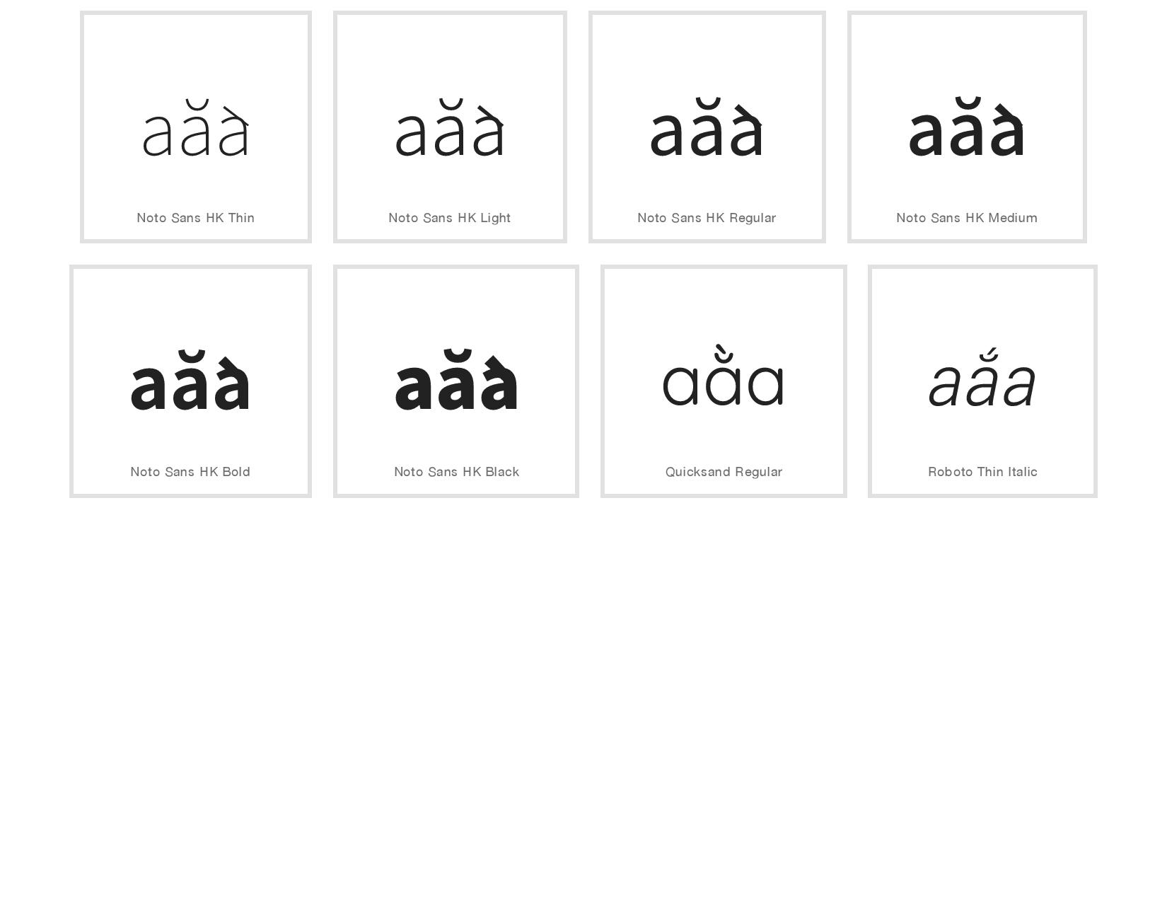
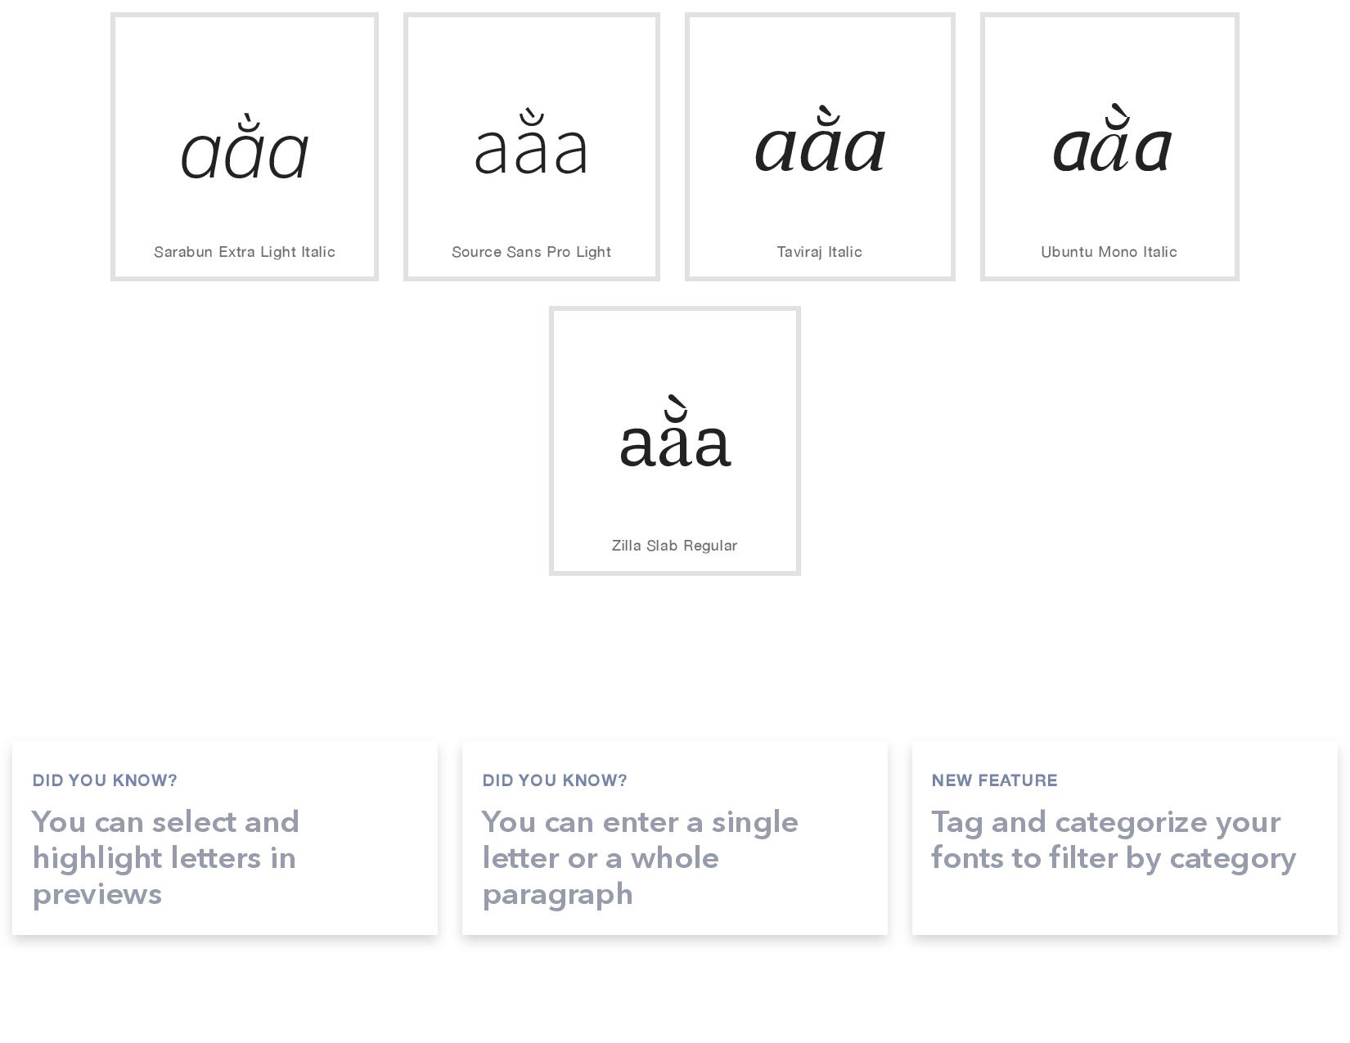
Findings:
- Stacking diacritics are in place in most cases
- One font namely Noto Sans HK has an error in design, or there are some errors in wordmark.it software: on the screen diacritics are not positioned properly, in .png downloaded from wordmark.it diacritics are positioned properly, in .pdf presentation of the same web page diacritics are not positioned properly

Conclusion:
- Stacking diacritics are almost always in place

