4. D.1.7 Letter K vs. Letter K With Hook Code points are not adjacent in screenshot. HH

D.1.7 Latin Small Letter K vs. Latin Small Letter K with Hook

Hypothesis:
Latin Small Letter K and Latin Small Letter K with Hook may be considered equivalent by readers and writers, since the extended hook is a frequent variation encountered in hand-writing.

Code Points Considered:
Code Points | Glyph | Name
006B | k | Letter K
0199 | ƙ | Letter K with Hook

Sequence K (006B) and K with Hook: ƙ (0199) compared using Google Fonts in https://wordmark.it/:

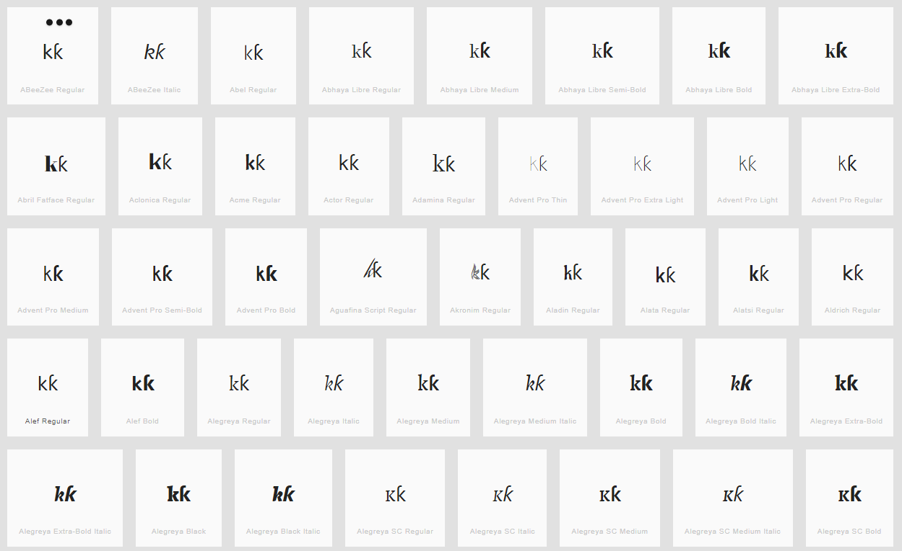

9. D.3.10 Caron vs. Hook Missing analysis

D.3.10 Caron vs. Hook

Code Points Considered:
Sequence ďɗ (010F 0257) compared using Google Fonts in https://wordmark.it/:
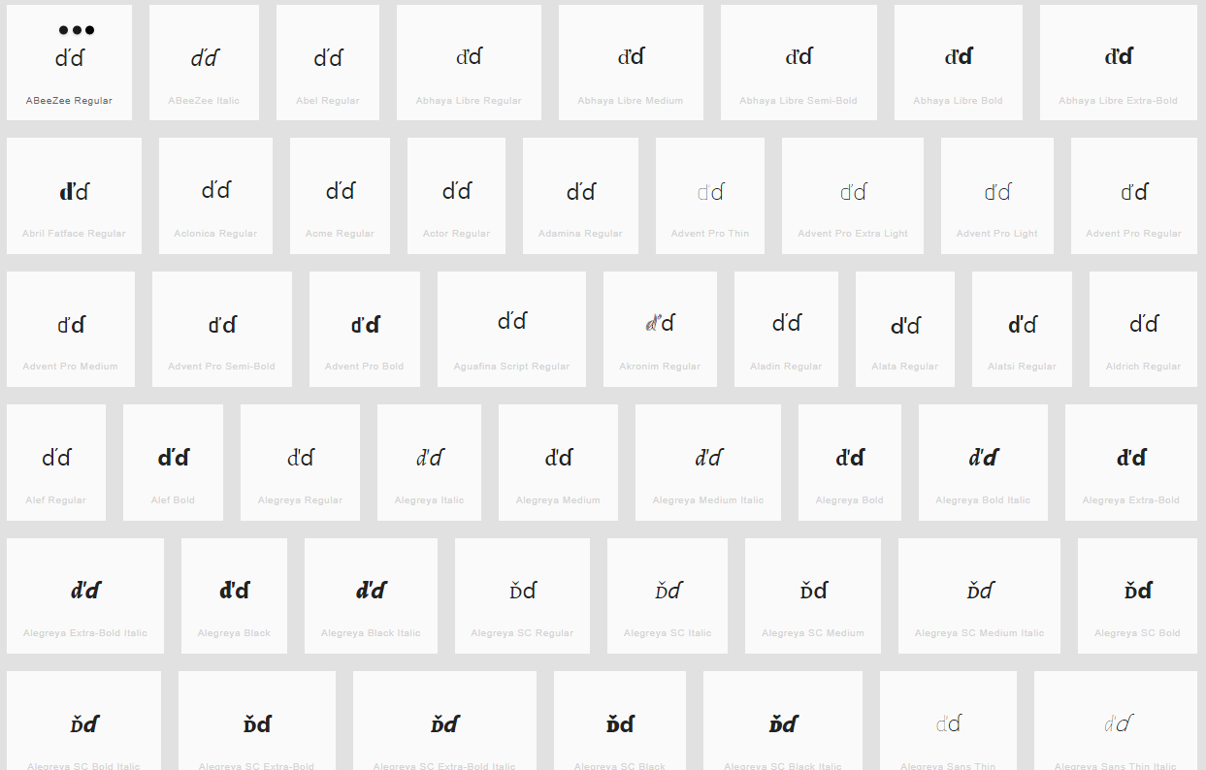
Findings: Caron and Hook are distinguishable in most fonts viewed

Sequence åả (00E5 1EA3) compared using Google Fonts in https://wordmark.it/:
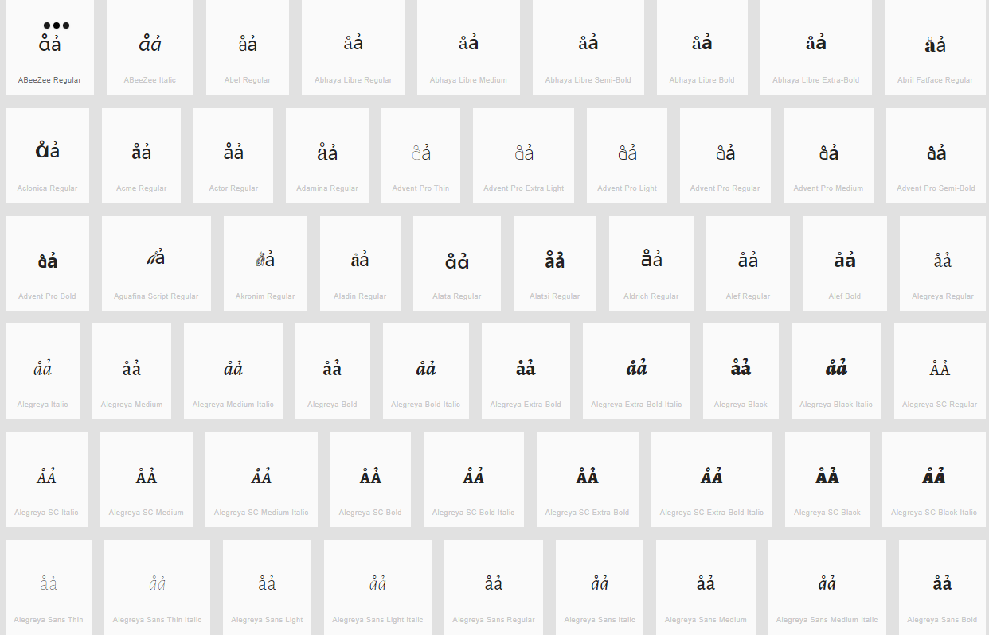

Sequence ůủ (016F 1EE7) compared using Google Fonts in https://wordmark.it/:
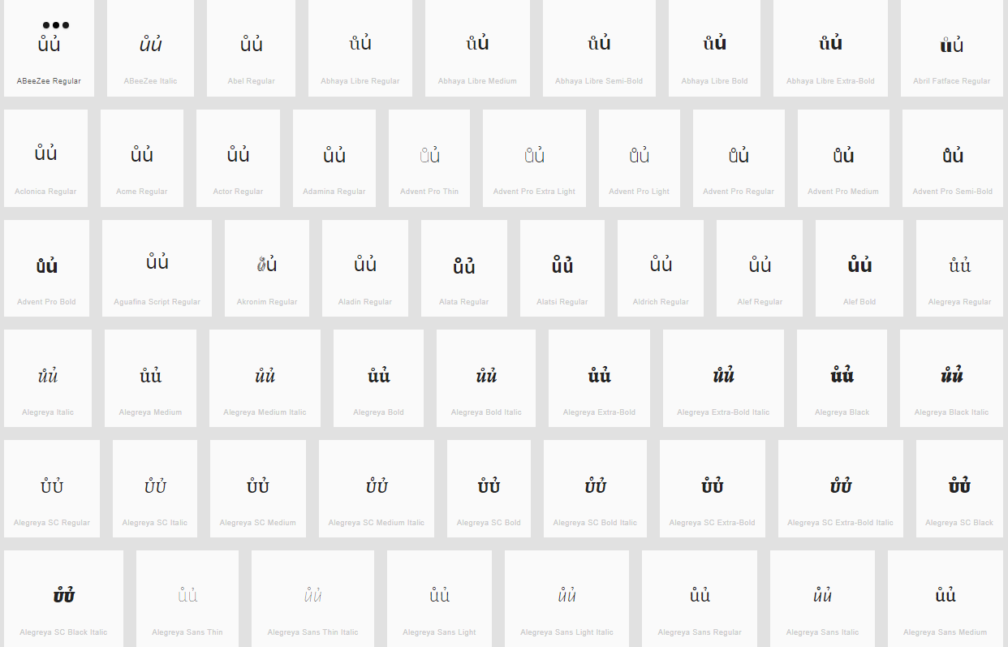

Findings: Ring above and Hook above are distinguishable in all fonts viewed

13. D.3.12 Caron (Above) vs. Horn (Above) Code points are not adjacent in screenshot.
Missing placeholder in the IP-Report

What is the difference to #12? Moreover Caron and Horn are very distinguishable

Sequence ǔ ư (01D4 01B0) compared using Google Fonts in https://wordmark.it/:
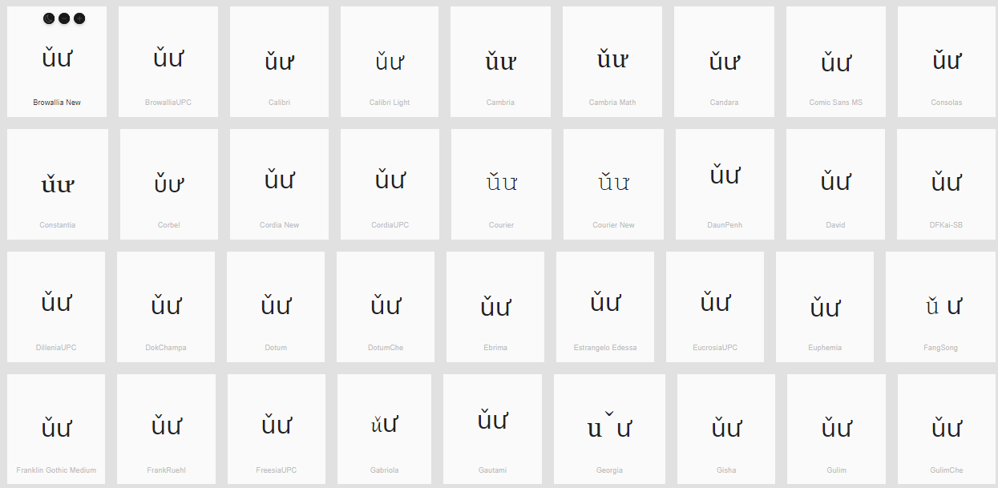

17. D.4.6 Horn and Acute (Above) Missing context in screenshots
Code Points Considered:
1EDB | ớ | Latin Small Letter O with Horn and Acute
1EE9 | ứ | Latin Small Letter U with Horn and Acute

Sequence ớ (1EDB) compared using Google Fonts in https://wordmark.it/:

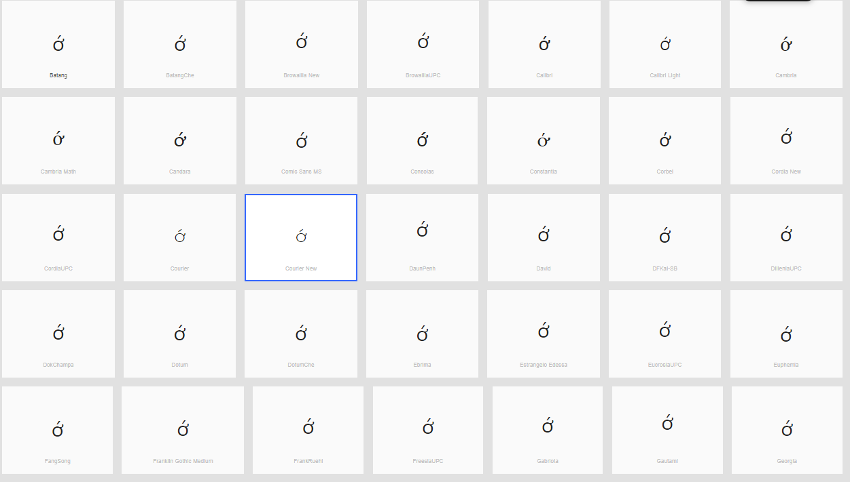

Sequence ứ (1EE9) compared using Google Fonts in https://wordmark.it/:
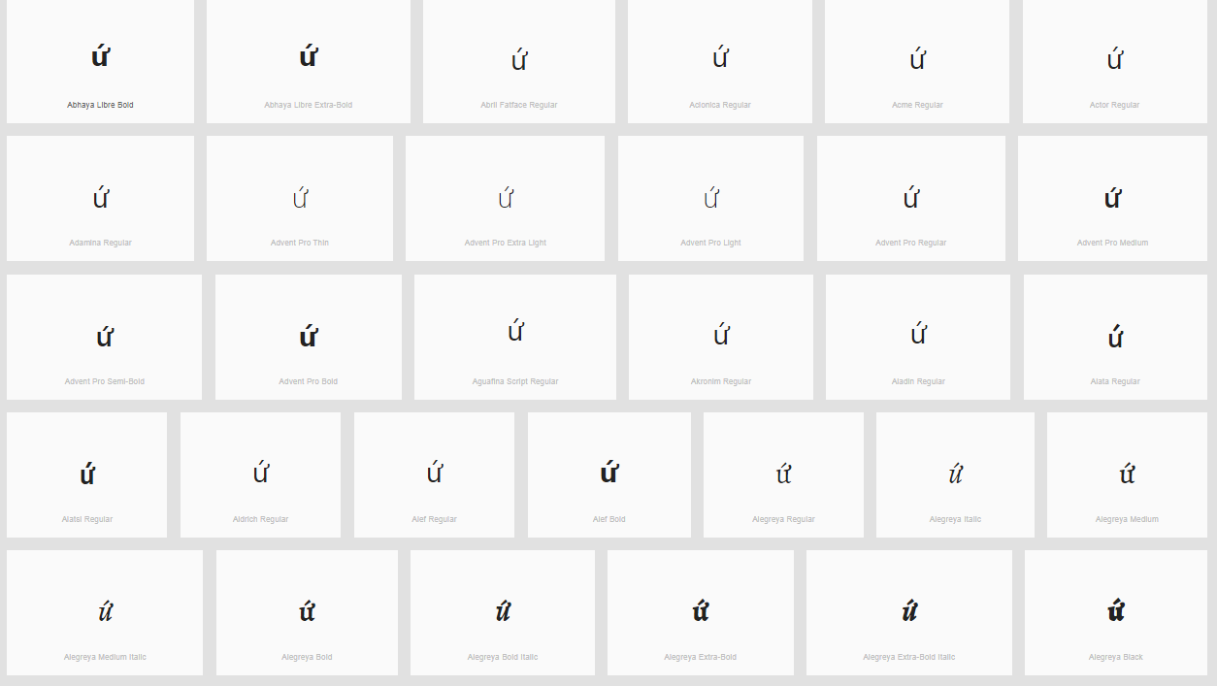

Finding: Diacritics are rendered in a consistent manner

22. D.4.14 Circumflex + Acute Above Missing analysis
Sequence ấaâá (1EA5 0061 00E2 00E1) compared using Google Fonts in https://wordmark.it/:
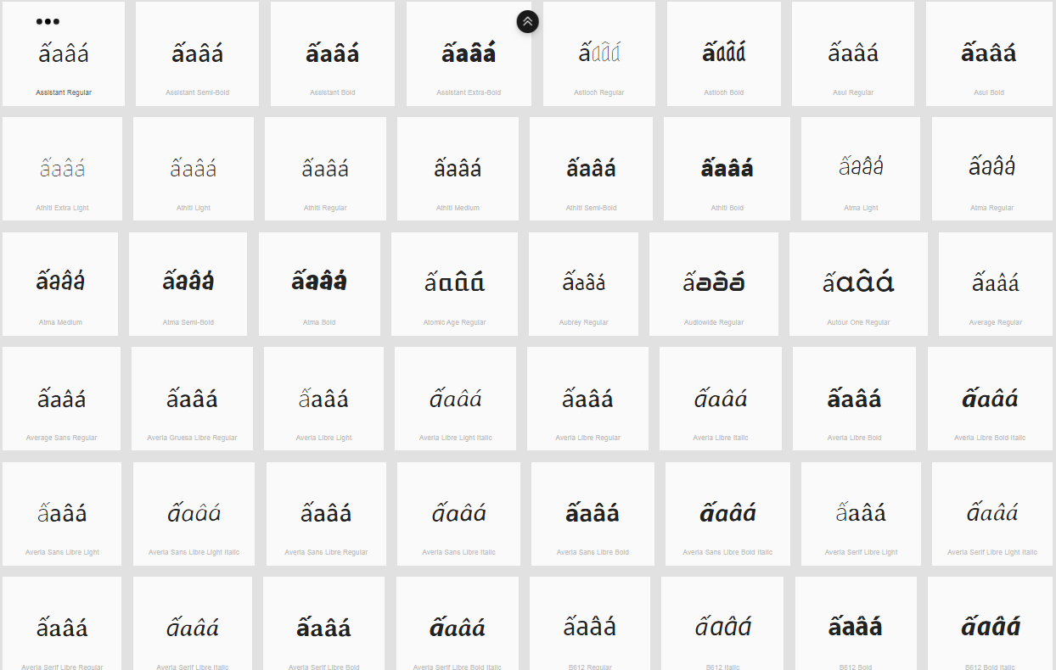

Sequence ếeêé (1EBF 0065 00EA 00E9) compared using Google Fonts in https://wordmark.it/:
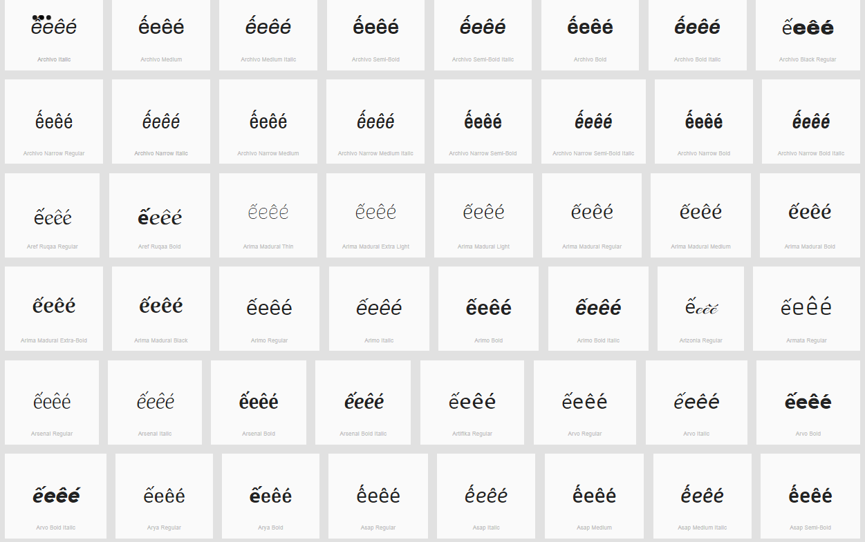

Sequence ốoôó (1ED1 006F 00F4 00F3) compared using Google Fonts in https://wordmark.it/:
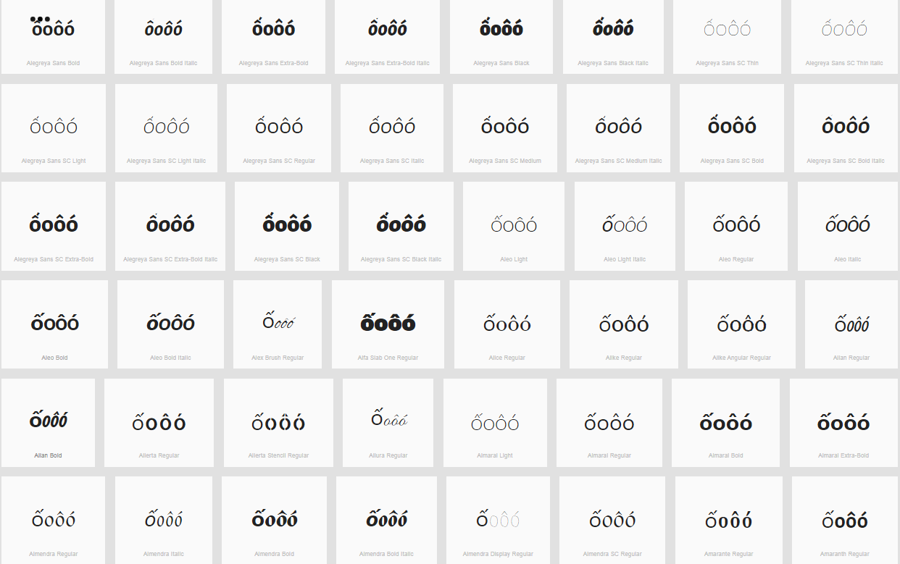

Findings: Diacritics are rendered in a consistent manner, but in some fonts circumflex and acute together can be confused with a Tilde

26. D.4.18 Tilde and Horn (Above) Missing analysis

Sequence ỡoõơ (1EE1 006F 00F5 01A1) compared using Google Fonts in https://wordmark.it/:
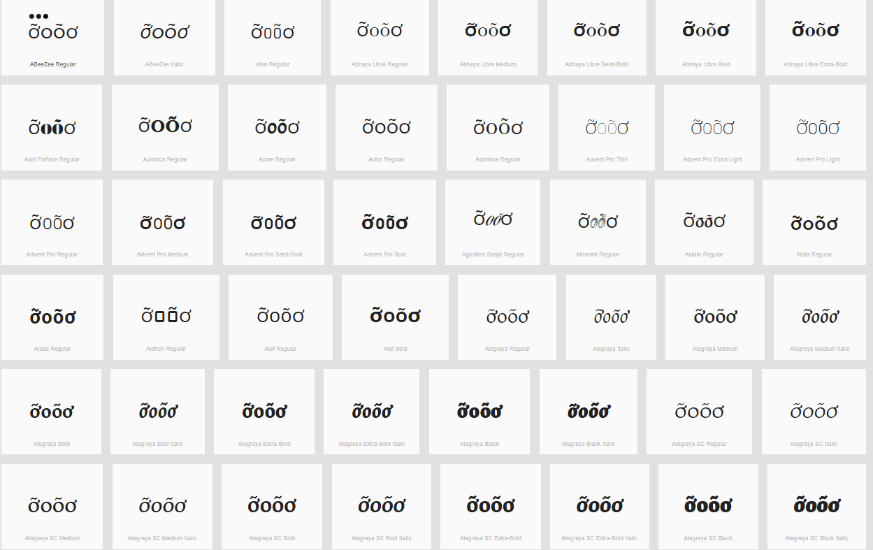

Sequence ữuũư (1EEF 0075 0169 01B0) compared using Google Fonts in https://wordmark.it/:
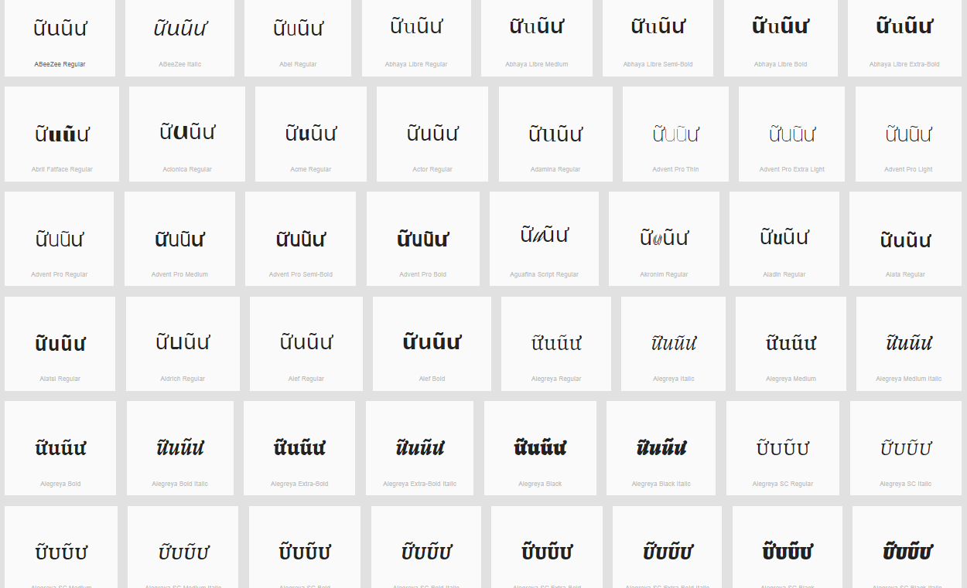

Findings: Diacritics are rendered in a consistent manner

27. D.4.19 Dot Below + Combining Grave Accent Missing analysis

Sequence ọ̀oòọ (1ECD + 0300 006F 00F2 1ECD) compared using Google Fonts in https://wordmark.it/:
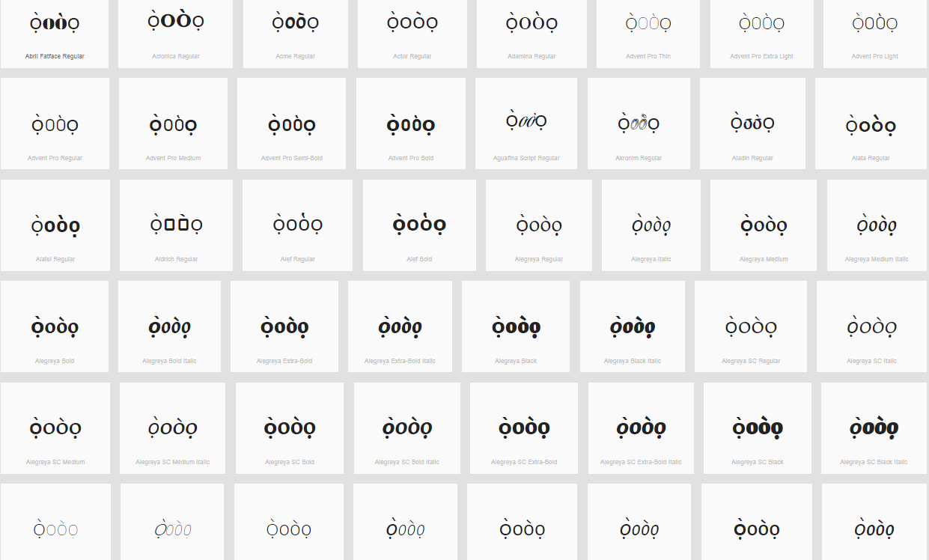

Sequence ẹ̀eèẹ (1EB9 + 0300 0065 00E8 1EB9) compared using Google Fonts in https://wordmark.it/:
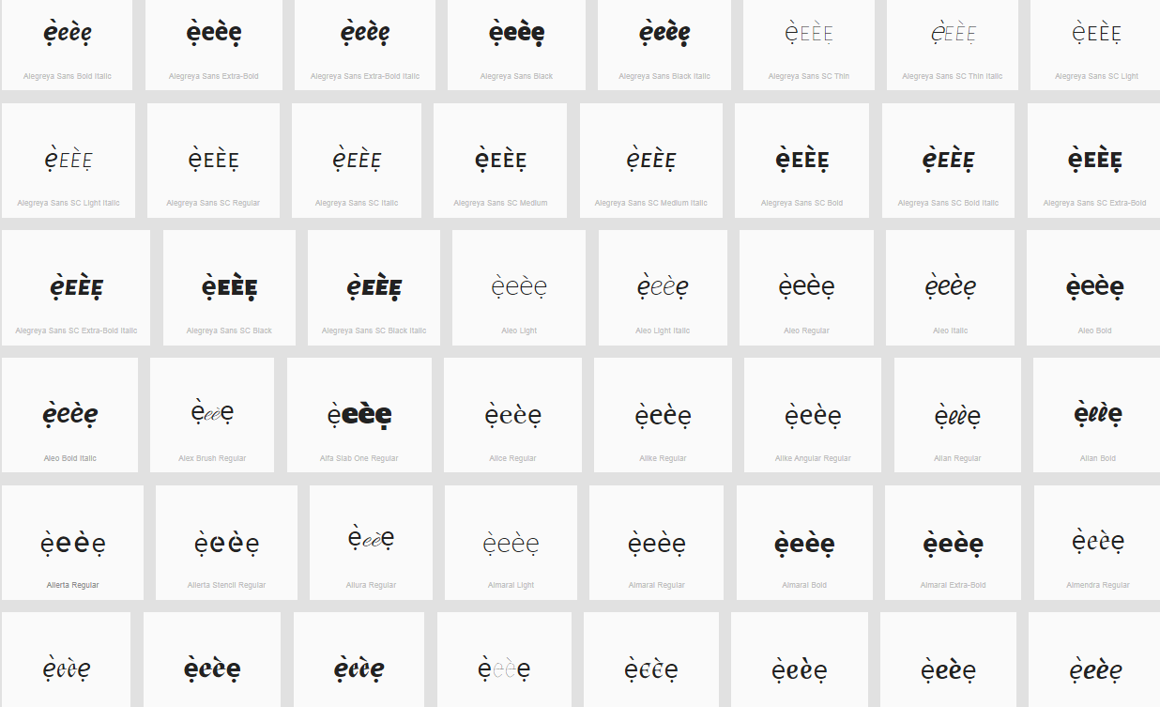

Findings: Diacritics are rendered in a consistent manner

