Proposal for a Kannada Script Root Zone Label Generation Ruleset (LGR)

LGR Version: 3.0
Date: 2018-03-02
Document version: 1.5
Authors: Neo-Brahmi Generation Panel [NBGP]

General Information/ Overview/ Abstract

The purpose of this document is to give an overview of the proposed Kannada LGR in the XML format and the rationale behind the design decisions taken. It includes a discussion of relevant features of the script, the communities or languages using it, the process and methodology used and information on the contributors. The formal specification of the LGR can be found in the accompanying XML document:
Proposed-LGR-knda2017MMDD.xml

Labels for testing can be found in the accompanying text document:

Labels-knda-version-2017MMDD.txt

Script for which the LGR is proposed

ISO 15924 Code: Knda
ISO 15924 N°: 345
ISO 15924 English Name: Kannada
Latin transliteration of the native script name:
Native name of the script: ಕನ್ನಡ
Maximal Starting Repertoire (MSR) version: MSR-2

Some languages using the script: Kannada, Tulu, Beary, Konkani, Havyaka, Kodava
Name of the language as per ISO 639-3 : Kannada

Background on Script and Principal Languages Using It

3.1 Kannada language
Kannada is one of the scheduled languages of India. It is spoken predominantly by the people of Karnataka State of India. It is one of the major languages among the Dravidian languages. Kannada is also spoken by significant linguistic minorities in the states of Andhra Pradesh, Telangana, Tamil Nadu, Maharashtra, Kerala, Goa and abroad. As per scholars, Kannada was a spoken language during the 3rd century B.C. Ptolemy, a scholar from Alexandria, in his The Geography written during the first half of the second century A.D mentions some Kannada words. Ptolemy speaks of many places in Karnataka such as Kalgeris (identified as Kalkeri), Modogoulla (Mudugal), Badamios (Badami) and so on. All these are not only places in Karnataka, but are also names of Kannada origin.

The famous Halmidi Record of the Kadambas which is an inscription of the 5th century AD, is the oldest available evidence of Kannada language written in the pre Old Kannada script. Kappe Arabhatta’s Record at Badami (700 A.D.) has the first Kannada poem in ತ್ರಿಪದಿ tripadi metre. The oldest available literary work in Kannada is ಕವಿರಾಜಮಾರ್ಗ – Kavirajamarga, a book on poetics belonging to 9th century. This work speaks of some earlier poets in Kannada. Hence, Kannada must have been a fully developed language by the 5th or the 6th century A.D and must have been a spoken language for at least a few centuries earlier. Kannada is attested epigraphically for about one and a half millennia, and literary Old Kannada flourished in the 6th-century Ganga dynasty and during the 9th-century Rashtrakuta Dynasty. Kannada has an unbroken literary history of over a thousand years.

3.2 Evolution of Kannada script

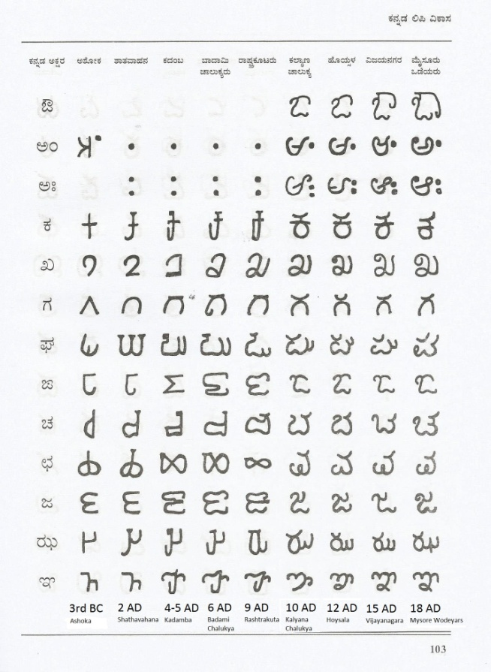
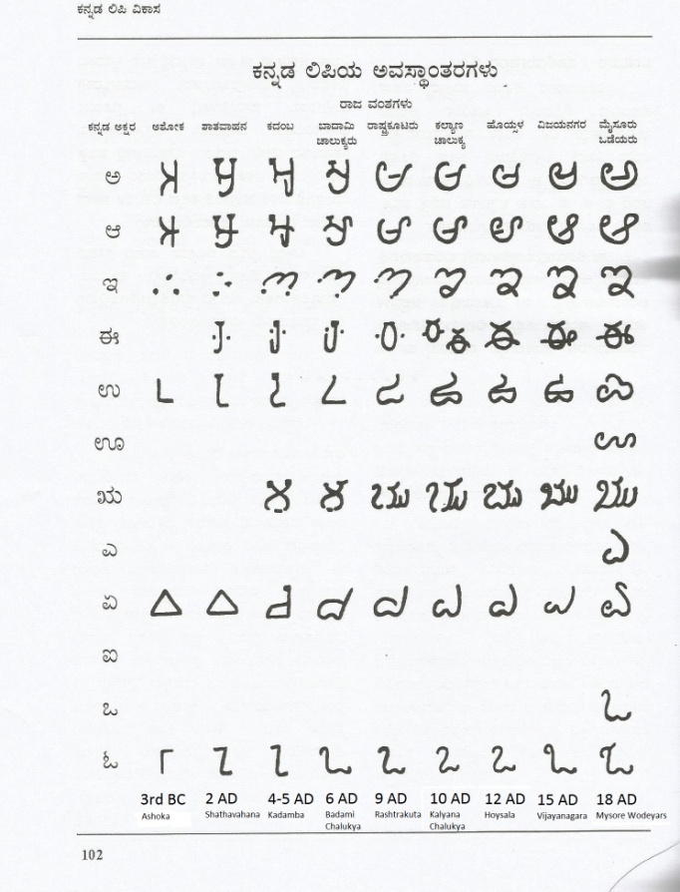
The Kannada language is written using the Kannada script, which evolved from the 5th-century Kadamba script. The oldest form of Kannada script begins in 3rd century B.C. The first popular and well known Kannada script was called Kadamba script used by the Kadamba dynasty during 5th century A.D. Buhler, the famous epigraphist says that the Kadamba script is the earliest form of the present day Kannada script. During Ganga dynasty, in the 6ht century A.D., the script used is known as Adi Ganga script, which resembles Kadamba script. During 6-7th century A.D., the Chalukyas of Badami used a script which is now called by historian as Badami Chalukya script.Rashtrakuta was the next famous dynasty which ruled during 8-10th century A.D. and the script used during those time is referred to as Rashtrakuta script. The script used by the Kalyana Chalukya rulers is called Kalyana Chalukya script. It can be seen in the records of 10-12 century AD. Cursive writing was started during the 13th century by Hoysala kings. They built the decorative cursive way of writing based on the script of Kalyana Chalukyas. Inscriptions at Beluru and Halebeedu have text written using this kind of script. The Vijaynagar kings ruled during the 14-16th century A.D. did not make any major modifications to the script. The last dynasty of Karnataka, the kings of Mysore developed what is known as Modi script. It is called Modi script or ಮೋಡಿ ಬರಹ (Modi baraha). Most of the public records were written during Mysore kings are in Modi script. No inscriptions were written in Modi script as this style is difficult to inscribe on a stone. This can easily be called the last developed script which taught even now in schools for cursive writing of Kannada.

Evolution of Kannada script from 3rd century B.C. to 18th century A.D.
(from https://karnatakaitihasaacademy.org/karnataka-history/evolution-of-kannada-script/)

3.3 Languages considered
Apart from the Kannada language, other languages that use the Kannada script are -Tulu, Kodava (Coorgi), Konkani, Havyaka, Sanketi, Beary (byaari), Arebaase, Koraga, etc. Tulu had its own script which is not in much use nowadays even though lot of efforts are being done of late to revive the Tulu script. The Konkani language is written in Devanagari, Roman, Malayalam scripts also.

3.4 Structure of written Kannada
The structure of Kannada is similar to other Indian languages, especially to Telugu. The heart of the writing system is the Akshar. The Kannada alphabet is known as aksharamale or varnamale. The modern alphabet contains 49 characters. This has been arrived at by removing two characters that are mainly used to write classical Kannada texts. These two characters were in use just about 50 years ago. Characters combine to form compound characters called as samyuktakshara. These compound characters have distinct display forms. The total number of such combinations will be about 650,000. The basic characters in varnamale are classified into three main categories. They are - swara (vowels), vyanjana (consonants) and yogavahas.

3.4.1 Swaras (vowels)
There are thirteen vowels
Letter | Diacritic | ISO notation
ಅ | N/A | a
ಆ | ಾ | ā
ಇ | ಿ | i
ಈ | ೀ | ī
ಉ | ು | u
ಊ | ೂ | ū
ಋ | ೃ | rū
ಎ | ೆ | e
ಏ | ೇ | ē
ಐ | ೈ | ai
ಒ | ೊ | o
ಓ | ೋ | ō
ಔ | ೌ | au
(from https://en.wikipedia.org/wiki/Kannada_alphabet)
When a vowel follows a consonant, it is written with a diacritic rather than as a separate letter. Sometimes these are referred to as vowel signs or matras.

3.4.2 Yogavahas
The Yōgavāha (part-vowel, part consonant) include two letters:
- The anusvara: ಅಂ (aṁ)
- The visarga: ಅಃ (aḥ)

3.4.3. Vyanjanas (consonants)
Two categories of consonant characters (Vyan̄janas) are defined in Kannada: the structured consonants (Vargīya Vyañjana) and the unstructured consonants (Avargīya Vyañjana

The structured consonants are classified according to where the tongue touches the palate of the mouth and are classified accordingly into five structured groups. These consonants are shown here
 | voiceless | voiceless aspirate | voiced | voiced aspirate | nasal
Velars | ಕ (ka) | ಖ (kha) | ಗ (ga) | ಘ (gha) | ಙ (ṅa)
Palatals | ಚ (ca) | ಛ (cha) | ಜ (ja) | ಝ (jha) | ಞ (ña)
Retroflex | ಟ (ṭa) | ಠ (ṭha) | ಡ (ḍa) | ಢ (ḍha) | ಣ (ṇa)
Dentals | ತ (ta) | ಥ (tha) | ದ (da) | ಧ (dha) | ನ (na)
Labials | ಪ (pa) | ಫ (pha) | ಬ (ba) | ಭ (bha) | ಮ (ma)
(from https://en.wikipedia.org/wiki/Kannada_alphabet)

The unstructured consonants are consonants that do not fall into any of the above structures:
ಯ (ya), ರ (ra), ಱ (ṟa) (obsolete), ಲ (la), ವ (va), ಶ (śa), ಷ (ṣa), ಸ (sa), ಹ (ha), ಳ (ḷa), ೞ (ḻ) (obsolete).
From this list the two obsolete characters (ಱ and ೞ) have been removed in modern varnamale bringing the total number of characters to 49.

3.4.4 Implicit vowel ಅ (a) in consonants
All consonants (vyanjanas) in Kannada when written as ಕ (ka), ಖ (kha), ಗ (ga), etc. actually have a built-in vowel sign (matra) of vowel ಅ (a) in them. These consonants are actually ಕ್, ಖ್, ಗ್, etc., shown after removing the implicit vowel ಅ (a). In fact many grammar books on Kannada list the consonants by removing the implicit ಅ (a). In Unicode the character U+0CCD, which is the Kannada equivalent of Deavanagari’s Halant U+094D (or VIRAMA as Unicode calls it), follows consonants to remove the implicit ಅ (a).

Overall Development Process and Methodology

Neo-Brahmi Generation Panel (NBGP) has been formed by members having experience in linguistics and computational linguistics. Under the Neo-Brahmi Generation Panel, there are nine scripts belonging to separate Unicode blocks. Each of these scripts will be assigned a separate LGR; however the Neo-Brahmi GP will ensure that the fundamental philosophy behind building those LGRs are all in sync with all other Brahmi-derived scripts.

NBGP considered all the languages with EGIDS scale 1 to 4 and found that Kannada script is being used in Kannada, Tulu, Beary, Konkani, Havyaka, Kodava, among other languages.

4.1 Guiding Principles

The NBGP adopts following broad principles for selection of code-points in the code-point repertoire across the board for all the scripts within its ambit.

4.1.1 Inclusion principles:

4.1.1.1 Modern usage:
Every character proposed should be in the everyday usage of a particular linguistic community. The characters which have been encoded in the Unicode for transcription purposes only or for archival purposes will not be considered for inclusion in the code-point repertoire.

4.1.1.2 Unambiguous use:
Every character proposed should have unambiguous understanding among the linguistic about its usage in the language.

4.1.2 Exclusion principles:
The main exclusion principle is that of Acknowledgement of Environmental Limitations. These comprise of protocols or standards which are pre-requisites to the Label Generation Rulesets. All further principles are in fact subsumed under these limitations but have been spelt out separately for the sake of clarity.

4.1.2.1 Acknowledgement of Environment Limitations:
The code point repertoire for root zone being a very special case, up the ladder in the protocol hierarchies, the canvas of available characters for selection as a part of the Root Zone code point repertoire is already constrained by various protocol layers beneath it. Following three main protocols/standards act as successive filters:

i. The Unicode Chart:
Out of all the characters that are needed by the given script, if the character in question is not encoded in Unicode, it cannot be incorporated in the code point repertoire. Such cases are quite rare, given the elaborate and exhaustive character inclusion efforts made by Unicode Consortium.

ii. IDNA Protocol:
Unicode being the character encoding standard for providing the maximum possible representation of a given script/language, it has encoded as far as possible all the possible characters needed by the script. However the Domain name being a specialized case, it is governed by an additional protocol known as IDNA (Internationalized Domain Names in Applications). The IDNA protocol introduces exclusion of some characters out of Unicode repertoire from being part of the domain names.

Example: Kannada sign CHANDRABINDU ಁ (U+0C81) is not allowed to be part of the domain name.

iii. Maximal Starting Repertoire:
The Root-zone LGR being a repertoire of the characters which are going to be used for creation of the root zone TLDs, which in turn are an even more specialized case of domain names, the ROOT LGR procedure introduces additional exclusions on IDNA allowed set of characters.

Example: Kannada Sign AVAGRAHA "ऽ" (U+0CBD) even if allowed by IDNA protocol, is not permitted in the Root Zone Repertoire as per the [MSR].

To sum up, the restrictions start off by admitting only such characters as are part of the code-block of the given script/language. This is further narrowed down by the IDNA 2008 Protocol and finally an additional filter in the form of Maximal Starting Repertoire restricts the character set associated with the given language even more.

4.1.2.2 No Rare and Obsolete Characters:
There are characters which have been added to Unicode to accommodate rare forms especially like KANNADA LETTER VOCALIC L "ಌ" (U+0C8C) as well as its matra forms "ೢ" (U+0CE2). All such characters will not be included. This is in consonance with the Conservatism principle as laid down in the Root Zone LGR procedure.

Repertoire

5.1 Unicode codepoints included

Given below is the repertoire for Kannada based on Unicode character set.
Sr. No. | Unicode Code Point | Glyph | Character Name | GC | Indic Syllabic Category | Reference
1 | 0C82 | ಂ | KANNADA SIGN ANUSVARA | Mc | Anusvara | 10
2 | 0C83 | ಃ | KANNADA SIGN VISARGA | Mc | Visarga | 10
3 | 0C85 | ಅ | KANNADA LETTER A | Lo | Vowel | 10
4 | 0C86 | ಆ | KANNADA LETTER AA | Lo | Vowel | 10
5 | 0C87 | ಇ | KANNADA LETTER I | Lo | Vowel | 10
6 | 0C88 | ಈ | KANNADA LETTER II | Lo | Vowel | 10
7 | 0C89 | ಉ | KANNADA LETTER U | Lo | Vowel | 10
8 | 0C8A | ಊ | KANNADA LETTER UU | Lo | Vowel | 10
9 | 0C8B | ಋ | KANNADA LETTER VOCALIC R | Lo | Vowel | 10
10 | 0C8E | ಎ | KANNADA LETTER E | Lo | Vowel | 10
11 | 0C8F | ಏ | KANNADA LETTER EE | Lo | Vowel | 10
12 | 0C90 | ಐ | KANNADA LETTER AI | Lo | Vowel | 10
13 | 0C92 | ಒ | KANNADA LETTER O | Lo | Vowel | 10
14 | 0C93 | ಓ | KANNADA LETTER OO | Lo | Vowel | 10
15 | 0C94 | ಔ | KANNADA LETTER AU | Lo | Vowel | 10
16 | 0C95 | ಕ | KANNADA LETTER KA | Lo | Consonant | 10
17 | 0C96 | ಖ | KANNADA LETTER KHA | Lo | Consonant | 10
18 | 0C97 | ಗ | KANNADA LETTER GA | Lo | Consonant | 10
19 | 0C98 | ಘ | KANNADA LETTER GHA | Lo | Consonant | 10
20 | 0C99 | ಙ | KANNADA LETTER NGA | Lo | Consonant | 10
21 | 0C9A | ಚ | KANNADA LETTER CA | Lo | Consonant | 10
22 | 0C9B | ಛ | KANNADA LETTER CHA | Lo | Consonant | 10
23 | 0C9C | ಜ | KANNADA LETTER JA | Lo | Consonant | 10
24 | 0C9D | ಝ | KANNADA LETTER JHA | Lo | Consonant | 10
25 | 0C9E | ಞ | KANNADA LETTER NYA | Lo | Consonant | 10
26 | 0C9F | ಟ | KANNADA LETTER TTA | Lo | Consonant | 10
27 | 0CA0 | ಠ | KANNADA LETTER TTHA | Lo | Consonant | 10
28 | 0CA1 | ಡ | KANNADA LETTER DDA | Lo | Consonant | 10
29 | 0CA2 | ಢ | KANNADA LETTER DDHA | Lo | Consonant | 10
30 | 0CA3 | ಣ | KANNADA LETTER NNA | Lo | Consonant | 10
31 | 0CA4 | ತ | KANNADA LETTER TA | Lo | Consonant | 10
32 | 0CA5 | ಥ | KANNADA LETTER THA | Lo | Consonant | 10
33 | 0CA6 | ದ | KANNADA LETTER DA | Lo | Consonant | 10
34 | 0CA7 | ಧ | KANNADA LETTER DHA | Lo | Consonant | 10
35 | 0CA8 | ನ | KANNADA LETTER NA | Lo | Consonant | 10
36 | 0CAA | ಪ | KANNADA LETTER PA | Lo | Consonant | 10
37 | 0CAB | ಫ | KANNADA LETTER PHA | Lo | Consonant | 10
38 | 0CAC | ಬ | KANNADA LETTER BA | Lo | Consonant | 10
39 | 0CAD | ಭ | KANNADA LETTER BHA | Lo | Consonant | 10
40 | 0CAE | ಮ | KANNADA LETTER MA | Lo | Consonant | 10
41 | 0CAF | ಯ | KANNADA LETTER YA | Lo | Consonant | 10
42 | 0CB0 | ರ | KANNADA LETTER RA | Lo | Consonant | 10
43 | 0CB2 | ಲ | KANNADA LETTER LA | Lo | Consonant | 10
44 | 0CB3 | ಳ | KANNADA LETTER LLA | Lo | Consonant | 10
45 | 0CB5 | ವ | KANNADA LETTER VA | Lo | Consonant | 10
46 | 0CB6 | ಶ | KANNADA LETTER SHA | Lo | Consonant | 10
47 | 0CB7 | ಷ | KANNADA LETTER SSA | Lo | Consonant | 10
48 | 0CB8 | ಸ | KANNADA LETTER SA | Lo | Consonant | 10
49 | 0CB9 | ಹ | KANNADA LETTER HA | Lo | Consonant | 10
50 | 0CBE | ಾ | KANNADA VOWEL SIGN AA | Mc | Matra | 10
51 | 0CBF | ಿ | KANNADA VOWEL SIGN I | Mn | Matra | 10
52 | 0CC0 | ೀ | KANNADA VOWEL SIGN II | Mc | Matra | 10
53 | 0CC1 | ು | KANNADA VOWEL SIGN U | Mc | Matra | 10
54 | 0CC2 | ೂ | KANNADA VOWEL SIGN UU | Mc | Matra | 10
55 | 0CC3 | ೃ | KANNADA VOWEL SIGN VOCALIC R | Mc | Matra | 10
56 | 0CC6 | ೆ | KANNADA VOWEL SIGN E | Mn | Matra | 10
57 | 0CC7 | ೇ | KANNADA VOWEL SIGN EE | Mc | Matra | 10
58 | 0CC8 | ೈ | KANNADA VOWEL SIGN AI | Mc | Matra | 10
59 | 0CCA | ೊ | KANNADA VOWEL SIGN O | Mc | Matra | 10
60 | 0CCB | ೋ | KANNADA VOWEL SIGN OO | Mc | Matra | 10
61 | 0CCC | ೌ | KANNADA VOWEL SIGN AU | Mn | Matra | 10
62 | 0CCD | ್ | KANNADA SIGN VIRAMA | Mn | Halant / Virama | 10

5.2 Codepoints not included

Following code points have not been included in the repertoire.

Sr. No. | Unicode Code Point | Glyph | Character Name | Reason for exclusion
1. | 0C8C | ಌ | KANNADA LETTER VOCALIC L | Not used in Kannada
2. | 0CB1 | ಱ | KANNADA LETTER RRA | Obsolete character, not used in modern Kannada
3. | 0CBC | ಼ | KANNADA SIGN NUKTA | Does not belong to Kannada, not needed in LGR
4. | 0CC4 | ೄ | KANNADA VOWEL SIGN VOCALIC RR | Not used in Kannada
5. | 0CD5 | ೕ | KANNADA LENGTH MARK | Not in use
6. | 0CD6 | ೖ | KANNADA AI LENGTH MARK | Not in use

Variants

6.1 In-script variants
There are no variants within Kannada script.

6.2 Cross-script variants
Some characters of Kannada look somewhat similar to some characters in Devanagari, Gujarati, Telugu, Malayalam and Sinhala. The tables below list them.

6.2.1 Cross-script variants for Kannada and Telugu

Variant Set | Telugu Code Point | Kannada Code Point
1 | ం (0C02) | ಂ (0C82)
2 | ః (0C03) | ಃ (0C83)
3 | అ (0C05) | ಅ (0C85)
4 | ఆ (0C06 ) | ಆ (0C86)
5 | ఇ (0C07) | ಇ (0C87)
6 | ఈ (0C08) | ಈ (0C88)
7 | ఐ (0C10) | ಐ (0C90)
8 | ఒ (0C12) | ಒ (0C92)
9 | ఓ (0C13) | ಓ (0C93)
10 | ఔ (0C14) | ಔ (0C94)
11 | ఖ (0C16) | ಖ (0C96)
12 | గ (0C17) | ಗ (0C97)
13 | జ (0C1C) | ಜ (0C9C)
14 | ఝ (0C1D) | ಝ (0C9D)
15 | ఞ (0C1E) | ಞ (0C9E)
16 | ట (0C1F) | ಟ (0C9F)
17 | ఠ (0C20) | ಠ (0CA0)
18 | డ (0C21) | ಡ (0CA1)
19 | ఢ (0C22) | ಢ (0CA2)
20 | ణ (0C23) | ಣ (0CA3)
21 | థ (0C25) | ಥ (0CA5)
22 | ద (0C26) | ದ (0CA6)
23 | ధ (0C27) | ಧ (0CA7)
24 | న (0C28) | ನ (0CA8)
25 | బ (0C2C) | ಬ (0CAC)
26 | భ (0C2D) | ಭ (0CAD)
27 | మ (0C2E) | ಮ (0CAE)
28 | య (0C2F) | ಯ (0CAF)
29 | ర (0C30) | ರ (0CB0)
30 | ల (0C32) | ಲ (0CB2)
31 | ళ (0C33) | ಳ (0CB3)
32 | ి (0C3F) | ಿ (0CBF)
33 | ు (0C41) | ು (0CC1)
34 | ృ (0C43) | ೃ (0CC3)

6.2.2 Cross-script variants for Kannada and Devanagari
Devanagari Code Point | Kannada Code Point
ः (0903) | ಃ (0C83)

They are identical but as there are not enough other variant code points to form two labels with each script that look the same. Therefore, these are not defined as variant code points.

6.2.3 Cross-script variants for Kannada and Gujarati
Gujarati Code Point | Kannada Code Point
ઃ (0A83) | ಃ (0C83)

They are identical but as there are not enough other variant code points to form two labels with each script that look the same. Therefore, these are not defined as variant code points.

6.2.4 Cross-script variants for Kannada and Malayalam
Kannada Code Point | Malayalam Code Point
ಂ (0C82) | ം (0D02)
ಃ (0C83) | ഃ (0D03)

They are identical but as there are not enough other variant codes point to form two labels with each script that look the same. Therefore, these are not defined as variant code points.

6.2.5 Cross-script variants for Kannada and Sinhala
Kannada Code Point | Sinhala Code Point
ಂ (0C82) | ං (0D82)
ಃ (0C83) | ඃ (0D83)

They are identical but as there are not enough other variant code points to form two labels with each script that look the same. Therefore, these are not defined as variant code points.

Whole Label Evaluation Rules (WLE)

Variables or definitions -
V → Vowel
M → Matra
C → Consonant
H → Halant / Virama
B → Anusvara
X → Visarga
Rules for forming akshar or a cluster of one unit -
- Rule 1: H must be preceded by C
- Rule 2: M must be preceded by C
- Rule 3: B must be preceded by C, V or M
- Rule 4: X must be preceded by C, V or M

Contributors
1. Dr. U.B. Pavanaja, pavanaja@vishvakannada.com
2. Dhanalakshmi K.T., lakshmikt96@gmail.com
3. Tejas Jain, teju2friends@gmail.com
4. NBGP Members

References
101. A Comparative Grammar of the Dravidian or South Indian Family of Languages by Robert Caldwell, Trubner & Co, London, Second Edition, 1875
102. Evolution of Kannada script - https://karnatakaitihasaacademy.org/karnataka-history/evolution-of-kannada-script/
103. History of the Kannada Script and Language - https://bookstalkist.com/history-of-the-kannada-script-and-language/
104. History of the Kannada Literature - http://kamat.com/kalranga/kar/literature/history1.htm
105. Kannada alphabet - https://en.wikipedia.org/wiki/Kannada_alphabet
106. About Kannada language - https://en.wikipedia.org/wiki/Kannada
107. Ethnologue entry about Kannada - http://www.ethnologue.com/19/language/kan/
108. OLAC resources in and about the Kannada language - http://www.language-archives.org/language/kan
109. Encyclopaedia Britannica entry about Kannada - https://www.britannica.com/topic/Kannada-language
110. ಕನ್ನಡ ಮಧ್ಯಮ ವ್ಯಾಕರಣ, ತೀ.ನಂ. ಶ್ರೀಕಂಠಯ್ಯ, ಗೀತಾ ಬುಕ್ ಹೌಸ್, ಮೈಸೂರು, ೨೦೦೧ (Kannada Madhyama Vyakarana (means An Intermediate Kannada Grammar), T. N. Sreekantaiya, Geetha Book House, Mysore, 2001.)

Appendix
Some cross-script variants for Kannada with Telugu script are listed below. Some characters of Kannada look somewhat similar to some characters in Telugu. This mostly dependent on the type of fonts used for both languages.

Ser. No. | Kannada Character | Unicode codepoint | Telugu character | Unicode codepoint
1 | ಎ | 0C8E | ఎ | 0C0E
2 | ಘ | 0C98 | ఘ | 0C18
3 | ಙ | 0C99 | ఙ | 0C19
4 | ಚ | 0C9A | చ | 0C1A
5 | ಛ | 0C9B | ఛ | 0C1B
6 | ಪ | 0CAA | ప | 0C2A
7 | ಫ | 0CAB | ఫ | 0C2B
8 | ವ | 0CB5 | వ | 0C35
9 | ಶ | 0CB6 | శ | 0C36
10 | ಷ | 0CB7 | ష | 0C37
11 | ಸ | 0CB8 | స | 0C38
12 | ೌ | 0CCC | ౌ | 0C4C

