Proposal for a Kannada Script Root Zone Label Generation Ruleset (LGR)

LGR Version: 3.0
Date: 2018-06-05
Document version: 1.8
Authors: Neo-Brahmi Generation Panel [NBGP]

General Information/ Overview/ Abstract

The purpose of this document is to give an overview of the proposed Kannada LGR in the XML format and the rationale behind the design decisions taken. It includes a discussion of relevant features of the script, the communities or languages using it, the process and methodology used and information on the contributors. The formal specification of the LGR can be found in the accompanying XML document:
Proposal-LGR-knda_20180605.xml

Labels for testing can be found in the accompanying text document:

Labels-knda-version-20180605.txt

Script for which the LGR is proposed

ISO 15924 Code: Knda
ISO 15924 N°: 345
ISO 15924 English Name: Kannada
Latin transliteration of the native script name:
Native name of the script: ಕನ್ನಡ
Maximal Starting Repertoire (MSR) version: MSR-3

Some languages using the script: Kannada, Tulu, Beary, Konkani, Havyaka, Kodava
Name of the language as per ISO 639-3 : Kannada

Background on Script and Principal Languages Using It

3.1 Kannada language
Kannada is one of the scheduled languages of India. It is spoken predominantly by the people of Karnataka State of India. It is one of the major languages among the Dravidian languages. Kannada is also spoken by significant linguistic minorities in the states of Andhra Pradesh, Telangana, Tamil Nadu, Maharashtra, Kerala, Goa and abroad. As per scholars, Kannada was a spoken language during the 3rd century B.C. Ptolemy, a scholar from Alexandria, in his The Geography written during the first half of the second century A.D mentions some Kannada words. Ptolemy speaks of many places in Karnataka such as Kalgeris (identified as Kalkeri), Modogoulla (Mudugal), Badamios (Badami) and so on. All these are not only places in Karnataka, but are also names of Kannada origin.

The famous Halmidi Record of the Kadambas which is an inscription of the 5th century AD, is the oldest available evidence of Kannada language written in the pre Old Kannada script. Kappe Arabhatta’s Record at Badami (700 A.D.) has the first Kannada poem in ತ್ರಿಪದಿ tripadi metre. The oldest available literary work in Kannada is ಕವಿರಾಜಮಾರ್ಗ – Kavirajamarga, a book on poetics belonging to 9th century. This work speaks of some earlier poets in Kannada. Hence, Kannada must have been a fully developed language by the 5th or the 6th century A.D and must have been a spoken language for at least a few centuries earlier. Kannada is attested epigraphically for about one and a half millennia, and literary Old Kannada flourished in the 6th-century Ganga dynasty and during the 9th-century Rashtrakuta Dynasty. Kannada has an unbroken literary history of over a thousand years.

3.2 Evolution of Kannada script

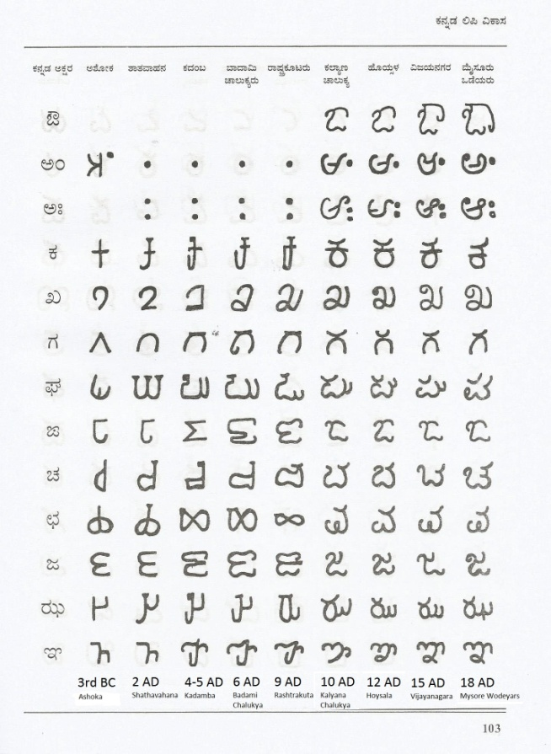
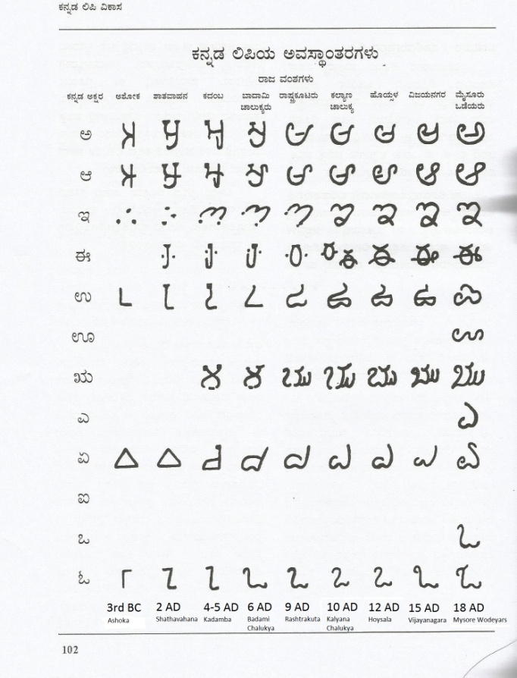
The Kannada language is written using the Kannada script, which evolved from the 5th-century Kadamba script. The oldest form of Kannada script begins in 3rd century B.C. The first popular and well known Kannada script was called Kadamba script used by the Kadamba dynasty during 5th century A.D. Buhler, the famous epigraphist says that the Kadamba script is the earliest form of the present day Kannada script. During Ganga dynasty, in the 6ht century A.D., the script used is known as Adi Ganga script, which resembles Kadamba script. During 6-7th century A.D., the Chalukyas of Badami used a script which is now called by historian as Badami Chalukya script.Rashtrakuta was the next famous dynasty which ruled during 8-10th century A.D. and the script used during those time is referred to as Rashtrakuta script. The script used by the Kalyana Chalukya rulers is called Kalyana Chalukya script. It can be seen in the records of 10-12 century AD. Cursive writing was started during the 13th century by Hoysala kings. They built the decorative cursive way of writing based on the script of Kalyana Chalukyas. Inscriptions at Beluru and Halebeedu have text written using this kind of script. The Vijaynagar kings ruled during the 14-16th century A.D. did not make any major modifications to the script. The last dynasty of Karnataka, the kings of Mysore developed what is known as Modi script. It is called Modi script or ಮೋಡಿ ಬರಹ (Modi baraha). Most of the public records were written during Mysore kings are in Modi script. No inscriptions were written in Modi script as this style is difficult to inscribe on a stone. This can easily be called the last developed script which taught even now in schools for cursive writing of Kannada.

Evolution of Kannada script from 3rd century B.C. to 18th century A.D.
(from https://karnatakaitihasaacademy.org/karnataka-history/evolution-of-kannada-script/)

3.3 Languages considered
Apart from the Kannada language, other languages that use the Kannada script are -Tulu, Kodava (Coorgi), Konkani, Havyaka, Sanketi, Beary (byaari), Arebaase, Koraga, etc. Tulu had its own script which is not in much use nowadays even though lot of efforts are being done of late to revive the Tulu script. The Konkani language is written in Devanagari, Roman, Malayalam scripts also.

3.4 Structure of written Kannada
The structure of Kannada is similar to other Indian languages, especially to Telugu. The heart of the writing system is the Akshar. The Kannada alphabet is known as aksharamale or varnamale. The modern alphabet contains 49 characters. This has been arrived at by removing two characters that are mainly used to write classical Kannada texts. These two characters were in use just about 50 years ago. Characters combine to form compound characters called as samyuktakshara (conjuncts). These compound characters have distinct display forms. The total number of such combinations will be about 650,000. The basic characters in varnamale are classified into three main categories. They are - swara (vowels), vyanjana (consonants) and yogavahas.

3.4.1 Swaras (vowels)
There are thirteen vowels
Letter | Diacritic | ISO notation
ಅ | N/A | a
ಆ | ಾ | ā
ಇ | ಿ | i
ಈ | ೀ | ī
ಉ | ು | u
ಊ | ೂ | ū
ಋ | ೃ | rū
ಎ | ೆ | e
ಏ | ೇ | ē
ಐ | ೈ | ai
ಒ | ೊ | o
ಓ | ೋ | ō
ಔ | ೌ | au
Table1: Kannada Swaras (vowels)
(from https://en.wikipedia.org/wiki/Kannada_alphabet)
When a vowel follows a consonant, it is written with a diacritic rather than as a separate letter. Sometimes these are referred to as vowel signs or matras. Vowel signs or matras are attached only to consonants.

3.4.2 Yogavahas
The Yōgavāha (part-vowel, part consonant) include two letters:
- The anusvara: ಅಂ (aṁ)
- The visarga: ಅಃ (aḥ)

3.4.3. Vyanjanas (consonants)
Two categories of consonant characters (Vyan̄janas) are defined in Kannada: the structured consonants (Vargīya Vyañjana) and the unstructured consonants (Avargīya Vyañjana

The structured consonants are classified according to where the tongue touches the palate of the mouth and are classified accordingly into five structured groups. These consonants are shown here

 | voiceless | voiceless aspirate | voiced | voiced aspirate | nasal
Velars | ಕ (ka) | ಖ (kha) | ಗ (ga) | ಘ (gha) | ಙ (ṅa)
Palatals | ಚ (ca) | ಛ (cha) | ಜ (ja) | ಝ (jha) | ಞ (ña)
Retroflex | ಟ (ṭa) | ಠ (ṭha) | ಡ (ḍa) | ಢ (ḍha) | ಣ (ṇa)
Dentals | ತ (ta) | ಥ (tha) | ದ (da) | ಧ (dha) | ನ (na)
Labials | ಪ (pa) | ಫ (pha) | ಬ (ba) | ಭ (bha) | ಮ (ma)
Table2: Kannada Consonants
(from https://en.wikipedia.org/wiki/Kannada_alphabet)

The unstructured consonants are consonants that do not fall into any of the above structures:
ಯ (ya), ರ (ra), ಱ (ṟa) (obsolete), ಲ (la), ವ (va), ಶ (śa), ಷ (ṣa), ಸ (sa), ಹ (ha), ಳ (ḷa), ೞ (ḻ) (obsolete).
From this list the two obsolete characters (ಱ and ೞ) have been removed in modern varnamale bringing the total number of characters to 49.

3.4.4 Implicit vowel ಅ (a) in consonants
All consonants (vyanjanas) in Kannada when written as ಕ (ka), ಖ (kha), ಗ (ga), etc. actually have a built-in vowel sign (matra) of vowel ಅ (a) in them. These consonants are actually ಕ್, ಖ್, ಗ್, etc., shown after removing the implicit vowel ಅ (a). In fact many grammar books on Kannada list the consonants by removing the implicit ಅ (a). In Unicode the character U+0CCD, which is the Kannada equivalent of Devanagari’s Halant U+094D (or VIRAMA as Unicode calls it), follows consonants to remove the implicit ಅ (a). Halant can follow a consonant only and no other character.

3.4.5 Conjuncts

Kannada is known to have large number of conjuncts which are nothing but combination of consonants and vowel signs (matras). These are also known as syllables. Different types of consonants and vowel sign combinations possible. They are –
- Consonant + Vowel sign,
eg., ಕ (ka, U+0C95) + ೊ (U+0CCA, matra of vowel ಒ) = ಕೊ
- Consonant + Halant + Consonant,
eg., ಕ (ka, U+0C95) + Halant (U+0CCD) + ಕ (ka, U+0C95) = ಕ್ಕ
- Consonant + Halant + Consonant + Vowel sign,
eg. ಕ (ka, U+0C95) + Halant (U+0CCD) + ಕ (ka, U+0C95) + ೊ (U+0CCA, matra of vowel ಒ) = ಕ್ಕೊ
- Consonant + Halant + Consonant + Halant + Consonant
eg., ಷ (ṣa, U+0CB7) + Halant (U+0CCD) +ಟ (ṭa, U+0C9F) + Halant (U+0CCD) + ರ (ra, U+0CB0) = ಷ್ಟ್ರ
- Consonant + Halant + Consonant + Halant + Consonant + Vowel sign
eg., ಷ (ṣa, U+0CB7) + Halant (U+0CCD) + ಟ (ṭa, U+0C9F) + Halant (U+0CCD) + ರ (ra, U+0CB0) + ೊ (U+0CCA, matra of vowel ಒ) = ಷ್ಟ್ರೊ
Conjunct cluster having more than 3 consonants in one syllable are normally not seen in Kannada.

3.4.6 Pure vowels in the middle of a word

In Kannada, it is common to have words starting with a vowel. Sometimes, of late, people are writing words having pure vowels in the middle of a word. This kind of writing was originally normally not seen in Kannada. This kind of writing has been made a requirement to write the words imported from other languages, especially from English. Linguistically this is not invalid and hence can be allowed.

3.4.7 Illegal combinations

There are some combinations which are invalid as per Kannada grammar. They are listed below-
- Having two or more consecutive vowel signs.
- Having a vowel sign after a vowel.
- Having a vowel sign after a Yōgavāha (anusvara or visarga).
- Having a Halant after a vowel or vowel sign.
- There can’t be a Yōgavāha after a Halant as per Kannada language.

Overall Development Process and Methodology

Neo-Brahmi Generation Panel (NBGP) has been formed by members having experience in linguistics and computational linguistics. Under the Neo-Brahmi Generation Panel, there are nine scripts belonging to separate Unicode blocks. Each of these scripts will be assigned a separate LGR; however the Neo-Brahmi GP will ensure that the fundamental philosophy behind building those LGRs are all in sync with all other Brahmi-derived scripts.

NBGP considered all the languages with EGIDS scale 1 to 4 and found that Kannada script is being used in Kannada, Tulu, Beary, Konkani, Havyaka, Kodava, among other languages.

4.1 Guiding Principles

The NBGP adopts following broad principles for selection of code-points in the code-point repertoire across the board for all the scripts within its ambit.

4.1.1 Inclusion principles:

4.1.1.1 Modern usage:
Every character proposed should be in the everyday usage of a particular linguistic community. The characters which have been encoded in the Unicode for transcription purposes only or for archival purposes will not be considered for inclusion in the code-point repertoire.

4.1.1.2 Unambiguous use:
Every character proposed should have unambiguous understanding among the linguistic about its usage in the language.

4.1.2 Exclusion principles:
The main exclusion principle is that of Acknowledgement of Environmental Limitations. These comprise of protocols or standards which are pre-requisites to the Label Generation Rulesets. All further principles are in fact subsumed under these limitations but have been spelt out separately for the sake of clarity.

4.1.2.1 Acknowledgement of Environment Limitations:
The code point repertoire for root zone being a very special case, up the ladder in the protocol hierarchies, the canvas of available characters for selection as a part of the Root Zone code point repertoire is already constrained by various protocol layers beneath it. Following three main protocols/standards act as successive filters:

i. The Unicode Chart:
Out of all the characters that are needed by the given script, if the character in question is not encoded in Unicode, it cannot be incorporated in the code point repertoire. Such cases are quite rare, given the elaborate and exhaustive character inclusion efforts made by Unicode Consortium.

ii. IDNA Protocol:
Unicode being the character encoding standard for providing the maximum possible representation of a given script/language, it has encoded as far as possible all the possible characters needed by the script. However the Domain name being a specialized case, it is governed by an additional protocol known as IDNA (Internationalized Domain Names in Applications). The IDNA protocol introduces exclusion of some characters out of Unicode repertoire from being part of the domain names.

Example: Kannada sign CANDRABINDU ಁ (U+0C81) is not allowed to be part of the domain name.

iii. Maximal Starting Repertoire:
The Root-zone LGR being a repertoire of the characters which are going to be used for creation of the root zone TLDs, which in turn are an even more specialized case of domain names, the ROOT LGR procedure introduces additional exclusions on IDNA allowed set of characters.

Example: Kannada Sign AVAGRAHA "ऽ" (U+0CBD) even if allowed by IDNA protocol, is not permitted in the Root Zone Repertoire as per the [MSR].

To sum up, the restrictions start off by admitting only such characters as are part of the code-block of the given script/language. This is further narrowed down by the IDNA 2008 Protocol and finally an additional filter in the form of Maximal Starting Repertoire restricts the character set associated with the given language even more.

4.1.2.2 No Rare and Obsolete Characters:
There are characters which have been added to Unicode to accommodate rare forms especially like KANNADA LETTER VOCALIC L "ಌ" (U+0C8C) as well as its matra forms "ೢ" (U+0CE2). All such characters will not be included. This is in consonance with the Conservatism principle as laid down in the Root Zone LGR procedure.

Repertoire

Section ‎5.1 provides the section of the [MSR] applicable to the Kannada script on which the Kannada code point repertoire is based. Section ‎5.2 details the code point repertoire that the Neo-Brahmi Generation Panel [NBGP] proposes to be included in the Kannada LGR.

5.1 Kannada section of Maximal Starting Repertoire [MSR] Version 3
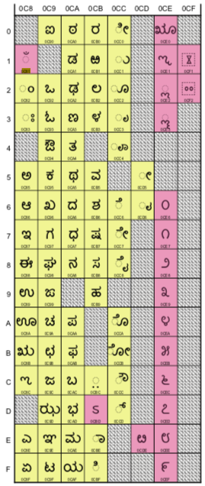  Figure 1: Kannada Code Page from [MSR] | Color convention:  All characters that are included in the [MSR] - Yellow background  PVALID in IDNA2008 but excluded from the [MSR] - Pinkish background  Not PVALID in IDNA2008, or are ineligible for the root zone (digits, hyphen) - White background

5.2 Code point repertoire

Given below is the repertoire for Kannada based on Unicode character set.
Sr. No. | Unicode Code Point | Glyph | Character Name | Indic Syllabic Category | Reference
1 | 0C82 | ಂ | KANNADA SIGN ANUSVARA | Anusvara | 110
2 | 0C83 | ಃ | KANNADA SIGN VISARGA | Visarga | 110
3 | 0C85 | ಅ | KANNADA LETTER A | Vowel | 110
4 | 0C86 | ಆ | KANNADA LETTER AA | Vowel | 110
5 | 0C87 | ಇ | KANNADA LETTER I | Vowel | 110
6 | 0C88 | ಈ | KANNADA LETTER II | Vowel | 110
7 | 0C89 | ಉ | KANNADA LETTER U | Vowel | 110
8 | 0C8A | ಊ | KANNADA LETTER UU | Vowel | 110
9 | 0C8B | ಋ | KANNADA LETTER VOCALIC R | Vowel | 110
10 | 0C8E | ಎ | KANNADA LETTER E | Vowel | 110
11 | 0C8F | ಏ | KANNADA LETTER EE | Vowel | 110
12 | 0C90 | ಐ | KANNADA LETTER AI | Vowel | 110
13 | 0C92 | ಒ | KANNADA LETTER O | Vowel | 110
14 | 0C93 | ಓ | KANNADA LETTER OO | Vowel | 110
15 | 0C94 | ಔ | KANNADA LETTER AU | Vowel | 110
16 | 0C95 | ಕ | KANNADA LETTER KA | Consonant | 110
17 | 0C96 | ಖ | KANNADA LETTER KHA | Consonant | 110
18 | 0C97 | ಗ | KANNADA LETTER GA | Consonant | 110
19 | 0C98 | ಘ | KANNADA LETTER GHA | Consonant | 110
20 | 0C99 | ಙ | KANNADA LETTER NGA | Consonant | 110
21 | 0C9A | ಚ | KANNADA LETTER CA | Consonant | 110
22 | 0C9B | ಛ | KANNADA LETTER CHA | Consonant | 110
23 | 0C9C | ಜ | KANNADA LETTER JA | Consonant | 110
24 | 0C9D | ಝ | KANNADA LETTER JHA | Consonant | 110
25 | 0C9E | ಞ | KANNADA LETTER NYA | Consonant | 110
26 | 0C9F | ಟ | KANNADA LETTER TTA | Consonant | 110
27 | 0CA0 | ಠ | KANNADA LETTER TTHA | Consonant | 110
28 | 0CA1 | ಡ | KANNADA LETTER DDA | Consonant | 110
29 | 0CA2 | ಢ | KANNADA LETTER DDHA | Consonant | 110
30 | 0CA3 | ಣ | KANNADA LETTER NNA | Consonant | 110
31 | 0CA4 | ತ | KANNADA LETTER TA | Consonant | 110
32 | 0CA5 | ಥ | KANNADA LETTER THA | Consonant | 110
33 | 0CA6 | ದ | KANNADA LETTER DA | Consonant | 110
34 | 0CA7 | ಧ | KANNADA LETTER DHA | Consonant | 110
35 | 0CA8 | ನ | KANNADA LETTER NA | Consonant | 110
36 | 0CAA | ಪ | KANNADA LETTER PA | Consonant | 110
37 | 0CAB | ಫ | KANNADA LETTER PHA | Consonant | 110
38 | 0CAC | ಬ | KANNADA LETTER BA | Consonant | 110
39 | 0CAD | ಭ | KANNADA LETTER BHA | Consonant | 110
40 | 0CAE | ಮ | KANNADA LETTER MA | Consonant | 110
41 | 0CAF | ಯ | KANNADA LETTER YA | Consonant | 110
42 | 0CB0 | ರ | KANNADA LETTER RA | Consonant | 110
43 | 0CB2 | ಲ | KANNADA LETTER LA | Consonant | 110
44 | 0CB3 | ಳ | KANNADA LETTER LLA | Consonant | 110
45 | 0CB5 | ವ | KANNADA LETTER VA | Consonant | 110
46 | 0CB6 | ಶ | KANNADA LETTER SHA | Consonant | 110
47 | 0CB7 | ಷ | KANNADA LETTER SSA | Consonant | 110
48 | 0CB8 | ಸ | KANNADA LETTER SA | Consonant | 110
49 | 0CB9 | ಹ | KANNADA LETTER HA | Consonant | 110
50 | 0CBE | ಾ | KANNADA VOWEL SIGN AA | Matra | 110
51 | 0CBF | ಿ | KANNADA VOWEL SIGN I | Matra | 110
52 | 0CC0 | ೀ | KANNADA VOWEL SIGN II | Matra | 110
53 | 0CC1 | ು | KANNADA VOWEL SIGN U | Matra | 110
54 | 0CC2 | ೂ | KANNADA VOWEL SIGN UU | Matra | 110
55 | 0CC3 | ೃ | KANNADA VOWEL SIGN VOCALIC R | Matra | 110
56 | 0CC6 | ೆ | KANNADA VOWEL SIGN E | Matra | 110
57 | 0CC7 | ೇ | KANNADA VOWEL SIGN EE | Matra | 110
58 | 0CC8 | ೈ | KANNADA VOWEL SIGN AI | Matra | 110
59 | 0CCA | ೊ | KANNADA VOWEL SIGN O | Matra | 110
60 | 0CCB | ೋ | KANNADA VOWEL SIGN OO | Matra | 110
61 | 0CCC | ೌ | KANNADA VOWEL SIGN AU | Matra | 110
62 | 0CCD | ್ | KANNADA SIGN VIRAMA | Halant / Virama | 110

Table3: Code point repertoire

5.2 Codepoints not included

Following code points have not been included in the repertoire.

Sr. No. | Unicode Code Point | Glyph | Character Name | Reason for exclusion
1. | 0C8C | ಌ | KANNADA LETTER VOCALIC L | Not used in Kannada
2. | 0CB1 | ಱ | KANNADA LETTER RRA | Obsolete character, not used in modern Kannada
3. | 0CBC | ಼ | KANNADA SIGN NUKTA | Does not belong to Kannada, not needed in LGR
4. | 0CC4 | ೄ | KANNADA VOWEL SIGN VOCALIC RR | Not used in Kannada
5. | 0CD5 | ೕ | KANNADA LENGTH MARK | Not in use
6. | 0CD6 | ೖ | KANNADA AI LENGTH MARK | Not in use
Table4: Code point not included

Variants

6.1 In-script variants
There are no variants within Kannada script.

6.2 Cross-script variants analysis
Some characters of Kannada look somewhat similar to some characters in Devanagari, Gujarati, Telugu, Malayalam and Sinhala. The tables below list them.

6.2.1 Cross-script variants for Kannada and Telugu analysis

Variant Set | Telugu Code Point | Kannada Code Point
1 | ం (0C02) | ಂ (0C82)
2 | ః (0C03) | ಃ (0C83)
3 | అ (0C05) | ಅ (0C85)
4 | ఆ (0C06 ) | ಆ (0C86)
5 | ఇ (0C07) | ಇ (0C87)
6 | ఈ (0C08) | ಈ (0C88)
7 | ఐ (0C10) | ಐ (0C90)
8 | ఒ (0C12) | ಒ (0C92)
9 | ఓ (0C13) | ಓ (0C93)
10 | ఔ (0C14) | ಔ (0C94)
11 | ఖ (0C16) | ಖ (0C96)
12 | గ (0C17) | ಗ (0C97)
13 | జ (0C1C) | ಜ (0C9C)
14 | ఝ (0C1D) | ಝ (0C9D)
15 | ఞ (0C1E) | ಞ (0C9E)
16 | ట (0C1F) | ಟ (0C9F)
17 | ఠ (0C20) | ಠ (0CA0)
18 | డ (0C21) | ಡ (0CA1)
19 | ఢ (0C22) | ಢ (0CA2)
20 | ణ (0C23) | ಣ (0CA3)
21 | థ (0C25) | ಥ (0CA5)
22 | ద (0C26) | ದ (0CA6)
23 | ధ (0C27) | ಧ (0CA7)
24 | న (0C28) | ನ (0CA8)
25 | బ (0C2C) | ಬ (0CAC)
26 | భ (0C2D) | ಭ (0CAD)
27 | మ (0C2E) | ಮ (0CAE)
28 | య (0C2F) | ಯ (0CAF)
29 | ర (0C30) | ರ (0CB0)
30 | ల (0C32) | ಲ (0CB2)
31 | ళ (0C33) | ಳ (0CB3)
32 | ి (0C3F) | ಿ (0CBF)
33 | ు (0C41) | ು (0CC1)
34 | ృ (0C43) | ೃ (0CC3)
Table5: Telugu and Kannada code point analysis

6.2.2 Cross-script variants for Kannada and Devanagari analysis
Devanagari Code Point | Kannada Code Point
ः (0903) | ಃ (0C83)
Table6: Devanagari and Kannada code point analysis

They are identical but as there are not enough other variant code points to form two labels with each script that look the same. Therefore, these are not defined as variant code points.

6.2.3 Cross-script variants for Kannada and Gujarati analysis
Gujarati Code Point | Kannada Code Point
ઃ (0A83) | ಃ (0C83)
Table7: Gujarati and Kannada code point analysis

They are identical but as there are not enough other variant code points to form two labels with each script that look the same. Therefore, these are not defined as variant code points.

6.2.4 Cross-script variants for Kannada and Malayalam analysis
Kannada Code Point | Malayalam Code Point
ಂ (0C82) | ം (0D02)
ಃ (0C83) | ഃ (0D03)
Table8: Kannada and Malayalam code point analysis

They are identical but as there are not enough other variant codes point to form two labels with each script that look the same. Therefore, these are not defined as variant code points.

6.2.5 Cross-script variants for Kannada and Sinhala analysis
Variant Set | Kannada Code Point | Sinhala Code Point
1 | ಂ (0C82) | ං (0D82)
2 | ಃ (0C83) | ඃ (0D83)
3 | ರ (0CB0) | ර(0DBB)
Table9: Kannada and Sinhala code point analysis

0C82-0D82 and 0C83-0D83 are identical. The NBGP discussions decided 0CB0 and 0DBB are distinguishable. Therefore, there are not enough other variant codes point to form two labels with each script that look the same. Therefore, these are not defined as variant code points.

Whole Label Evaluation Rules (WLE)

The structure of written Kannada is provided in section 3.4.

Variables or definitions -
V → Vowel
M → Matra
C → Consonant
H → Halant / Virama
B → Anusvara
X → Visarga
Rules for forming akshar or a cluster of one unit -
- Rule 1: H must be preceded by C
- Rule 2: M must be preceded by C
- Rule 3: B must be preceded by C, V or M
- Rule 4: X must be preceded by C, V or M

Contributors
1. Dr. U.B. Pavanaja, pavanaja@vishvakannada.com
2. Dhanalakshmi K.T., lakshmikt96@gmail.com
3. Tejas Jain, teju2friends@gmail.com
4. NBGP Members

References
101. A Comparative Grammar of the Dravidian or South Indian Family of Languages by Robert Caldwell, Trubner & Co, London, Second Edition, 1875
102. Evolution of Kannada script - https://karnatakaitihasaacademy.org/karnataka-history/evolution-of-kannada-script/
103. History of the Kannada Script and Language - https://bookstalkist.com/history-of-the-kannada-script-and-language/
104. History of the Kannada Literature - http://kamat.com/kalranga/kar/literature/history1.htm
105. Kannada alphabet - https://en.wikipedia.org/wiki/Kannada_alphabet
106. About Kannada language - https://en.wikipedia.org/wiki/Kannada
107. Ethnologue entry about Kannada - http://www.ethnologue.com/19/language/kan/
108. OLAC resources in and about the Kannada language - http://www.language-archives.org/language/kan
109. Encyclopaedia Britannica entry about Kannada - https://www.britannica.com/topic/Kannada-language
110. ಕನ್ನಡ ಮಧ್ಯಮ ವ್ಯಾಕರಣ, ತೀ.ನಂ. ಶ್ರೀಕಂಠಯ್ಯ, ಗೀತಾ ಬುಕ್ ಹೌಸ್, ಮೈಸೂರು, ೨೦೦೧ (Kannada Madhyama Vyakarana (means An Intermediate Kannada Grammar), T. N. Sreekantaiya, Geetha Book House, Mysore, 2001.)

Appendix I : Confusable Kannada and Telugu Analysis
Some code points for Kannada and Telugu script were discussed and the NBGP concluded that there is no confusable code point. Table below lists all discussed code points and its resolution.

Ser. No. | Kannada Character | Unicode codepoint | Telugu character | Unicode codepoint | NBGP Resolution
1 | ಎ | 0C8E | ఎ | 0C0E | Distinguishable
2 | ಘ | 0C98 | ఘ | 0C18 | Distinguishable
3 | ಙ | 0C99 | ఙ | 0C19 | Distinguishable
4 | ಚ | 0C9A | చ | 0C1A | Distinguishable
5 | ಛ | 0C9B | ఛ | 0C1B | Distinguishable
6 | ಪ | 0CAA | ప | 0C2A | Distinguishable
7 | ಫ | 0CAB | ఫ | 0C2B | Distinguishable
8 | ವ | 0CB5 | వ | 0C35 | similar
9 | ಶ | 0CB6 | శ | 0C36 | similar
110 | ಷ | 0CB7 | ష | 0C37 | Distinguishable
11 | ಸ | 0CB8 | స | 0C38 | similar
12 | ೌ | 0CCC | ౌ | 0C4C | Distinguishable
Table10: NBGP resolution of Telugu and Kannada code points

Appendix II : Zero Width Joiner and Zero Width Non Joiner in Kannada domain names

Zero Width Joiner (ZWJ) and Zero Width Non Joiner (ZWNJ) have special roles in Kannada. ZWNJ is used in sequences like Consonant (C) + Halant (U+0CCD) + Consonant kind where the second C should not take the vattu form after (below) the first consonant.

Example:
1.ಜ (U+0C9C) + ್ + (U+0CCD) + ಕ (U+0C95) = ಜ್ಕ – without using ZWNJ
2. ಜ (U+0C9C) + ್ + (U+0CCD) + ZWNJ (U+200C) + ಕ (U+0C95) = ಜ್‌ಕ – using ZWNJ

Example of the word not using ZWNJ – ರಾಜ್ಕುಮಾರ್ (Rajkumar)
Example of word using ZWNJ – ರಾಜ್‌ಕುಮಾರ್ (Rajkumar)

Both words mean the same. But their pronunciations are slightly different. The second form does not originally belong to Kannada, but nowadays due to the influence of English and Hindi, some people are using the form. But this form is needed to write many English words in Kannada like software (ಸಾಫ್ಟ್‌ವೇರ್, using ZWNJ). The word software will become ಸಾಫ್ಟ್ವೇರ್ if ZWNJ is not used.

ZWJ has a unique purpose in Kannada where conjuncts are formed with consonants where the first consonant is ರ (Ra) (U+0CB0). When conjunct is formed with Ra + Halant + <consonant>, the default form is second <consonant> followed by arkavattu, which is Kannada equivalent of the reph of Devanagari.

Example: ರ (U+0CB0) + ್ (U+0CCD) + ಕ (U+0C95) = ರ್ಕ

Original Kannada did not have this arkavattu or reph. It was like any other C1+ Halant + C2 where the C2 takes the vattu form, even when C1 = ರ (Ra). To get the vattu form for ರ + Halant + <consonant>, ZWJ is used.

Example:
ರ (U+0CB0) + ್ (U+0CCD) + ZWJ (U+200D) + ಕ (U+0C95) = ರ್‍ಕ –Microsoft’s implementation
ರ (U+0CB0) + ZWJ (U+200D) + ್ (U+0CCD) + ಕ (U+0C95) = ರ್‍ಕ – as per Unicode’s definition. Browsers Firefox and Chrome use this rendering rule.

The original Kannada form (not using arkavattu or reph) is needed when the first letter of the word itself is ರ (Ra, U+0CB0) followed by Halant and a consonant.
Example- ರ (U+0CB0) + Halant (U+0CCD) + ಯ (U+0CAF) = ರ್ಯ as in ರ್ಯಾಲಿ (rally written in Kannada). This is wrong as per the writing style followed in Kannada. Here the second consonant ಯ (Ya, U+0CAF) must take the vattu form. To get that one must use ZWJ as explained above. Correct form of rally written in Kannada will be ರ್‍ಯಾಲಿ making use of ZWJ. One such word I can think of will be the company Rallis India. When they go for registering domain name in Kannada, if ZWJ is not allowed in domain name, they will have to go for ರ್ಯಾಲೀಸ್.ಭಾರತ, which is the wrong form in Kannada. They should write it as ರ್‍ಯಾಲೀಸ್.ಭಾರತ by making use of ZWJ.

Thus both ZWJ and ZWNJ are needed for having proper domain names in Kannada.

How to avoid duplicate domain names involving ZWJ and ZWNJ?

ZWJ and ZWNJ are used mainly to have two display forms of linguistically same word or combination of characters in Kannada. When ZWJ and ZWNJs are allowed in domain names for Kannada, it will create two domain names which have two display forms but linguistically they are same. To make the browsers and DNSs to treat them as equal, we have to ignore ZWJ and ZWNJs for comparing two words. This methodology is followed by the spell-check used in Microsoft Word. Same philosophy can be applied here also.

Accepting this as part of the IDN protocol may create a perceptual difference between the two labels (with and without H) but creates confusion to a majority of the linguistic community, hence this is explicitly prohibited by the NBGP. In future if required, depending on the prevailing requirements by the community, the future NBGP may consider revisiting this rule.

This document needs to be printed in color for this to be read correctly.

