Response of IP to Tamil Draft LGR of 2018-08-31
DATE: 2018-09-12

Overview
This document provides IP response to the Tamil LGR proposal dated 2018-08-31.
Since further changes recommended by the IP are minimal, the LGR appears ready for public comment after incorporating the suggestions.

General Comments
Item | Issue | IP Comment | Finalized Document
 | A marked-up copy of the DOCx file is attached, with minimal changes in punctuation, and one typographical error. | Please review and make any further changes as appropriate | Reviewed and Finalized
§5 | Please list all sequences of Tamil code points defined for use in variants and/or WLE as part of Section 5 (in addition to discussing them in section 6).  For a possible example, see the Malayalam LGR:  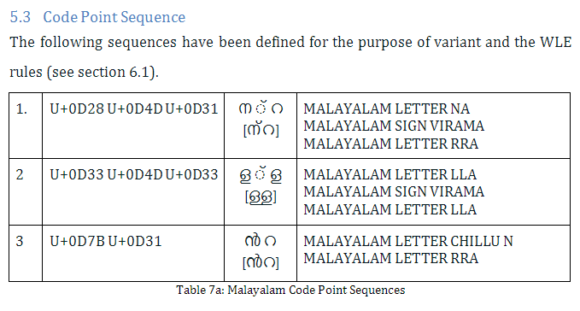 | Please add the requested information. | Added section 5.2.1
references | The reference to MSR needs to be updated to MSR-3 | Please fix | Fixed

Whole Label Evaluation Rules
Item | Issue | IP Comment
 | no issue

XML document
Item | Issue | IP Comment | Finalized XML
comments | Some code points / variants could benefit from additional comments  Suggest to mark the SHRII / SRII as “alternate sequence” in the comments | Please add | Adopted IP version, no further changes.
references | Reference 1003 should be “Tamil Sign Visarga” and it should actually be referenced from code point U+0B83 | Please fix
 | An edited copy of the XML file has been attached, containing the suggestions by the IP. | Please review and make further changes as appropriate

Test files
Item | Issue | IP Comment
 | No issues

