梁海 Liang Hai lianghai at gmail.com (https://lianghai.github.io)
Mon Oct 8 10:38: 03 UTC 2018
Comments: 2, “oḍiā”: Not an accurate transliteration as it doesn’t distinguish ଓଡିଆ and ଓଡ଼ିଆ.
Answer:
The above ‘oḍiā’transliteration has been extensively used in many articles (see reference 2.1, 2.2, 2.3). We had thus followed it. But, as you say, it requires to distinguish ଓଡିଆ and ଓଡ଼ିଆ, for which we can use ISO 15919 system and transliterate as ‘oṛiā’.
Here onwards for lossless transliteration of all Oriya words we will follow ISO 15919 system.

Reference:
2.1 https://trove.nla.gov.au/work/32072148?q&versionId=38952581
2.2 https://search.library.wisc.edu/catalog/999675412802121
2.3 http://www.worldcat.org/title/odia-upanyasa-sahityara-paricaya/oclc/30912921
2.4 http://www.worldcat.org/title/odia-padya-mahakabyara-kramabikasa/oclc/20062769

- 3, “known in Unicode as Oriya”: It’s known also as “Oriya” everywhere.
Answer:
Previously the spelling was Oriya; was changed to ‘Odia’ after recommendation of govt in September, 2011 and subsequent amendment by constitution. To avoid the confusion, in our whole oriya LGR proposal, ‘Odia’ is written along with ‘Oriya’ within parenthesis.

Reference:
https://www.corporate-cases.com/2018/04/orissa-to-odisha-oriya-to-odia-name-change.html
The Orissa (Alteration of Name) Bill and the Constitution (113th) Amendment Bill were unanimously passed by the 301 members present in the lok sabha house. https://www.hindustantimes.com/delhi-news/constitution-amended-orissa-is-odisha-oriya-is-odia/story-ueHHnEL8pOLbup8JuT1UOP.html

- 3, “Oriya script seems to be a variant of Devanāgarī … mahājani (trader's) script.”: Seriously? Is this copied from the Gujarati proposal? Odia doesn’t seem to be a variant of Devanagari to anyone who knows the existence of the Bangla script.

Answer:
The word ‘variant’ was used to indicate that both Oriya script and Devanagari script are of Brahmic origin and diverged at certain point in due course of evolution. But if according to you confusion still persists about the word ‘variant’, it can be dropped. The terms Mahajani(trader's) etc are not copied from Gujarati but based on the well known maritime history of Orissa. The origin and history of any script and language are variously theorized, interpreted by various authors. This creates controversy which has no relevance in our current LGR proposal, thus it’s better to omit such historical words and phrases.
In summary : the word variant and topics related to historical aspects have been removed from the LGR document.

Reference:

- 3.1, “The diagram below shows the major stages in the evolution of Oriya attesting its late divergence from Devanāgarī.”: Are the authors trying to ignore/deny Odia’s relationship with Bangla?

Answer:
The given diagram clearly depicts Oriya and Bengali together. We have never ignored/denied Oriya’s relationship with Bengali and the allegation is false. TLD proposal is about our domain generation and has nothing to do with its relation with Bengali. So, this part has not been discussed in the proposal. .
On one hand you are asking us to write Oriya and not Odia, but you yourself spell Bangla instead of Bengali and Odia instead of Oriya.

In conclusion : Your current allegation about Bengali is false and thus not accepted.

Reference:

- 3.4: Why the IPA of ଯ is missing? The whole set of IPA transcriptions is apparently inaccurate as it doesn’t reflect even some of the Odia language’s typical features (eg, the rounded schwa). Actually the proposal doesn’t need IPA transcriptions for every letter because it’s text encoding being discussed. Lossless transliterations are much more useful. The whole Table 1 can be removed.

Answer:
Reference:
You have rightly pointed out the missing ‘ଯ’.
Schwa (ə/ଅ) has been described as the first vowel. In Oriya it is always unrounded. Thus description of rounded schwa is irrelevant in Oriya.
IPA transcription is required so that the non-Oriyas can also comprehend the phonemic and allophonic nature of a particular character. Lossless transliteration is also required for which we are following ISO 15919 system.

In conclusion : The missing IPA of ‘ଯ’has been included but rounded schwa is not mentioned.

- 3.6: Authors are not using accurate transliterations.
Answer:
The transliterations had been according to the system widely used in Orissa. However, if non-oriyas find it confusing, then for them in the revised document we will follow the ISO 15919 system to transliterate all the Oriya words.
In conclusion : You are repeating the same transliteration comment, and we have already mentioned about ISO 15919 system.

Reference:

- 3.7, “Half form of consonants (pre-base form)”: Pre-base forms don’t seem relevant to Odia discussions.
Answer:

In Oriya, consonant clusters are written in many ways :
- in most cases the second component is in half form (without the rounded top) or reduced form and put under the first component e.g. ସ୍କ,ସ୍ତ, ବ୍ଧ,
- Sometimes the reverse case happens and the first component (esp. when it is ତ) is reduced and is put below the second as in ତ୍ସ, ତ୍ମ, ତ୍କ ତ୍ପ
- Pre-base forms are also seen in ବ୍ଦ ଦ୍ଭ, but due to cursive writing the prebase components seem to be like new glyphs.

In conclusion : pre-base forms do occur in certain cases in Oriya orthography. But other forms are also there which will be addressed.

Reference:

- 3.8, “… to show that words having these consonants with a nukta are to be pronounced in the Perso-Arabic style.”: Inaccurate. At least the usage of nukta on dda and ddha is not related to Perso-Arabic words.

Answer:
Oriya script is derived from Brahmi and thus has the essential Brahmic orthographic features. But sometimes we use certain indigenous as well as loan nonbrahmic characters which can be written by using Brahmic character with a nukta as required below :

- For indigenous words : Oriya has certain indigenous sounds like the alveolar flap allophones of "ଡ" and "ଢ” which are positional allophones and depend on whether located on the first position or not. When ‘ଡ’ and its aspirated form ‘ଢ’ are in the first position of a word it is pronounced as retroflex. But if the position of ‘ଡ’/‘ଢ’ is not first in a word, then it is pronounced by flapping tongue from retroflex to alveolar ridge. For such flapping positional allophonic variants, a nukta is used for 'ଡ଼' and 'ଢ଼' respectively. Their allophonic nature is evidenced by the analysis of minimum pairs e.g. 'ବଡ଼' and 'ବଡ' have the same meaning i.e. 'big', 'ଜାଡ଼' and 'ଜାଡ' have the same meaning i.e. 'cold', ବୁଢ଼ା and ବୁଢା have same meaning i.e. ‘old man’. In fact the flapping does not occur even in second position of a word in Ganjamia and Koraputia dialects of Oriya. Nukta for 'ଡ଼' and 'ଢ଼' is frequently used in Oriya.
- For words of nonindic tribal origin :
Nukta has been used for 'ଚ' for words like ଚ଼ା / Chaa (Sino-Tibetan origin), ଚ଼ାଉଳ (probably Austroasiatic origin), ଚ଼ୁଇଁ (probably Dravian origin) which is/are not exactly ‘ଚ’ but its allophonic variant(s), represented as ଚ଼ with a Nukta. Use of nukta for ‘ଚ’ once common is now ignored by many.
- For Arabic and Persian words :
Nukta may be pronounced in Perso-Arabic style for certain words of Arabic and Parsi origin by certain communities only. But this is not universal and so not significant.

Reference:

- 3.10, “/ãala/”: Either use a phonetic transcription (then the first syllable’s vowel is probably not /a/ and the consonant is not /l/), or use transliteration: am̐ḷā. It’s not helpful and is only confusing if an inaccurate transcription/transliteration is provide. Drop it or correct it.

- 3.11: Rendering failure of the second example (saṁkhyā).

Answer:
You are repeating the same transliteration comment, and we have already mentioned about ISO 15919 system that will be followed for all transliteration in LGR Oriya proposal.

Reference:
A figure depicted in State museum, Orissa reveals evolution of Oriya script:
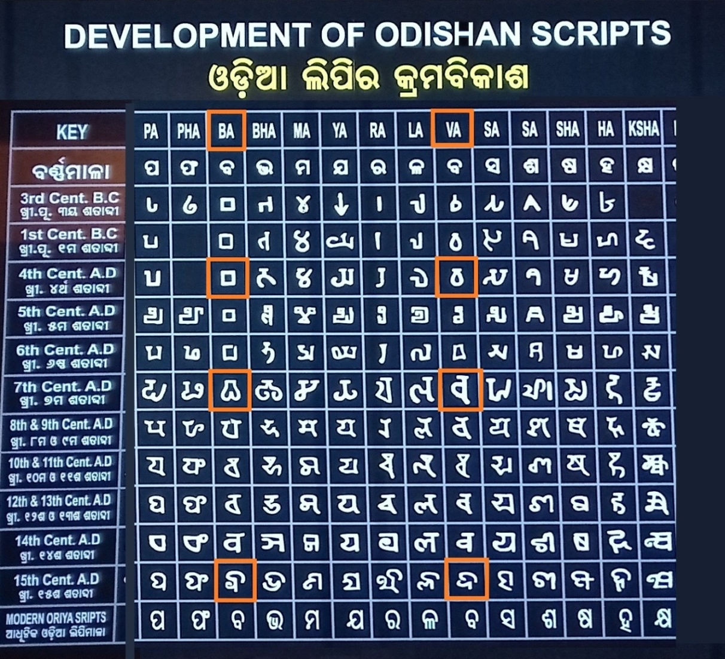
The above figure reveals that the bilabial 'Ba' and dentolabial 'Va' were treated separately as distinct characters until 15th century. However Wa is conspicuously absent in this depiction.

There are several instances of ancient Oriya literature where the verses are written in alphabetical order from 'ଅ' to 'କ୍ଷ'. These two characters have been described separately, one in bilabial plosive sequence after. 'pha' ଫ and other in nonplosive sequence after 'la' ଲ . There are numerous such writings few have been illustrated below.
Kishore Chandrananda Champu :
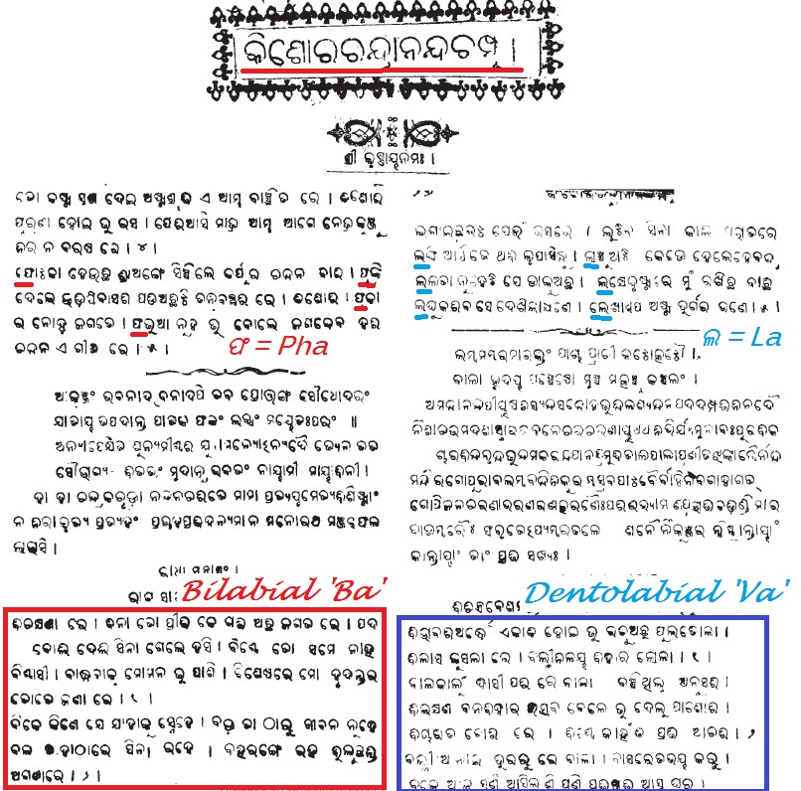

NiLakaNTha ChautisA in 1903
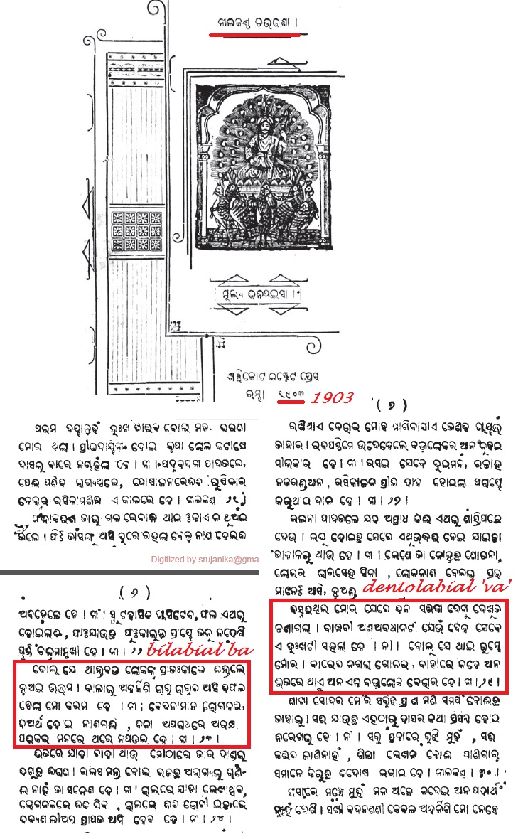

Champu in 1905
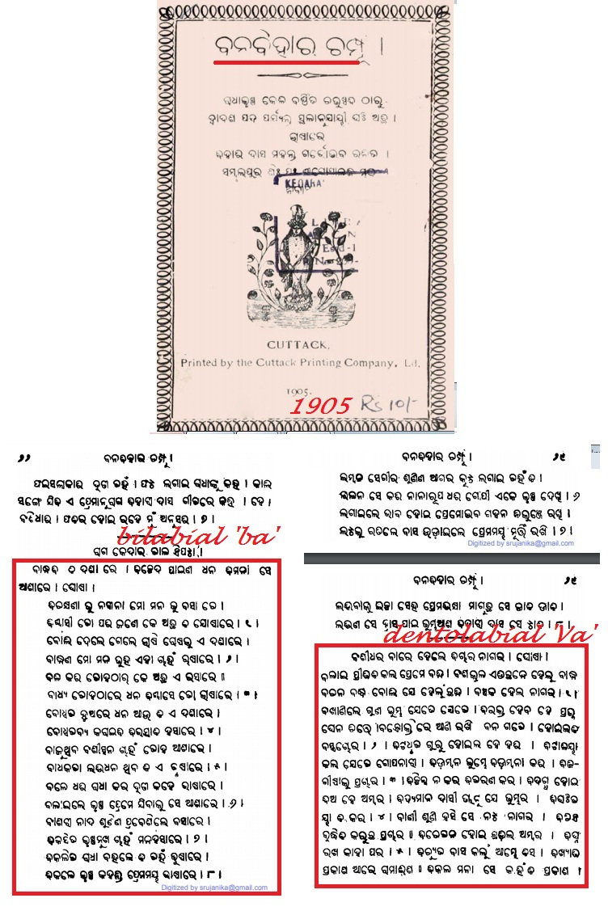
Jagannatha chautisa in 1912
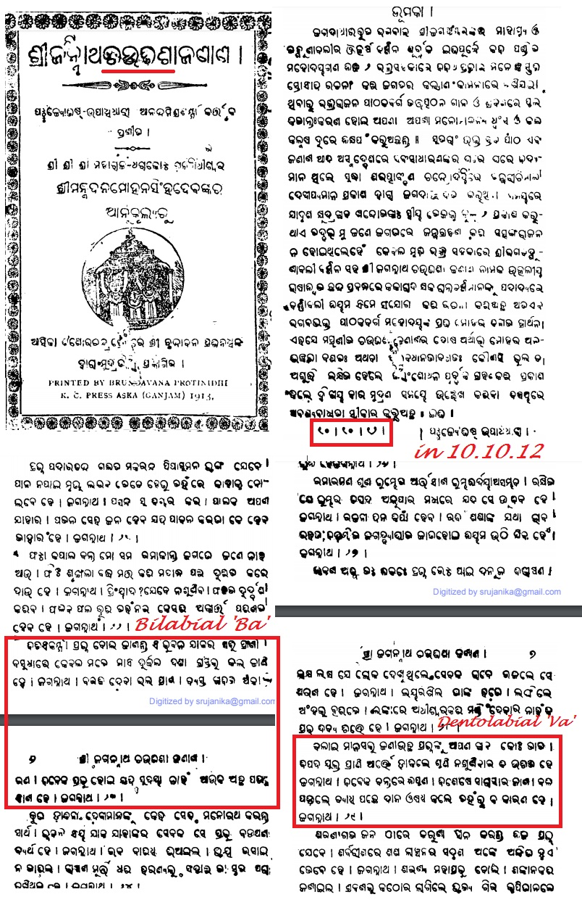
BhUpati Chautisa in 1929
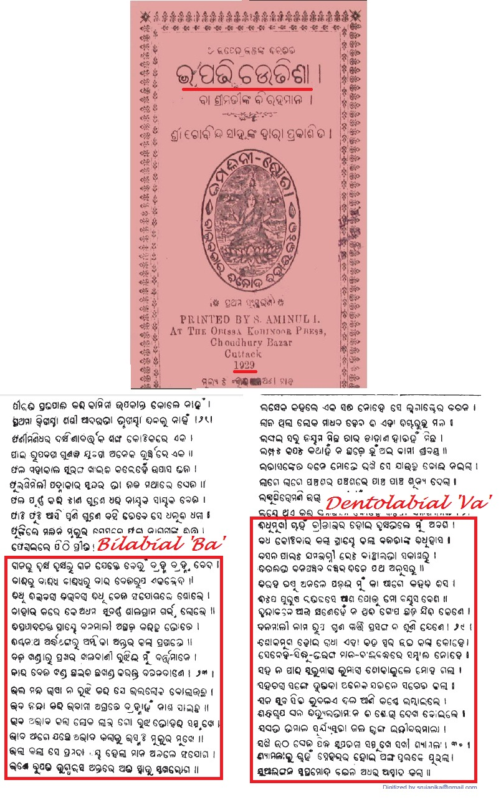
Chautisa madhuchakra in 1931
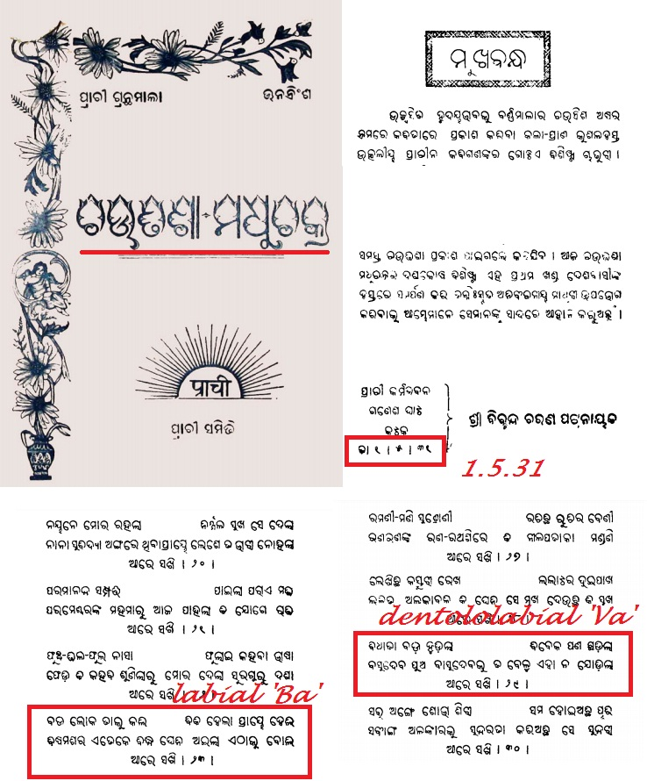

Prof Sarat Jena has given the following information :
I am Dr Sarat kumar Jena, Asst. Professor, Department of Odia, Santiniketan belong to the Ganjam district located in south Orissa where I have spent my school and college days. Now i am also a man of Berhampur, south odisha. The bilabial Ba ବ and dentolabial Va “ଵ” (U+0B35) are properly and distinctly pronounced by the native speakers in south Orissa and may be in some other parts of Orissa also. In our place, we say karivA କରିଵା, dekhivA ଦେଖି ଵା, Karivu କରିଵୁ, dekhivu ki ଦେଖିଵୁ, galAvele ଗଲାଵେଳେ, sadAveLe ସଦାଵେଳେ, Bhadrava ଭାଦ୍ରଵ etc. The nonavailability of a ‘va’ character in printing press, lead to its unfortunate substitution by ‘Ba’ in books. This has created much confusion. There are many colloquial terms, tasama , tatbhava, terms as well as English terms where Va is conspicuous.
Being a professor in Oriya I have experienced, that our students get confused when Ba is used for Va. We have no right to remove a character va (“ଵ” (U+0B35)) which is present in the colloquial accent of a language and then teach our students the wrong pronunciation and spellings e.g. English letter 'V' is taught in Oriya schools as 'Bhi'. Students are forced to write their native language incorrectly as well as are taught English incorrectly like vision is taught as Bhijan, tv as tibhi, voda as Bhoda, video as Bhideo, volume as Bholume etc. Similarly they fail to spell their names correctly in English e.g. Bharati becomes Varati, Bhola as Vola etc.
The Va character once an integral part of Oriya orthography and conspicuous in ancient Oriya literatures, was suddenly missing in printing press and books. This has reappeared in Unicode and it is high time to use it.

In Orissa, Oriya script is also written for the tribal languages where Va is there. It is also used for write Sanskrit the online dictionary of which maintains the difference between the two characters as shown below. The word Buddhadeva has both bilabial ‘Ba’ / ‘ବ’ and dentolabial ‘Va’ / “ଵ” (U+0B35).
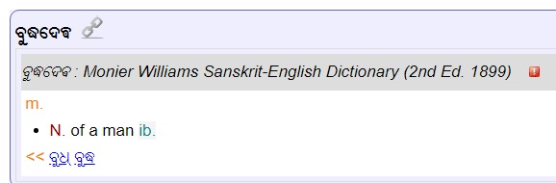
Few more instances :
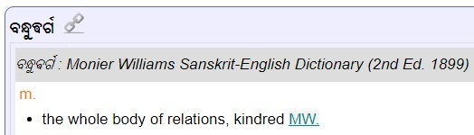

When Va character has already in use online, it will be soon available for printing also.

- 3.12, Table 3: Clean up the duplicated dotted circles. Why is vocalic rr excluded but vocalic l adn vocalic ll are included? Be consistent with the discussions in later sections.

Answer:
Few dotted circles are duplicated and will be cleaned.
Just below the given table 3, we have clearly mentioned that “ଌ”U+0B0C, “ୡ”U+0B61, “◌ୢ”U+0B62 and ”◌ୣ”U+0B63are hardly in use in modern days. Thus these may be excluded.

Reference:

- 5.2 and 5.2.1: Doesn’t U+0B35 ORIYA LETTER VA fall into “4.1.2.4 No Rare and Obsolete Characters“? Why is U+0B57 ORIYA AU LENGTH MARK excluded but U+0B56 ORIYA AI LENGTH MARK is included?

Answer:
There are lithographic as well as manuscriptal evidences of use of 'Va' character in Oriya for centuries since ancient times to mid 20th century. Then came the era of letterpress, whereby the technical difficulties could not maintain the distinction between ‘Ba’ ବ and ‘Va’ “ଵ” (U+0B35) in printed books leading to the substitution of ‘Va’ by ‘Ba’. Oriya ‘Va’ is not vanished as it is prevalent and well marked in spoken Oriya in different parts of Orissa. In the current age of computers clearly differentiable ‘Va’ is available with Oriya Unicode.

Thus the Va which was in written manuscripts for centuries disappeared from books for few decades only and now back in the age of computers. Thus it is not an obsolete character.

Oriya script is not only used for writing Oriya language but also for writing tribal languages of 62 tribes constituting more than 22 percent of total population. In their language also ‘Va’ is conspicuous. So we can not regard it as obsolete in Orissa.
There are numerous tatsama and English words assimilated into Oriya vocabulary where ‘Va’ is essential. So it is not obsolete.

Reference:

- 6.1, “… there are no characters/character sequences which can be created by using the Oriya characters permitted as per the [MSR] and look identical.”: **FALSE**. Odia has a seriously problem of confusables because of multiple ways of encoding the signs of ba and ya. Many fonts (eg, Nirmala UI) allow both <virama, U+0B2F ya> and <virama, U+0B5F yya> to form the post-base form of ya; and allow all of <virama, U+0B2C ba>, <virama, U+0B35 va>, and <virama, U+0B71 wa> to form the blow-base forms of ba. To the very least, this is the problem the propasal should’ve captured, and the NBGP failed. And these variants probably need to be proposed as “allocatable”. Also, Odia does have other natural (not because of technical issues like the problem aforementioned) ambiguities that need to be addressed (note many of them are stylistic and depend on what font is used to render text), see [https://en.wikipedia.org/wiki/Odia_alphabet#Ambiguities](https://en.wikipedia.org/wiki/Odia_alphabet#Ambiguities)

Answer:
In Oriya no two characters, character sequences and their clusters are exactly alike and hence it is not at all confusing for Oriya people to read or write. However the beginners might find it difficult to learn. In certain consonant clusters, a part of the glyph may look alike but pronunciation differs which however can easily be differentiated from other part of the glyph; hence, it does not lead to confusion. The differences found in different fonts and UIs are only technical errors, but such errors are not found with Unicode which is followed by NBGP. Ambiguities are found in all scripts of all languages, but the users are comfortable with it, we cannot change the script.

Reference:

- 7: For other reviewers’ reference: `C[N][M][B|D|X] | V[B|D|X] | C[N]H`
Answer:
Please elaborate

Reference:

