Subhashish Panigrahi psubhashish@gmail.com Mon Oct 8 13:18:50 UTC 2018

Odia/Oriya:

Largely agree with Liang. Additionally, it feels like a majority portion of the content is lifted from Wikipedia without correcting anything based on verification. Liang has already flagged the Gujarati part. It is weird to see that researchers are referring to Wikipedia rather than referring to primary and secondary sources. Wikipedia itself refers to tertiary and above sources and at times contains factual inconsistencies.

Answer:
We agree with you that Wikipedia is not a standard reference and hence wherever cited as a reference it has been replaced.

Reference:

3.4:
It is important to note that "ଵ" (U+0B35) is a burrowed character from Sanskrit that was inserted in the Unicode chart. Apart from any alleged publications that might have been created by the authors, the character has not seen the day of light in any authentic source (e.g. news publication by noted publication houses, text books, other published books from noted publishers, etc.). What is the point in pushing the agenda of a few people that is not largely accepted by the community.

Answer:
Sanskrit does not have a character looking like Oriya "“ଵ” (U+0B35)" for ‘va’. Had it been borrowed from Sanskrit, it would look like ‘व’for ‘va’.

There is no reason to assume that ‘Va’ is borrowed from Sanskrit , because it also occurs in so many languages in and near such as Tamil, Telugu, Malayalam, Kannada, Marathi, Hindi, English, tribal languages (of Orissa)like Kui, Kuvi, Santhali, Ho, in the rural colloquial Oriya accent such as 'KeteveLe'(when), ‘Dekhiva’(let’s see), BhAdhrava, various names of places (of Orissa) like Navarangpur (distorted as Nabarangpur), Devagarh (distorted as Deogarh), Kokalva (distorted as Kokalba), Devabhuin (distorted as Deobhuin) etc (note that even after distortion of these spellings by removal of va from the spellings the local people pronounce these names correctly). When ‘Va’ character does exist in colloquial accent of Oriya people in different parts of Orissa (especially the Southern districts) and in tribal languages of tribes who constitute more than 22 percent of total population of Orissa it is foolishness to assume that the character is borrowed from Sanskrit.

Reference:

A figure depicted in State museum, Orissa reveals evolution of Oriya script:
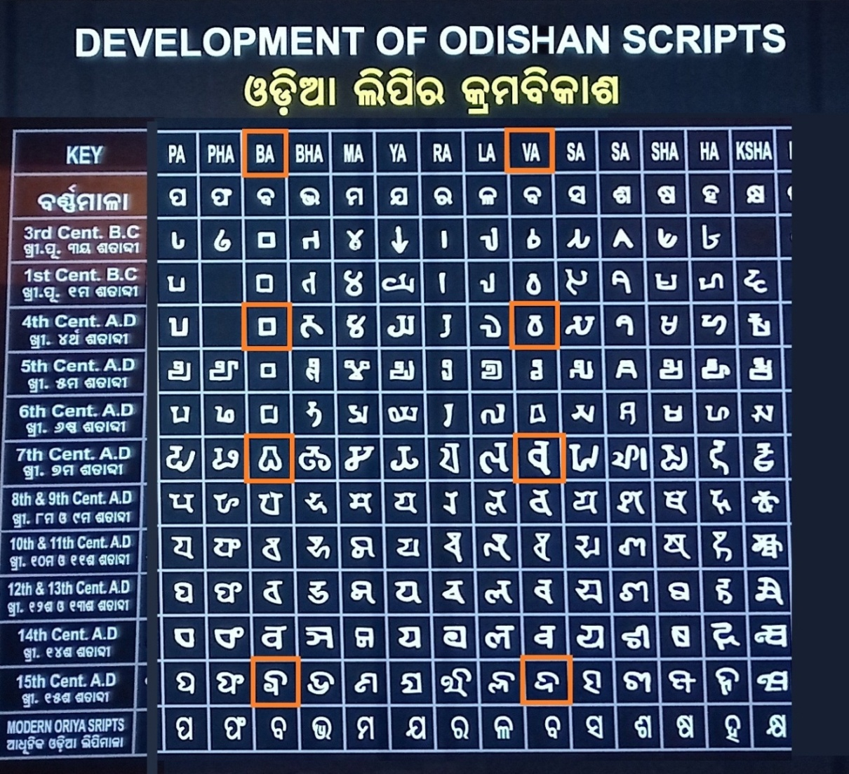
The above figure reveals that the bilabial 'Ba' and dentolabial 'Va' were treated separately as distinct characters until 15th century. However Wa is conspicuously absent in this depiction.

There are several instances of ancient Oriya literature where the verses are written in alphabetical order from 'ଅ' to 'କ୍ଷ'. These two characters have been described separately, one in bilabial plosive sequence after. 'pha' ଫ and other in nonplosive sequence after 'la' ଲ . There are numerous such writings few have been illustrated below.

Kishore Chandrananda Champu :
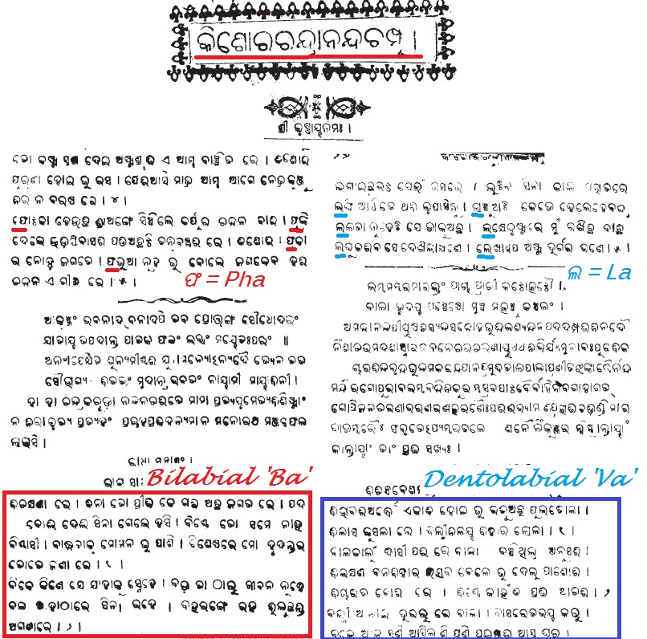

NiLakaNTha ChautisA in 1903
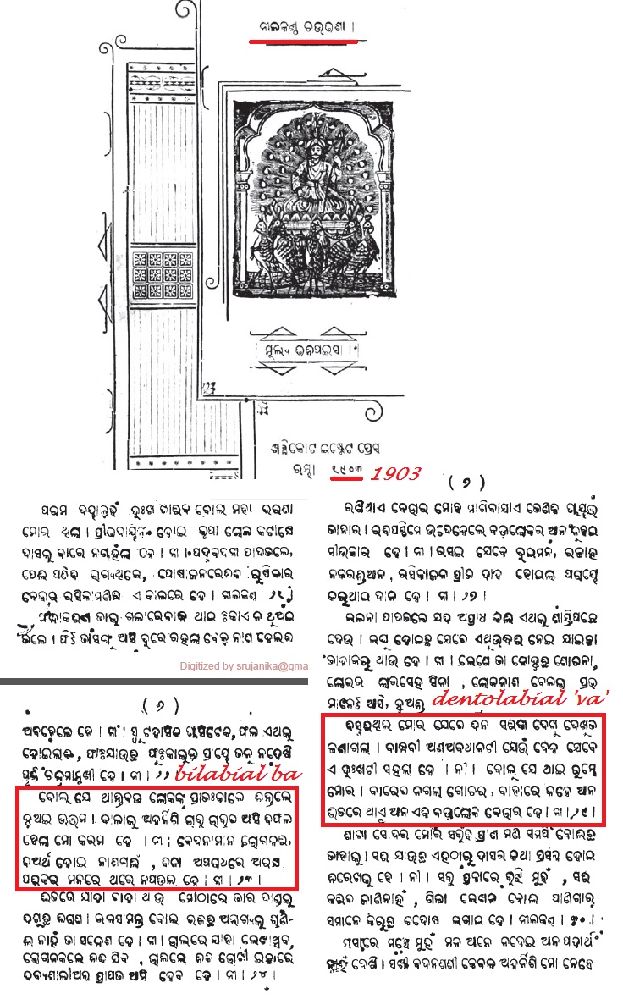

Champu in 1905
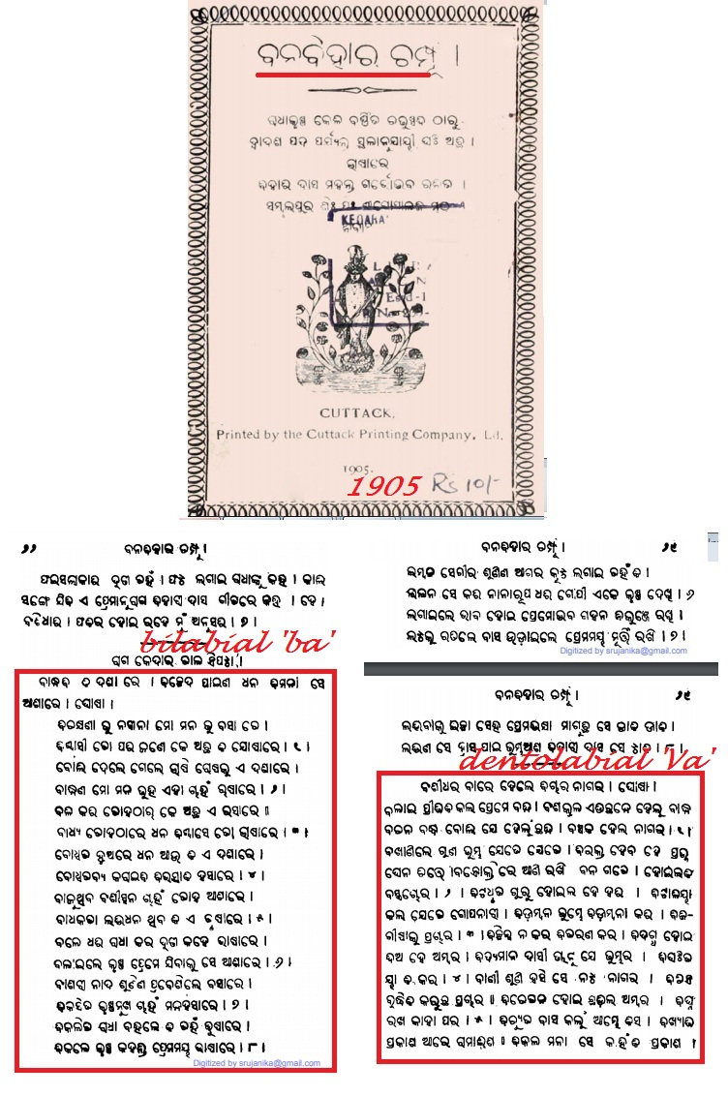
Jagannatha chautisa in 1912
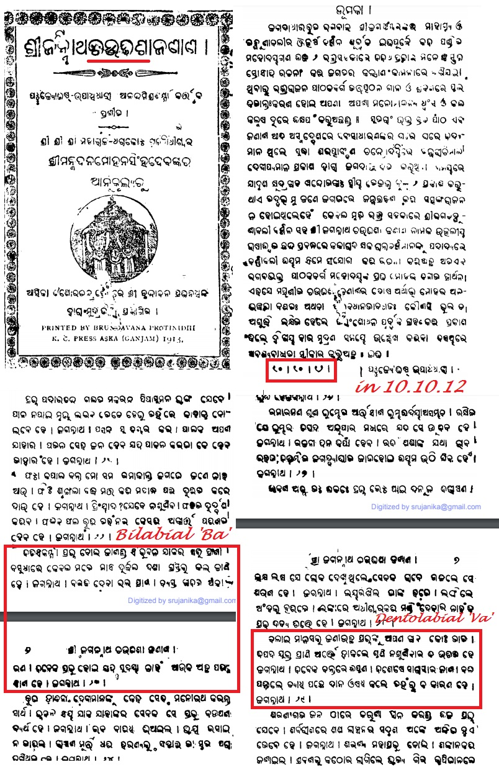
BhUpati Chautisa in 1929
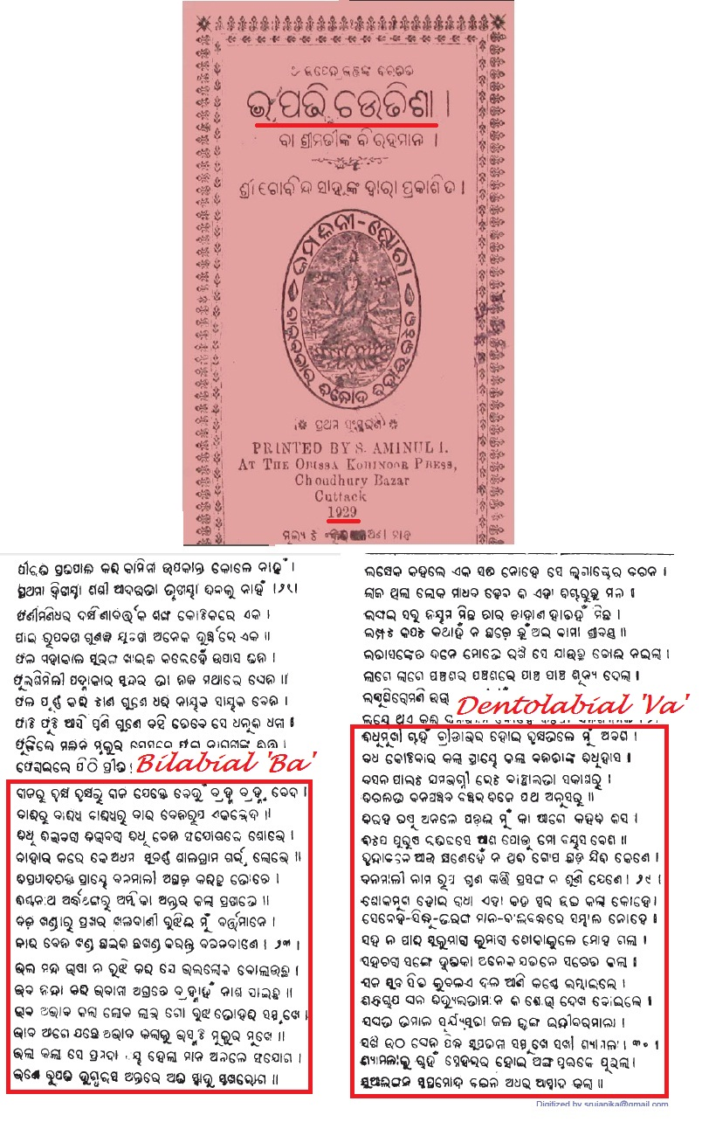
Chautisa madhuchakra in 1931
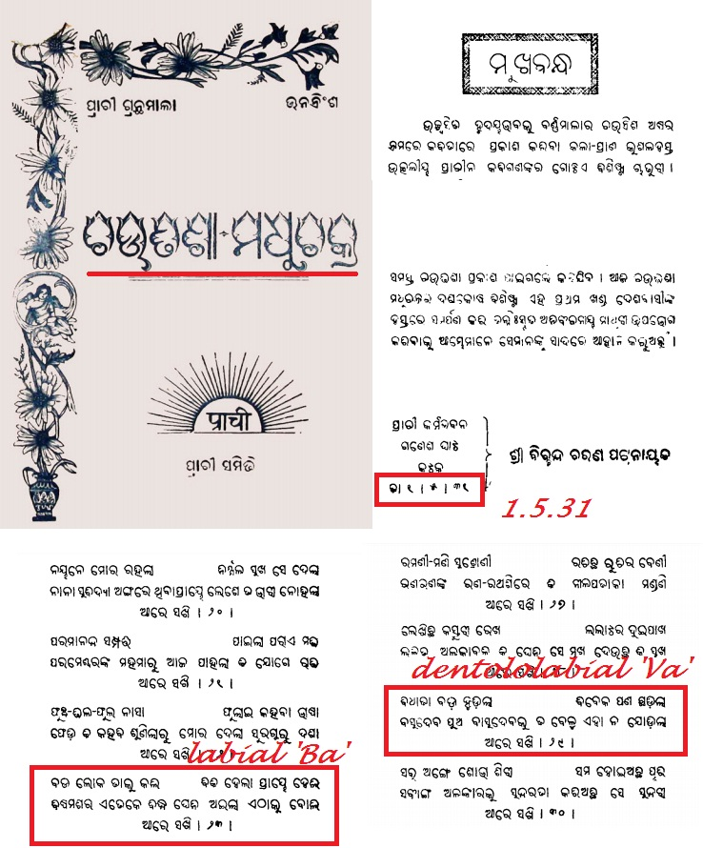

Prof Sarat Jena has given the following information :
I am Dr Sarat kumar Jena, Asst. Professor, Department of Odia, Santiniketan belong to the Ganjam district located in south Orissa where I have spent my school and college days. Now i am also a man of Berhampur, south odisha. The bilabial Ba ବ and dentolabial Va “ଵ” (U+0B35) are properly and distinctly pronounced by the native speakers in south Orissa and may be in some other parts of Orissa also. In our place, we say karivA କରିଵା, dekhivA ଦେଖି ଵା, Karivu କରିଵୁ, dekhivu ki ଦେଖିଵୁ, galAvele ଗଲାଵେଳେ, sadAveLe ସଦାଵେଳେ, Bhadrava ଭାଦ୍ରଵ etc. The nonavailability of a ‘va’ character in printing press, lead to its unfortunate substitution by ‘Ba’ in books. This has created much confusion. There are many colloquial terms, tasama , tatbhava, terms as well as English terms where Va is conspicuous.
Being a professor in Oriya I have experienced, that our students get confused when Ba is used for Va. We have no right to remove a character va (“ଵ” (U+0B35)) which is present in the colloquial accent of a language and then teach our students the wrong pronunciation and spellings e.g. English letter 'V' is taught in Oriya schools as 'Bhi'. Students are forced to write their native language incorrectly as well as are taught English incorrectly like vision is taught as Bhijan, tv as tibhi, voda as Bhoda, video as Bhideo, volume as Bholume etc. Similarly they fail to spell their names correctly in English e.g. Bharati becomes Varati, Bhola as Vola etc.
The Va character once an integral part of Oriya orthography and conspicuous in ancient Oriya literatures, was suddenly missing in printing press and books. This has reappeared in Unicode and it is high time to use it.

Both Ba and Va have been mentioned in the ‘Chhavila madhu varnabodha’Compiled by Madhusudan Rao, first published in 1895 and still a standard reference book for Oriya orthography.
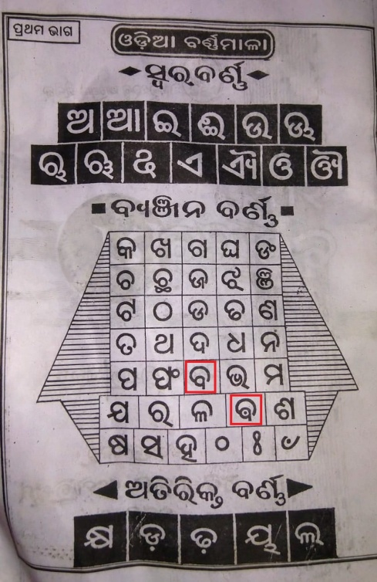
In this book, ‘ବ’ and ‘“ଵ” (U+0B35)’ are mentioned not only separately but also in diffent groups ବ under plosives/vargya and "ଵ" (U+0B35) under nonplosive/avargya. The highly authentic Oriya orthography (Madhu Varnabodha first published nearly 100 years ego), has separately depicted Ba and Va in different groups one as plosive/vargya 'Ba', and other as nonplosive/ avargya 'Va'.

3.8
It's laughable and there is no logic whatsoever to explain why nukta is added “କ” (U+0B15),“ଖ” (U+0B16), “ଗ” (U+0B17), “ଚ” (U+0B1A), “ଜ” (U+0B1C),and “ଫ” (U+0B2B). There is no reference or any published resources to show the need or historical use of these. Simply put, the researchers should have gone beyond Wikipedia to find if the historical use actually exist as these characters not only mimic the efforts of those standardized the language and the script on the basis of which the Indian state of Odisha was formed in 1936. If a script would evolve, it would evolve based on a dialog between the experts and the larger community. Insertion of nukta to these characters are done in this document in a monolithic manner without any consensus, historical reference and to promote a new trend one of the researchers for Odia is promoting on social media. This should not be treated as allegation but a serious flag as these serious flaws will tarnish the hard work of ICANN.

Answer:

Please note that we are working for Oriya script which is used for writing Oriya language as well as the 62 tribes constituting more than 22 percent of total population of Orissa. These tribal language include Kui, Kuvi, Gondi, Santali, Ho, Munda etc. They also depend solely on Oriya script to write their respective mother tongues. These belong to one or other of Indic, Austroasitic and Dravidian language families and as such their pronunciation differs and the phonetic character may not always match Oriya characters. If the diacriticals are not allowed then they will fail to write their mother tongues in Oriya script.

The word laughable used by you, reveals that you are laughing at the tribal people’s pitiable situation in which the major script which the tribal people learn, fails to write their own mother tongue leading to its extinction.

You are speaking about historical documents but how about these tribal people living in Orissa since prehistoric time? Many of these tribal languages do not have any scripts of their own and hence there are inadequate written documents. Many of these tribes know only one script that is Oriya which they learn at primary school level. Thus, most of the tribes in Orissa are fully dependant on Oriya script.

Oriya belongs to Indo-European language family, whereas many tribal languages of Orissa belong to Austroasiatic and Dravidian family. As a result, the phonemic characters of tribal languages of Orissa are not always exactly the same as in Oriya, but rather in many cases are allophones thereof. Such allophones prevalent in tribal languages can easily be addressed by use of nukta with Oriya graphemes. There is no logic to say no to use of nukta system for expressing the tribal language.

Religious issue:
Orissa has a sizable population of Muslims and Christians, whose mother tongue is Oriya. But, unfortunately many of their religious terms cannot be written using Oriya script without nukta. For example Quran (sacred book), Namaz (religious prayer) Fajar (morning prayer), Kafir (unbeliever) etc. these terms can be easily be written using nukta in Oriya script viz. କ଼ୋରାନ୍, ନମାଜ଼୍, ଫ଼ଜର୍, କାଫ଼ିର୍,ମଜ଼ହବ, ଜ଼ନାବ, etc. The use of nukta is accepted in scripts of Bengali and Assamese languages (which are closely allied to Oriya), but why not in Oriya script? Is it not a reason why Bengali Muslims freely make use of Bengali script, but Muslims of Orissa are compelled to use Arabic script for religious texts leading to their hesitation to embrace Oriya.
How will I write my name Sharif using Oriya script? Because I know that f is a voiced dentolabial for which an aspirated bilabial ଫ should not be used. But use of nukta like ଫ଼ facilitates use of Oriya script correctly.
Similar problems arise with our relative’s names like Firoz, Afroz, Iqbal etc. for which ଫିରୋଜ, ଏଫରୋଜ, ଇକବାଲ are wrong transliteration and can be correctly transliterated using nukta as ଫ଼ିରୋଜ, ଏଫ଼ରୋଜ, ଇକ଼ବାଲ
If we are born in Orissa, our mother tongue is Oriya, the script we are most familiar with is Oriya then why should we be barred from writing the most common names of our community correctly in Oriya script? When nukta is allowed for Gone are the days of … printing press, when there was no scope for putting nukta in Oriya script and we faced a lot of problems. But now situation has changed. ICANN should take care so that tomorrow if I open a domain name like sarifsahitya then I should not face any problem.

Scientific terminology
Scientific nomenclature should be the same in all languages and the transliteration should be lossless. Orissa flora and fauna includes many families, genera and species the scientific names of which cannot be written without nukta in Oriya. For example zingberaceae, zea, flagellates, volvox funaria etc. become Jingber, Jea, Phlagellates, Bholbhox, Phunaria. Substituting dentolabials like va and fa with aspirated bilabials like Bha and Pha deforms thousands of scientific terminology in Oriya.
In Physics and Chemistry also, the names of the scientists cannot be written in Oriya without nukta, for example Faradays, Flemming, Fischer, Hofmann, Cannizzaro, Weizmann.

However, we know although nukta is essential for a script to accommodate all languages which use the concerned script, yet there is a serious drawback in using it for domain purpose due to fishing issues. Even when we put ‘U’ matras ‘ୁ’ for the most widely accepted characters like "ଡ଼" and "ଢ଼", nukta is not visible that creates fishing issues.
Thus if NBGP wants to remove nukta due to fishing issues, it can be removed.

Reference:
http://censusindia.gov.in/Tables_Published/SCST/dh_st_orissa.pdf
https://r12a.github.io/scripts/bengali/block
https://r12a.github.io/uniview/?char=09BC

Nukta in “ଚ” (U+0B1A), however, is visible in the Karani script which is another historical variation/predecessor of the current Odia script but has to be treated as a different script. The reason for nukta in “ଚ” (U+0B1A) was for a different purpose and bringing it back for another purpose is gross manipulation.

Answer:
Rationale for use of NUKTA has already been discussed above. The same holds true for cha also i.e. to express those characters of Kui, Santali which are not exactly ORIYA cha but its allophone
CHUIN, HACHHAEME

Reference:

Strongly support Liang's point about "ଡ଼" and "ଢ଼" as those two characters are regarded as treasure troves of Odia script. The very name of the language "ଓଡ଼ିଆ" and the geographical place — the state of Odisha (ଓଡ଼ିଶା) contains these characters. "ଡ଼" and "ଢ଼" are supposed to be treated as characters rather than variations of "ଡ" and "ଢ" as the usage case for the former two are more than the latter.
Answer:
Please refer the answer given elsewhere.

Reference:

