Neo-Brahmi Generation Panel

Analysis of comments for Bangla script LGR Proposal for the Root Zone
Revision: May 11, 2020

Neo-Brahmi Generation Panel (NBGP) published the Bangla script LGR Proposal for the Root Zone for public comment on 2 March 2020. This document is an additional document of
The public comment report, collecting NBGP analyses as well as the concluded responses.
There are nine (9) comment submissions. The analyses are as follow:

No. | 1 | From | Integration Panel (IP)
Comment |  | Using the list of delegated IDN TLDs, the IP performed collision checks and found one collision.  (09AD 09BE 09B0 09A4) <==> (09AD 09BE 09F0 09A4)  The labels in question differ between code points 09B0 and 09F0, which are blocked variants in the Bangla LGR. These labels spell "India" in Bangla and Assamese and are both currently delegated.  Normally, with a blocked disposition, a label can only exist in the spelling used by one community, and members of the other community might be unable to access the label altogether. To be able to address such usability issues, variants can be made allocatable, which would allow the same resource to be made available equally for each community.  The IP brings this to the attention of the community. There is no requirement for the RZ-LGR to cover every previously delegated IDN TLDs. However, the NBGP may decide based on the usability considerations to make a change or to better explain the rationale for the existing design.
NBGP Analysis |  | Both dispositions address the security issue. However, there are different usability implications. The NBGP used an example of the labels রাজা and ৰাজা, trying to answer the following question: “Should the Bangla LGR solution be ‘allocatable’ variant mapping; If a company applies for ৰাজা, then which option should be considered?”  - ‘blocked’ variant codepoints (current solution, case 2  - Only original label ৰাজা is available in the root-zone.  - This option might limit the usability e.g. customer who does not have ৰ on the keyboard would not be able to access ৰাজা, because they would only be able to type রাজা TLD.  - ‘allocatable’ variant codepoints  - Both original label ৰাজা and variant labels রাজা are available in the root-zone.  - Better for usability, it is possible for users to access either ৰাজা or রাজা TLD.  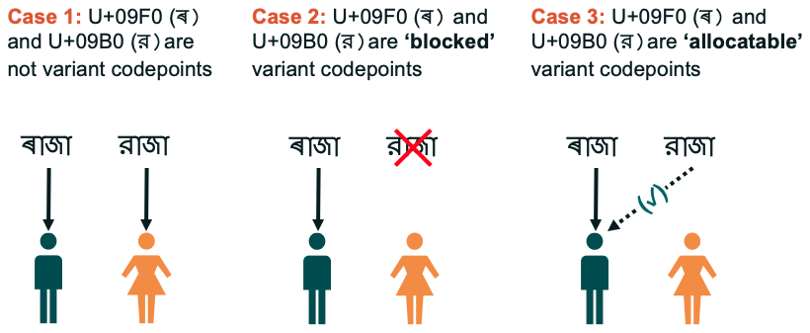
NBGP Concluded Response |  | < to be discussed and finalized on 11 May 2020>  The NBGP decided to update the disposition of code points 09B0 and 09F0 variants as ‘allocatable’. The LGR proposal will be updated accordingly.

No. | 2 | From | Vernacular Internet Ecosystem Working Group (VIEW Group)
Comment |  | VIEW Group has taken its members’ input from academia and industry, as well as social organizations. The overwhelming response was received in favour of the proposal. VIEW Group reviewed the proposal and found it well constructed, covering all the important aspects. It does not see any substantial change is required.
NBGP Analysis |  | The NBGP acknowledges the comment.
NBGP Concluded Response |  | No requirement to update the proposal.

No. | 3 | From | Reamogetse Mojafi (RM)
Comment |  | RM requests for more information.
NBGP Analysis |  | The NBGP acknowledges the comment. Information regarding RZ-LGR and Internationalized domain names was shared to RM.
NBGP Concluded Response |  | No requirement to update the proposal.

No. | 4 | From | Azharul Huq Chowdhury (AHC)
Comment |  | AHC says it is great news for Bangla speaking people. AHC posts questions regarding the Unicode version, the authority of Bangla TLD zone files, and how to create or apply for a Bangla TLD.
NBGP Analysis |  | The NBGP acknowledges the comment. The information regarding the new gTLD was shared to AHC.
NBGP Concluded Response |  | No requirement to update the proposal.

No. | 5 | From | Rasel Hasan (RH)
Comment |  | RH notes that Bangla domains are needed.
NBGP Analysis |  | The NBGP acknowledges the comment.
NBGP Concluded Response |  | No requirement to update the proposal.

No. | 6 | From | Marufa Akhter (MA)
Comment |  | MA notes that the characters ড়, ঢ় and য় should be depicted the same way as 'র'. He is happy to note that the terms ‘Bangla’ and ‘Taka’ are being used.
NBGP Analysis |  | The IDNA Protocol (RFC 5891) states that IDNs must be in Unicode Normalization Form C (NFC). RFC 7940 applies this requirement to LGRs. The definition of NFC in the Unicode Standard contains a number of composition exclusions. As a result, the Bangla letters য় YYA, ড় RRA and ঢ় RRHA have to be represented in the this LGR by using the sequences (YA +Nukta: U+9AF + U+09BC), (DDA + Nukta: U+9A1 + U+09BC), and (DDHA + Nukta: U+9A2 + U+09BC) instead of the single code points YYA (U+9DF), RRA (U+09DC), and RRHA (U+09DD), although the use of ‘Nukta’ is otherwise completely unnatural in Bangla.  It is noted that in the current Unicode Standard chart, these characters are listed as additional consonants. As per the LGR Procedure, however, these decisions depend on the IDNA Protocol through a set of procedures developed by the IETF. Even though the Unicode Standard also prescribes methods to produce these three characters both as atomic characters (for example, 09DC for ড় [ṛ], 09DD for ঢ় [ṛh], and 09DF as য় [y] as single key stroke), the IDNA protocol requires that we treat them as conjunct characters and then allocate codes for these in the Unicode Bengali Block.  As it look on the screen, all the three characters would look like the atomic র to the users.
NBGP Concluded Response |  | No requirement to update the proposal.

No. | 7 | From | Labonno Ahmed (LA)
Comment |  | LA also shares that the characters ড়, ঢ় and য় should be depicted the same way as 'র'. The dot should not be separated. He thanks the NBGP to refer to ‘Bengali’ as ‘Bangla’.
NBGP Analysis |  | The NBGP acknowledges the comment. Also, see NBGP analysis in comment number 6.
NBGP Concluded Response |  | No requirement to update the proposal.

No. | 8 | From | Mizanur Rahman Khan (MR)
Comment |  | MR notes that Bangla is considered one of the world’s richest languages. He is happy to learn that domain names will be available in the Bangla language. He comments that the Bangla characters must be used in domain names exactly in the same manner they are used otherwise.
NBGP Analysis |  | The NBGP acknowledges the comment. Also, see NBGP analysis in comment number 6.
NBGP Concluded Response |  | No requirement to update the proposal.

No. | 9 | From | Hanif Miah (HM)
Comment |  | HM shares that the characters ড়, ঢ় and য় should be depicted the way they are normally done in the system of Bangla alphabets.
NBGP Analysis |  | The NBGP acknowledges the comment. Also, see NBGP analysis in comment number 5.
NBGP Concluded Response |  | No requirement to update the proposal.

