RDS-WHOIS2 RT
Face-to-Face Meeting # 2, Brussels - Belgium
16-17-18 April 2018
Meeting Report

Review Team Members: Alan Greenberg, Susan Kawaguchi, Cathrin Bauer-Bulst, Erika Mann, Lili Sun, Dmitry Belyavsky, , Stephanie Perrin, Chris Disspain, Carlton Samuels (days 1-2)  Apologies: Volker Greimann, Thomas Walden, Carlton Samuels (day 3) | Observers: Sathya Sree, Justine Chew, Pascal Crowe, Nadira Al-Araj, Taras Heichenko  ICANN Org: Alice Jansen, Jean-Baptiste Deroulez, Lisa Phifer, Sara Caplis

Meeting materials may be found on the wiki at: https://community.icann.org/display/WHO/Face+to+Face+Meeting+-+16%2C+17%2C+18+April+2018

The RDS-WHOIS2 Review Team undertook the following:
- Meeting Goals
The RDS-WHOIS2 defined the following goals for the meeting:
- Review and discuss subgroup’s findings/recommendations;
- Flag any open questions, potential overlaps and gaps;
- Assess current status of each subgroup and need for strategic changes;
- Confirm next steps and work plan.
All of the above were addressed.
- S.M.A.R.T.
To ensure that all members have a solid understanding of what constitutes an effective and clear recommendation, ICANN org provided an overview of required information and parameters for a recommendation to be specific, measurable, achievable, relevant, time-bound (S.M.A.R.T.).
- WHOIS1 Implementation Assessment
The review team dedicated much of its meeting to discussing in detail the findings and potential recommendations (if any) that WHOIS1 implementation-related subgroups had assembled, based on their data research and analysis.
Each subgroup presented the WHOIS1 recommendation(s) it had considered, the questions it had analyzed, the research materials and methodology used to answer those questions, and the subgroup’s main findings thus far. Based on those initial findings, subgroups then presented problems that it had identified and (in some cases) draft recommendations intended to address those problems. Review team members were encouraged to ask clarifying questions, provide feedback to each subgroup, identify any overlaps between subgroups, and consider whether all subgroups had fully addressed the team’s objective to (a) evaluate the extent to which ICANN Org has implemented each WHOIS1 recommendation, and (b) to the degree practical, assessed the extent to which implementation was effective in addressing the issues identified by WHOIS1.
The WHOIS1 recommendations covered during this meeting are listed below:
- Recommendation 1: Strategic Priority
- Recommendation 2: Single WHOIS Policy
- Recommendation 3: Outreach
- Recommendation 4: Compliance
- Recommendations 5-9: Data Accuracy
- Recommendation 10: Privacy/Proxy Services
- Recommendation 11: Common Interface
- Recommendations 12-14: Internationalized Domain Names
- Recommendations 15-16: Plans and Annual Reports
In addition to specifically assessing implementation of WHOIS1 recommendations, the review team performed a cumulative review of each topic identified above, including all changes implemented to date to WHOIS (the now current gTLD RDS). The review team acknowledged that further changes will likely result from GDPR compliance. However, as those changes are not yet finalized nor implemented, they cannot be reviewed at this point in time.
In addition, the review team made the overarching observation that overall implementation of WHOIS1 recommendations took a long time. The review team agreed to include this finding in its report and to consider possible recommendation(s) to address this concern.
Subgroups are now working towards finalizing their reports, findings and recommendations (if any) by 24 May – COB. The RDS-WHOIS2 leadership reiterated the need to use the implementation assessment framework, produced earlier in the process (see here), as a checklist.

Refer to here for agreements reach during the meeting and action items assigned to further progress each subgroup’s outputs.

- Anything New

With respect to the subgroup focused on assessing the effectiveness of today’s WHOIS (the now current gTLD RDS, including cumulative changes made to the then-current RDS which was assessed by the prior RT), it was agreed that:.
- several items already are covered by WHOIS1 implementation-related subgroups: i.e., several items to be addressed by the Compliance subgroup, reseller lack of transparency to be addressed under Consumer Trust subgroup.
- A general comment related to handling of conflicts with privacy law should be made under auspices of overall report.
- A note clarifying that impact of GDPR has not yet been addressed in this review should be made under auspices of overall report’s preamble.
The rapporteur took an action to formulate text detailing these findings in the subgroup’s report, and to include any further observations the subgroup wishes to make on the development of policies and procedures. Refer to draft agreements and actions (see here) for further detail.

- Law Enforcement Needs

After considering progress to date made by this subgroup, including likely impact of GDPR compliance changes on this topic, the review team agreed that It would be useful to survey the law enforcement community now, to establish a baseline for post-GDPR comparison. The objective of the survey will be to examine how well WHOIS meets the needs of law enforcement previously identified by this subgroup (i.e., speed, availability, accuracy of data). It is envisioned that the same survey will be re-run post-GDPR compliance implementation to assess the impact of those changes on meeting the needs of law enforcement. The review team agreed that the survey should be conducted with global reach. Cathrin Bauer-Bulst (standing in for this subgroup’s rapporteur) volunteered to draft the survey questions for subgroup consideration, followed by feedback and assistance by the full review team. Refer to draft agreements and actions (see here) for further detail.

- Consumer Trust

The review team considered the research assembled by this subgroup, and agreed that the definition of consumer must be broad and include Internet users. Initial findings agreed upon during this meeting include:
- WHOIS contributes to consumer trust, mostly indirectly.
- There is a potential for review to drift into non-WHOIS aspects of consumer trust.
- Lack of Reseller transparency in WHOIS appears to create a potential gap in consumer trust, which might be addressed through policy and/or contractual changes.
This subgroup intends to perform a gap assessment after other subgroups have completed their outputs, examining the extent to which implementation of WHOIS1 recommendations impacted consumer trust in order to identify any further recommendations that may be appropriate. Refer to draft agreements and actions (see here) for further detail.

- Safeguarding Registrant Data

The review team considered the findings of this subgroup, the approach the subgroup plans to use to examine safeguarding of escrowed WHOIS data. Subject to subgroup review of current contracts to confirm gap, the review team agreed to formulate a recommendation that ICANN should use contemporary standards for securing data storage and retention in its contracts.
The subgroup decided to defer its request to interview escrow providers and contracted parties and is planning a review of contracts in place with the objective of developing further findings/issues.
The subgroup rapporteur took an action item to draft specific questions about escrow data safeguards to be answered by ICANN org. Refer to draft agreements and actions (see here) for further detail.

- Assessment of Subgroups’ Progress

The review team studied overall progress made by all subgroups in completing their mandate and in delivering findings, identifying problems, and drafting recommendations (if any) for objectives specified in its terms of reference (here). See the review team’s assessment of progress towards completion of subgroup-assigned tasks below.

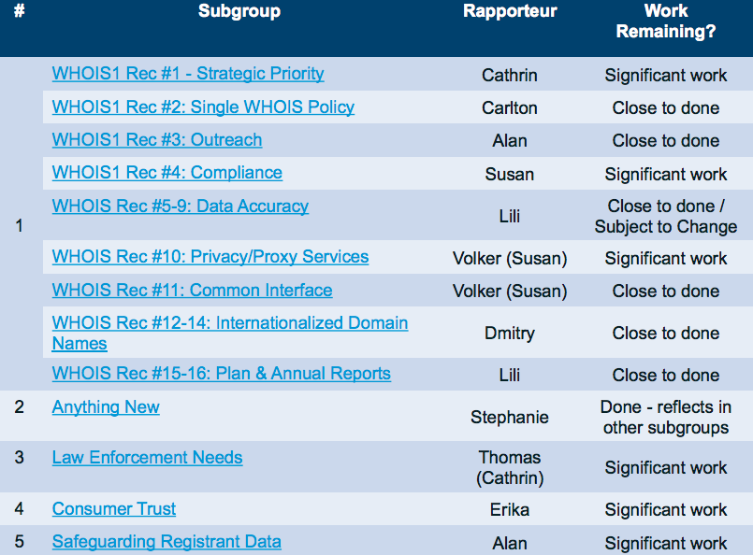

Overall, some subgroups are nearly done with their work, while others still have significant work – often due to dependencies on other work. In other cases, subgroups could benefit from assistance by additional review team members. As such, additional volunteers were assigned to law enforcement and privacy/proxy subgroups, based on their fields of expertise.

- RDS-WHOIS2 Draft Report

The review team agreed to proceed with the draft report structure ICANN org presented, with the caveat that edits may be needed to report organization as work progresses. In particular, the report outline was adjusted during this meeting to include a statement about how the review team handled the changing landscape (GDPR and other applicable laws). Within each subgroup report, a section will be included to reflect any impact the GDPR may have on its findings (e.g. where recommendations apply without impact by data protection laws, areas that might need to be reassessed after policies change as a result of applicable laws).ICANN org received an action item to begin populating sections that pertain to background, methodology etc., by drawing draft text from the Terms of Reference and each subgroup’s draft reports.

- Commitment and Membership

Concerns were expressed on lack of participation/representation from two review members on the review team. RDS-WHOIS2-leadership took an action item to determine if the matters that prevented those concerned from participating more actively to date are expected to continue, to inform leadership consideration of possible next steps.

- Work Plan

The review team confirmed that no revisions are currently needed to the major work plan milestones it adopted in February 2018. The most recent version of the work plan can be viewed here. As previously noted in its Terms of Reference, some of the review team’s tasks may yet be impacted by GDPR compliance.

- Next Steps

Subgroups are working towards refining their findings and recommendations in light of the above conclusions by 24 May.

The review team will hold an engagement session at ICANN62. Comment was made that it will be key to ensure the session does not conflict with the auctions proceed related session.

The review team expressed a wish to hold a third face-to-face meeting in July 2018, preferably in Brussels, with the objective of finalizing and approving its draft report for public comment. ICANN org was tasked to contact meetings team to enquire about availability for a two-day face-to-face meeting.

Consensus reached on decisions/action items:
Consensus on all of the agreements reached during this meeting (see here) with exception of WHOIS1 recommendation 2 assessment: Stephanie Perrin disagrees with conclusion and the draft RDS-WHOIS2 conclusions reached about WHOIS1 recommendation 2 during this meeting.

Background: The Registration Directory Service (RDS), formerly known as "WHOIS," Review is mandated by ICANN Bylaws Section 4.6(e) to assess the effectiveness of the then current gTLD registry directory service and whether its implementation meets the legitimate needs of law enforcement, promoting consumer trust and safeguarding registrant data. For more information, read terms of reference and work plan.

Action items:

WHOIS1 – Recommendation 4 – Compliance
- Susan Kawaguchi to confirm questions for ICANN compliance.
- Subgroup to try testing recommendation on WHOIS policies that are being examined by this review (e.g., Privacy/Proxy, IDN) to see if metrics/monitoring/reporting and enforcement have been defined for those.
- Susan Kawaguchi to formulate recommendation to include compliance taking a risk-based approach that is not just reactive - addressing systemic complaints and taking a risk-based approach.
- Susan Kawaguchi to examine CCT recommendation on DAAR to build this subgroup’s recommendation.
- Susan Kawaguchi to research 2013 RAA negotiation materials to determine any reasons for allowing grandfathering.

WHOIS1 – Recommendations 5-9 – Data Accuracy
- Lili Sun to look into Compliance actions and link their work to data accuracy subgroup.
- Lili Sun to confirm list of questions to ICANN Compliance.

WHOIS1 – Recommendation 10 – Privacy/Proxy
- Volker Greimann to clarify following issues for RT:
Issue #1: Current funding proposals for accreditation program create concerns of ICANN failing the goal of onboarding all providers of such services due to inflation of costs. ICANN Org staff seems to be unable to justify proposed accreditation fees, which may endanger the entire program.
Issue #2: Impact of GDPR data redaction requirements on privacy services are yet unknown, but significant impact is expected as personal data becomes hidden by default without use of privacy services.

WHOIS1 – Recommendations 15-16 – Plan/Annual Report
- Cathrin Bauer-Bulst and Lili Sun to coordinate on recommendations related to Reports also addressed under Strategic Priority

Anything New
- Stephanie Perrin to formulate text describing the lack of strategic plan for WHOIS leads to disjoint development of policies and procedures.

Law Enforcement Needs
- Cathrin Bauer-Bulst to draft survey questions for subgroup to review the questions.

Consumer Trust
- Erika Mann to take feedback on-board and use outputs of other subgroups to assess impact of WHOIS1 rec implementation on consumer trust
- Subgroup to take on “reseller lack of transparency” topic.

Safeguarding Registrant Data
- Questions for ICANN org :
  - What are contractual requirements to secure stored escrow data
  - What are contractual requirements to notify ICANN in the event of breach
  - How do you secure registrant data under your control?
- Alan Greenberg to refine question number 3.
- Stephanie Perrin to provide draft formulation to Alan.
- Alan Greenberg to confirm revisions made RT agreements.

Next steps
- ICANN org to ensure/monitor the ICANN62 session does not conflict with the Auctions Proceed session. (Session was submitted as a high interest session by Alan Greenberg).
- Leadership to contact Volker Greimann and Thomas Walden to determine if the matters that prevented them from participating actively are expected to continue.
- Rapporteurs to reach out to Stephanie Perrin if need help (Stephanie Perrin’s areas of expertise: risk management, privacy, and law enforcement).
- Stephanie Perrin and Lili Sun to be added to Subgroup 3 - Law Enforcement.
- Dmitry Belyavsky to be added to Rec #10: Privacy/Proxy Services.
- ICANN org to contact meetings team to enquire about availability for a 2 day face-to-face meeting in July (preferably in Brussels).
- ICANN org to insert Introduction section to contain over-arching findings and recommendations, including impact of GDPR.
- ICANN org to begin populating sections that pertain to background, methodology etc.
- No plenary call scheduled for 30 April.
- ICANN Org to produce meeting statement for approval by RT leadership.
- RT to submit any comments on agreements/action items by Wednesday 25 April 2018, COB.

