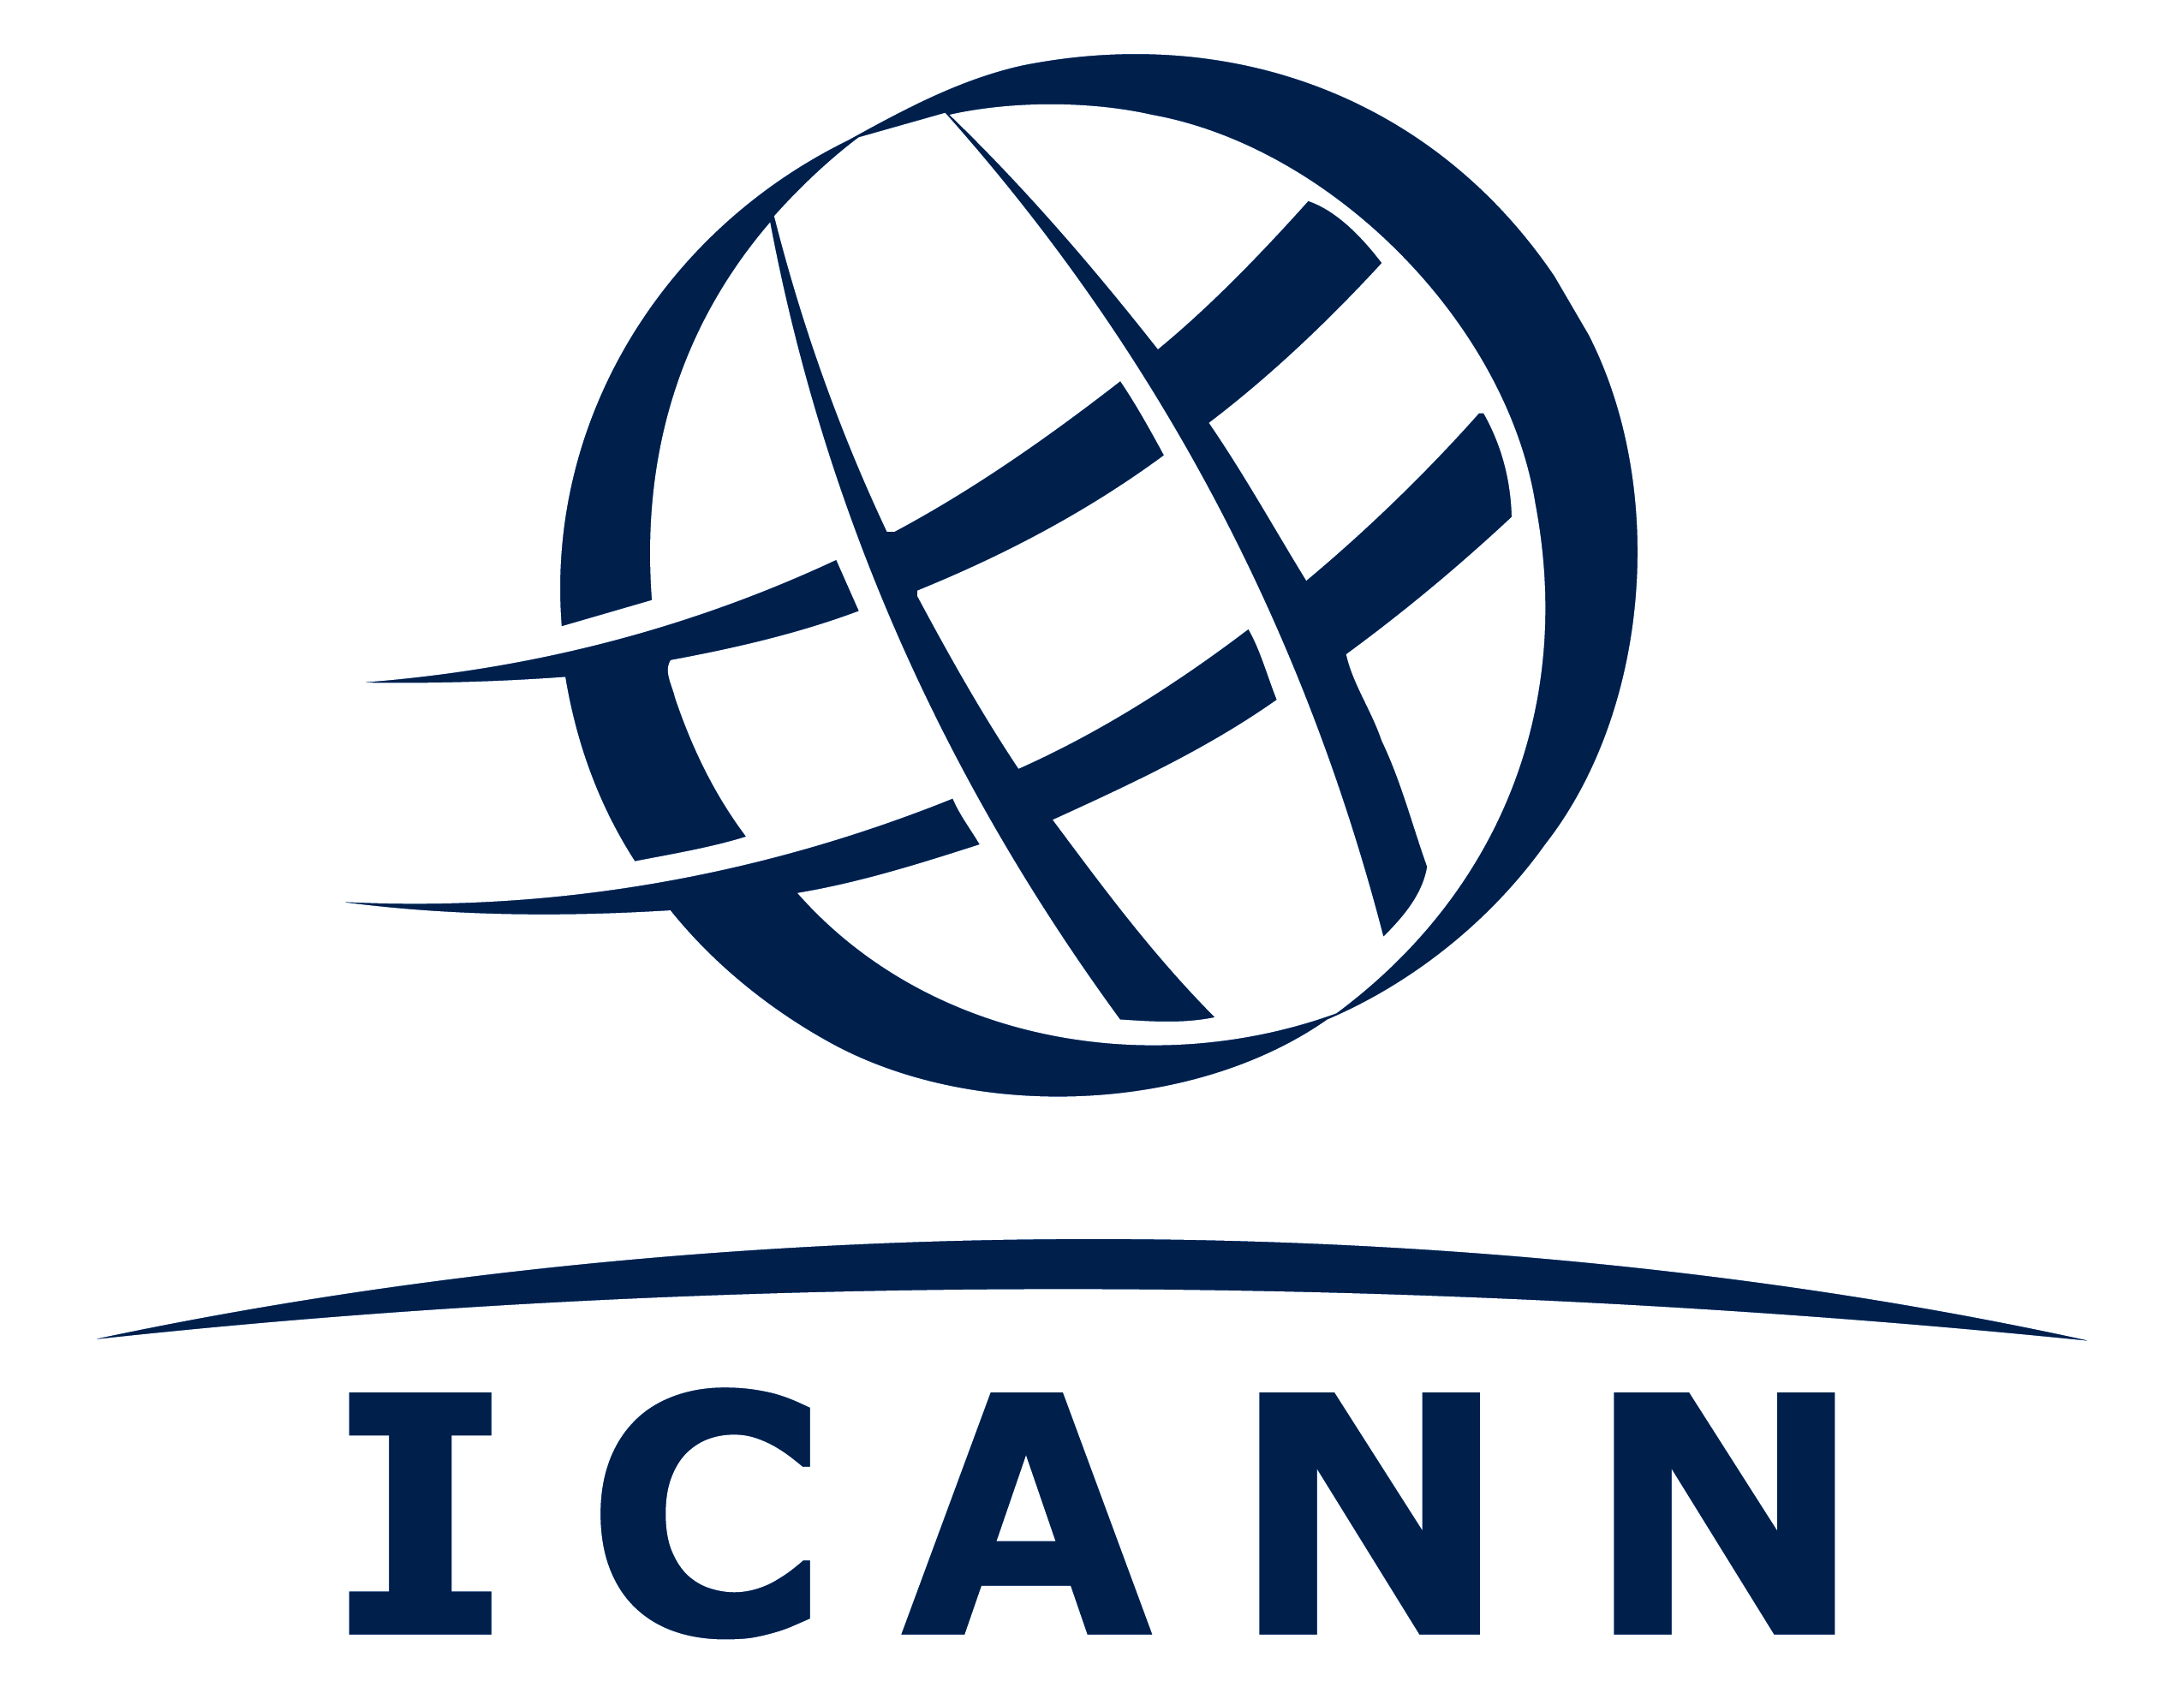
RDS-WHOIS2-Review

04 June 2018
Theresa Swinehart, Senior Vice President, Multistakeholder Strategy and Strategic Initiatives
cc: Khaled Koubaa, Chair, Board Organizational Effectiveness Committee (OEC)

Re: Public Comment on Short-Term Options to Adjust the Timeline for Specific Reviews
Dear Theresa,
I am writing on behalf of the RDS-WHOIS2 Review Team (RT). The Review Team believes that the RDS-WHOIS2 Review should be excluded from the ongoing Public Comment (PC) on Short-Term Options to Adjust the Timeline for Specific Reviews.
There are a number of inaccuracies and misrepresentations in the current PC document (https://www.icann.org/en/system/files/files/specific-reviews-short-term-options-timeline-14may18-en.pdf), and once they are corrected, we believe that, at this point, there is little to be gained and potentially much to lose if the Review scope is altered or the Review paused.
There are some review team members and others in the community who believed that this review should have been deferred, or its scope restricted to just a review of the first WHOIS RT’s Recommendations. Others believed that a full and thorough review should be performed. This was thoroughly discussed prior to the review and during the scoping phase. Ultimately, it was decided that the review should continue and should not be restricted. That was many months ago and we cannot turn back the clock but must look at today’s situation, and where we will be when the Public Comment (PC) completes in July.
With respect to the PC document:
- The document correctly reports that the Review Terms of Reference (ToR) states that due to GDPR, we MAY defer some aspects of the review which we did not believe would substantially alter our completion target. In fact, we have not deferred anything at this point and now believe that GDPR will not have a significant impact on our work. The full implementation of GDPR may or may not be understood by the time we deliver our report, but we will certainly understand the overall direction and that will be a factor in our report. It is clear that the real impact will not be well understood by then nor even a few months later, so the analysis of that will have to wait for a subsequent review.
- The document implies that because there are only ten RT members, there are insufficient people to do the work. In fact there are just ten members, but all are working together and the number of active workers may well exceed the number of active workers on previous larger teams.
- The PC document says that $460k will be saved in FY19 by restricting the scope of the review and that $590k will be saved by pausing the review. The review team has not been involved in estimating any of these budgets and does not believe that they are accurate.
Based on current projections, which include a significant “cushion” for error, we estimate that if we continue as currently planned, the FY19 cost will be $145k, and the Total Review cost will be $290k, $400k under the original ICANN Org budget of $690k.
The PC Option C also predicts a savings of $130k in FY18. It is unclear how a decision taken based on a public comment that will deliver its verdict on 23 July 2018 (nearly a month after FY18 ends) can save $130K in FY18. Moreover, the RT notes that our estimated total expenditure for FY18 will be $130k.
- The public comment is due to close on 06 July 2018 with the staff report due on 23 Jul 2018. According to the current Review Team work plan, the Review Team is scheduled to have a face to face meeting 19-20 July 2018. Our intent is that we finalize the content of our draft report at that time. Moreover, unlike some draft reports which are comprised of many questions to the community, we believe that this will really be a draft report looking for community comment before finalizing it. It makes little sense for the group to reduce its scope or completely pause just at the point when it is ready to deliver its draft report. By that time, the bulk of the work will have been done, and to scrap part of it or pause for a year implies much of that work will have to largely be repeated again later. The RT specifically notes that Option C, to have the Review paused in April (a date that had long past when the PC was issued on 14 May) made no sense whatsoever given that the community input to make that decision would only be available in late July.
The Review Team believes that if it had been consulted when this Public Comment was being contemplated and developed, the RDS-WHOIS2 Review would never have been included.
Moreover, the Review Team strongly believes that if a RT is to be held accountable for keeping to its “budget” (as is the current practice), the RT MUST be involved in developing that overall budget and the annual FY budgets that it must operationally adhere to.

Alan Greenberg
Chair, RDS-WHOIS2 Review Team

