Proposed Subgroup Report Structure
WHOIS1 Rec #12-14: Internationalized Domain Names Subgroup Report
Name
[XX Month Year]

- Table of Contents
1 Topic 3
2 Summary of Relevant Research 3
3 Analysis & Findings 3
4 Problem/Issue 3
5 Recommendations 3

Topic
Consistent with ICANN’s mission and Bylaws, Section 4.6(e)(iv), the Review Team will (a) evaluate the extent to which ICANN Org has implemented each prior Directory Service Review recommendation (noting differences if any between recommended and implemented steps), (b) assess to the degree practical the extent to which implementation of each recommendation was effective in addressing the issue identified by the prior RT or generated additional information useful to management and evolution of WHOIS (RDS), and (c) determine if any specific measurable steps should be recommended to enhance results achieved through the prior RT’s recommendations.

The recommendations to be covered by subgroup are Recommendations #12, 13, 14 - Internationalized Domain Names originally assessed by the prior RT.

Recommendation 12
ICANN should task a working group within six months of publication of this report, to determine appropriate internationalized domain name registration data requirements and evaluate available solutions (including solutions being implemented by ccTLDs). At a minimum, the data requirements should apply to all new gTLDs, and the working group should consider ways to encourage consistency of approach across the gTLD and (on a voluntary basis) ccTLD space.
The working group should report within a year of being tasked.

Recommendation 13
The final data model, including (any) requirements for the translation or transliteration of the
registration data, should be incorporated in the relevant Registrar and Registry agreements
within 6 months of adoption of the working group’s recommendations by the ICANN Board. If
these recommendations are not finalized in time for the next revision of such agreements,
explicit placeholders for this purpose should be put in place in the agreements for the new gTLD program at this time, and in the existing agreements when they come up for renewal.

Recommendation 14
Metrics should be developed to maintain and measure the accuracy of the internationalized
registration data and corresponding data in ASCII, with clearly defined compliance methods and targets.

Summary of Relevant Research

Methodology
The subgroup has studied the provided materials (listed below) and the decisions reached by ICANN after the RT1 Report was published. The subgroup checked whether the measures taken by ICANN covers the recommendations made by RT1 and whether it is necessary to provide any additional measures to fully cover the recommendations.

List of relevant materials:

The materials found relevant are enlisted on the subgroup page https://community.icann.org/display/WHO/WHOIS1+Rec+%2312-14%3A+Internationalized+Domain+Names

Translation and Transliteration PDP’s Final Issue Report, March 2013
https://gnso.icann.org/en/issues/gtlds/transliteration-contact-final-21mar13-en.pdf

Translation and Transliteration PDP web page
https://gnso.icann.org/en/group-activities/active/transliteration-contact

Translation and Transliteration PDP Working Group Final Report, Jun 2015
https://community.icann.org/download/attachments/53779599/Final%20Report%20Final%20(with%20links%20working).pdf

IRD Expert Working Group Final Report, September 2015
http://whois.icann.org/sites/default/files/files/ird-expert-wg-final-23sep15-en.pdf

Translation and Transliteration IRT wiki
https://community.icann.org/display/gnsottcii/Translation+and+Transliteration+of+Contact+Information+IRT+Home

Translation and Transliteration Implementation Project Status
https://www.icann.org/resources/pages/transliteration-contact-2016-06-27-en

RDAP Webpage
https://www.icann.org/rdap

[Include methodology that was employed, list of relevant materials, briefings received, reading, input from meetings (as appropriate)]

Analysis & Findings

Board action related to Rec 12-14:
The Board directs the CEO to have Staff:
1. Task a working group to determine the appropriate internationalized domain name
registration data requirements, evaluating any relevant recommendations from the SSAC or
GNSO
2. Produce a data model that includes (any) requirements for the translation or transliteration of the registration data, taking into account the results of any PDP initiated by the GNSO on
translation/ transliteration, and the standardized replacement protocol under development in the IETF’s Web-based Extensible Internet Registration Data Working Group
3. Incorporate the data model in the relevant Registrar and Registry agreements within 6
months of adoption of the working group’s recommendations by the ICANN Board or put explicit placeholders in place for gTLD program agreements, and existing agreements
4. Evaluate available solutions (including solutions being implemented by ccTLDs)
5. To provide regular updates on technical development of the IRD, including the estimated
timeline or roadmap of such technical development, so that the ICANN community, particularly the IDN gTLD applicant, can fully prepare for implementation of IRD features in its operation.
Investigate using automated tools to identify potentially inaccurate internationalized gTLD
domain name registration data in gTLD registry and registrar services, and forward potentially inaccurate records to gTLD registrars for action.

The results related to Recommendation 12:

The ICANN Board adopted an Action Plan in response to the WHOIS Review Team’s Final Report that instructs Staff to implement these recommendations.Subsequently a set of related efforts were formed to implement the WHOIS review team recommendations. These are:
● An expert working group to determine the requirements for the submission and display of internationalized registration data.
● A commissioned study to evaluate available solutions for internationalized registration data.
● A Policy Development Process (PDP) to determine whether translation or transliteration of contact information is needed. If so, specify who should bear the burden of the transformation.

WHOIS Review Team Internationalized Registration Data Expert Working Group (IRD Working Group) was created (https://www.icann.org/en/system/files/bm/briefing-materials-1-08nov12-en.pdf).
The timeline of IRD Team analysis is enlisted below:
- Draft Final Report of IRD Team published for Public Comment – 9 Mar 2015 (https://www.icann.org/news/announcement-2015-03-09-en)
- Report of Public Comments – 18 May 2015 (https://www.icann.org/en/system/files/files/report-comments-ird-study-18may15-en.pdf)
- Final Report from the Expert Working Group on Internationalized Registration Data - 23 September 2015 (http://whois.icann.org/sites/default/files/files/ird-expert-wg-final-23sep15-en.pdf)
- Board Approval of IRD recommendations Resolution 2016.03.10.05 – 2016.03.10.07 – 10 March 2016 (https://www.icann.org/resources/board-material/resolutions-2016-03-10-en#1.e )
- Implementation Plan to be developed – (TBD) 2016

The IRD Working Group developed three principles of internationalization:
- User Capability Principle: In defining a requirement for a particular data element or category of data elements, the capability of the data-submitting user should be the constraining factor. Such users should not be burdened with tasks that cannot be completed under ordinary circumstances (i.e. inputting domain name registration data in a language or script the registrant is not familiar with).
- Simplicity and Reusability Principle: Where possible, existing standards that are widely used for handling internationalized data should be applied. Where simpler standards exist for internationalization, they should be preferred rather than more complex standards.
- Extensibility - Where possible, the data model should be able to be easily extended to tailor to the evolution of data elements displayed by directory services for various TLD registries and registrars.

Based on these principles, the IRD Working Group proposes two high level requirements for community consideration:
- registrants should only be required to input registration data in a language(s) or script(s) that they are skilled at;
- unless explicitly stated otherwise, all data elements should Defining Requirements for Internationalized Registration Data be tagged with the language(s) and script(s) in use, and this information should always be available with the data element.

The detailed classification provided by IRD WG is available in Appendix A.

The Board requested that the GNSO Council review the broader policy implications of the IRD Final Report as they relate to other GNSO policy development work on WHOIS issues, and, at a minimum, forward the IRD Final Report as an input to the GNSO PDP on the Next Generation Registration Directory Services to Replace WHOIS that is currently underway (https://gnso.icann.org/en/correspondence/crocker-to-bladel-11may16-en.pdf).

Conclusion: The subgroup treats recommendation #12 as fulfilled. See also findings related to Rec#13.

The results related to Recommendation 13:
As the requirements for the translation and transliteration of the registration data were not finalized in time for the revision of the documents in 2013, the placeholders can be found both in Registry Agreement (RA) and Registrar Accreditation Agreement (RAA):

RA-2013, Specification 4 (http://newgtlds.icann.org/sites/default/files/agreements/agreement-approved-09jan14-en.docx) says:
Registration Data Directory Services. Until ICANN requires a different protocol, Registry Operator will operate a WHOIS service available via port 43 in accordance with RFC 3912, and a web-based Directory Service at <whois.nic.TLD> providing free public query-based access to at least the following elements in the following format. ICANN reserves the right to specify alternative formats and protocols, and upon such specification, the Registry Operator will implement such alternative specification as soon as reasonably practicable.
Registry Operator shall implement a new standard supporting access to domain name registration data (SAC 051) no later than one hundred thirty-five (135) days after it is requested by ICANN if: 1) the IETF produces a standard (i.e., it is published, at least, as a Proposed Standard RFC as specified in RFC 2026); and 2) its implementation is commercially reasonable in the context of the overall operation of the registry.

RAA-2013, Registration Data Directory Services(WHOIS)Specification, (https://www.icann.org/en/resources/registrars/raa/approved-with-specs-27jun13-en.htm#whois) says:

Registration Data Directory Services. Until ICANN requires a different protocol, Registrar will operate a WHOIS service available via port 43 in accordance with RFC 3912, and a web-based Directory Service providing free public query-based access to at least the elements set forth in Section 3.3.1.1 through 3.3.1.8 of the Registrar Accreditation Agreement in the format set forth in Section 1.4 of this Specification. ICANN reserves the right to specify alternative formats and protocols, and upon such specification, the Registrar will implement such alternative specification as soon as reasonably practicable.
Following the publication by the IETF of a Proposed Standard, Draft Standard or Internet Standard and any revisions thereto (as specified in RFC 2026) relating to the web-based directory service as specified in the IETF Web Extensible Internet Registration Data Service working group, Registrar shall implement the directory service specified in any such standard (or any revision thereto) no later than 135 days after such implementation is requested by ICANN. Registrar shall implement internationalized registration data publication guidelines according to the specification published by ICANN following the work of the ICANN Internationalized Registration Data Working Group (IRD-WG) and its subsequent efforts, no later than 135 days after it is approved by the ICANN Board.

The recommendations of the Translation and Transliteration of Contact Information Policy Development Process are available in the Appendix B.

Board has adopted (https://www.icann.org/resources/board-material/resolutions-2015-09-28-en#1.b) the recommendations listed here:
Resolved (2015.09.28.02), the Board adopts the GNSO Council Policy Recommendations concerning the translation and transliteration of contact information as presented in the Final Report.
Resolved (2015.09.28.03), the CEO, or his authorized designee(s), is directed to develop and complete an implementation plan for these Recommendations and continue communication and cooperation with the GNSO Implementation Review Team and community on the implementation work.

In Rationale Board noticed that
However, the Registration Data Access Protocol (RDAP) is currently being rolled out as the WHOIS replacement and it [the RDAP] is fully compatible with different scripts.

The IETF produced the RDAP protocol matching the requirements enlisted in the Rec#12 findings. The RDAP protocol is described in RFCs 7480-7484 (http://datatracker.ietf.org/wg/weirds/documents/). The efforts taken by ICANN related to the RDAP protocol are enlisted on page https://www.icann.org/rdap/.
Conclusion: The subgroup treats recommendation #13 as fulfilled. See also findings related to Rec#12. The implementation of the recommendation depends on RDAP progress.

The results related to Recommendation 14:
Regarding the RDS/WHOIS1 Review Team’s third IRD recommendation that metrics should be developed to maintain and measure the accuracy of the internationalized registration data and corresponding data in ASCII, this is currently being performed as part of the Accuracy Reporting System (ARS). The page of the Accuracy Reporting System is here: https://whois.icann.org/en/whoisars

The ARS project Phases 1 and 2 DO NOT have special requirements related to the accuracy of the internationalized registration data as the data is not available according to the ARS study methodology. The methodology is available in the Appendix C.

The subgroup treats the metrics and measures developed by ARS are suitable when the internationalized registration data become available for studying.

Conclusion: The subgroup treats recommendation #14 as fulfilled. The subgroup notices that

Overall Conclusion

Work was done to the extent it can be done without an RDAP-based WHOIS system.
Note the commercial feasibility loophole in the current contracts allows registrars and registries to not implement RDAP.

Recommendations
Recommendation:
The Review Team recommends to review the implementation of Rec #12-14 again after RDAP is implemented, and the translation and transliteration of the registration data launches.

Findings:
There is no actual IRD in current Whois system to review the implementation of Rec #12-14 in a pragmatic way. And even after the RDAP was implemented, the IRD can still be waiting for implementation due to lacking of requesting party and financial support.

Rationale:
There is still a need to offer IRD, when all prerequisites are ready, a follow up review could be able to close the implementation of Rec #12-14.

Impact of Recommendation: [What are the impacted areas, e.g. security, transparency, legitimacy, efficiency, diversity etc. Which group/audience will be impacted by this recommendation]

Feasibility of Recommendation: [Document feasibility of recommendation]

Implementation:
[Who are responsible parties that need to be involved in implementation? Community/ICANN org/combination)
What is the target for a successful implementation?
Is related work already underway and how will that dovetail with recommendation?
What is the envisioned implementation timeline? Within 6 months/12 months/more than 12 months]

Priority: [If only 5 recommendations could be implemented due to community bandwidth and other resource constraints, would this recommendation be one of the top 5? Why or why not?]

Consensus:

Appendices

Appendix A. The IRD WG Classification

The IRD WG categorized the common registration data elements into twelve groups and proposed the following internationalization requirements for each category, which are supported by a consensus of its members.

The IRD classification and requirements were summarized in the final report Table 1 - Requirements for contact data
elements and Table 2 - Requirements for other data elements.

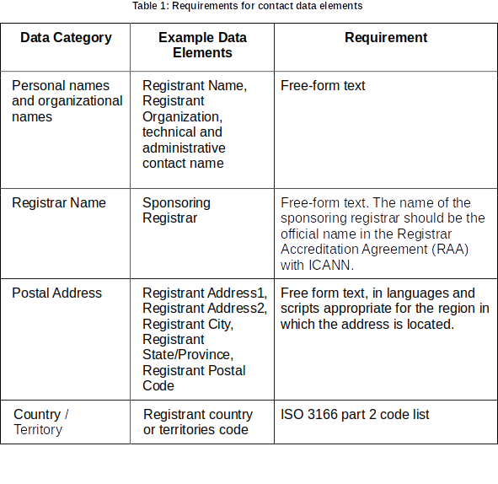
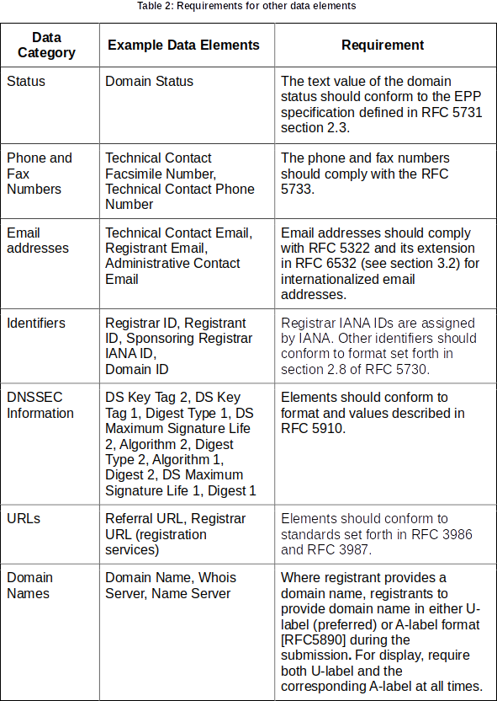
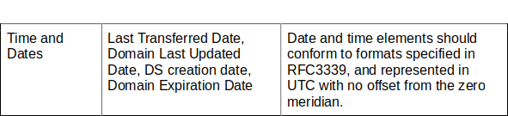

Appendix B. The recommendations of the Translation and Transliteration of Contact Information Policy Development Process
According to the Final Report on the Translation and Transliteration of Contact Information Policy Development Process (https://gnso.icann.org/en/issues/gtlds/translation-transliteration-contact-final-12jun15-en.pdf) the following recommendations were worked out:

- The Working Group recommends that it is not desirable to make transformation of contact information mandatory. Any parties requiring transformation are free to do so on an ad hoc basis outside Whois or any replacement system, such as the Registration Data Access Protocol (RDAP). If not undertaken voluntarily by registrar/registry (see Recommendation #5), the burden of transformation lies with the requesting party.
- Whilst noting that a Whois replacement system should be capable of receiving input in the form of non-ASCII script contact information, the Working Group recommends its data fields be stored and displayed in a way that allows for easy identification of what the different data entries represent and what language(s)/script(s) have been used by the registered name holder.
- The Working Group recommends that the language(s) and script(s) supported for registrants to submit their contact information data may be chosen in accordance with gTLD provider business models.
- The Working Group recommends that, regardless of the language(s)/script(s) used, it is assured that the data fields are consistent to standards in the Registrar Accreditation Agreement (RAA), relevant Consensus Policy, Additional Whois Information Policy (AWIP) and any other applicable policies. Entered contact information data are verified, in accordance with the aforementioned Policies and Agreements and the language/script used must be easily identifiable.
- The Working Group recommends that if the transformation of contact information is performed, and if the Whois replacement system is capable of displaying more than one data set per registered name holder entry, these data should be presented as additional fields (in addition to the authoritative local script fields provided by the registrant) and that these fields be marked as transformed and their source(s) indicated.
- The Working Group recommends that any Whois replacement system, for example RDAP, remains flexible so that contact information in new scripts/languages can be added and expand its linguistic/script capacity for receiving, storing and displaying contact information data.
- The Working Group recommends that these recommendations are coordinated with other Whois modifications where necessary and are implemented and/or applied as soon as a Whois replacement system that can receive, store and display non-ASCII characters, becomes operational.

Appendix C. The ARS studying methodology

A subsample of 12,000 records was taken from an initial sample of approximately 200,000 WHOIS records. The 12,000 records were then evaluated using criteria based on requirements from the 2009 RAA, which acts as a baseline to assess the overall accuracy of WHOIS records in gTLDs. As noted above, Phase 2 reports focus on rates of syntax and operability accuracy by contact mode (email address, telephone number, and postal address) to the requirements of RAAs (2009 RAA or 2013 RAA). The results from the analyzed subsample are then used to estimate the results for the entire gTLD population or the particular subgroup of interest. These data are presented in this report at a 95 percent confidence interval with an estimated percentage plus or minus approximately two standard errors. Based on sampling error, there is a 95 percent chance that the true parameter is within the confidence interval.

