Identification and inventory of ICANN’s implementation

The components of implementation
The term implementation covers a number of aspects which are dealt with below. Implementation involves both contracted parties and the wider population of Internet users. The WHOIS Review Team considers that key elements of successful policy implementation are promoting awareness, the effective communication of policies, fostering a “culture of compliance” and effective enforcement of contractual provisions.
In this report, the term “compliance” is has a wider meaning than “enforcement”. The WHOIS RT’s view is that ICANN should encourage compliance through education, awareness raising and communication. The term compliance is proactive in nature, and involves all parties (ICANN, registries, registrars, registrants and Internet users), acting cooperatively to achieve shared policy goals. In contrast, “enforcement” is a narrower concept, and refers specifically to how the legal obligations of ICANN and its contracted parties, the registries and registrars, are monitored and followed up.
This section is structured as follows:
- [It sets out the steps taken by the WRT to understand stakeholders’ impressions of compliance;]
- It reviews implementation of key contractual terms (highlighted in section [ ] above) relating to ICANN’s contracted parties, registrars and registries;
- It provides an inventory of the ICANN compliance team’s activities as reported in their web pages (ie the view available to interested stakeholders), and by the compliance team themselves.
- [it summarises stakeholder views on the effectiveness of ICANN’s compliance efforts.]

Learning about implementation – interaction with stakeholders
In approaching its task to understand the effectiveness of ICANN’s implementation of its existing WHOIS policy, the Review Team undertook the following consultations:
- ICANN’s contractual compliance team:
  - Presentation at London meeting (January 2011)
  - Face to face meeting in Singapore (June 2011)
  - Visit to Marina del Rey offices (July 2011)
  - Informal interactions
- Registries and registrars
  - Face to face meeting, focused on compliance (June 2011), see Appendix [ ] for list of questions covered.
- Other stakeholders
  - Law enforcement (January 2011)
  - ICANN’s Intellectual Property Constituency (IPC) (telecon, May 2011)
  - ICANN’s Business Constituency, ISPs’ Constituency and IPC face to face meeting (June 2011)
  - ICANN’s At Large Advisory Committee (ALAC) face to face meeting (June 2011)
  - ICANN’s Non-Commercial Users’ Constituency (NCUC) face to face meeting (June 2011).
- Public comment
  - The Review Team’s discussion paper, published in June 2011, raised 7 questions relating to implementation. The responses to these questions are discussed under the gap analysis at section [ ] below.

Link between the contracts and compliance

Registrar Accreditation Agreement (RAA)
The Registrar Accreditation Agreement (RAA) governs all registrar contracts. A revised version was introduced in 2009, to which [90%] have signed up. The previous version [date] remains in force for [10%] of registrars. The provisions
As explained in section [ ] above, there are three principal obligations for Registrars set out in the RAA, 2009.
- Registrars must allow public access to WHOIS data (3.3)
- Registrars must obtain registered domain holders’ consent to terms of registration, which include obligations on the registered domain holder to:
  - Provide and maintain accurate data
  - Accept that the domain name can be cancelled for failure to do so (3.7.7).
- Registrars must take reasonable steps to investigate inaccuracies (3.7.8).

Registry Agreements
Registry contracts are individually negotiated, and the WRT has considered all current contracts between ICANN and its Registries.
In general, obligations relating to WHOIS are consistent across the contracts, with the notable exception that VeriSign, the .com registry, is obliged only to provide a “thin” WHOIS.
Otherwise, it was noted that there was inconsistent use of terminology across the Registry contracts relating to WHOIS, and that apparently identical obligations were described differently.
However, the relevant provisions relating to WHOIS are:
- 3.1 (c) (i) Data Escrow which refers to Appendix 4: Report (Escrow) Container [Michael, have I got this right? Please expand on why this is relevant]
- 3.1 (c) (v) describes the Whois Service, and refers to Appendix 5 and 7. Appendix 5 sets out a full WHOIS specification, including:
  - Reference to RFC954,
  - WHOIS Service Data Elements,
  - WHOIS Output Fields,
  - WHOIS Provider Data Specification (Procedures, Format),
  - WHOIS Data Specification - ICANN
- Appendix 7 contains WHOIS Service Requirements, Performance Specifications etc.
- Appendix S (Part 6): Public WHOIS Specification
[Michael please add any extra explanation here]

Key concepts
Two key concepts carry through the contractual obligations, and are echoed in the Affirmation of Commitments. These are:
- The availability of WHOIS data; and
- Accuracy of WHOIS data.
In its gap analysis, this report will review the current WHOIS policy and its implementation against these two concepts, and will also consider the extent to which the concepts are compatible with each other, and with applicable laws.

Inventory of compliance activity

What do the public see? ICANN’s website
The WRT identified that in order for a policy to be effective, it must not only be implemented, but also communicated effectively. Communication of policy is important because it feeds a public awareness of the norms and standards expected. Without effective communication, the legitimate expectations of the distinct stakeholder groups who rely on WHOIS will remain unmanaged, leading to sometimes unnecessary conflict, or complaints.
In reviewing the effectiveness of ICANN’s implementation of WHOIS policy, the WRT considered what a member of the public, or other interested stakeholder would learn from ICANN’s website.
In general, strengths are the publication of the compliance team’s operating place, reports of its activities, and of studies on Data Accuracy and Privacy/Proxy.
Areas for improvement are that locating information is extremely difficult: compliance pages are hidden away, heavy with jargon (eg WDPRS), and assume a level of knowledge by users which may not exist in practice. The home compliance page is a jumble of news links, mixed in with explanatory pages, and a user has to scroll down the page to find out what the compliance team is.
While the presentation of the pages may be thought of secondary importance compared to the work of the team itself, the WRT heard from compliance team staff that users tended to ‘misunderstand’ their role, what they could and could not do.
Moving to more detailed comments, it is difficult to locate the pages relating to contractual compliance from ICANN’s current home page:

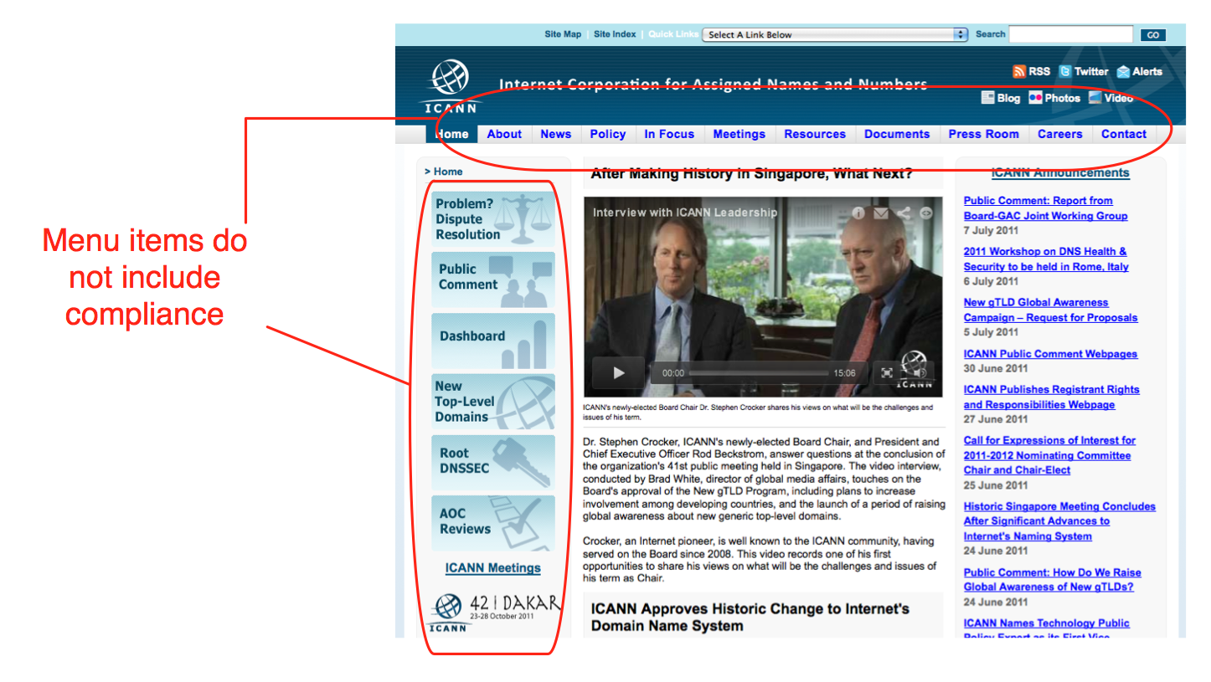

A user can find the contractual compliance pages in two ways: first by following the “In focus” link (whose contents are not obvious from the label) from the top menus, and finding contractual compliance amongst an alphabetical list of ICANN’s activities; second, by following a single link located at the bottom of the home page:

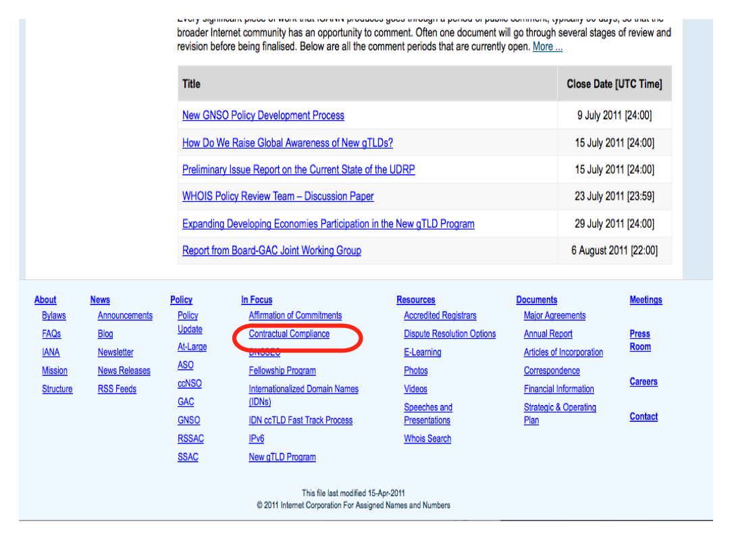
Having located the compliance pages, the user is presented with a jumble of news items (Notices of Breach, Termination and Non-Renewal, Compliance related correspondence, Updates to Notices). Only underneath this, is a heading “What is the ICANN Contractual Compliance Program?” which explains that “ICANN has a limited technical and policy coordination role” – an important piece of information for stakeholders, and one which the compliance team members observe has not filtered through into the minds of people who contact them asking for help.
Even further down, is an “Operating Plan”, which enunciates 8 principles. These are:
- Work constructively with registrars and registries to foster a culture of compliance.
- Proactively monitor compliance by contracted parties
- Resolve contractual compliance matters informally, if appropriate
- Aggressively pursue cases of non-compliance
- Maintain the highest standards of integrity and professionalism
- Continue to develop and enhance procedures for consistent handling of compliance matters
- Analyse WDPRS reports and consumer complaint data to analyse trends
- Provide timely reporting of Contractual Compliance activities
The principles themselves are strong, and sensible. They emphasise partnership with registries and registrars, as well as fostering a culture of compliance – the softer, normative controls which are essential in situations where the responsibility for a successful outcome is spread across a number of organisations, through to the individual registrant.
The use of jargon in principle 7 is out of place, as is the jump to a detailed operational intervention, amongst other high level statements.
Despite the 8th operating principle, there are notable gaps in the timely reporting of contractual compliance activities:
- The ICANN contractual compliance newsletters began in 2008 and are stated to be “monthly”. Indeed, there were 6 monthly newsletters between April-September 2008. Thereafter publication dropped off. There was a further newsletter in December 2008, one in October 2009 and then in April and October 2010. There have been no monthly newsletters published in 2011 (as of July 2011).
- Likewise, the “Semi-Annual” reports were published once in 2007, and 2008, twice in 2009 and there have been none since.
It may be that these newsletters and semi-annual reports have been superseded with other forms of communications. But this is not clear to a casual user with no knowledge of ICANN’s inner workings.
In general, there is a sense that key documents are missing. In the WRT’s view, this indicated what the compliance team themselves told us – they are overstretched, and have struggled to obtain priority (in terms of budget or visibility) within the organisation, and to fill vacant positions. In such circumstances, communication with the outside world tends to be the first thing to go.

How does ICANN describe its compliance work relating to WHOIS?
According to ICANN’s web pages relating to compliance, the Compliance Team’s work spans a range of ten areas, including functional and performance specifications, equivalent access to registry services, and data escrow. ICANN describes its WHOIS work as follows:
“This is a multi-level area and the subject of an ongoing PDP. Registries are required to provide a public Whois service, containing required data elements. They must also provide access to the Whois data to ICANN and to a third-party operator in the event that a centralized Whois system is developed. Compliance questions include whether the registry is providing appropriate access, meeting update frequency requirements, and following bulk access provisions. We will continue to enforce any Whois policies which may be developed and adopted as a consensus policy as a result of the PDP. We are also working to coordinate with registries the use of compatible formats (as an example, the Whois Data Problem Report System which encompasses all registries but requires several mapping tables which must be maintained and corrected by staff).”

Focus on specific compliance activities:
At the WRT’s meeting in January 2011, the compliance team presented a helpful review of their work, and highlighted the activities set out below. Their communication with the WRT was characterized by openness, professionalism, and candour. They summarized their work as:
- Conducting audits to assess compliance with RAA provisions
- Investigating complaints of non-compliance
- Escalating cases in which registrars do not comply after informal efforts to bring those parties into compliance fail.

1. Audits
According to the Compliance Team, the following WHOIS-related audits have been undertaken since 2008:
2010 – Registrar Whois Data Access Audit
2010 – Registrar Whois Data Reminder Policy Audit
2009 – Registrar Whois Data Reminder Policy Survey
2008 – Registrar Whois Data Reminder Policy Survey
2008 – Registrar Whois Data Inaccuracy Investigation Audit

1. WHOIS Data Access Audit 2010
The 2010-11 Registrar WHOIS Data Access Audit concluded that 99% of registrars comply with their contractual obligations to provide Port 43 access to WHOIS services. The Audit gave rise to 11 compliance interventions by the ICANN team, of which 10 were resolved through dialogue. In the single outstanding case, the registrar accreditation agreement was terminated for breach.
This is an example of a successful compliance intervention. The parameters of the audit were limited, relating squarely to a contractual obligation which is clear to both registrars and ICANN (ie the obligation to provide Port 43 access to WHOIS data). The follow-up action is well documented, and exemplifies ICANN compliance’s first operating principle: working constructively with registrars. There is also a strong sense that compliance improved as a result of the intervention – an important aspect, which directly impacts on staff morale.
Areas for improvement include communication, sustaining the momentum and developing performance measures/goals over time. The Audit Report is published as a PDF following a link on the Compliance home page. However, the communication would be enhanced if, as well as the detailed report, there was a brief summary of key facts and outcomes, and how the intervention supports the Compliance Team’s operational goals. For example, there is good news about this approach as an example of working in partnership with registrars, but this message is hidden amongst a plethora of links, updates (which assume pre-existing knowledge on the part of the user) and background information.

2. WHOIS Data Reminder Policy Audits 2008-2010.
Three of the above interventions relate to ICANN’s WHOIS Data Reminder Policy. Confusingly, the acronym for this, WDRP, is nearly identical to one of the few other key compliance activities, the WHOIS Data Problem Reporting System, WDPRS – and ICANN is giving itself an unnecessary communications challenge in this regard.
At the time of writing, the 2010 WHOIS Data Reminder Policy Audit Report has not yet been published for comment.
The WHOIS Data Reminder Policy requires every registrar to send a notice to each registrant at least annually and remind the registrant that the provision of false data can be grounds for cancellation of a registration. Registrants must review their Whois data and make any necessary corrections.
Registrars told the WHOIS Review Team that the costs of sending the notices are substantial, in terms of the support load generated (registrants questioning why they received the notices) and disruption to business (eg by being mistakenly blacklisted for spam as a result of sending out the notices).
According to the 2009 report (the 6th annual report on registrar compliance), 93% of registrars participated, of which 99% were found to be in compliance.
However, 83% of registrars who responded said that they were unable to track the changes resulting from the WHOIS Data Reminder notices. Therefore, it is impossible to measure the impact of this flagship policy on improving data accuracy.

3. Registrar Whois Data Inaccuracy Investigation Audit, 2008
The issue of data inaccuracy is described more fully under [ ] below.

2. Investigate complaints of non-compliance

1. WHOIS Data Problem Report System (WDPRS)
ICANN introduced the WHOIS Data Problem Report System (WDPRS) in 2002, and is described as “one of the tools developed to assist registrars in carrying out their responsibility to investigate WHOIS data inaccuracy claims”. The goal of the WDPRS is to streamline the process for receiving and tracking complaints about inaccurate and incomplete WHOIS data, and thereby help improve the accuracy of WHOIS data.
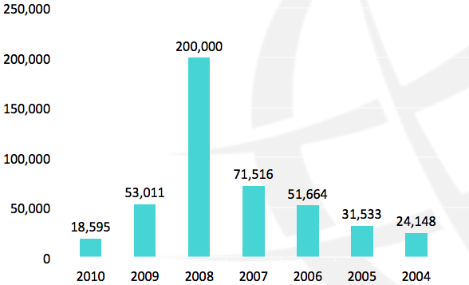
Its purpose is to receive and track complaints about inaccurate or incomplete Whois data entries. Users can raise problems by completing an online form, which ICANN then forwards to the registrar of record for appropriate action.
The number of WDPRS Reports received by ICANN since 2004 is as follows:

According to a report in 2007, there were 50,189 reports for which ICANN received follow- up responses during the year. Of these, 34,029 unique domain names were subject to reports. Thus, 16,160 duplicate reports were submitted. In 2006, 51,664 submissions were received, relating to 25,219 unique domain names.
It is unclear how widely known the WDPRS is amongst stakeholders who rely on the WHOIS. For example, in 2007, 10 people were responsible for 87% of all WHOIS inaccuracy reports. Considering the WHOIS Data Accuracy Study’s finding that there was some inaccuracy in 77% of gTLD domain name records (equating to approximately 98 million gTLD inaccurate domain name records), and near total failure in 21% (equating to 26.9 million), the number of WDPRS reports is small, and the base of complainants is tiny.
In 2007, approximately 53% of the reports indicated “spam”, “phishing” or “fraud” in the comments accompanying the report, indicating a correlation between fraudulent or antisocial use and inaccurate WHOIS data.
As for follow-up, the WDPRS requires the registrar to report back to ICANN after 15 days. ICANN provides provides a pro-forma template for the registrar to indicate what action was taken, as follows:
a) registrar verified contact info is correct
b) domain suspended, deleted or expired (system automatically closes ticket)
c) contact info updated
d) more time requested (one time option)
This is helpful, because it provides the opportunity to quantify the response, and provide metrics for success.
In 2007, ICANN reported that an estimated 35% of reported domain names with bad data were corrected, suspended, or no longer registered. An additional 28% of domains with clearly bad information were not changed. For the remaining 37% of reported domains, the WHOIS data was without obvious errors.
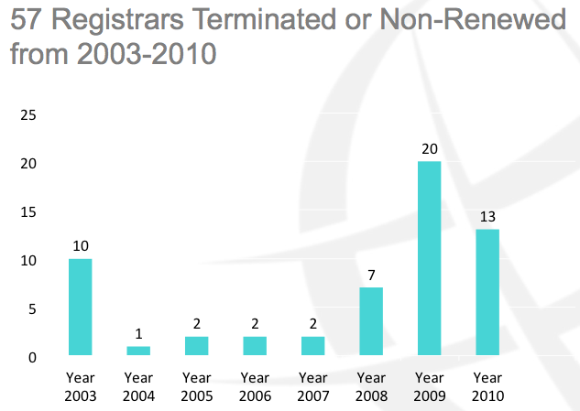
Clearly, given the prevalence of inaccuracy found in 2010, the significant drop in WDPRS in the same year is of concern. However, the follow up (measured by ICANN Compliance Team’s indicator of “registrars terminated or non-renewed”) has improved since 2007. 26% of terminations/non-renewals since 2007 reference WHOIS Non-compliance [redo chart to show proportion of WHOIS terminations (1 in 2007, 0 in 2008, 10 in 2009, 4 in 2010)]:

[Explore reasons for improvement with compliance team]

Other WHOIS Related Work and Efforts
The following reports were highlighted by the Compliance Team as other WHOIS related work and efforts.

1. Privacy/Proxy study 2009
A study on the prevalence of privacy and proxy services relating to WHOIS data was undertaken by [ the National Opinion Research Center (NORC) at the University of Chicago, USA ], and published by the compliance team in 2009. It found the proxy or privacy services were used in approximately 15-25% of WHOIS records. It also defined the terms “proxy” and “privacy” services, and set out a methodology for classification. Out of scope for the study were an analysis of the costs or a differentiation of proxy/privacy services.
This is a good example of an evidence-based approach, within simple, stated parameters, to inform both policy and compliance activities. It shows that use of proxy/privacy services is widespread, indicating a strong market demand for such services. This makes the policy lacuna relating to proxy/privacy services all the more concerning. The study has the potential to contribute to the collective understanding. However, it is impossible to find without the specific URL, as there is no link to it from the compliance pages.
There is also a sense of this study existing in isolation: it is unclear what, if any, follow-up steps are recommended or have been taken, and how this evidence was or will be fed into ICANN’s policy making or operational processes.

2. Study of WHOIS Accuracy 2010
In January 2010, a study of WHOIS Accuracy, undertaken by NORC at the University of Chicago, USA, was published. This was the first in a series of WHOIS studies commissioned by ICANN. Others [eg …] are ongoing at this time, and will no doubt inform subsequent WHOIS Review Teams.
A stated purpose of the WHOIS Accuracy Study was to inform ICANN’s compliance effort. The study found that:
- 23% of WHOIS records show “no failure”, ie are fully accurate according to the strictest criteria
- 21% of records show “substantial” or “full” failure, meaning that it is impossible to make contact with the registered holder.
- For the remaining 56% of records, it is possible to contact the registered domain holder (and the Study makes a number of classifications indicating the degree of difficulty in making contact).
The Study also acknowledges the growing use of privacy and proxy services.
The Study gives a helpful insight into the types of inaccuracy encountered. For example, the most common error was tardiness in keeping data updated following a change of address. Another apparent inaccuracy (where in fact the records were accurate) arose from script transliteration problems between non-Latin scripts and ASCII.
These examples illustrate that the concept of “accuracy” is nuanced, and one which would merit further consideration in the context of WHOIS, in particular to consider what are the accuracy needs of the various stakeholders who rely on WHOIS.
The Study commented that there were low incentives for registrants to keep their data accurate, and a sense that there were no adverse consequences for failure to do so. It highlighted as barriers to accuracy that no proof of identity is required to register a domain name, and that there is no requirement for the registrant’s full legal name to given. On a practical level, the Study noted that respondent confusion at the point of data entry could also decrease data accuracy (for example the requirement to fill in at least three sets of name and address for administration, technical and billing contacts).
Considering the Study in terms of its stated objective as contributing to ICANN’s compliance effort, it provides a helpful baseline, founded in evidence which quantifies the extent of WHOIS data inaccuracy for the first time. In this way, it supports the hunch of many involved in policy discussions, law enforcement or brand protection. Some (including members of the WHOIS Review Team) have questioned the categorization of WHOIS data into [5] separate strands. However, the utility of the metrics will become apparent in later studies according to the same criteria, as only then will it be clear whether compliance efforts are having a measurable impact on improving data accuracy over time.
Despite the strengths of the Study, several concerns remain. It is unclear what ICANN’s compliance response to the Study has been, whether its systems or processes have been reviewed as a result. It is also unclear whether there is a plan from the Compliance team to demonstrate improvements over time, what metrics would apply, and what targets are in place. In fact, it is difficult to see whether any follow-up measures have been implemented.
[Again, from a transparency point of view, the Study is difficult to find on the ICANN website].

What the stakeholders told us

ICANN’s compliance team
The WRT met with members of the compliance team both formally and informally on several occasions. We found the compliance team to be helpful and cooperative with our investigations. As individuals, they exuded a strong sense of professionalism, and of commitment to their task and to ICANN. At the same time, they were open about the challenges they face, their frustration at lack of resources (both staffing and automated workflows), they felt that their contractual powers were lacking in key aspects, which hampers their effectiveness, and perceived that external stakeholders did not adequately understand their role, or the constraints within which they operate.
The Compliance Team voiced particular frustration that WHOIS data is not validated at the point of registration. They expressed the view that without validation of user data, it was near impossible for to achieve compliance in terms of data accuracy. Another weakness, in their view, with regard to WHOIS Data Problem Reporting System, was that they had no power to compel registrars to update the information. In effect, they told us, they felt that they were just “throwing the problem over the wall”.
[The WRT found the team’s presentation at our London meeting helpful, and informal dialogue. The meeting in Singapore was less successful, as it repeated many of the messages from earlier meetings, but in less detail, and contradicted a number of the statements made on those occasions.]
[INSERT information about visit to Marina del Rey]

ICANN’s Intellectual Property Constituency

The high level message given to the WRT by members of the Intellectual Property Constituency (IPC) was, “If you read the contract in isolation, it ought to work. In practice, it does not happen.”
Much of the interaction focused on perceived difficulties with privacy and proxy services. IPC members recognised that there are legitimate reasons for business and individuals to use such services, and described the IPC as “extremely supportive” of them.
IPC members informed us that “with the good players there’s a process for getting registrant data from proxy services”, but that some registrar providers of proxy/privacy services “never respond”.
IPC members stated the opinion that “The contracts say everything that’s needed, but no one is enforcing the contracts”, and expressed frustration at a perceived “lack of resources” within ICANN for compliance.
Other comments included support from some IPC members of progressive remedies, or promotion of good practices, but they felt that there were no incentives for “bad players” to sign up. Some IPC members acknowledged that “inexperience, not malice, is sometimes the reason for non-compliance”.

Business and ISPCP constituencies

[add comments]

GAC

[add comments]

Registries and Registrars
In striking contrast to the comments received from other constituencies, including ICANN’s Compliance Team, the Registrars and Registries were extremely positive about the effectiveness of the implementation of WHOIS policy.
[add specific comments]
The gap in perceptions between the Registries and Registries (the contracted parties who are regulated by ICANN’s Compliance Team) and all the other constituencies we spoke to merits further exploration.

ICANN Compliance Team’s Operating Plan, item 1 http://www.icann.org/en/compliance/, accessed 7/7/11
April 2008: “Each month, the newsletter will cover….”
See http://www.icann.org/en/compliance/newsletter/
See http://www.icann.org/en/compliance/reports-archive-en.htm, accessed 8 July 2011
http://www.icann.org/en/compliance/gtld-compliance.htm, accessed 11 July 2011.
http://www.icann.org/en/compliance/archive/update-wdprs-enhancements-09mar11-en.htm, accessed 11 July 2011.
www.icann.org/en/whois/whois-data-accuracy-program-27apr07.pdf, accessed 11 July 2011
Source: ICANN Compliance Team, presentation to WHOIS RT, January 2011.
www.icann.org/en/whois/whois-data-accuracy-program-27apr07.pdf, accessed 11 July 2011
Derived from VeriSign Domain Name Industry Brief, May 2011 issue, which reports that the total number of domains registered is 209.8 million, with the ccTLD base being 81.7 million. Therefore the total of gTLDs is 128.1 million. If 23% are completely accurate (29.5 m) then 77% are in some way inaccurate (98.7 m). See http://www.verisigninc.com/en_US/why-verisign/research-trends/domain-name-industry-brief/index.xhtml

