DRAFT_20170426v1.2JB

SSR2-RT Meeting #11

Face-to-Face Meeting #2

Madrid, Spain – 14-15 May 2017

Venue:  NH Collection Eurobuilding  Padre Damián, 23. 28036, Madrid, España  Tel.: +34 91 3537300  Map | Reading list & session archives: https://community.icann.org/pages/viewpage.action?pageId=64082359  SSR2-RT Members - Remote participation: Refer to calendar invite for dial-in details. Sessions are being archived and follow the ICANN Expected Standards of Behavior: http://www.icann.org/en/news/in-focus/accountability/expected-standards  Observers – In-person/remote participation: Observers may join the session in-person or remotely. Refer to details below for remote participation in the break-out sessions you are interested in. Feedback can be relayed to the SSR2-RT at any time via: input-to-ssr2@icann.org (publicly archived).  Questions? Contact staff at ssr2-staff@icann.org  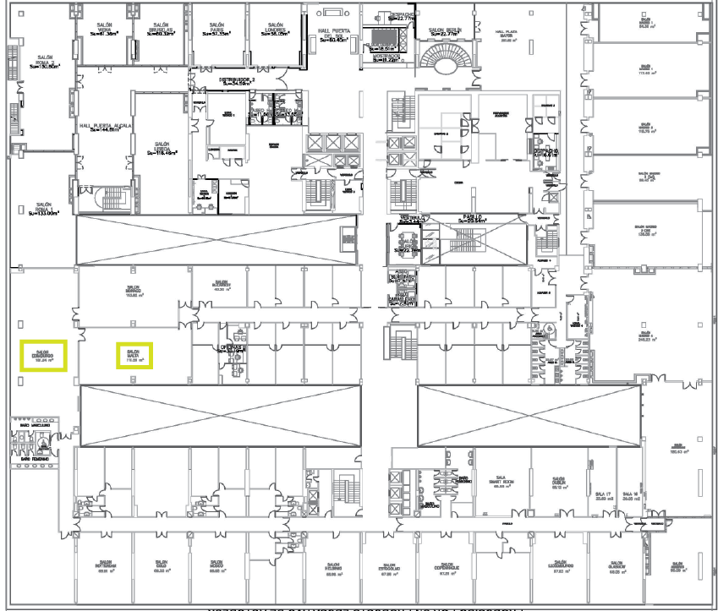

Friday, 12 May 2017 | 18:30 – 20:30 CEST
ICANN DNS Symposium Meet & Greet Welcome Reception
Florencia Room
-------------
  - Day 0 – Saturday, 13 May 2017 | 09:00 – 17:00 CEST | 07:00 – 15:00 UTC (timezone converter)

ICANN DNS Symposium
The ICANN DNS Symposium is a one-day event focused on all aspects of the domain name system (DNS). Join
members of the ICANN organization to explore ICANN's current initiatives and projects relating to DNS research,
operations, threats and countermeasures and technology evolution. More information and registration details: https://www.icann.org/ids.
Remote participation in English: Adobe Connect Link | Link to Dial-in Numbers | Participant Passcode: 3801410560

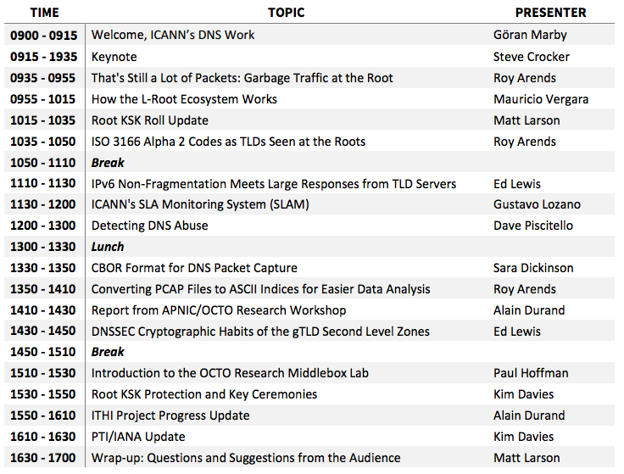

Day 1 – Sunday 14 May 2017 | 08:30 – 17:30 CEST | 06:30 – 15:30 UTC (timezone converter)
Meeting Room: Salon Edinburgo / https://participate.icann.org/ssrreview-observers
1. Welcome, rollcall, Statement of Interest updates and opening remarks (08:30 - 09:00)
2. SSR1 Implementation Briefing: Office of the CTO (09:00 - 12:00)
David Conrad, (ICANN Chief Technology Officer), Steve Conte (ICANN Office of the CTO Programs Director), John Crain (ICANN Chief Security, Stability & Resiliency Officer, David Piscitello (VP of Security and ICT Coordinator – ICANN Security, Stability & Resiliency Team)

- SSR Framework
- Recommendation #1: ICANN should publish a single, clear and consistent statement of its SSR remit and limited technical mission. ICANN should elicit and gain public feedback in order to reach a consensus-based statement.
- Recommendation #4: ICANN should document and clearly define the nature of the SSR relationships it has within the ICANN Community in order to provide a single focal point for understanding the interdependencies between organizations.
- Recommendation #5: ICANN should use the definition of its SSR relationships to maintain effective working arrangements and to demonstrate how these relationships are utilized to achieve each SSR goal.
- Recommendation #14: ICANN should ensure that its SSR-related outreach activities continuously evolve to remain relevant, timely and appropriate. Feedback from the Community should provide a mechanism to review and increase this relevance.
- Recommendation #15: ICANN should act as facilitator in the responsible disclosure and dissemination of DNS security threats and mitigation techniques.
Break (10:30 – 10:45)

- Recommendation #16: ICANN should continue its outreach efforts to expand Community participation and input into the SSR Framework development process. ICANN also should establish a process for obtaining more systematic input from other ecosystem participants.
- Recommendation #18: ICANN should conduct an annual operational review of its progress in implementing the SSR Framework and include this assessment as a component of the following year’s SSR Framework.
- Recommendation #19: ICANN should establish a process that allows the Community to track the implementation of the SSR Framework. Information should be provided with enough clarity that the Community can track ICANN’s execution of its SSR responsibilities, while not harming ICANN’s ability to operate effectively. The dashboard process being used to track implementation of the ATRT recommendations serves as a good model.
- Recommendation #24: ICANN must clearly define the charter, roles and responsibilities of the Chief Security Office Team.
- Recommendation #28: ICANN should continue to actively engage in threat detection and mitigation, and participate in efforts to distribute threat and incident information.

2.1 (Other briefings TBD)
Review Team Lunch (12:30 – 13:15) Salon Malta
3. Identifier Technology Health Indicators (ITHI) (13:15 – 14:15)
Steve Conte (ICANN Office of the CTO Programs Director)
- Questions from ITHI session at DNS Symposium
- How does ITHI fit into RT’s scope?
- Which areas of ITHI are particularly important for RT’s consideration?
- Areas of risk missing from ITHI?
4. SSR2-RT Reflection on SSR1 Implementation Briefings (14:15 – 17:15)
- How can the RT best evaluate the implementation of recommendations?
- Do the recommendations of SSR1 effectively address all the concerns raised in the report?
- What information does the RT need to assess the effectiveness of the recommendations and its implementation?

Break (15:00-15:15)

- What does the RT want its SSR1 recommendation implementation report to look like?
- What process does the RT want to use to reach final approval on the report on SSR1 recommendations?
- Who provides drafting instructions? (RT, Co-Chairs, sub-group?)
- Staff draft
- Who reviews draft report (RT, Co-Chairs, sub-group?)
- How to get final approval by RT?
- Public consultation on this part or integrated in main report?

6. A.O.B, recap of action items and closing remarks (17:15 - 17:20)
7. Recap of action items and closing remarks (17:20 - 17:30)

Day 2 – Monday 15 May 2017 | 08:30 – 17:30 CEST | 06:30 – 15:30 UTC (timezone converter)
Meeting Room: Salon Edinburgo / https://participate.icann.org/ssrreview-observers
1. Day 1 recap, outstanding items (08:30 - 09:00)
2. Terms of Reference & Work plan (09:00 – 10:30)
- Areas of contention discussed on email list and during plenary calls
- Are there areas where we need more information to inform our scope?
- Is there any further information ICANN organization can provide us to inform scope development? How can the RT work best effectively and efficiently?
- Is our approach to work working so far?
- Should the RT have sub-teams?
- How should we divide the sub-teams?
- How do we determine sub-team membership and leadership?
- How can we maintain transparency throughout our work?
- Do we need other background materials to inform our work?
Break (10:30 – 10:45)
3. Project plan and timeline (10:45 – 12:30)
- What are our key milestones?
- What are the barriers to meeting key milestones?
- How can we ensure we stay on target with the review timeline?
Review Team Lunch (12:30 – 13:15) Salon Malta
4. Outreach plan and next steps (13:15 – 15:00)
- What is the objective of outreach?
- How can we determine if outreach is successful?
- What organizations should the RT meet with to discuss the objective and purpose?
- What opportunities can we utilize for outreach efforts, e.g. individual meetings?
Break (15:00 – 15:15)
5. Next face-to-face meeting (15:15 - 17:00)
- What does the RT hope to achieve at the next face-to-face meeting?
- What groups does the RT wish to receive briefings from during the meeting?
- What materials should the RT prepare ahead of the meeting?
- What do we need from ICANN Organization to help us best prepare for the meeting?
6. A.O.B (17:00 - 17:10)
7. Recap of action items and closing remarks (17:10 - 17:30)

