DRAFT_20170504v1.5

SSR2-RT Meeting #11

Face-to-Face Meeting #2

Madrid, Spain – 14-15 May 2017

Venue:  NH Collection Eurobuilding  Padre Damián, 23. 28036, Madrid, España  Tel.: +34 91 3537300  Map | Reading list & session archives: https://community.icann.org/pages/viewpage.action?pageId=64082359  SSR2-RT Members - Remote participation: Refer to calendar invite for dial-in details. Sessions are being archived and follow the ICANN Expected Standards of Behavior: http://www.icann.org/en/news/in-focus/accountability/expected-standards  Observers – In-person/remote participation: Observers may join the session in-person or remotely. Refer to details below for remote participation in the sessions you are interested in. Feedback can be relayed to the SSR2-RT at any time via: input-to-ssr2@icann.org (publicly archived).  Questions? Contact staff at ssr2-staff@icann.org  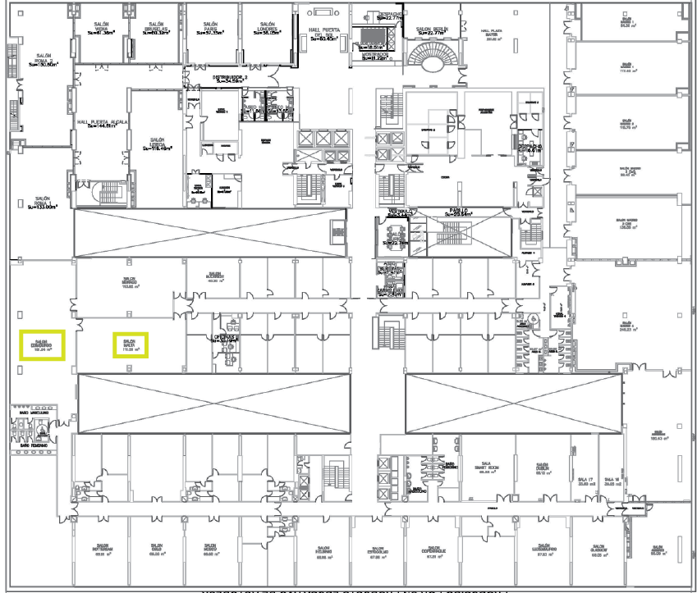

Friday, 12 May 2017 | 18:30 – 20:30 CEST
ICANN DNS Symposium Meet & Greet Welcome Reception
Florencia Room
-------------
  - Day 0 – Saturday, 13 May 2017 | 09:00 – 17:00 CEST | 07:00 – 15:00 UTC (timezone converter)

ICANN DNS Symposium
The ICANN DNS Symposium is a one-day event focused on all aspects of the domain name system (DNS). Join members of the ICANN organization to explore ICANN's current initiatives and projects relating to DNS research, operations, threats and countermeasures and technology evolution. More information and registration details: https://www.icann.org/ids.
Remote participation in English: Adobe Connect Link | Link to Dial-in Numbers | Participant Passcode: 3801410560
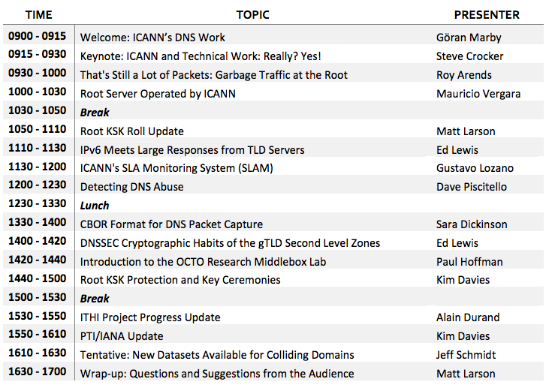

Day 1 – Sunday 14 May 2017 | 08:00 – 17:00 CEST | 06:00 – 15:00 UTC (timezone converter)
Meeting Room: Salon Edinburgo / https://participate.icann.org/ssrreview-observers
1. Welcome, rollcall, Statement of Interest updates and opening remarks (08:00 – 08:30)
2. Threat Landscape and DNS Symposium Follow-up – Briefing and Discussion (08:30 - 10:00)
- Office of the Chief Technology Officer (OCTO) Staff briefing/discussion on the threat landscape facing ICANN, including key risks/challenges now and in the future
- Follow-up questions/discussion on matters addressed at ICANN DNS Symposium (time for Team members to ask questions that arose from yesterday’s session)
3. SSR1 Implementation Briefing: OCTO Staff (10:00 - 12:30)
David Conrad (ICANN Chief Technology Officer), Steve Conte (ICANN Office of the CTO Programs Director), John Crain (ICANN Chief Security, Stability & Resiliency Officer), Patrick Jones (Senior Director, ICANN Global Stakeholder Engagement), David Piscitello (VP of Security and ICT Coordinator – ICANN Security, Stability & Resiliency Team)
- SSR1 implementation overview
- SSR Framework
  - Recommendation 1
  - Recommendation 18
  - Recommendation 19
Break 10:30-10:40
- ICANN’s SSR role and remit within its limited mission
  - Recommendation 24
- SSR relationships to support ICANN’s work
  - Recommendation 4
  - Recommendation 5
- SSR community outreach and info sharing – security threats & mitigation
  - Recommendation 14
  - Recommendation 15
  - Recommendation 28
  - Recommendations 16
- Additional information
Review Team Lunch (12:30 – 13:15) Salon Malta
3. SSR2-RT reflection on SSR1 implementation briefings – Discussion (13:15 – 14:30)
- What are Team members’ thoughts on implementation?
- How can the RT best evaluate the implementation of recommendations?
- Do the recommendations of SSR1 effectively address all the concerns raised in the report?
- What additional information does the RT need to assess the effectiveness of the recommendations and its implementation?
- Next steps?
4. Identifier Technology Health Indicators (ITHI) Discussion (14:30 – 15:30)
Steve Conte (ICANN Office of the CTO Programs Director)
- Team member questions from ITHI session at DNS Symposium?
- How does ITHI fit into RT’s scope?
- Which areas of ITHI are particularly important for RT’s consideration?
Break 15:00-15:10
- Are there areas of risk missing from ITHI?
5. A.O.B, recap of action items (15:30 - 16:30)
6. Review tomorrow’s agenda, closing remarks (16:30 - 17:00)

Review Team Dinner (19:30)
Domo
NH Collection Eurobuilding
https://www.domoeurobuilding.com/restaurante/
Phone: +34 91 345 61 60

Day 2 – Monday 15 May 2017 | 08:30 – 17:30 CEST | 06:30 – 15:30 UTC (timezone converter)
Meeting Room: Salon Edinburgo / https://participate.icann.org/ssrreview-observers
1. Proposed SSR2 work approach (08:30 – 10:00)
Led by James Gannon
- How does the SSR2-RT propose to approach its work in blocks?
- How do we best approach the work in each block (subgroup)?
- How should we assign membership of each subgroup?
Break (10:30 – 10:40)
3. Work plan and timeline (10:40 – 12:30)
- Is there any further information ICANN organization can provide us to inform or work?
- What additional data do we need?
- Do we need additional support (consultant)?
- How can the RT work best effectively and efficiently?
- What are our key milestones?
- What are the barriers to meeting key milestones?
- How can we ensure we stay on target with the review timeline?
Review Team Lunch (12:30 – 13:15) Salon Malta
4. Subgroup discussions (13:15 – 15:15)
- Confirm group topics and identify group members
- What are the next steps for each group?
- (Subgroup meetings if appropriate)
Break (15:15 – 15:30)
5. Outreach plan and next steps (15:30 – 16:30)
- Review current outreach mechanisms, objectives, draft outreach target list
- Based on workplan, what groups should the RT outreach to and what’s the objective and purpose?
- What opportunities should we use for outreach efforts, e.g. conference calls, meetings?
6. Items requiring additional discussion & A.O.B (16:30 - 17:10)
7. Recap of action items and closing remarks (17:10 - 17:30)

