SSR2 RT – DNS SSR Work Stream
This work stream relates to Bylaw 4.6(c) (ii) A, 4.6(c) (ii) B, 4.6(c) (ii) C, and 4.6(c) (iii) and focused on the effectiveness of ICANN’s stewardship over the areas of the Internet’s globally unique identifier systems over which ICANN has purview. The evaluation of this effectiveness necessarily considers performance indicators, measures, and metrics that span administrative domains and operations that include (but are not limited to) ICANN. However, the focus of this work relates only to those systems within ICANN’s remit.

Methodology Statement
The methodology of this sub-team focuses on the identifier systems which the review will evaluate: the global DNS, the IANA numbers databases (IP allocations and ASNs), and the IANA protocol registries. As each of these areas support complex networked systems to different degrees and in very different ways, the evaluation of them must be done in varying ways. Understanding the way that these identifiers are used is a critical component in evaluating “the effectiveness of the security efforts to deal with actual and potential challenges…” In part, this becomes necessarily complicated to measure because, for example, abuse in a user-facing application could conceivably only be possible because of an otherwise seemingly innocuous feature of a supporting component of the globally unique identifier system.
In order to evaluate the complex and multidimensional nature of the globally unique identifier system, its usage is a critical consideration. Therefore, the methodology to evaluate its SSR (for those portions under ICANN’s purview) must start by broadly considering actual concerns, threats, attacks, abuse, other dependent signals and then mapping those signals to the relevant ICANN component(s), procedures, policies, etc. Due to the nature and complexity of abuse and SSR signals, it is anticipated that there might be multiple systems, policies, or other enabling components that work together. Those elements or systems that enable or facilitate actions, behaviors, etc. are broadly considered to be “dependent systems.” The extent to which there is a relation to elements that fall under ICANN’s purview, and that relation is contributory to the signal, is the extent to which the signal is included in this evaluation. This logic is illustrated in the figure below. For example, abuse that includes a DNS component, but only at hierarchical level below ICANN’s operations would not be a relevant consideration for this work stream. However, if that example abuse were only able to be effectuated because of contents of the DNS Root Zone, or because a registry was operating outside of contractual operational norms, then there would be a causal relationship whose relevance would fall within the remit of this review team’s evaluation.
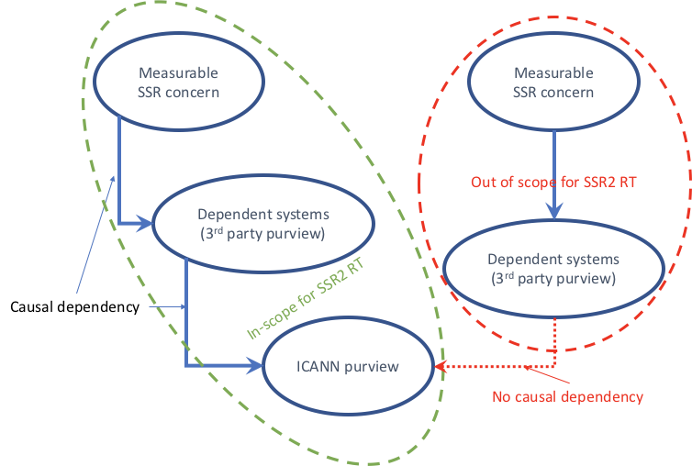

Issues
These qualitative concerns will be decomposed into more precise concerns, and those elements that fall within the purview of this work-stream (per the above) will result in recommendations.

Who needs to be interviewed, what questions do we need answered

Root KSK Rollover
<>

Alternate Root Deployment and Co-Existence
<>

Root Zone SSR Measurement Reports
<>

Top-Level Domain SSR Measurement Reports
<>

Namespace Abuse
<>

IANA Registry SSR Measurement Reports
<>

Root KSK Cryptography
<status, agility, etc.>

IANA Numbers Abuse
<>

Change control for the root zone
<>

Recommendations
<>

