How to find and share recording files in Zoom:

- Open https://icann.okta.com/app/UserHome and click on the Zoom tile.
- Click on recordings:

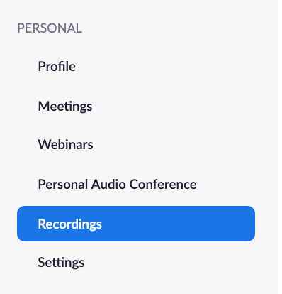

- Using the search features, find and open your recording.
- Hover over the file you would like to download with your mouse to see different options.
- Select the download icon.

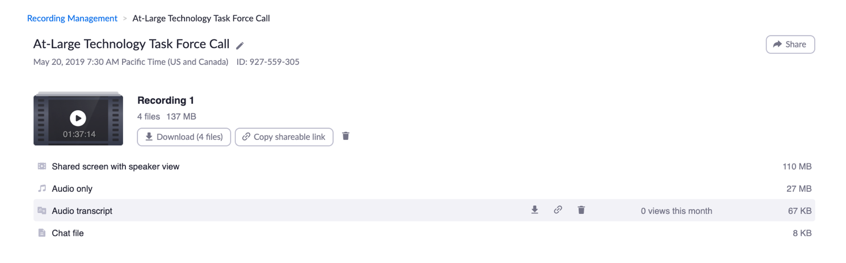
Click here!
- Once your file is downloaded, you can open it from your downloads folder.
- Choose to open the file in word.
- Save the document as a word file and share.

