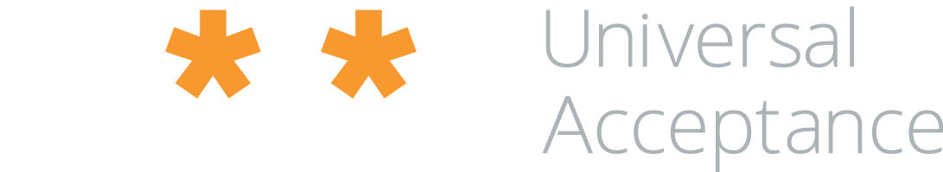

The Universal Acceptance Steering Group

invites you to a gathering in Redmond

• To Meet  
• To Talk  
• To launch the White Paper on Universal Acceptance

18:30

11th April 2017  
Salon 4 of the Grand Ballroom

Seattle Marriott Redmond   
Redmond Town Center

7401 164th Ave NE

Redmond, WA 98052, USA

RSVP: info@uasg.tech

The Universal Acceptance Steering Group

invites you to a gathering in Redmond

• To Meet  
• To Talk  
• To launch the White Paper on Universal Acceptance

18:30  
Seattle Marriott Redmond   
Redmond Town Center, 7401 164th Ave NE, Redmond, WA 98052, USA