Cross-Community Working Group on Enhancing ICANN Accountability
Work Party 1: Community Empowerment

Scope, Measures and Mechanisms Working Paper
Draft 1, 5-Feb-2015
(circulated at 0045 UTC)

Background:
CCWG Work Team 2 developed an inventory of accountability suggestions gathered from previous public comments and WG input. This inventory was last updated 15-Jan and published here. At its Frankfurt meetings, the CCWG used that inventory to develop high-level requirements for accountability measures, portrayed in the ‘mind map’ shown below (1/2 designate Work Stream):
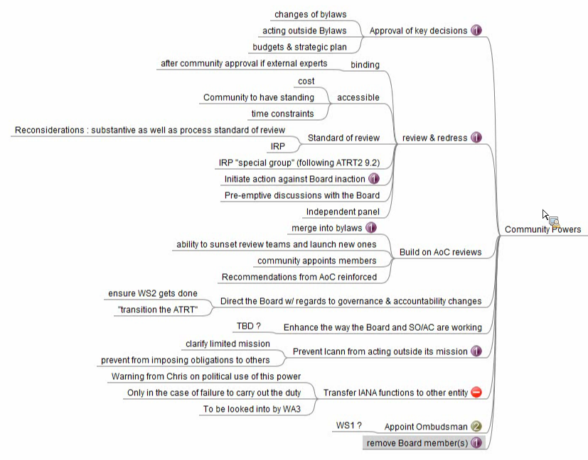

From the figure above, here are requirements that fall into the category of Community Empowerment:

Approval of key decisions: (Work Stream 1)
Changes to ICANN Bylaws and Articles of Incorporation
Board or management action in conflict with Bylaws or Articles of Incorporation
Budget and Strategic Plan

Build on AoC (Affirmation of Commitments) Reviews:
Merge AoC into the ICANN Bylaws (Work Stream 1)
Ability to sunset review teams and launch new ones
Community appoints Affirmation review team members
Enforcement of recommendations from Affirmation reviews

Direct the Board w/r/t governance & accountability changes:
Ensure that Work Stream 2 accountability enhancements are implemented
“Transition the ATRT”

Enhance the way Board and SO/AC are working

Prevent ICANN from acting outside its mission: (Work Stream 1)
Clarify ICANN’s limited technical mission
Prevent ICANN from imposing obligations on others unless needed to continue operation of DNS

Community to appoint the Ombudsman (Work Stream 2)

Remove ICANN board director(s) (Work Stream 1)

Next steps:
Work Party 1 has been tasked to suggest specific measures and mechanisms that could fulfill the requirements for community empowerment shown above. It is intended this work be completed by the end of March 2015.

Drawing on the previous inventory document and discussions in the CCWG, below is a table of measures and mechanisms, organized by requirement. A threshold question is how the ‘community’ could be represented and empowered to override decisions of the ICANN board. Options for that question appear below the requirements table.

Community Empowerment: Requirements and potential measures/mechanisms | WS1/2
Approval of key decisions: (Work Stream 1) | WS1
Changes to ICANN Bylaws and Articles of Incorporation  In Bylaws or Articles, add new power for community representatives (Members, CCWG, etc.) to block the ICANN board from adopting a proposed change to ICANN Bylaws or Articles of Incorporation. By supermajority or simple majority vote? | WS1
Board or management action in conflict with Bylaws or Articles of Incorporation  In Bylaws or Articles, add new power for community representatives (Members, CCWG, etc.) to challenge a board for management decision that would be conflict with ICANN Bylaws or Articles of Incorporation. By supermajority or simple majority vote? Should this vote trigger an Independent Review Panel? | WS1
Budget and Strategic Plan  In Bylaws or Articles, add new power for community representatives (Members, CCWG, etc.) to block the ICANN board from adopting a proposed budget or strategic plan. By supermajority or simple majority vote? | WS1
Build on AoC (Affirmation of Commitments) Reviews:
Merge AoC into the ICANN Bylaws  Amend ICANN Bylaws to incorporate commitments and review teams currently required in the AoC | WS1
Ability to sunset review teams and launch new ones  As part the Bylaws amendment, empower community representatives (Members, CCWG, etc.) to sunset required reviews and create new reviews. | WS2
Community appoints Affirmation review team members  As part the Bylaws amendment, when formal reviews are initiated, empower community representatives (Members, CCWG, etc.) to designate members of the review teams. This is presently controlled by the ICANN CEO and GAC Chair. | WS2
Enforcement of recommendations from Affirmation reviews

Enforcement of recommendations from Affirmation reviews

As part of the Bylaws amendment, give Review Teams access to all ICANN internal documents
Direct the Board w/r/t governance & accountability changes:
Ensure that Work Stream 2 accountability enhancements are implemented

“Transition the ATRT”

Enhance the way Board and SO/AC are working
[not sure about this one]

Prevent ICANN from acting outside its mission: (Work Stream 1)
Clarify ICANN’s limited technical mission

Prevent ICANN from imposing obligations on others unless needed to operate DNS  Create an Accountability Contract between ICANN and Registries, Registrars, and Registrants. Contract lets ICANN impose rules on others only when supported by consensus of affected parties and necessary to protect operation of the DNS. Disputes go to independent arbitration panel that could issue binding decisions.  -or-  Describe this limitation in a ‘golden’ Bylaw or Article that cannot be amended by any means.  -or-  Using enhanced review and redress mechanisms, the community can override any board or management decision that the community believes exceeds ICANN bylaws. | WS1
Community to appoint the Ombudsman (Work Stream 2)
In Bylaws or Articles, add new power for community representatives (Members, CCWG, etc.) to select the ICANN Ombudsman. By supermajority or simple majority vote?

Remove ICANN board director(s) (Work Stream 1)
In Bylaws or Articles, add new power for community representatives (Members, CCWG, etc.) to terminate one or all ICANN directors. By supermajority or simple majority vote? | WS1

Options to organize community representation and empower it to override ICANN board decisions.

Ad-hoc Cross Community Working Group (CCWG)
Each AC/SO/SG would respond to initiatives or challenges filed by any other AC/SO/SG.

Permanent Cross Community Working Group (CCWG)
Each AC/SO/SG would designate its representative to a permanent CCWG that stands ready to vote on challenges or initiatives filed by any AC/SO/SG.

Community Veto process
This would make use of existing structures, following the process set out by the proposer (see blog post at http://www.circleid.com/posts/20150203_proposal_for_creation_of_community_veto_for_key_icann_decisions/ for details) to action the enumerated powers.

Statutory Delegates
California law provides for delegates with a subset of the powers outlined for statutory members below. Empowering such delegates is a suggestion to refine and investigate.

Statutory Members
California Nonprofit Corporation Law expressly authorizes non-profit organizations to have Members with ultimate authority to control the organization. Under Cal. Corp. Code § 5310 “A corporation may admit persons to Membership, as provided in its Articles or Bylaws”. California law recognizes that Members may reserve the right to approve nonprofit actions and oversee the Board of Directors. (§ 5210) A Board of Directors’ authority to conduct the affairs of a nonprofit may be limited by the rights of the Members specified in the law or in the nonprofit corporation’s Articles or Bylaws.

Although ICANN does not currently have Members under Article XVII of its Bylaws, ICANN’s Articles of Incorporation expressly anticipate that ICANN may have Members: “These Articles may be amended by the affirmative of at least two-thirds of the directors of the Corporation. When the Corporation has Members, amendments must be ratified by a two-thirds (2/3) majority of the Members voting on any proposed amendment.” (Section 9)

Each AC/SO/SG would designate its Member representative. The Members stand ready to vote on challenges or initiatives filed by any Member

Supervisory Board
Create a two-tier board structure for ICANN as is common in some European companies, where the community’s representatives sit in the Supervisory Board and have specific enumerated powers, and the general governance of ICANN remains the role of the ICANN Board
[get details from Roelof Meijer]

