Information on AOC Review Team Composition

Sources:
- Review Teams’ Composition: https://www.icann.org/resources/pages/teams-2012-02-25-en
- ATRT1 – https://www.icann.org/resources/pages/governance/composition-en
- ATRT2 – https://www.icann.org/resources/pages/composition-2013-02-15-en
- SSR – https://www.icann.org/resources/pages/composition-13-2012-02-25-en
- WHOIS – https://www.icann.org/resources/pages/composition-ee-2012-02-25-en
- CCT – (none yet since ICANN just launched the Call for Volunteers; the RT will be selected and announced in December)

Summary Infographic:
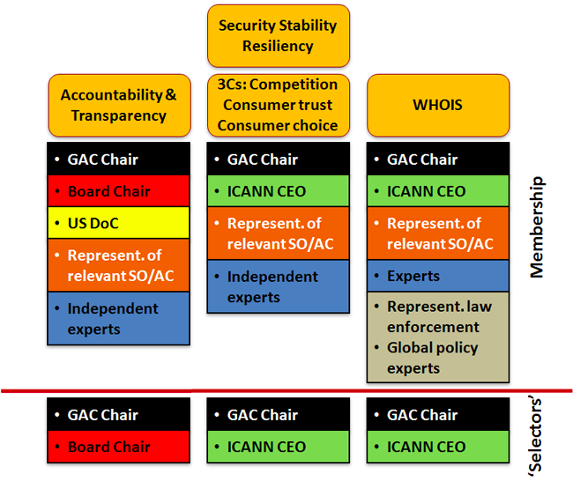

ATRT1 (15 people):
- 1 ALAC
- 2 GAC
- 1 ASO
- 3 ccNSO
- 5 GNSO
- Chair of the GAC or designated nominee
- ICANN Board Chairman or designated nominee
- Assistant Secretary for Communications and Information of the US Department of Commerce

ATRT2 (16 people):
- 2 ALAC
- 3 GAC
- 1 SSAC
- 1 ASO
- 2 ccNSO
- 2 GNSO
- 2 Experts
- Chair of the GAC or designated nominee
- ICANN Board Chairman or designated nominee
- Assistant Secretary for Communications and Information of the US Department of Commerce

SSR (16 people):
- 1 ALAC
- 1 GAC
- 2 SSAC
- 1 RSSAC
- 2 ASO
- 3 ccNSO
- 2 GNSO
- 2 Independent Experts
- Chair of the GAC or designated nominee
- ICANN CEO or designated nominee

WHOIS (15 people):
- 2 ALAC
- 1 GAC
- 1 SSAC
- 1 ASO
- 1 ccNSO
- 3 GNSO
- 3 Independent Experts / Law Enforcement Representative
- Chair of the GAC or designated nominee
- ICANN CEO or designated nominee

