Community Decision Process
Purpose of Group | To describe a method of consensus-style decision making that will replace the voting system in the Second Draft Proposal.
Requirements | - Based on objections from SOs and advice from AC  - No single SO or AC should be able to capture decision-making through a veto right or through lack of broad support/participation  - Flexibility for SOs or ACs to participate in any particular issue, or on all issues  - Recognize that RSSAC and SSAC are appointed by board
Deliverables | - Rules for decision making  - Analyze corner cases  - For each community power, do we have different participation requirements and thresholds for consensus?  - Final step after decision: discourse with board

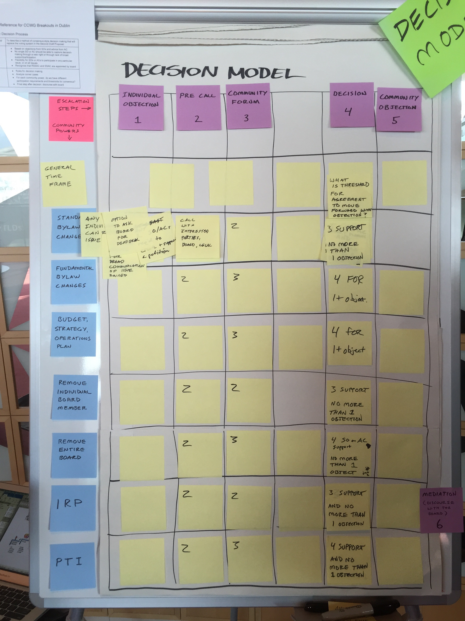
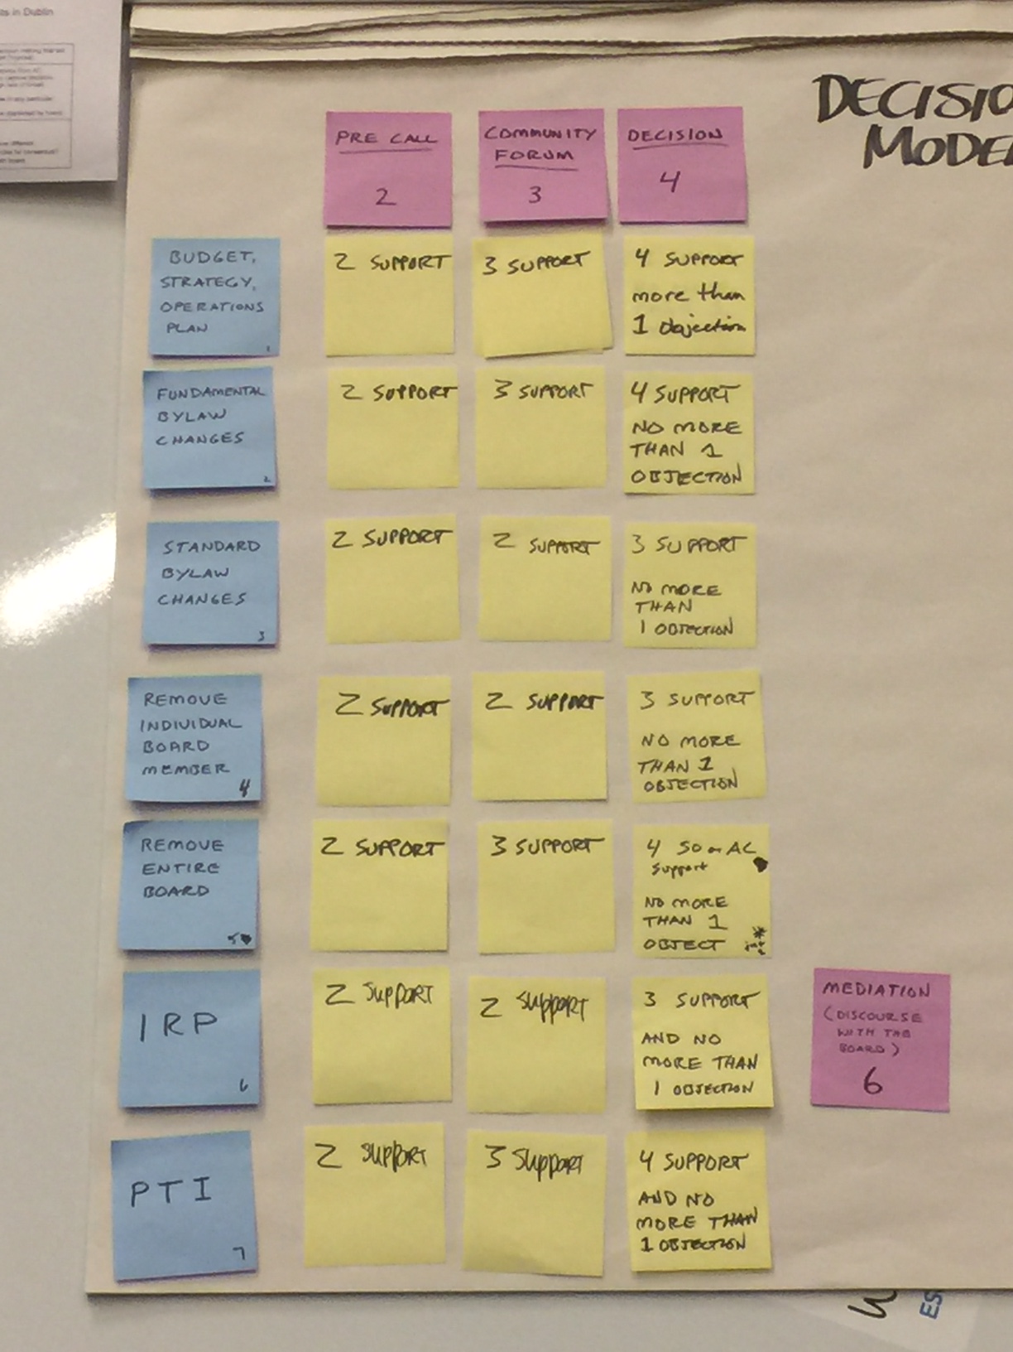

Required Community Powers | Should we have a  Conference  Call? | Should we Convene Community Forum? | Do we have Consensus Support for this decision?
1. Block a proposed Operating Plan/Strategic Plan/Budget | 2 support | 3 support | 4 support, and no more than 1 objection
2. Approve changes to Fundamental Bylaws and Articles of Incorporation | 2 support | 3 support | 4 support, and no more than 1 objection
3. Block changes to regular bylaws | 2 support | 2 support | 3 support, and no more than 1 objection
4. Remove individual board directors | 2 support | 2 support | 3 support, and no more than 1 objection
5. Recall the entire board of directors | 2 support | 3 support | 4 support, and no more than 1 objection* | *
6. Mechanism for binding IRP where a panel decision is enforceable in any court recognizing international arbitration results | 2 support | 2 support | 3 support, and no more than 1 objection | Mediation before IRP
7. Reconsider/reject board decisions relating to reviews of IANA functions, including trigger of PTI separation | 2 support | 3 support | 4 support, and no more than 1 objection
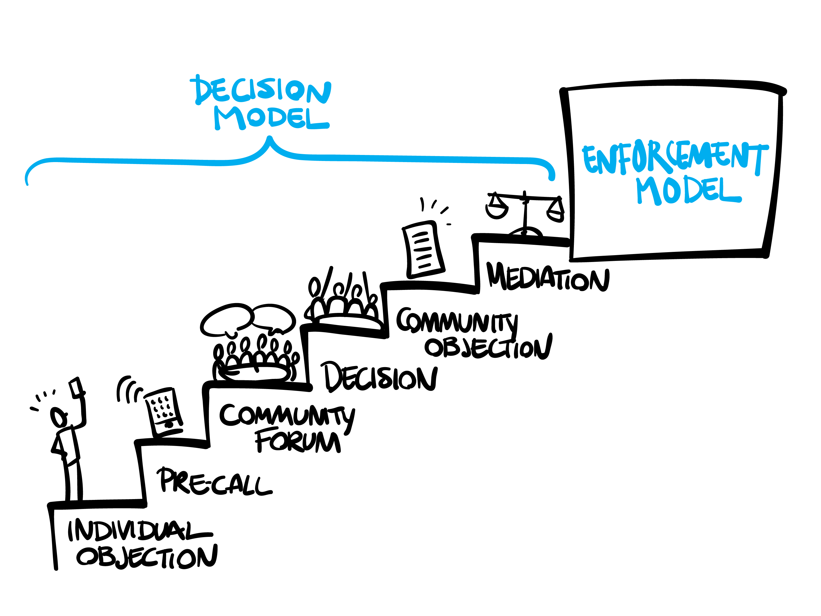
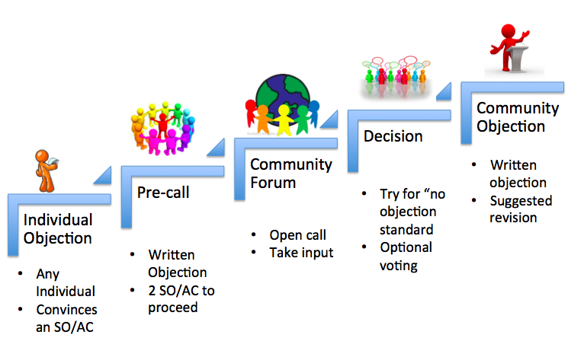

Los Angeles meeting -- First breakout:
Start with a new bylaw: Board must announce it plans to consider a bylaws change, and must wait 30 days to vote.
1. Trigger: any individual can begin an online petition in any AC or SO. Each AC/SO defines its own threshold for petition support. If the threshold is met in any AC or SO, all others are invited to participate in a pre-call to decide whether to have a Community Forum.
2. Pre-call to decide whether to have a Community Forum: The Petitioning ACs/SO(s) circulate written justification for blocking the bylaw. ICANN hosts a conf call with all interested participants. After the call, at least 2 ACs/SOs must indicate they are sufficiently affected that they intend to participate.
3. Decision-making: Debate and Aim for CCNSO-style consensus, as in “no strong objection”. If no consensus, the petitioning AC/SO may ask for voting. Each AC/SO decides its vote using its own methods. To block the bylaw, at least 66% of participating AC/SOs must vote.
4. Outcome: if community decides to block the bylaw, it must publish a statement explaining why, incl any amended language that would overcome the objection, etc. Minority statement could be published by participating AC/SO that did not agree with the decision or explanation.

Los Angeles meeting -- Second breakout:
Note: CCWG has never claimed that any difference with the board must be reconciled. We proposed specific community powers and R&R mechanisms with a strict standard of review.
Precursor for Community-based Challenge (IRP or Reconsideration):
1. Trigger: any individual can begin an online petition in any AC or SO. Each AC/SO defines its own threshold for petition support. If the threshold is met in any AC or SO, all others are invited to participate in a pre-call to decide whether to have a Community Forum.
2. Pre-call to raise awareness of the difference, and decide whether to have a Community Forum: The Petitioning ACs/SO(s) circulate written explanation for the difference with board. Board must send a representative. ICANN hosts a conf call with all interested participants. After the call, there is expected to be continuing calls/emails to reconcile differences. If no reconciliation, at least 2 ACs/SOs could indicate they intend to participate in a Community Forum.
3. ICANN hosts a 1-2 day Community Forum. Goal is to find a mutually acceptable solution. If reconciliation is not evident, the Community Forum turns to the question of whether to request a Community Reconsideration or IRP.

