Community Decision-Making: The Dublin Approach
Paper for CCWG | 27 October 2015
https://docs.google.com/document/d/1zHZl_NvQ1WChatX8NT2Q1rQi4zQZgbrbAxrQSsH3tZQ/edit?usp=sharing

A. Introduction
- At the Dublin ICANN meeting, CCWG participants evolved the decision-making framework for the Community Mechanism. This paper outlines the new consensus-based decision framework ready for approval: the “Dublin Approach”.

- The decision-making processes set out here form part of the process to exercise community powers. That is, the decision-making follows a Community Forum, which itself is instigated by a Conference Call. Each step requires various levels of support from SOs and ACs – see the enclosed Appendix 1 drafted by Steve DelBianco. This point is emphasised to remind the reader that however decisions get made, the whole community will have the chance to make its views known before decisions are taken.

- The next section (B) sets out the background to the issue. The following section (C) outlines the Dublin Approach. The fourth section (D) identifies remaining issues where decisions are needed.

- This paper has been written by Jordan Carter, Rapporteur for WP1, to help bring together information to assist the CCWG and WP1 deliberate on and resolve the approach. All content is subject to change following group deliberations.

- Comments on this paper will be sought from the full CCWG at its meeting on 27 October. These comments will be incorporated and a revised version of this paper circulated for WP1 to discuss on 30 October. A final version will be prepared after that for the CCWG to adopt at its subsequent meeting (currently, 06h UTC on 3 November).

B. Background
- Public comments received on the Second Draft Proposal for enhancing ICANN’s accountability registered concerns with the method of decision-making the CCWG had created for the Community Mechanism.

- The method proposed was of notional voting. Each SO and AC participating would have a known measure of influence. It would allocate this influence through its own internal processes, and was not required to express a uniform preference. In concrete terms, the GNSO would have been able to allocate 75% of its influence in favour of exercising a community power, and 25% against.

- Across the participating SOs and ACs, a requisite level of support would have been required to exercise a given community power. No votes or non-participation would have had no impact.

- This system allowed for different weights of influence between different SOs or ACs (with five “votes” allocated to the SOs, GAC and ALAC, and two “votes” to the SSAC and RSSAC).

- This system also allowed for the diversity of views within each SO or AC to be considered in making decisions – by allowing each SO or AC to delegate its “votes” down to sub-units, and by not requiring all “votes” to be either for or against a question.

- Widely varying concerns were raised with this system – in public comments, in the CCWG face-to-face meeting in Los Angeles in September, and in discussions in Dublin in October.

- The concerns included fundamental ones with the actual proposed method of decision (the casting of votes), a desire for certainty around the participation or otherwise of various SOs and ACs, discomfort with the proposed relative influence of various SOs and ACs, and discomfort with the ability for decisions to be “split”.

- In Dublin, a small group debated the model and developed a different approach.

C. The “Dublin Approach” for consensus decision-making
- Elaborated after a discussion held during CCWG working sessions in Dublin in October, the core elements of the Dublin Approach as I understand them are as follows:

  - Each participating SO or AC has the same relative influence (all participants are equal).

  - Each participating SO or AC uses its own internal processes to come to a consensus decision about whether to support or oppose the exercise of a community power.

  - Thresholds are set for each power and a given level of support, and a maximum allowable level of opposition, are required for a decision to exercise each given community power (See Appendix 1).

  - The diversity of voices within SOs and ACs, and from the broader ICANN and Internet community, are expressed through the deliberation and debate in the Community Forum, rather than through a ‘voting’ process in Community Mechanism decisions.

- Participants should be aware that the key differences between the Second Draft Proposal and the Dublin Approach are as follows:

  - Decision-making is by consensus rather than by counting of votes – in practical terms that means that while affirmative expressions of support are required, the level of opposition is also considered. Too much opposition prevents a power being exercised even if the threshold of support in favour of using it is reached.

  - Each SO or AC can only express one point of view – the possibility of delegation of share of voice to sub-units, or of an SO or AC splitting its decisional voice between yes and no, is removed. (The SO or AC does keep full control over how it arrives at its decision, identical with the Second Draft Proposal.)

  - Each SO and AC participating has the same relative influence – this marks additional influence for two Advisory Committees (RSSAC and SSAC) compared with the Second Draft Proposal, and this change is in the opposite direction to that suggested by the public comments received on the Second Draft Proposal (which argued for relatively more influence for SOs).

D. Open Issues and Options to Resolve Them
- The following sets out some known issues with the Dublin Approach. For each issue, ways to resolve are suggested. If there is a preferred one this is highlighted along with logic as to why it has been suggested.

Issue | Resolution/s
SSAC does not wish to participate in decision-making in the community mechanism. | - Exclude SSAC from decision-making, and check thresholds (Appendix A) to identify whether any adjustments are needed. Future inclusion would require a bylaws change.  - Include a provision in the bylaws to allow SSAC to choose participation in decision-making at a future point, but recognise non-participation at the outset.  - Require SSAC to participate in decision-making.  Option a) offers greatest certainty and respects SSAC’s clearly expressed preferences.
Uncertainty regarding RSSAC participation in decision-making in the community mechanism. | Consult with RSSAC and propose same option as is decided to be appropriate for SSAC (a-c noted in the cell above).
Reduce “concentration of voice” caused by requiring decisions only to be made by whole SOs or ACs. | - This is not an issue / does not need to be resolved, as it is the consensus-making model ICANN already uses.  - Allow SOs or ACs to grant decision rights to sub-units in arriving at decisions to support or oppose powers, but weight these decisions so the overall equality of voice between each SO and AC is not changed.  Option a) is simplest and seems most in keeping with the deliberations in Dublin.
[there may be other issues] | [each issue has resolution/s or should be identified as unresolvable]

E) Conclusion
- The CCWG needs to decide on the decision-making applicable in the Community Mechanism as soon as possible, as this is a core element of the final Third Draft Proposal.

- The Dublin Approach is a materially different approach to that presented by the CCWG to the Community in the Second Draft Proposal. If we confirm the new approach we must candidly and clearly explain the reasons. This paper does not seek to do that.

- Appendix 1, starting overleaf, is Steve DelBianco’s paper that summarises the Dublin breakout group’s conclusions on community decision-making.

- Appendix 2 is the two XPLANE graphics highlighting the decisional process of which the decision-making in this paper is used.

Jordan Carter
Rapporteur, WP1, CCWG

Appendix 1: Community Decision Making in the Dublin Approach

Community Decision Process, as described in CCWG breakout session on 17-Oct and updated 20-Oct.

Required Community Powers | Should we have a  Conference  Call? | Should we Convene a Community Forum? | Consensus Support to exercise the power?
1. Block a proposed Operating Plan/Strategic Plan/Budget | 2 AC/SOs support blocking | 3 AC/SOs support blocking | 4 support blocking, and no more than 1 objection
2. Approve changes to Fundamental Bylaws and Articles of Incorporation | 2 AC/SOs support approval | 3 AC/SOs support approval | 4 support approval, and no more than 1 objection
3. Block changes to regular bylaws | 2 AC/SOs support blocking | 2 AC/SOs support blocking | 3 support blocking, and no more than 1 objection
4a. Remove individual board directors appointed by AC/SO. | Majority within the appointing AC/SO | Majority within appointing AC/SO | Invite and consider comments from all SO/ACs.  75% majority within the appointing AC/SO to remove their director
4b. Remove individual board directors appointed by NomCom | 2 AC/SOs support | 2 AC/SOs support | 3 support, and no more than 1 objection.
5. Recall the entire board of directors | 2 AC/SOs support | 3 AC/SOs support | 4 support, and no more than 1 objection*
6. Initiate a binding IRP where panel decision is enforceable in any court recognizing int’l arbitration results | 2 AC/SOs support | 2 AC/SOs support | 3 support, and no more than 1 objection.  Require mediation before IRP begins
7. Reconsider/reject board decisions relating to reviews of IANA functions, including trigger of PTI separation | 2 AC/SOs support | 3 AC/SOs support | 4 support, and no more than 1 objection
*a minority of CCWG participants prefer to require 5 AC/SOs, or allow 1 objection to block consensus

Detail – Removal of Individual Directors appointed by SOs/ALAC
Detail on row 4a, Removal of individual board director appointed by AC/SO:
- A petition for removal would arise in the relevant SO/AC
- The SO/AC would organise a briefing call to establish whether there is sufficient support within the SO/AC to move to the next step. A clear reasoning/rationale must be provided and the Director given a chance to respond. Sufficient support threshold is simple majority. This call should be open to all to attend but is a discussion of the SO/AC.
- If there is a simple majority to proceed then the SO/AC would convene a Community Forum for the discussion to proceed. The forum can be light weight and very possibly not face to face. It is open to all. A clear reasoning/rationale must be provided and the Director given a chance to respond.
- Immediately after the Community Forum, the relevant SO/AC sends every other SO/AC a request for comment on the removal.
- The other SO/ACs provide written comments.
- The relevant SO/AC then makes a decision. Removal of the Director requires a 75% majority in the relevant SO/AC.
- The relevant SO/AC must publish the results and an explanation if the Director is removed.

Column 2: Should we have a Conference Call?
- Any individual can begin an online petition in any AC or SO, where that AC/SO defines its own threshold to determine whether it supports the petition.
- An AC/SO supporting the petition communicates the petition to other AC/SOs, along with sufficient preliminary rationale explaining the reasons for doing so. Each AC/SO may use its own methods to determine whether it supports the petition to hold a conference call.
- If any 2 AC/SOs (in total) support the petition, all AC/SOs are invited to participate in a conference call to discuss the petition and whether to convene a Community Forum.
- The Petitioning ACs/SOs circulate written justification for exercising the Community Power in preparation for the conference call. This should be circulated with enough advance notice to allow preparation by other AC/SOs. Any AC/SO may contribute preliminary thoughts or questions in writing before the call is held.
- ICANN hosts a conference call open to any interested participants, and the call would be recorded, transcribed, translated, etc. Representatives of the ICANN board are expected to attend.
- After the call, ACs and SOs use their own decision-making methods to decide whether they support convening a Community Forum. The threshold for convening a Community Forum is proposed in column 3 of the table.

Column 3: Should we convene a Community Forum?
- If the threshold for convening a Community Forum is met, ICANN organizes a Forum. AC/SOs determine whether to hold an online or face-to-face meeting. If a face-to-face meeting is chosen, it could be scheduled adjacent to a regular ICANN meeting or, if the timing is not appropriate, at an inter-sessional meeting.
- The Community Forum would be planned for 1 to 2 days, supported by ICANN staff and with travel funding for participants designated by ACs and SOs.
- The Community Forum would be open to all via Adobe Connect, and would be recorded, transcribed, translated, etc. Representatives of the ICANN board are expected to attend.
- AC/SOs may request independent legal advice to the community, depending upon the issue and power being considered.
- The Community Forum has as its purpose the sharing of information (the rationale for the petition, etc.) and the airing of views on the petition by the community. Accordingly, any AC/SO may circulate in writing their preliminary views on the exercise of this community power.
- The Community Forum will make no decision or attempts to take a “sense of the room” or strive to seek consensus. It will not decide on whether to advance the petition to the decision stage, since this is up to the AC/SOs to determine after the Forum.
- The Community Forum should be managed/moderated in a fair and neutral manner. Should the discussions of the petition require additional time it may extend the Forum. If AC/SOs determine need for further deliberation, a second and third session of the Community Forum could be held online, with at least least one week between each session.
- ICANN staff will collect and publish a public record of the Forum(s), including all written submissions.

Column 4: Is there Consensus Support to exercise the power?
- After the Community Forum, each AC/SO would decide, using its own methods, whether it supports the proposed exercise of the community power, whether it objects to the exercise of the community power, or whether it wishes to remain silent on the matter. .
- If the AC/SO community achieves the required levels of support without more than 1 objection, the power will be exercised. If so the AC/SO community must publish a statement of explanation. A minority statement could be published by any AC/SO that objected to the decision or explanation.

Appendix 2: XPLANE Graphics

The “Three Es”
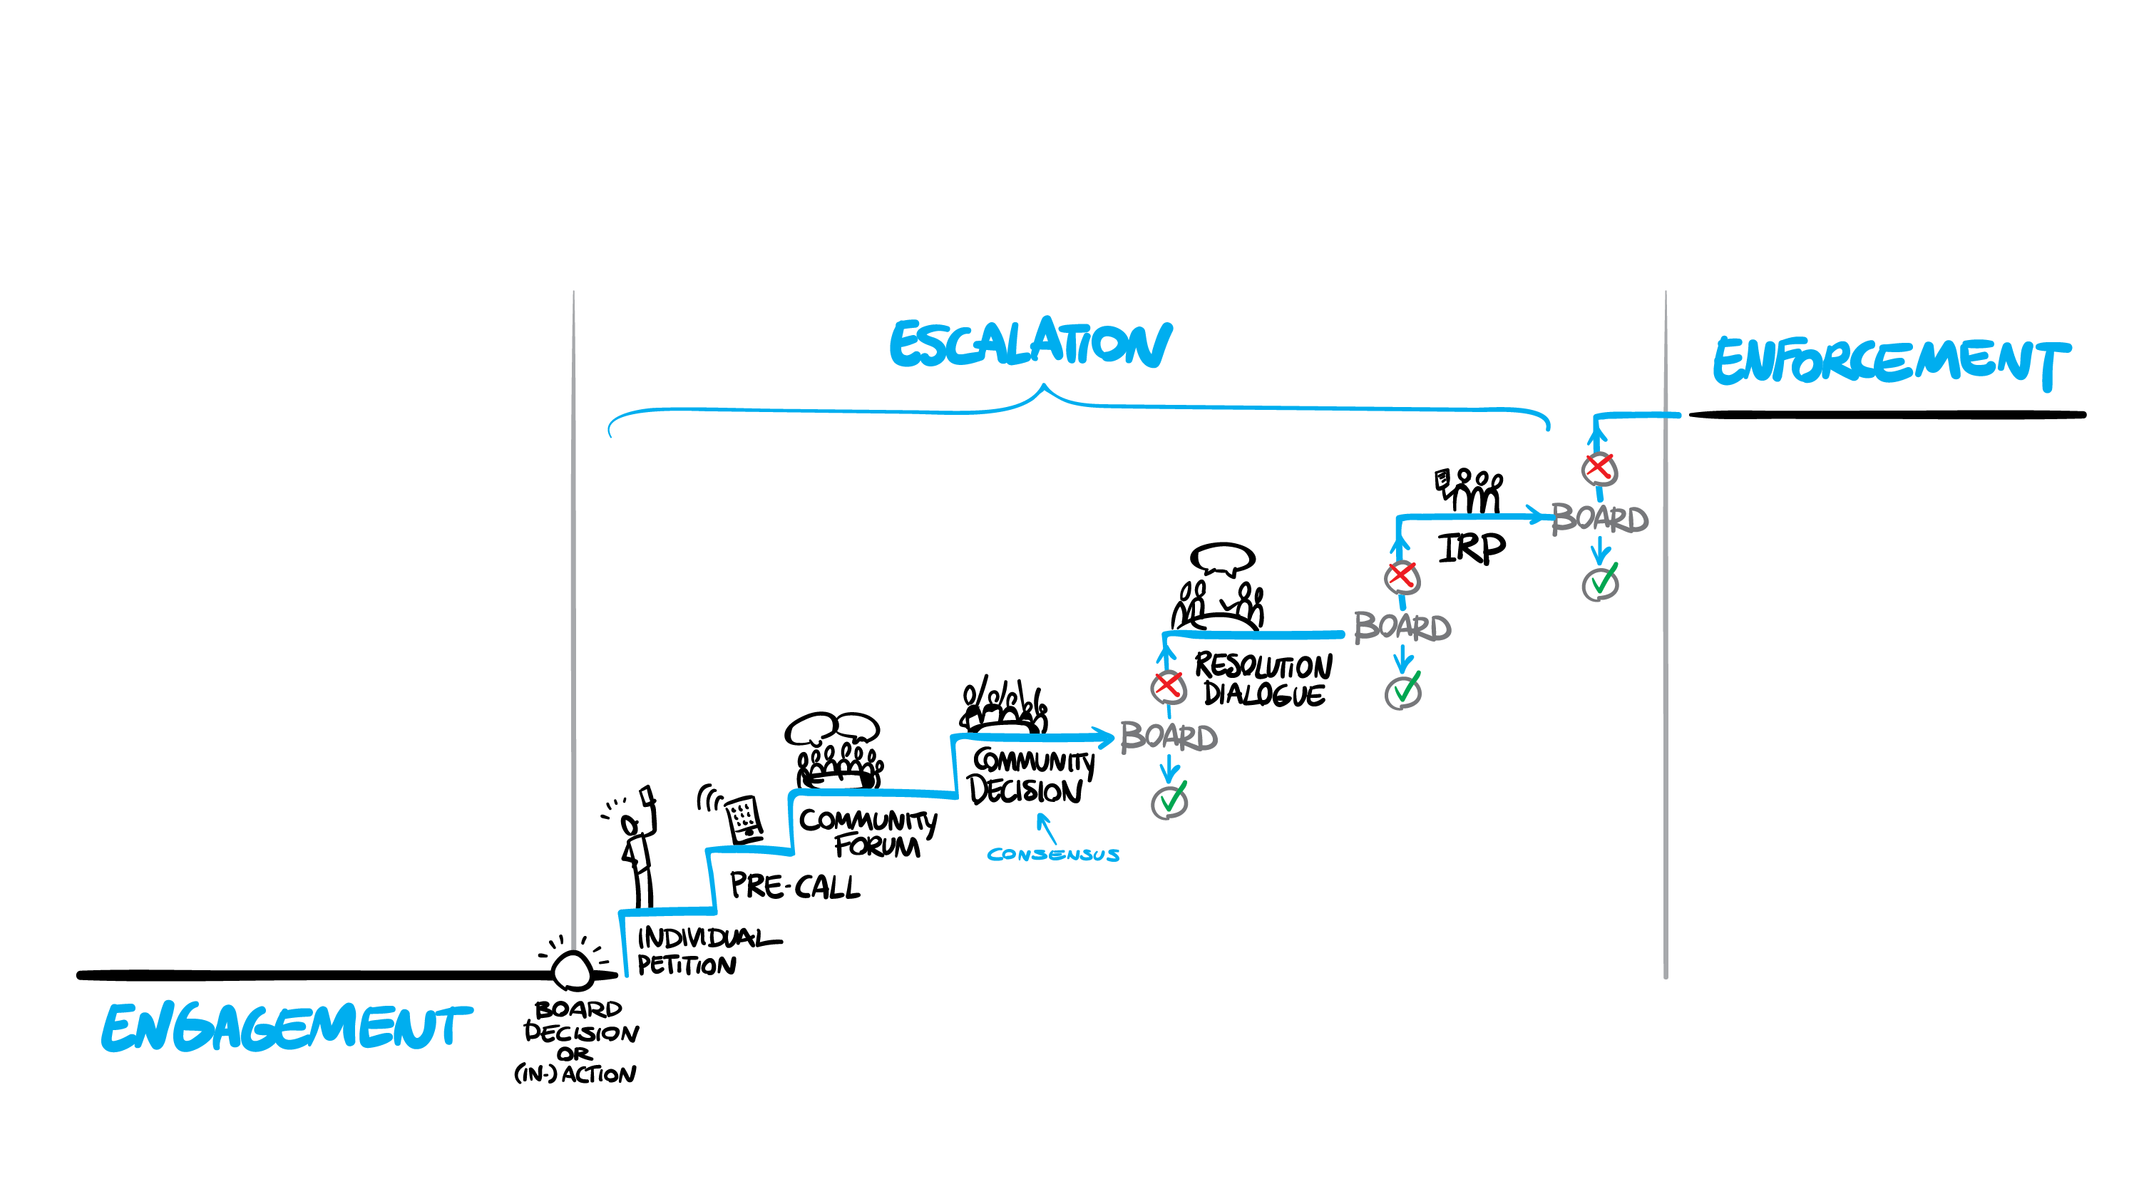

The Escalation path
