Xavier Calvez
Chief Financial Officer
ICANN

7 February 2022

Dear Xavier,

Statement of the Generic Names Supporting Organization Council on
ICANN’s Draft FY23-27 Operating & Financial Plan + Draft FY23 Operating Plan & Budget

The Generic Names Supporting Organization (GNSO) Council welcomes the opportunity to provide input on those aspects of the draft FY23-27 Operating & Financial Plan (“FY23 OFP”) including the draft FY23 Operating Plan & Budget (“FY23 Budget”) that are of relevance to the GNSO Council’s remit, which are managers of the policy development process for generic top-level domains. Thus, while this statement is made on behalf of the GNSO Council, our comments are intended to complement, and not replace, any input that may be provided by individual GNSO Stakeholder Groups and Constituencies.

This comment was prepared by the Council's Standing Committee on Budget and Operations (SCBO), whose membership includes both Councilors and Subject Matter Experts from across the GNSO. The SCBO focused its efforts on exploring whether or not the resources directed at policy development are appropriate, both in relation to current workload, and in view of planned policy activities for FY23 and the risks or threats to the fulfillment of the GNSO Council’s responsibilities within ICANN’s larger mission and remit.

General Comments:
- As we have mentioned in previous comments, as part of its review, the GNSO Council examines the proposed budget to understand what resources have been allocated to each GNSO Stakeholder Group, and to the other Supporting Organizations and Advisory Committees. The GNSO Council understands that ICANN Finance & Planning “acknowledges the [GNSO Council’s] request to understand resources allocated to each SO/AC and [ICANN Org is] planning to provide that information in a future version of the Budget.” Although we have budget experts drawn from the various GNSO constituencies as part of the SCBO, we find it is difficult (as noted in prior comment submissions) without greater detail to approximate the levels of financial support provided directly and indirectly to the various Supporting Organizations, Advisory Groups, and associated Stakeholder Groups and Constituencies. For instance, it would be important for the GNSO Council to understand the percentage of budget resources for Policy Development and Advice that was dedicated to the GNSO. Such information is essential for each of these groups, including the GNSO Council to hold ourselves, and others, mutually accountable to responsibilities, and expected level of performance and efficiency as good stewards of the funds allocated to these groups.
- It has also been mentioned in past comments that the GNSO Council seeks to ensure that the annual Operation and Financial Plans and annual Budgets provide Working Group Chairs with tools and support to ensure effective and efficient leadership. We were pleased to be informed that the enterprise-wide project management software has been purchased, and to see the planned addition of two full-time employees since the adopted FY22 FTE levels. In addition, the GNSO Council is informed that certain specific expenses for important policy-making tools, such as software and consultants, are covered in areas of the budget that appear well-funded.
Specific Comments Related to the draft FY23-27 Operating & Financial Plan:
In the GNSO Council’s comments on the Five Year Strategic and Operating Plan (“5YS&OP”) it identified the following specific issues that are applicable to the FY23 OFP:

- Evolve and Strengthen the Multistakeholder Model to Facilitate Diverse and Inclusive Participation in Policymaking
  - OFP Issue 1. Maintain adequate staffing for Policy Development Support. In its review of each OFP, the GNSO Council seeks to ensure that the OFP is providing sufficient personnel and non-personnel resources for the policy development and implementation activities. The FY23 OFP indicates that “the FY23 level of resources is generally expected to be consistent with the current level of staff, assuming that FY22 hiring requests are fulfilled and continuing ability to rely on professional services contractors for additional needs.” In FY23 the level of resources allocated to this Functional Activity indicates 36 FTE and $8.0M USD, which is an increase of 2 FTEs since 2022 and an increase of $0.9M USD in personnel expenses. The GNSO is pleased to see the planned addition of staff.
The two additional staff will be critically important to ensure that there is adequate support for policy development and implementation efforts. However, neither the FY23 OFP nor FY23 Budget provide insight for their readers into the factors analyzed by ICANN org to determine if staffing is adequate. Moreover, the FY23 OFP correctly identifies that (i) the need for data-driven policymaking results in requests for more robust data collection and analysis as well as external experts to aid in policy development; (ii) policy challenges (such as the SSAD) facing the community are becoming more legally and technically complex; and (iii) the growing complexity of the issues along with their broad impact and diversity of stakeholder interests (e.g., on data privacy and DNS abuse) means that significant time and effort needs to be expended on understanding the issue and multiple viewpoints in order to find consensus. In addition, the GNSO Council would point out that the following work is forecasted for the FY23 time frame:
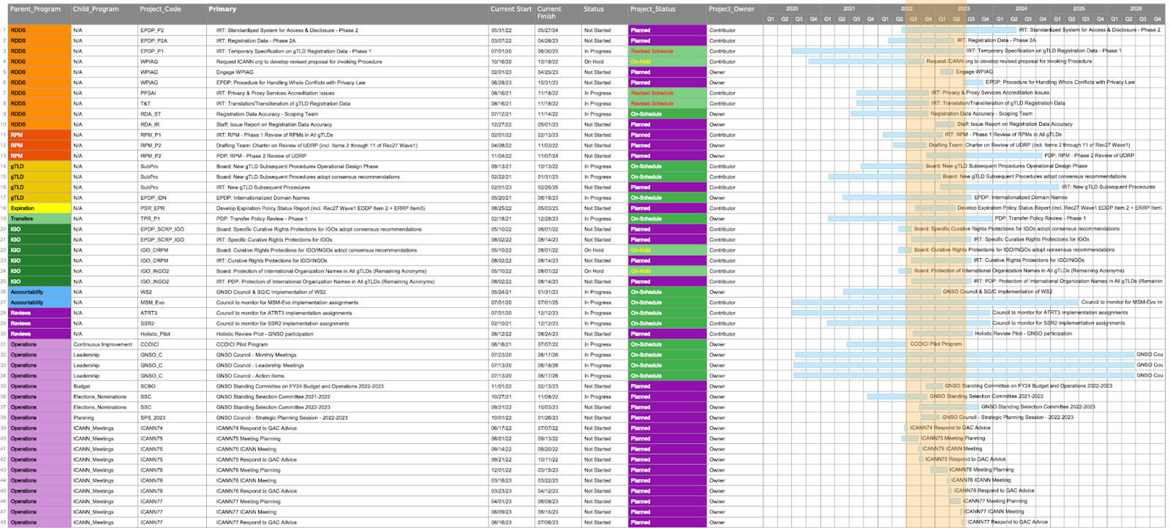
In light of these risk factors, the GNSO Council is happy to engage with ICANN org on the future work of the GNSO, the factors examined by ICANN org for personnel resource decisions and best-practices for project management staffing.
- Monitor Legislation, Regulation, Norms, Principles, and Initiatives in Collaboration with Others That May Impact the ICANN Mission
  - OFP Issue 2: With respect to the section in the FY23-27 OFP, How Progress is Tracked, the GNSO recommends that ICANN Org includes a goal to publish reports on the number of in-country engagements by ICANN Org/Affiliates at Fora (e.g., Internet Governance Forum) where potentially impactful issues are discussed, such as cybersecurity, data protection, privacy, cultural and geographic identifiers, emerging technologies, and proposed new systems of unique identifiers.
- Planning at ICANN
  - OFP Issue 3. Strategic priority should be given to collaboration between the GNSO Council, ICANN Org’s Policy Development Support and the ICANN Board and Community on prioritization and planning for anticipated future work. In its comments on the FY22 OFP, the GNSO Council noted that there had been no increase in the FY22 OFP as it pertains to resources dedicated to collaboration and planning for future ICANN Policy Work. Like the FY22 OFP, the FY23 OFP provides no detail concerning resources dedicated to planning because “Resources for this initiative are included within the functional activities of the financial plan”. These activities are especially critical as in FY23 ICANN will implement the draft prioritization plan during the planning process of the FY24 OFP. The GNSO Council was pleased to see those additional resources for coordination and “appropriate tools” were contemplated in the estimates of resources for the Policy Development and Advice Functional Activity. However, no further details are provided as to where these additional resources will be drawn from, such as the Supplemental Fund for Implementation of Community Recommendations (SFICR), the IT budget or contingency budget.

Specific Comments related to the draft FY23 Operating Plan & Budget:
In the GNSO Council’s comment on the FY23 Budget, the following issues were identified:

- Policy Development and Advice
  - Budget Issue 1. Maintain adequate non-personnel resources for Policy Development Support. In the GNSO Council’s comment on the FY22 Budget, we pointed out that the initiatives, tools and resources associated with PDP 3.0 should be explicitly individualized in the activities to enable the GNSO Council to adequately evaluate whether the recommended changes associated with PDP 3.0 were being adequately funded. As mentioned in the General Comments, the GNSO Council acknowledges that most of PDP 3.0 has been implemented and that its various tools and resources are covered by the Policy Development and Support Functional Activity section of the FY23 Budget, and, in particular, the Technical Services and Contingency subsections. The GNSO Council will continue to provide a review and analysis of these budget sections on a recurring annual basis.
  - Budget Issue 2. Maintain adequate staffing for Policy Development Support. In the GNSO’s comment on the FY22 Budget, the GNSO Council remarked that with respect to Policy Development the total budget for FY21 was the same as for FY20, $6.9M and 35 FTE. The GNSO Council was pleased to see that 36 FTE are budgeted. In the joint meeting between the GNSO Council’s Standing Committee on Operations and Budget (SCBO) and the ccNSO Strategic and Operational Planning Committee (SOPC), there was discussion with the ICANN Finance & Planning team concerning these committees gaining a better understanding of the process and factors that ICANN org undertakes to determine staffing needs. The SCBO looks forward to engaging with ICANN Finance and planning and the SOPC on this topic in the future.
Conclusion
The GNSO Council appreciates this opportunity to share our perspectives on these important issues. As the GNSO is a part of the Empowered Community we look forward to reviewing all inputs from the public comment process which addresses ICANN’s broader strategy and budget. Finally, the GNSO Council would be happy to answer any clarifying questions that you may have regarding the contents of this document.

Yours sincerely,

Philippe Fouquart
GNSO Council Chair

