IGO WORK TRACK: PROPOSED RECOMMENDATIONS
Draft as of 05 August 2021

Problem Statement:
International Governmental Organizations (IGOs) currently face challenges when considering whether to file a complaint under either the Uniform Domain Name Dispute Resolution Policy (UDRP) or the Uniform Rapid Suspension procedure (URS). These challenges arise because of the requirements that:

(1) A complainant must demonstrate that the domain name at issue is identical or confusingly similar to a trademark in which the complainant has rights; and
(2) A complainant must agree to submit to Mutual Jurisdiction, which can compromise an IGO’s privileges and immunities. .

The IGO Work Track has deliberated on both issues and considered possible policy solutions in light of the GNSO Council’s instructions, which were that the Work Track’s final recommendations should be “generally consistent” with four IGO-INGO Curative Rights Policy Development Process (PDP) recommendations that the GNSO Council has already approved.

Proposed Solution:
As a result of its discussions, the IGO Work Track recommends addressing the two issues noted above in the following manner.

- How IGO Complainants May Demonstrate Rights to Proceed Against a Domain Name Registrant

Recommendation 1: The IGO Work Track recommends that the UDRP Rules and URS Rules be modified in the following two ways.

(i) Add a description of “IGO Complainant” to section 1 (definitions section of both sets of Rules):

“ ‘IGO Complainant’ refers to:

(a) an international organization established by a treaty and which possesses international legal personality; or
(b) an ‘Intergovernmental organization’ having received a standing invitation to participate as an observer in the sessions and the work of the United Nations General Assembly; or
(c) a distinct entity, organ or program of the United Nations.”

(ii) Additionally, add the following explanatory text to UDRP Rules Section 3(b)(viii), URS Section 1.2.6 and URS Rules Section 3(b)(v):

“Where the Complainant is an IGO Complainant, it may show rights in a mark by demonstrating that the identifier which forms the basis for the complaint is used by the IGO Complainant to conduct public activities in accordance with its stated mission (as may be reflected in its treaty, charter, or governing document).”

Rationale for Recommendation 1:
The IGO Work Track’s scope of work in reference to IGO-INGO Curative Rights Recommendation #5, as instructed by the GNSO Council had specifically directed that the work should focus on “whether an appropriate policy solution can be developed that is generally consistent with Recommendations 1, 2, 3 & 4 of the PDP Final Report and:
- accounts for the possibility that an IGO may enjoy jurisdictional immunity in certain circumstances;
- does not affect the right and ability of registrants to file judicial proceedings in a court of competent jurisdiction;
- preserves registrants' rights to judicial review of an initial UDRP or URS decision; and
- recognizes that the existence and scope of IGO jurisdictional immunity in any particular situation is a legal issue to be determined by a court of competent jurisdiction.
The IGO Work Track has kept Recommendation #5 (regarding IGO jurisdictional immunity) at the forefront in its work. However, it concluded that a feasible and appropriate policy solution cannot be crafted simply by looking at that recommendation in isolation. Although Recommendation #5 is concerned with the outcome of a dispute resolution process where the affected IGO claims immunity from the jurisdiction of a court, the IGO Work Track agreed that it should first set out to determine how and which IGOs are able to file a case under the relevant dispute mechanism. In this regard, Work Track members have noted that due to national State obligations under the Paris Convention IGOs may not hold registered trademarks in their identifiers. Accordingly, the Work Track:
- Considered addressing the jurisdictional issue presented by Recommendation #5 by proposing that IGOs be exempt from the current requirement to agree to a Mutual Jurisdiction (as defined by the Uniform Domain Name Dispute Resolution Policy), as indicated in Recommendation 2A.
- Established better defined and determinative eligibility requirements to demonstrate unregistered rights under the UDRP.
This solution aims to affirm (and therefore preserve) a losing registrant’s right to file court proceedings while allowing for both parties to agree to binding voluntary arbitration, which are consistent with the direction from the Council’s guidance.

- How to Recognize IGO Jurisdictional Immunity While Preserving a Registrant’s Right to File Proceedings in a Court of Mutual Jurisdiction

To address this second issue, the IGO Work Track proposes the following recommendations as a single package (i.e., “interdependent” as contemplated by the GNSO PDP Manual, Section 13.)

Recommendation 2A: If the below recommendations are adopted by the GNSO Council, then the IGO WT recommends that the original Recommendation #5 should be rejected.

Recommendation 2B: The IGO Work Track recommends that IGO Complainants (as defined under the proposed modifications to the UDRP and URS Rules) be exempt from the requirement to agree to submit to Mutual Jurisdiction when filing a complaint under the UDRP or URS.

Recommendation 2C: The IGO Work Track recommends that the following be added to the UDRP and URS in order to accommodate a review of an initial dispute resolution determination.

Binding Arbitration Following the Initial Panel Determination

- In communicating a UDRP or URS panel determination to the parties where the complainant is an IGO Complainant, the UDRP or URS provider shall also request that the registrant indicate whether they agree that any review of the panel determination will be conducted via binding arbitration. The request shall include information regarding the applicable arbitral rules, which shall be determined by the Implementation Review Team. Existing arbitral rules like ICDR, WIPO, UNCITRAL should be considered. [As provided in Paragraph 5(k) of the UDRP, the relevant registrar shall wait ten (10) business days (as observed in the location of its principal office) before implementing a UDRP panel decision rendered in the IGO Complainant’s favor, and will stay implementation if, within that period, it receives official documentation that the registrant has initiated proceedings in a court of competent jurisdiction. In the event that the relevant court in such judicial proceeding determines that the IGO Complainant is immune from the court’s jurisdiction (with the result that the court is unable to consider the case on its merits), the registrant shall have the option to agree to submit the dispute to binding arbitration within [add time frame]. The registrar shall continue to stay implementation until it receives confirmation from at least one of the parties that they will not be proceeding to arbitration or official documentation concerning the outcome of an arbitration or other satisfactory evidence of a settlement or other final resolution of the dispute.]

- If the UDRP or URS provider receives notice that an arbitration proceeding has been initiated , it shall promptly inform both parties and the relevant registrar. The relevant registrar shall stay the implementation of the initial UDRP or URS decision until it has received official documentation concerning the outcome of the arbitration or other satisfactory evidence of a settlement or other final resolution of the dispute.
- The Registrar shall continue to maintain the Lock on the disputed domain name during the pendency of any [judicial proceedings and] arbitration, as applicable.
  - The arbitration will be conducted in accordance with the law as mutually agreed to by the parties; if the parties are unable to agree, then the IGO Complainant may nominate the applicable law to be either that of the relevant registrar’s principal office or where the respondent is resident.[If the parties raise concerns to the arbitral tribunal that the law of the registrar’s principal office or the respondent’s domicile does not have a satisfactory cause of action related to the parties’ dispute, the arbitral tribunal may request submissions from the parties as to the suggested applicable law or principles of law (which may include UDRP case precedent) to be applied.]
- In addition, the following but not exhaustive (can be further developed by the Implementation Review Team), general principles shall govern all arbitral proceedings conducted through this process:
- The arbitration shall be conducted as a de novo review; i.e., the parties are permitted to restate their case completely anew, including making new factual and legal arguments and submit new evidence;
- The arbitral tribunal should consist of one or [three] neutral and independent decision makers, who should not be panelist(s) who rendered the initial UDRP or URS decision; and
- Both parties should be able to present their case in a complete manner. The arbitral tribunal should, for example, have the authority within reasonable discretion to allow for, or request, additional written submissions, and it should be possible to hold in person hearings (which may be conducted online).
- Either party has the right to file proceedings in a court of competent jurisdiction, up to the point in time when it informs the UDRP or URS provider regarding its agreement to submit to binding arbitration.

Rationale for Recommendation 2:
TBD, will be completed after WT deliberation.

Text of Recommendation 5 from the IGO-INGO Access to Curative Rights PDP Final Report: Where a losing registrant challenges the initial UDRP/URS decision by filing suit in a national court of mutual jurisdiction and the IGO that succeeded in its initial UDRP/URS complaint also succeeds in asserting jurisdictional immunity in that court, the decision rendered against the registrant in the predecessor UDRP or URS shall be set aside (i.e. invalidated).
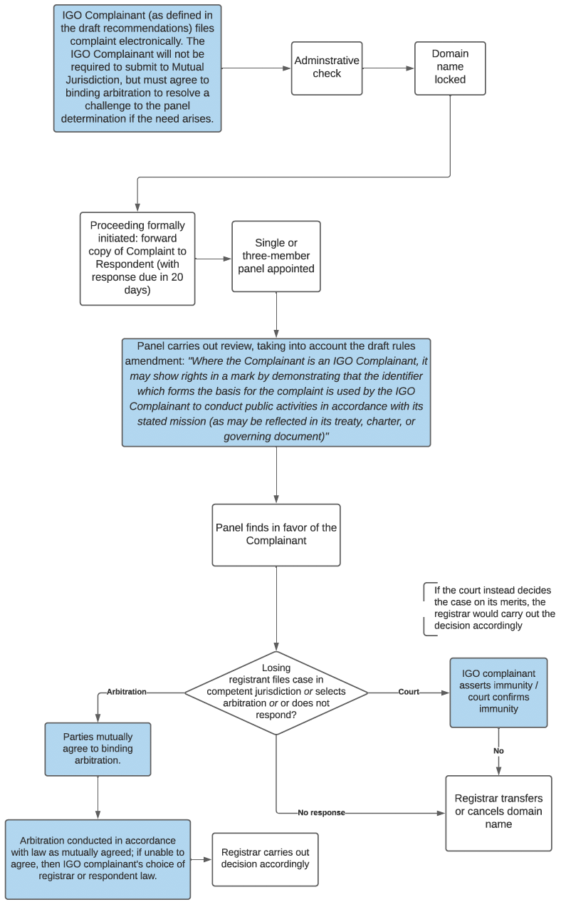

See https://gnso.icann.org/sites/default/files/file/field-file-attach/annex-2-pdp-manual-24oct19-en.pdf (“Although the GNSO Council may adopt all or any portion of the recommendations contained in the Final Report, it is recommended that the GNSO Council take into account whether the PDP Team has indicated that any recommendations contained in the Final Report are interdependent. The GNSO Council is strongly discouraged from itemizing recommendations that the PDP Team has identified as interdependent …“)

