DRAFT TEXT FOR PRELIMINARY RECOMMENDATIONS
EPDP on Specific Curative Rights Protections for IGOs
Draft as of 26 August 2021

Recommendation #1:
The EPDP team recommends that the UDRP Rules and URS Rules be modified in the following two ways.

(i) Add a description of “IGO Complainant” to section 1 (i.e., the definitions section of both sets of Rules):

“‘IGO Complainant’ refers to:
(a) an international organization established by a treaty and which possesses international legal personality; or
(b) an ‘Intergovernmental organization’ having received a standing invitation to participate as an observer in the sessions and the work of the United Nations General Assembly; or
(c) a Specialized Agency or distinct entity, organ or program of the United Nations.”

AND

(ii) Add the following explanatory text to UDRP Rules Section 3(b)(viii), URS Section 1.2.6 and URS Rules Section 3(b)(v):

“Where the Complainant is an IGO Complainant, it may show rights in a mark by demonstrating that the identifier which forms the basis for the complaint is used by the IGO Complainant to conduct public activities in accordance with its stated mission (as may be reflected in its treaty, charter, or governing document).”

Recommendation #2A:
If the GNSO Council approves the recommendations set out below, then the EPDP team recommends that the original Recommendation #5 from the IGO-INGO Access to Curative Rights Protections PDP be rejected.

Recommendation #2B:
The EPDP team recommends that IGO Complainants (as defined under Recommendation #1, above) be exempt from the requirement to agree to submit to Mutual Jurisdiction when filing a complaint under the UDRP [or URS].
Recommendation #2C:
The EPDP team recommends that the following be added to the UDRP [and URS] to accommodate a review of an initial determination under the UDRP [or URS].

** A Note from the EPDP team on Recommendation #2C:

The EPDP team continues to deliberate on the text and final concept for Recommendation #2C. While the EPDP team is in general agreement that arbitration is an appropriate solution, it has not yet reached agreement on two specific aspects relevant to such an option (viz., (i) whether the option to arbitrate will remain available to a registrant following the outcome of a court proceeding initiated by the registrant in light of an IGO’s jurisdictional immunity from process, and (ii) what should be the applicable choice of law for any arbitration that the parties may agree to). As such, the text that follows reflects proposals submitted by EPDP team members on these specific issues, as indicated by the square brackets around the relevant proposals and their text (see #2C(ii), (iii), (iv)and (vi), below.)

Binding Arbitration Following the Initial UDRP [or URS] Panel Determination

- When submitting its complaint, an IGO Complainant shall also indicate whether it agrees that final determination of the outcome of the UDRP [or URS] proceeding shall be through binding arbitration, where the registrant also agrees to arbitration.

- As provided in Paragraph 4(k) of the UDRP, the relevant registrar shall wait ten (10) business days (as observed in the location of its principal office) before implementing a UDRP [or URS] panel decision rendered in the IGO Complainant’s favor, and will stay implementation if, within that period, it receives official documentation that the registrant has either initiated proceedings in court or agreed to arbitration, as described further below.

- Option for consideration: [In communicating a UDRP [or URS] panel decision to the parties where the complainant is an IGO Complainant, the UDRP [or URS] provider shall also request that the registrant indicate whether they agree that any review of the panel determination will be conducted via binding arbitration. The request shall include information regarding the applicable arbitral rules, which shall be determined by the Implementation Review Team. Existing arbitral rules like ICDR, WIPO, UNCITRAL should be considered.]

[Where the registrant initiates court proceedings and the IGO Complainant does not waive its privileges and immunities, and [if] the result is that the court is unable to proceed further, the registrant may submit the dispute to binding arbitration within 10 days from the court order declining jurisdiction over the IGO, by submitting a request for or notice of arbitration to the competent arbitral institution with a copy to the registrar and the IGO Complainant.

If it receives such a request for or notice of arbitration, the registrar shall continue to stay implementation of the UDRP [or URS] panel decision until it receives official documentation concerning the outcome of an arbitration or other satisfactory evidence of a settlement or other final resolution of the dispute.

If the registrant does not submit a request for/notice of arbitration to the competent arbitral institution (with a copy to the registrar and the IGO Complainant) within 10 days from the court order declining jurisdiction over the IGO, the original UDRP decision will be implemented by the registrar.]

Note: With respect to the second option above, IGO members of the EPDP team have provided the following illustrative high-level potential court flow chart to explain the difference – in terms of added time and cost and legal uncertainty – when arbitration is not the direct path for review of a UDRP or URS decision:

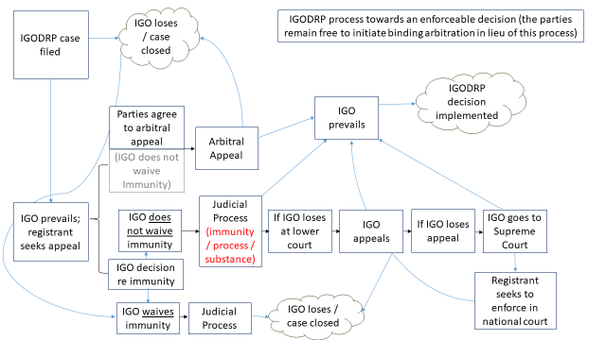

- If the UDRP [or URS] provider receives notice that an arbitration proceeding has been initiated, it shall promptly inform both parties and the relevant registrar. The relevant registrar shall stay the implementation of the initial UDRP [or URS] panel decision until it has received official documentation concerning the outcome of the arbitration or other satisfactory evidence of a settlement or other final resolution of the dispute.

- The Registrar shall continue to maintain the Lock on the disputed domain name during the pendency of any [judicial proceedings and] arbitration, as applicable.

- [The arbitration will be conducted in accordance with the law as mutually agreed to by the parties.]

-- OR --

[At the election of the Complainant, the arbitration will be conducted in accordance with the law of the relevant registrar’s principal office or where the respondent is resident. If either party raises concerns to the arbitral tribunal that the law of the registrar’s principal office or the respondent’s place of residence does not have a satisfactory cause of action related to the parties’ dispute, the arbitral tribunal may request submissions from the parties as to the suggested applicable law or principles of law (which may include UDRP case precedent) to be applied.]

(Note: With respect to the second sentence in the immediately above bracketed option, IGO members of the EPDP team have raised concerns that some jurisdictions may not have a substantive cause of action for the parties to invoke.)

- In addition, the following non-exhaustive general principles (which can be further developed by the expected Implementation Review Team) shall govern all arbitral proceedings conducted through this process:
  - The arbitration shall be conducted as a de novo review; i.e., the parties are permitted to restate their case completely anew, including making new factual and legal arguments and submit new evidence;
  - The arbitral tribunal should consist of one or [three] neutral and independent decision makers, who cannot be the panelist(s) who rendered the initial UDRP [or URS] decision; and
  - Both parties should be able to present their case in a complete manner. The arbitral tribunal should, for example, have the authority within reasonable discretion to allow for, or request, additional written submissions, and it should be possible to hold hearings (which may be conducted online).

- Either party has the right to file proceedings in a court, up to the point in time when an arbitration proceeding is commenced (if any).

The EPDP team is using the terms “notice of arbitration” and “request for arbitration” as the former is the term used by UNCITRAL while the latter is used for proceedings at the ICC and WIPO.]

