Extracts from the Corrected .WEB IRP Decision, for purposes of discussion on costs and fees;
IRP-IOT Call 6 December 2022

Cost shifting for Frivolous or Abusive Defence
397. Applying the relevant provisions of the Bylaws and Interim Procedures, properly construed, to the facts of this IRP, the only parts of the Claimant’s case as to which it has been designated as the prevailing party are the liability portion of its core claims and its Request for Emergency Interim Relief. This being so, those are the only parts of the Claimant’s case as to which the Panel needs to evaluate whether the Respondent’s defence was frivolous or abusive.
399. To state the obvious, not every claim or defence that does not prevail in an IRP will result in an award of costs. The applicable cost shifting rule requires that the claim or defence be found to be frivolous or abusive. This standard binds the Parties as well as the Panel.
407. In the opinion of the Panel, the Respondent’s requirement, as part of its defence strategy, that the Claimant introduce a Request for Emergency Interim Relief at the outset of the IRP, failing which the Respondent would lift the “on hold” status of the .WEB contention set, was “abusive” within the meaning of the cost shifting provisions of the Bylaws and Interim Procedures, all the more so in light of the Respondent’s subsequent decision to agree to keep the .WEB contention set on hold until the conclusion of this IRP. In the opinion of the Panel, this conduct on the part of the Respondent was unjustified and obliged the Claimant to incur wasted costs that it would be unfair for the Claimant to have to bear.
410. The Panel has difficulty accepting that such a significant amount of fees as that claimed by the Claimant in regard to the Request for Emergency Interim Relief can reasonably be attributed to the preparation of this request and the subsequent proceedings before the Emergency Panelist. Exercising its discretion in relation to the fixing of the legal expenses reasonably incurred that may be ordered to be reimbursed pursuant to a cost-shifting decision, the Panel reduces the Claimant’s claim on account of the Request for Emergency Interim Relief to USD 450,000, inclusive of pre-award interest.
Reimbursement of Claimant’s share of ICDR administrative and other costs
412. The ICDR has informed the Panel that the administrative fees of the ICDR and the fees and expenses of the Panelists, the Emergency Panelist, and the Procedures Officer in this IRP total USD 1,198,493.88. The ICDR has further advised that the Claimant has advanced, as part of its share of these non-party costs of the IRP, an amount of USD 479,458.27. In accordance with the general rule set out in Section 4.3(r) of the Bylaws, the Claimant is entitled to be reimbursed by the Respondent the share of the non-party costs of the IRP that it has incurred, in the amount of USD 479,458.27.

Claimant’s Reply Schedule Costs – Annex A:
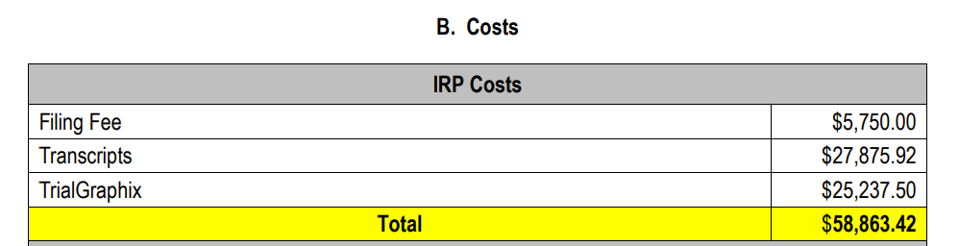
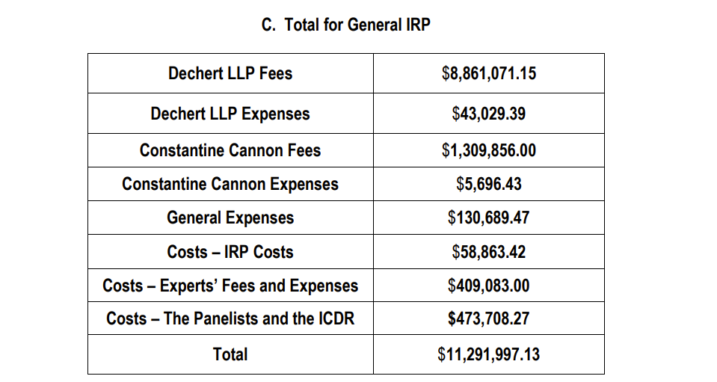
Note
Costs – Panellist and the ICDR: $473,708.27
Filing Fee: $5,750.00
Total: $479,458.27

https://www.icann.org/en/system/files/files/irp-afilias-corrected-final-declaration-redacted-15jul21-en.pdf
https://www.icann.org/en/system/files/files/irp-afilias-claimants-reply-schedule-costs-annex-a-23oct20-en.pdf

